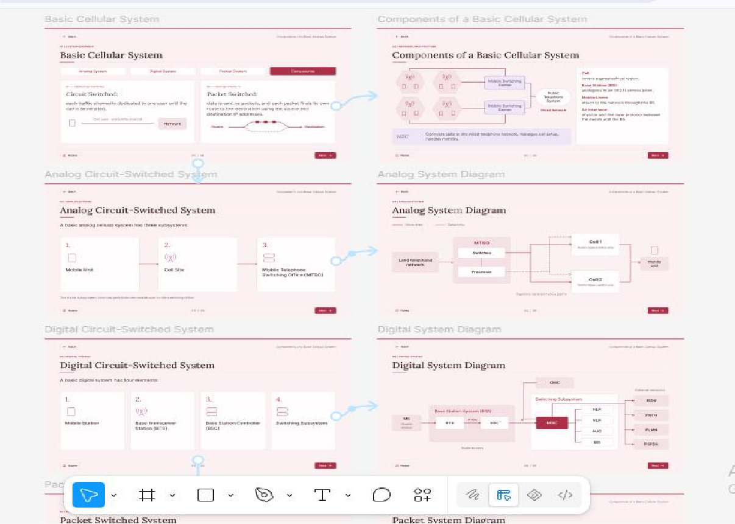
Exp No: 1

Use Figma to create an interactive diagram illustrating the components of a basic cellular system.
Aim:
To create an interactive diagram illustrating the components of a basic cellular system.

Procedure:
  - Open Figma.
  - Create a new design file.
  - Select the Frame tool and add frames (slides) for each screen.
  - Fill in the content required for the presentation.
  - Design the visual elements (shapes, icons, colours, images).
  - Make it interactive by linking the frames in the Prototype tab.
  - Add annotations and explanations.
  - Incorporate multimedia.
  - Storyboard the animation using Smart Animate or Dissolve.
  - Review and edit the prototype using the Present mode.
  - Save and share the file.

Output Screenshot:
Design:

Result:
Hence an interactive diagram illustrating the components of a basic cellular system using Figma is created and executed successfully.

