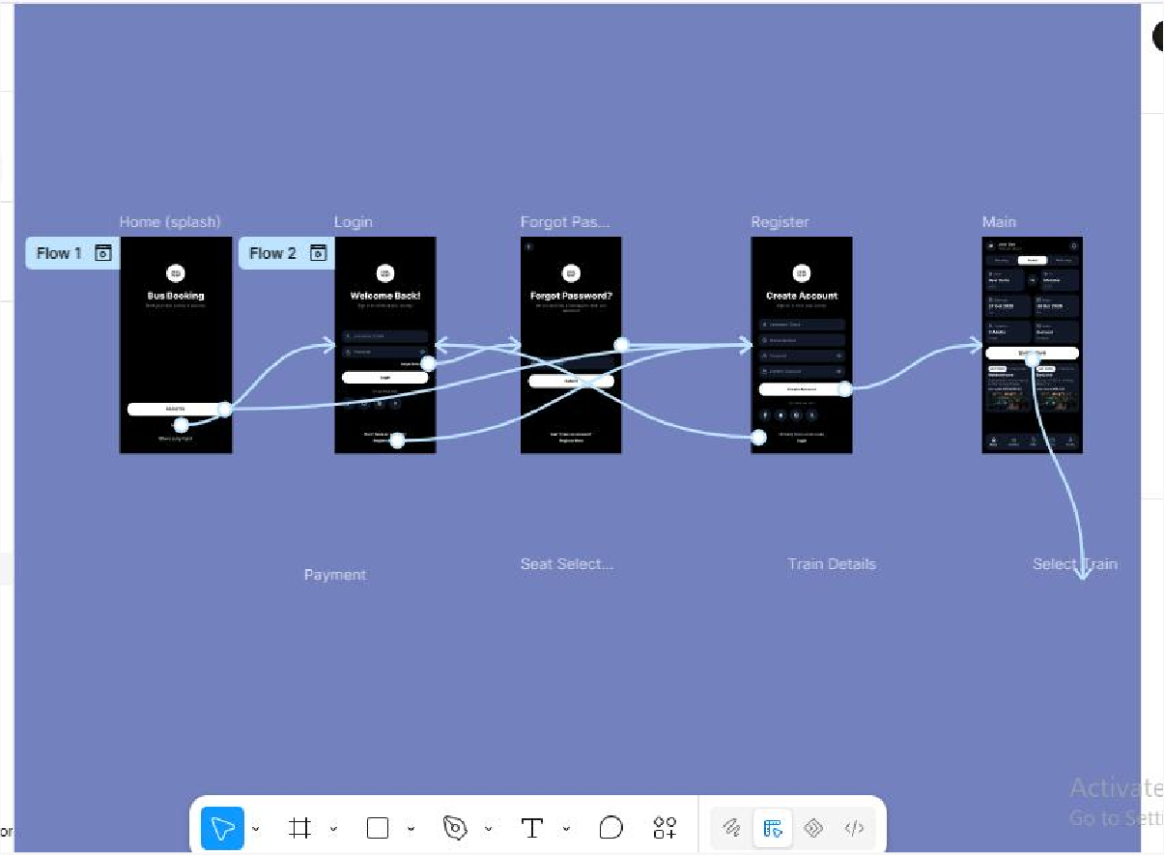
Exp No: 2

Design a user interface prototype for a mobile station using Figma, considering connectivity and convenience.
Aim:
To create a user interface prototype for a mobile station using Figma, considering connectivity and convenience.

Procedure:
  - Open Figma.
  - Create a new design file.
  - Select the Frame tool and add a mobile frame for each screen.
  - Design the visual elements (buttons, text fields, cards, colours).
  - Make it interactive by linking the screens in the Prototype tab.
  - Add icons on the frames.
  - Incorporate multimedia.
  - Storyboard the animation using Smart Animate or Dissolve.
  - Review and edit the prototype using the Present mode.
  - Save and share the file.

Output Screenshot:
Design:

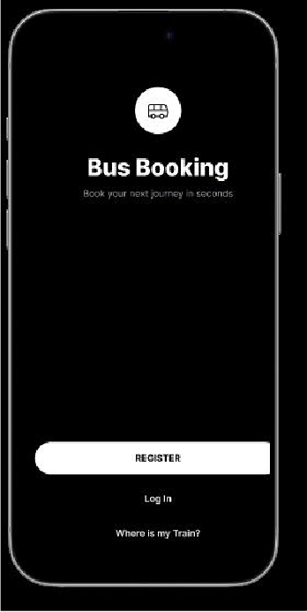
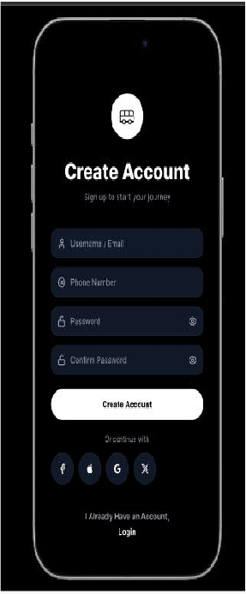
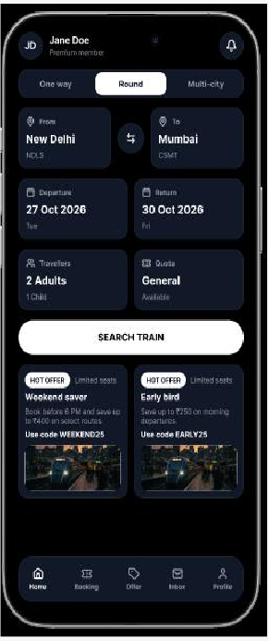
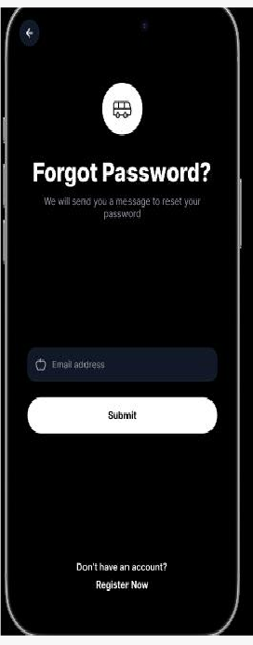
Prototype:

Result:
A user interface prototype for a mobile station using Figma, considering connectivity and convenience, is created and executed successfully.

