Crawl_Trace: Automated Detection and Tracing of Linear Landforms Using LiDAR

Version 1.0 — October 2025
Developed by PhD Candidate M. Jaweed Nazary
College of Engineering, University of Missouri — Columbia
Supported by EPA Grant No. CD97790701
Contact: mnxvx@umsystem.edu

1. Purpose
The Crawl Trace tool is designed to automatically detect, trace, and characterize levee-like or channel-like linear landforms from high-resolution LiDAR data. It operates on a 1000 m × 1000 m tile centered at a user-defined location and uses a “crawling” algorithm that follows the elevation gradient either uphill or downhill, depending on the selected method.
This tool supports wetland restoration studies, hydrological modeling, and geomorphometric mapping by providing an efficient, automated approach to identifying subtle terrain features that indicate anthropogenic levees or natural channels.

2. Background
Traditional identification of levees and small channel features from LiDAR involves manual inspection or threshold-based filtering of DEM derivatives (e.g., slope, curvature). The Crawl Trace algorithm introduces an adaptive method that:
- Randomly seeds multiple starting points within the study tile.
- Analyzes the local elevation gradient and orientation.
- “Crawls” along the likely path of ridge-like (uphill) or depression-like (downhill) terrain.
- Produces vectorized linear traces representing probable geomorphic features.
This approach balances automation and interpretability, making it well-suited for landscape-scale levee mapping and wetland reconnection studies.

3. Usage Overview
Example Python usage:
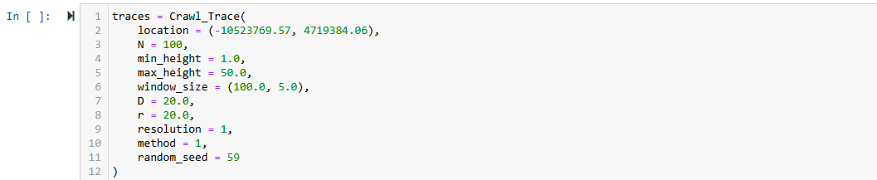
The function retrieves LiDAR data for the specified tile, performs random seed initialization, conducts iterative crawling, and returns a GeoDataFrame containing the traced linear features with associated attributes.

4. Parameter Guide
Parameter | Type | Description | Example
location | tuple(float, float) | Center coordinates of study tile in EPSG:3857 projection (x, y). | (-10523769.57, 4719384.06)
N | int | Number of random seed points inside the 1000 m tile. Higher values increase coverage but add runtime. | 100
min_height | float | Minimum relative elevation (m) for valid features. Filters low-relief noise. | 0.5
max_height | float | Maximum relative elevation (m) for valid features. Filters large-scale terrain. | 50.0
window_size | tuple(float, float) | Local tracing window dimensions (L, W) in meters. It affects the sensitivity of feature detection. | (100.0, 5.0)
D | float | Offset distance (m) during tracing. Controls how far the algorithm jumps along the feature of interest. | 20.0
r | float | Neighborhood radius (m) used to estimate local feature orientation. | 20.0
resolution | int | LiDAR processing resolution (m). Smaller values improve precision but increase computation time. | 1
method | int | Tracing mode: 1 = uphill (levees/ridges), 2 = downhill (channels/depressions). | 1
random_seed | int | Random seed for reproducibility. Use the same value to replicate results. | 59

5. Output Description
Returns a GeoPandas GeoDataFrame of points located on a traced linear feature. Each record represents a collection of point features with attributes such as:
relative elevation, method, height of the feature, directional anisotropy, normalized directional anisotropy, and the orientation angle of the feature in radians. Other attributes such as flow accumulation, leveed area, confidence level will be added in a later version of the code.

6. Recommended Workflow & Best Practices
1. Ensure input coordinates are projected in EPSG:3857 (meters).
2. Divide your study area into tiles of size 1000m by 1000m and run the code in loop for those.
3. Tune parameters (e.g., r, window_size, N, and min_height) based on feature scale of interest for one tile and the run the code for the entire study area.
4. Validate results visually against DEM or hillshade.
5. Compare extracted traces with reference datasets (e.g., National Levee Dataset). This method should get almost all of NLD levees in addition to many of the levees that are not in the NLD. Do not be surprised of you find many levees that are not in the NLD.

7. Troubleshooting

- ValueError : Invalid parameter types — check coordinate format
- No features detected: Relax min_height or increase N
- Early trace termination: (levees or channels are traced entirely). Increase r or check LiDAR point density is better than the resolution specified.
- PDAL failure: Verify LiDAR availability and coordinate projection.

8. Citation
Citation information will be available after publishing the paper related to this code.

