“EXPLORATORY DATA ANALYSIS AND INSIGHT GENERATION
ON THE GLOBAL VIDEO GAME MARKET (1980–2016)”
A PROJECT REPORT SUBMITTED TO BHARATHIAR UNIVERSITY
IN PARTIAL FULFILMENT OF THE REQUIREMENTS FOR THE
AWARD OF THE DEGREE OF
BACHELOR OF DATA SCIENCE
Submitted By
JAWER-22
(Reg. No. 2328MXXXX)
Under the Guidance of
PROJECT COORDINATOR
DEPARTMENT OF DATA SCIENCE
MARCH 2026

CERTIFICATE
This is to certify that the project work entitled “EXPLORATORY DATA ANALYSIS AND INSIGHT GENERATION ON THE GLOBAL VIDEO GAME MARKET (1980–2016)”, is a bona-fide work done by JAWER-22 during the period of 2025-2026 in the Department of Data Science. The project work is an original work of the candidate and to the best of my knowledge has not been submitted, in part or in full, for any Diploma / Degree / Associateship / Fellowship or other similar titles in this or any other University.
SIGNATURE OF THE GUIDE
SIGNATURE OF THE HOD SIGNATURE OF THE PRINCIPAL

ABSTRACT
The global video game industry has evolved from a niche hobby into a dominant multi-billion dollar entertainment sector. Understanding market trends, regional preferences, and platform lifecycles is critical for publishers and stakeholders. The present study focuses on a comprehensive Exploratory Data Analysis (EDA) of the VGChartz dataset, containing records for over 16,000 video games spanning 1980 to 2016. A systematic data cleaning and feature engineering pipeline was implemented, addressing missing values and standardizing platform data. Key findings reveal that the market experienced a significant peak between 2008 and 2009, with North America consistently holding the largest market share (~49%). Action and Sports genres were identified as high-volume leaders, while Platform and Shooter games showed superior average sales targets. The results highlight distinct regional taste differences, with Japan uniquely favoring Role-Playing games. This report demonstrates how data-driven visualizations and statistical analysis can uncover the hidden factors driving the success of video game titles globally.

1.1 INTRODUCTION
The entertainment industry has been revolutionized by the digital gaming era. From early pixelated consoles to high-fidelity modern hardware, video games have become a massive data-generating engine. This project seeks to explore the patterns within the global gaming market, focusing on how different factors like Genre, Platform, and Region drive commercial success.

1.2 PROJECT OBJECTIVE
- To perform deep exploratory analysis on 16,000+ game sales records.
- To identify regional differences in market behavior (NA, EU, JP).
- To visualize platform lifecycles and the impact of release decade.
- To provide an interactive dashboard for multi-dimensional data exploration.

1.3 DATA OVERVIEW
The dataset includes 11 core attributes for each game, ranging from categorical identifiers to numerical sales totals. Key features include Rank, Name, Platform, Year, Genre, Publisher, and Regional Sales (NA, EU, JP, Other) in millions.

CHAPTER 2: SYSTEM STUDY

2.1 SYSTEM SPECIFICATION

2.1.1 HARDWARE SPECIFICATION
- Processor: Intel Core i5 or higher
- RAM: 8 GB or more
- Storage: 256 GB SSD
- System Type: 64-bit Operating System

2.1.2 SOFTWARE SPECIFICATION
- Operating System: Windows 10/11
- Programming Language: Python 3.x
- Environment: Jupyter Notebook / Visual Studio Code
- Key Libraries: Pandas, NumPy, Matplotlib, Seaborn, Streamlit

CHAPTER 3: SYSTEM DEVELOPMENT

3.1 DATA PREPROCESSING
Data integrity was ensured by addressing missing values and standardizing columns. A critical constraint was applied to cap the analysis at the year 2016 to ensure data completeness and recency.

3.2 EXPLORATORY DATA ANALYSIS (EDA)
EDA uncovers the underlying structure of the global gaming market through distribution analysis and time-series trends.
Fig 3.1: Regional Sales Trends Over Time (Stacked Area Chart)
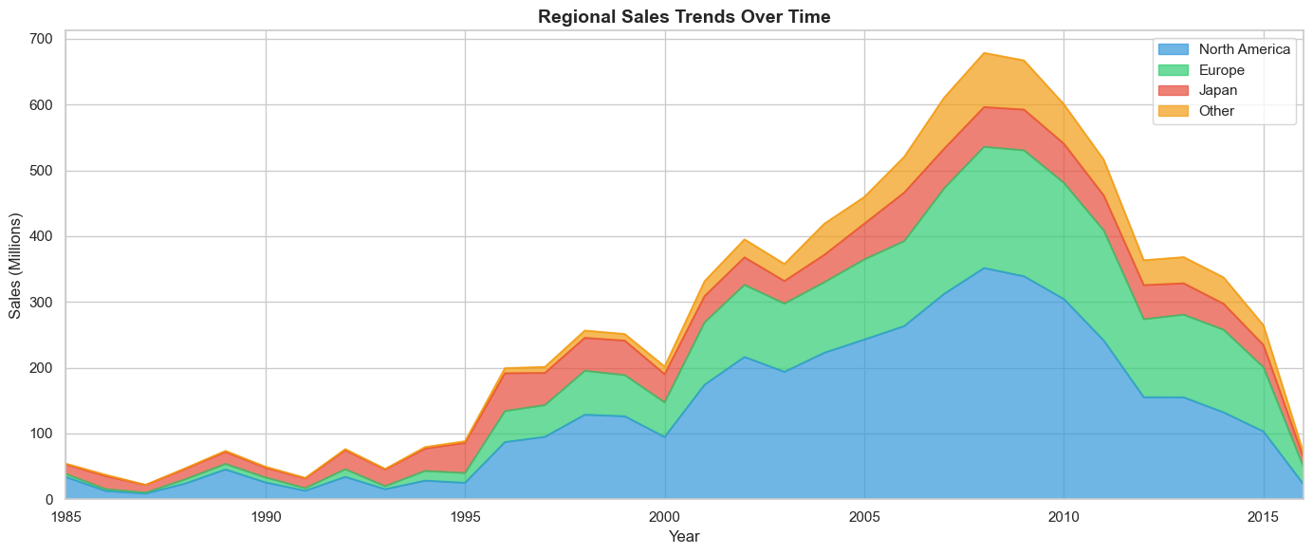

3.3 KEY INSIGHTS
- 2008 Peak: The gaming market reached its highest revenue peak during 2008-2009.
- Regional Dominance: North America accounts for nearly half of the global market share.
- Japan's Unique Taste: Unlike NA and EU (Shooters/Sports), Japan prefers Role-Playing games.

CHAPTER 4: STREAMLIT WEB INTERFACE
To provide stakeholders with a self-service tool, an interactive web application was developed using Streamlit. The interface allows users to filter data by year ranges (1980-2016), genres, and platforms in real-time.
Fig 4.1: Interactive Market Analysis Dashboard
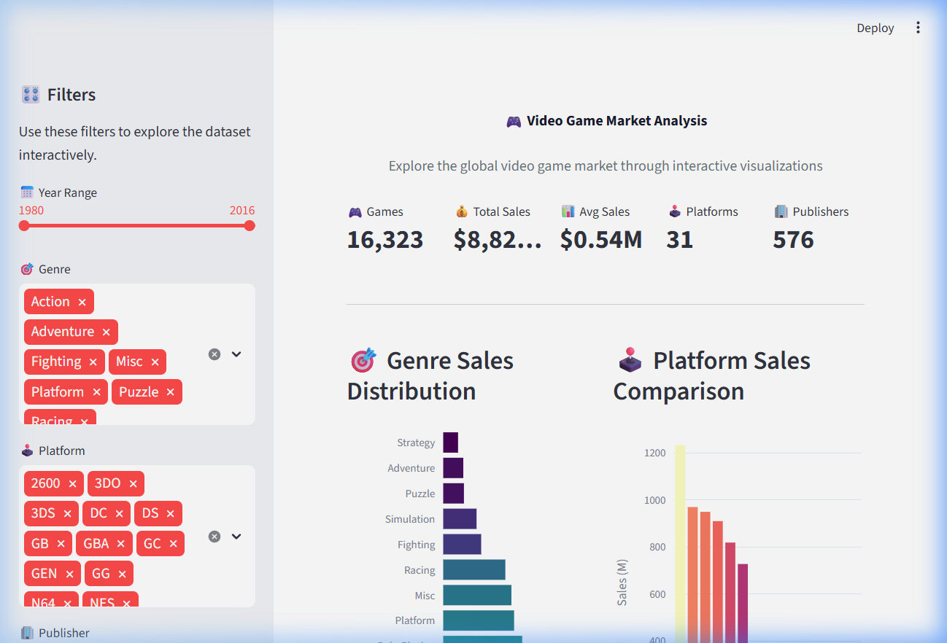

CHAPTER 5: CONCLUSION
The project successfully identifies the primary growth factors of the video game market. By leveraging automated data cleaning and modern visualization tools, we provide a robust framework for understanding global gaming commerce.

