

­

ANALYSIS

OF

UML DIAGRAMS

SPRING-2020

PAF-KIET KARACHI INSTITUTE OF ECONOMICS & TECHNOLOGY

OBJECT ORIENTED

ANALYSIS & DESIGN

SUBMITTED TO

*SIR SOHAIL IMRAN*

STUDENT NAME:

JAVERIA HASSAN (9517)

JAWERIA ASIF (9442)

CLASS ID: *103744*

(Thursday)

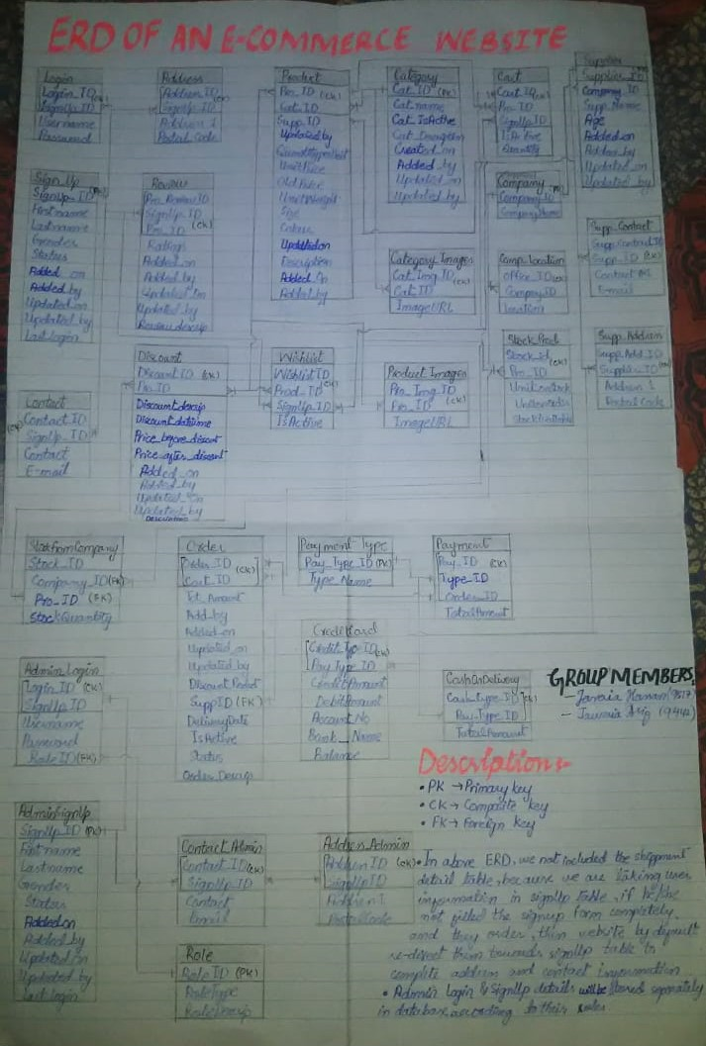

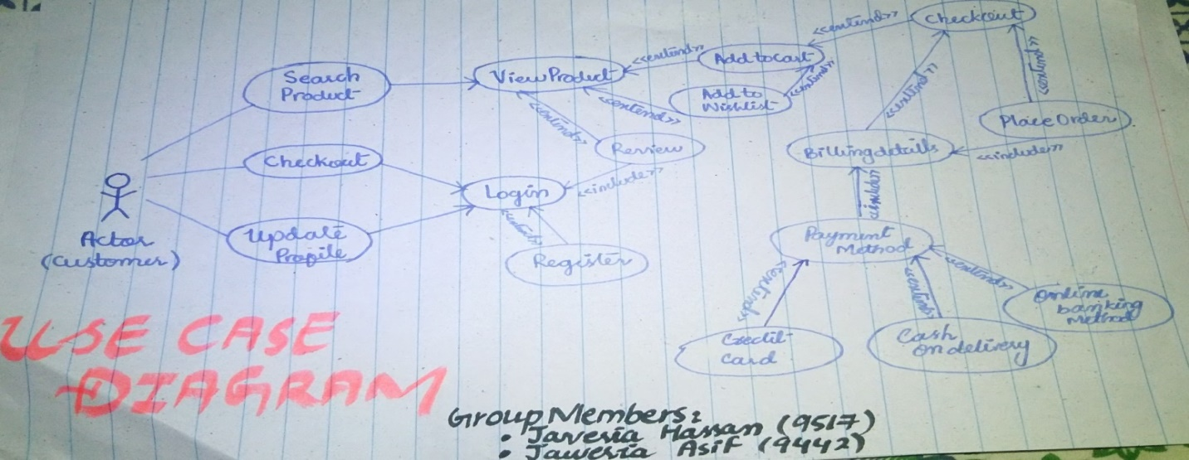

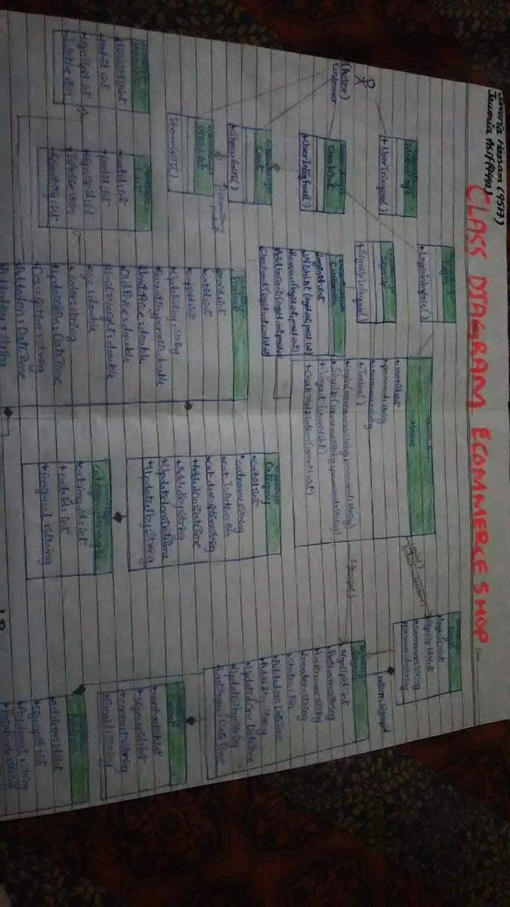

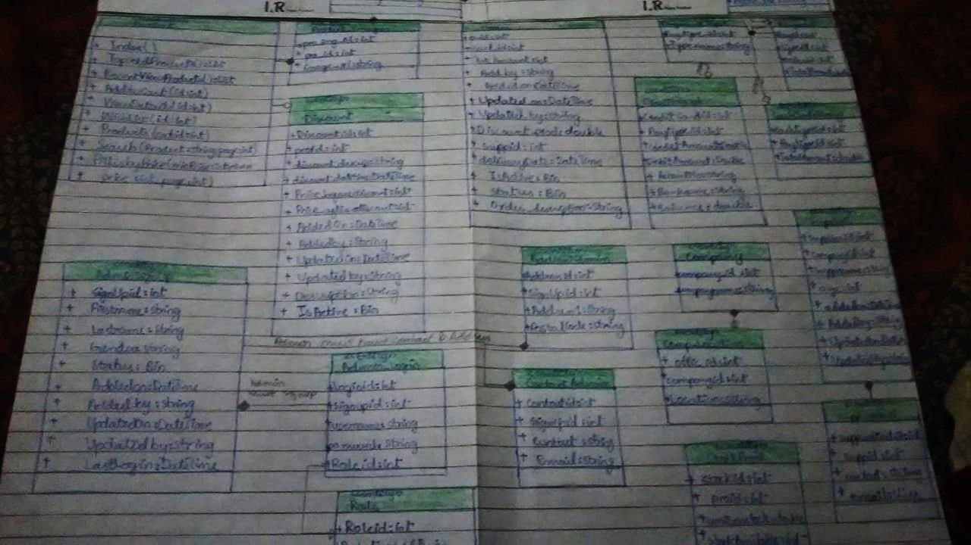

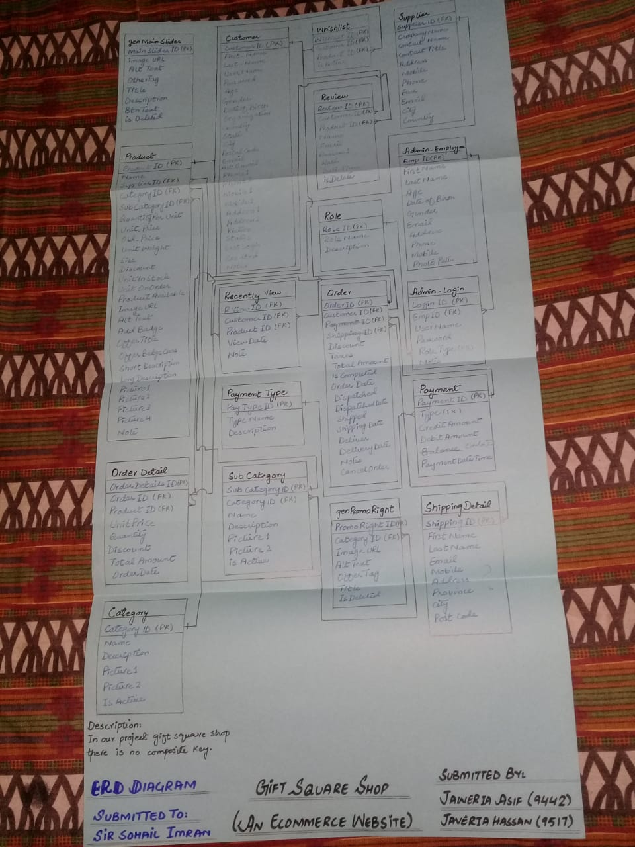

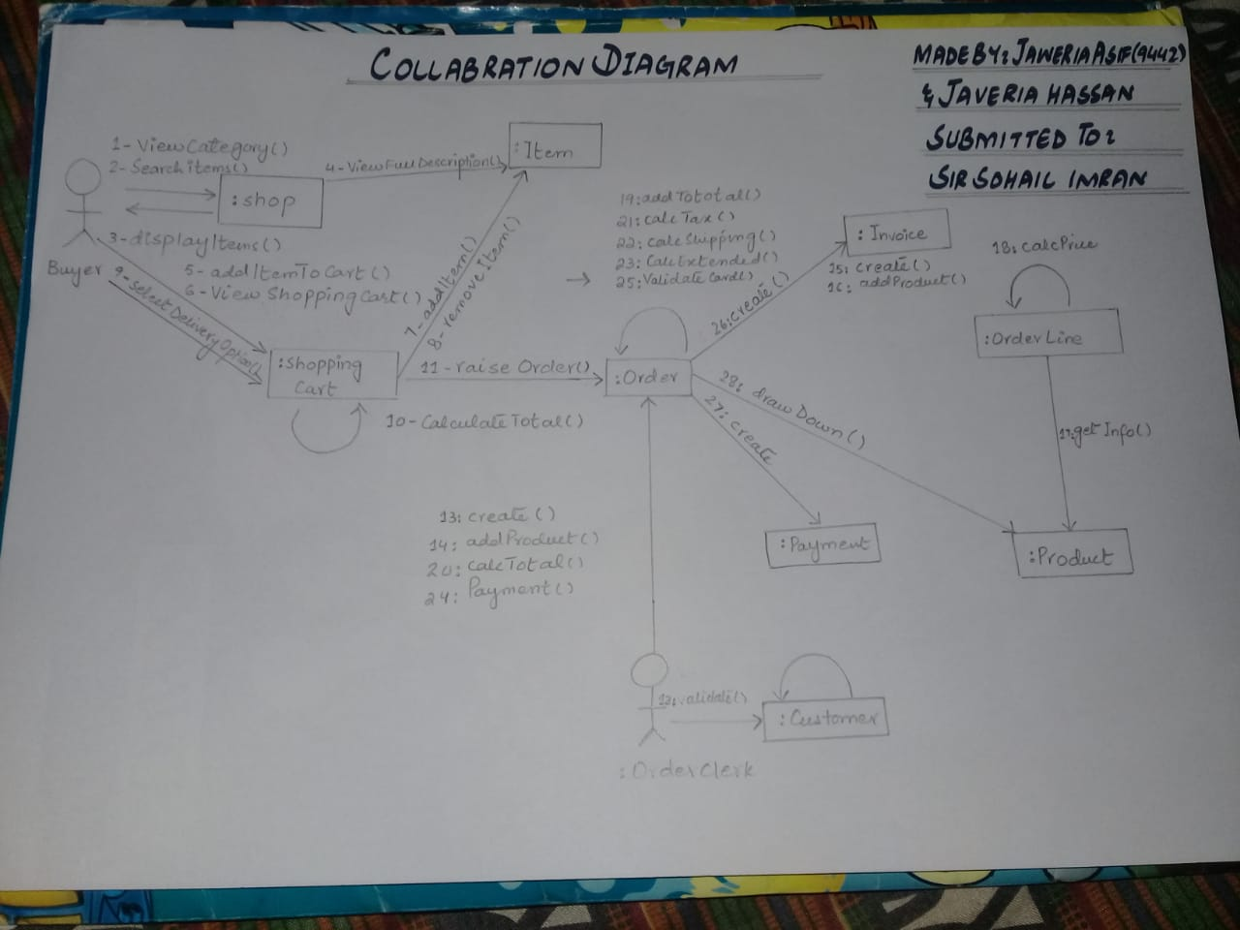

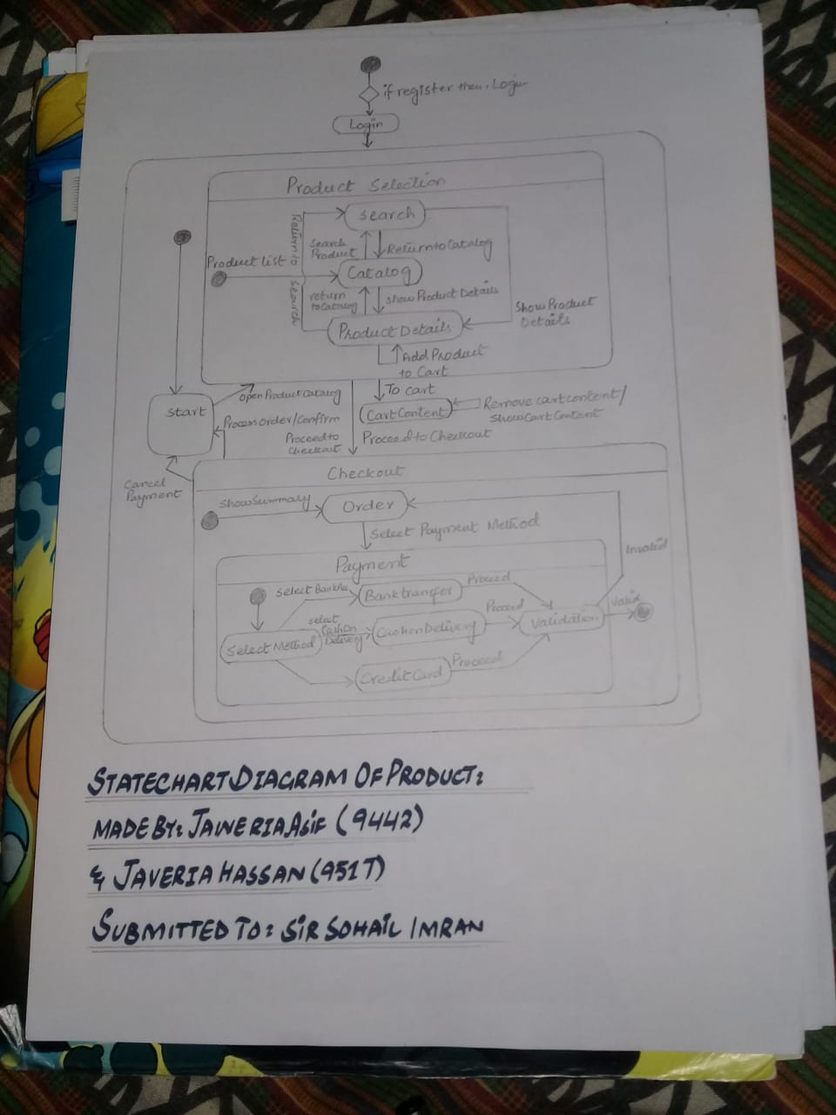

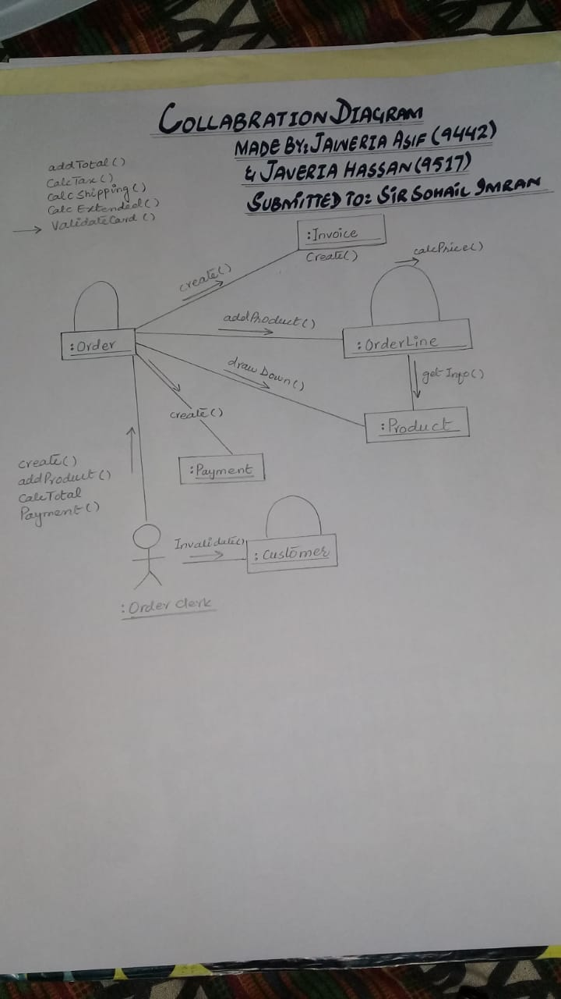

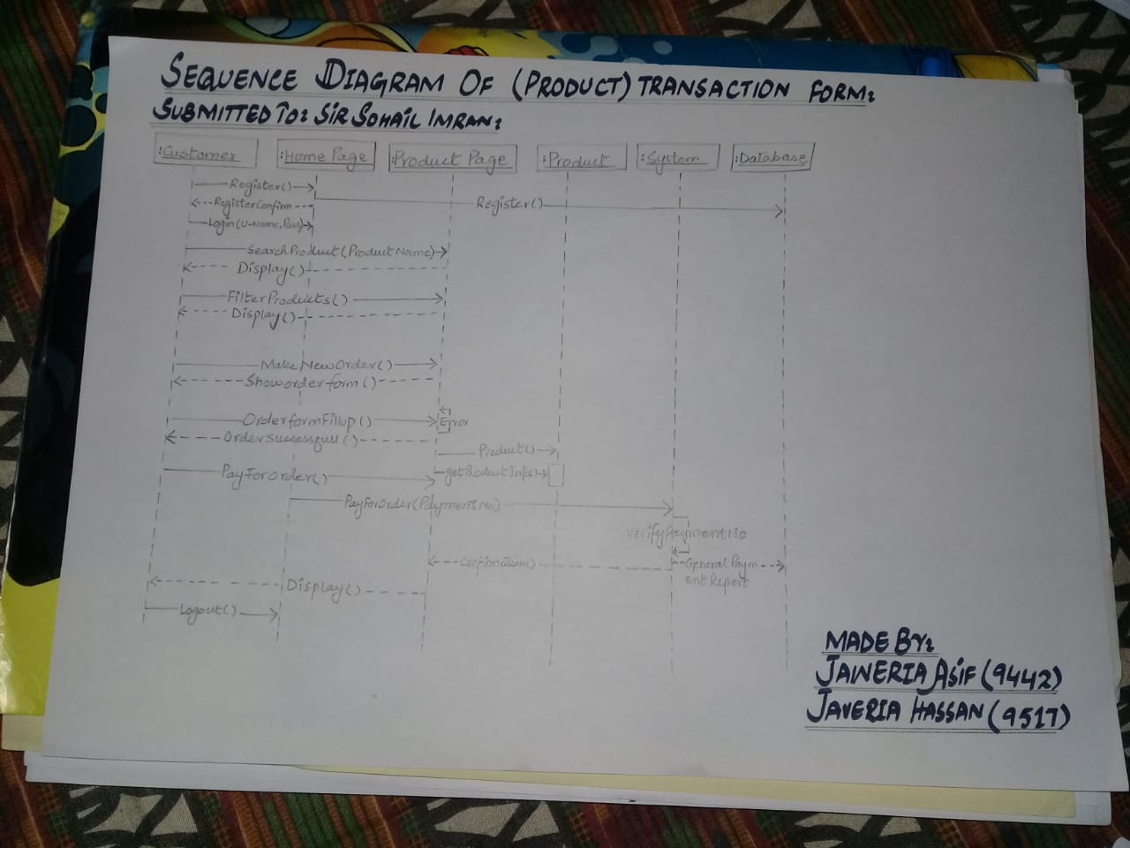

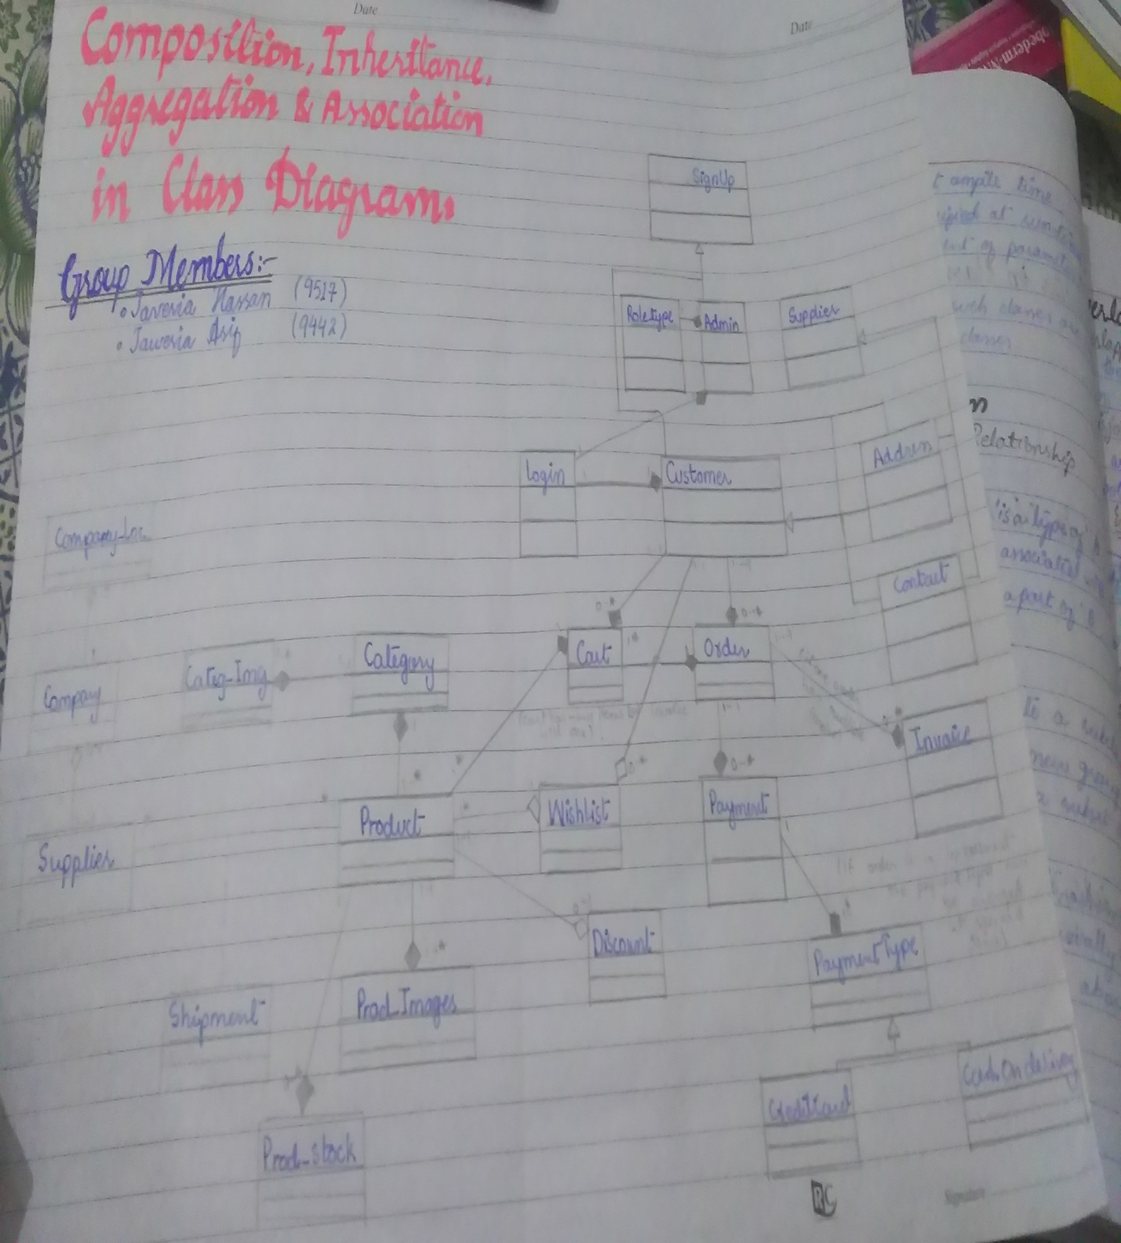

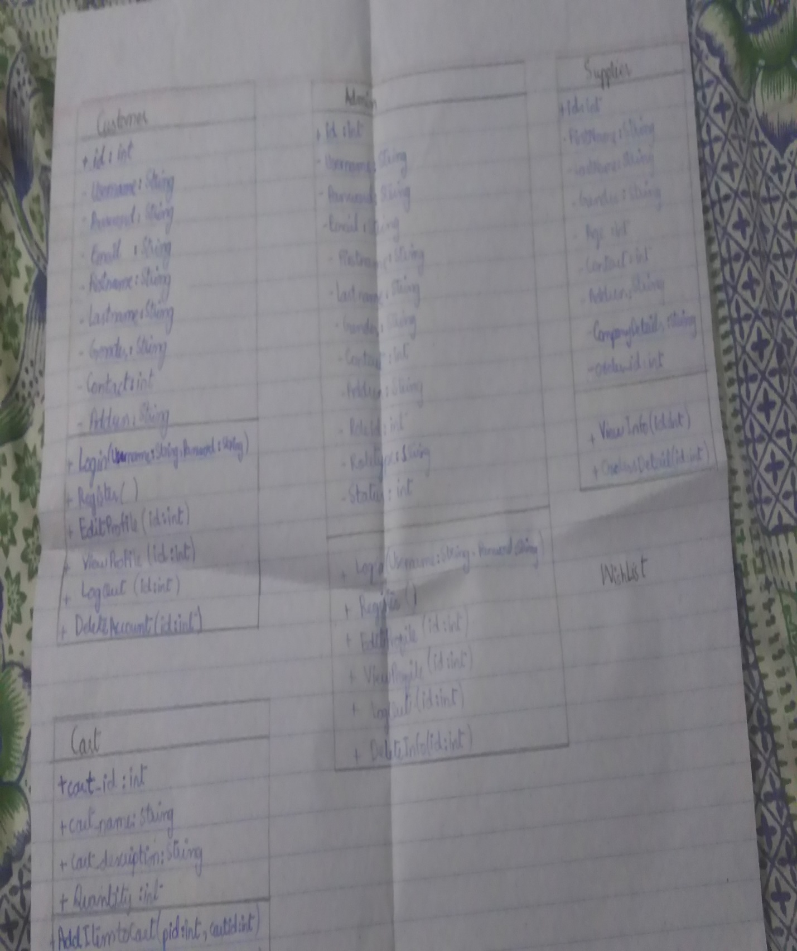

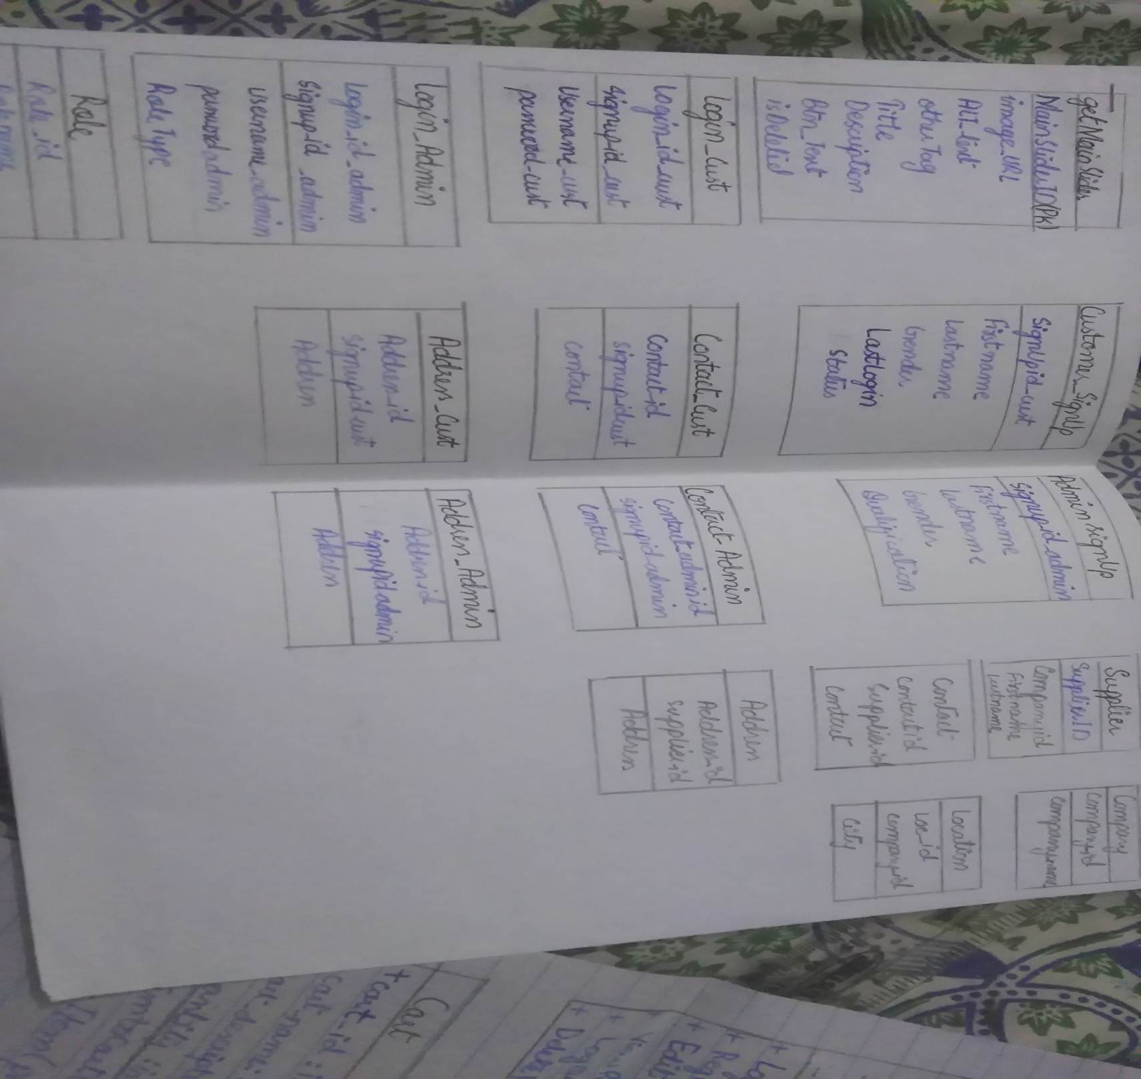

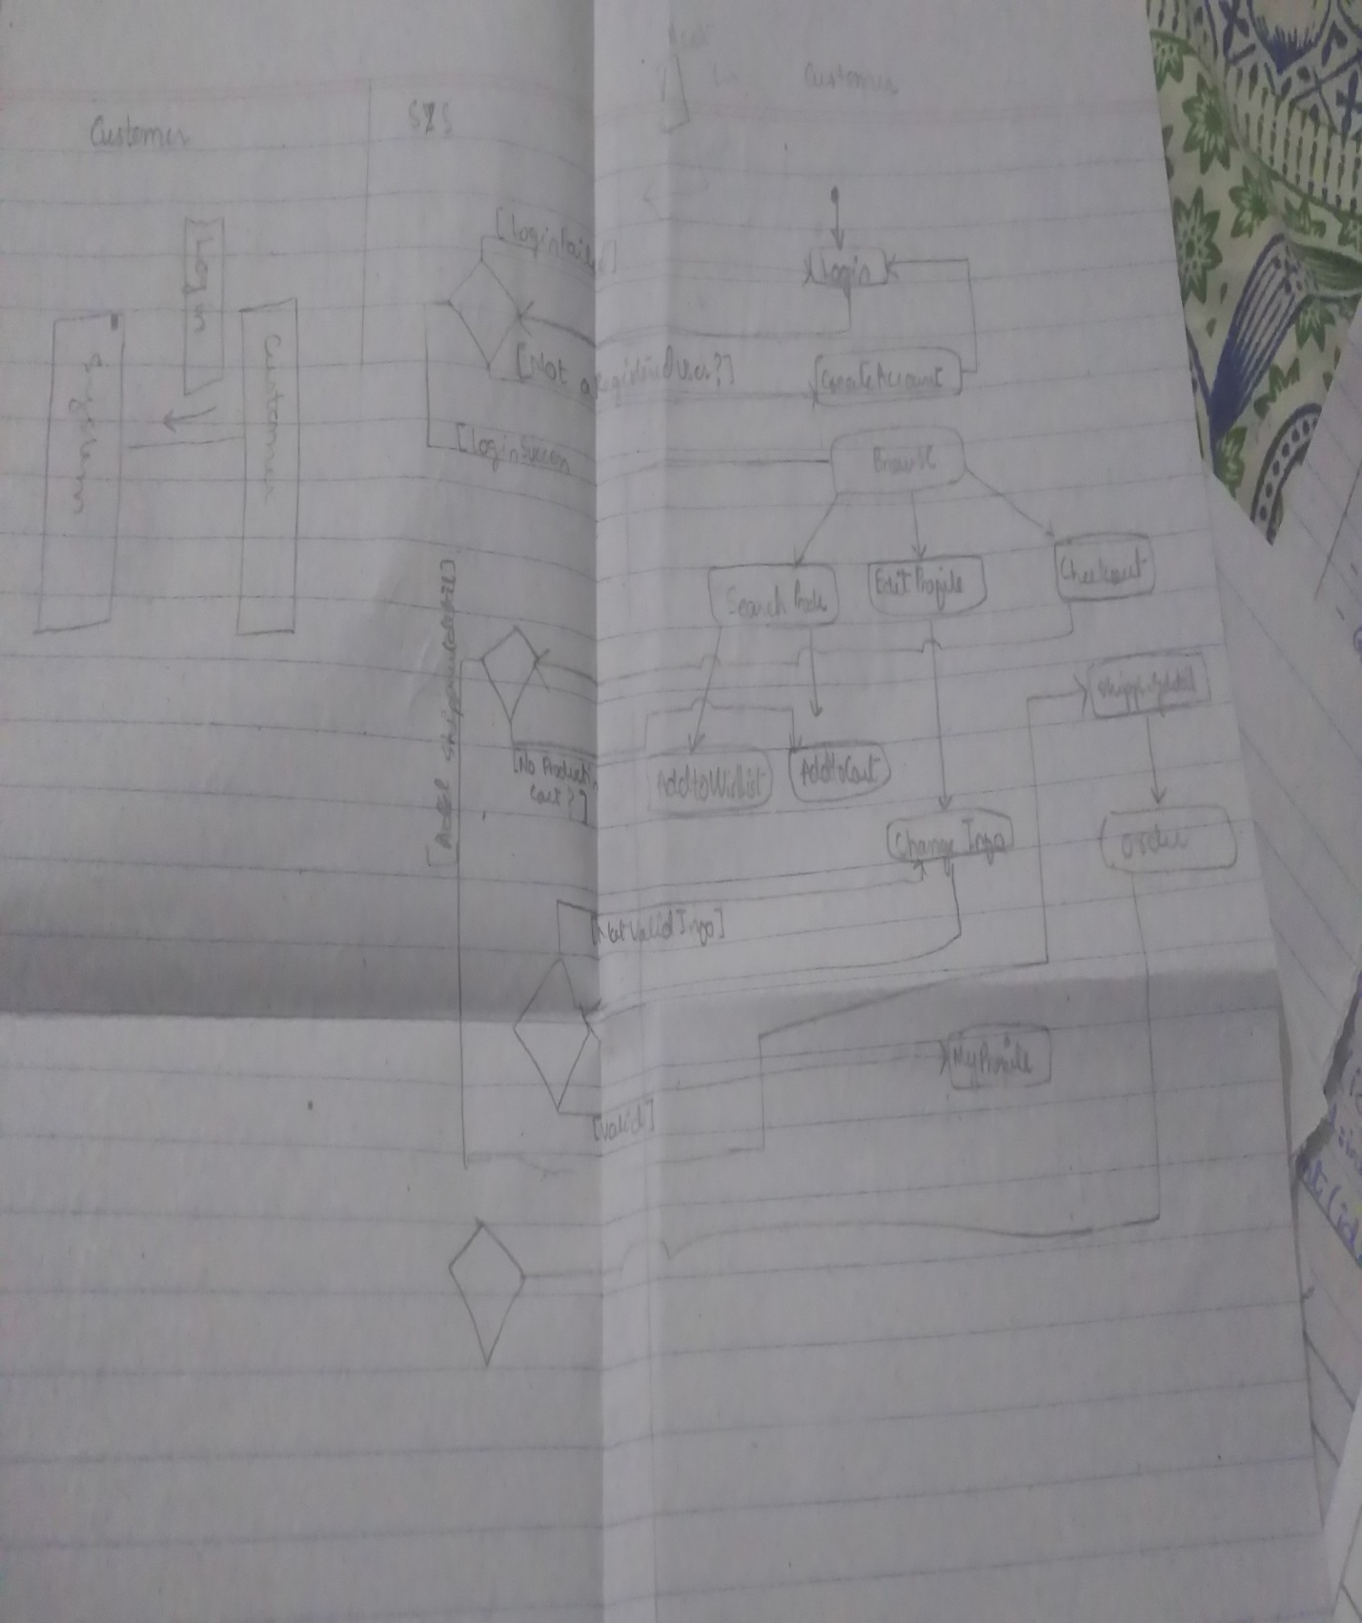

***CONCLUSION:***

These are all the analysis we did during drawing UML diagrams.