Question/Answers:
1.what is an embedding, and why does it let you "search by meaning" instead of by exact keyword?
Ans:
- The process of converting text into vectors(list of numbers) that AI models and LLMs can understand is called embedding.
- The sentences/text having closer vectors have similar meanings.
- It allows semantic search(search by meanings) instead of keyword search because if two words are having same meaning they are given close vector, while in case of keyword search it can go wrong.
- Keyword search looks for exact or matching words, while semantic search looks for similar meaning.
- Example:
A text of cooking will have similar vector value to the sentence related to food ; as compared to the car

2.What chunk size did you end up using, and what did you actually observe when you tried a different size?
Ans:
I used 400 because I learnt that :
- Using a smaller value of chunk_size gives you narrow/precise result; but it can sometimes loss the context and can cut the sentence from mid.
- Using a larger value of chunk_size gives you less precise results;can give extra information and keeps the context.
Result:
I used 400 here because 400 gave me a good balance between relevant context and retrieval.
3.Show me one question where the answer was wrong or made up. Was it a retrieval problem (wrong chunks came back) or a chunking problem (right info existed but got cut awkwardly)? How did you tell the difference?
Ans:
CASE 1:
Retrieval Error:
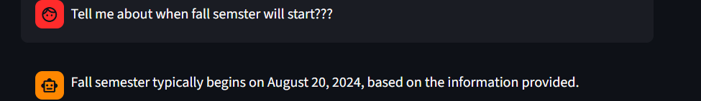

-Retrieval Issue: Initially correct chunk was not getting pointed(right info existed but got cut awkwardly), I reduced the chunking size from 1000 to 400;the retrieval issue to got resolved ;But the answer is still not correct
Generation by LLM issue:
- Concluded it’s a Generation issue, model limitation.The data exists, but search isn't finding it , this is a real model limitation, a genuine model-capability ceiling.
- Small LLM (qwen2.5:1.5b) occasionally misreads which row of a date table answers.
CASE 2:
Loader/Ingestion Issue(Uploaded a complex text PDF):
PDF text extraction (especially PyMuPDFLoader) can occasionally produce stray NUL, common with certain PDFs, especially ones having complex figures and all.
Solution:
So, I sanitize text before it goes into chunks. I tried removeing any NUL bytes before they ever reach chunking/embedding/storage.
CASE 3:
Genartion issue & Retreival Quality issue:
The model is having generation issues its better to user a bigger & better model e.g: phi3,etc., also the best chunk is 3rd one but there is retrieval-quality issue too, since first one is irrelevant.
Example:
Correct chunk and the most appropriate one would be the 3rd one ,but giving a chunk of some other prestored vector store chunk.
tell about education ?
The education section you've provided gives a detailed overview of the education background of the individual, highlighting their skills in software engineering and full-stack development. They have completed a BS in Software Engineering from COMSATS University Islamabad, Pakistan, with a strong focus on data structures, algorithms, and database management systems. This education aligns well with their current skill set in machine learning, as it emphasizes foundational skills in programming and data handling, which are crucial for developing and deploying machine learning models.
Source chunks used
Source 1 — d26f49e758fa83b40c8f22496c857f14_lec1.pdf, page 2
(2). A linear classiﬁer therefore does not have access to information about which pixels are close to each other in the image. Cite as: Tommi Jaakkola, course materials for 6.867 Machine Learning, Fall 2006. MIT OpenCourseWare (http://ocw.mit.edu/), Massachusetts Institute of Technology. Downloaded on [DD Month YYYY].

Source 2 — JAWERIA TAHIR_CV.pdf, page 0
SUMMARY Software Engineering student and aspiring Full Stack AI/ML Engineer with hands-on experience building end-to-end machine learning pipelines and deploying them as production-style APIs. Skilled in data preprocessing, feature engineering, and model development using NumPy, Pandas, scikit-learn, TensorFlow, and Keras, combined with backend development using FastAPI and full-stack web

Source 3 — JAWERIA TAHIR_CV.pdf, page 0
EDUCATION COMSATS University Islamabad, Lahore Campus 2024 – Present BS Software Engineering — CGPA: 3.58 Relevant Coursework: Object Oriented Programming, Data Structures & Algorithms, Database Management Systems TECHNICAL SKILLS Languages: Python, C++, Java, JavaScript, SQL

4. What broke because of session_state, and how did you find and fix it?
Ans:
session_state is Streamlit’s way of remembering data between screen resuns.
When st.session_state was uninitialized:
- RESET OF VECTORSTORE(DUPLICATED CHUNKS):
On every rerun, Streamlit could process the already-uploaded documents again, creating duplicate chunks in your vector store.
- RESET THE CHAT:
Everytime I used to rerun the app , it used to forget the entire memory/history and I was not able to ask the follow up questions.

