COMSATS University Islamabad
Lahore Campus

Assignment 2
Name | Jaweria Tahir
Registration No. | SP24-BSE-051
Section | C
Course Title | SRE
Instructor’s Name | Sir Fawad

GITHUB REPO:
https://github.com/Jaweria-Tahir/whisper-txt-writer-REA
TASK 1:
Reverse Engineering:
Reverse Engineering means studying an already existing product or software to understand how it was made and how it works internally.

Reverse Engineering Anything:
REA is an AI-assisted reverse-engineering toolkit.

Purpose of REA:
- It helps investigate how existing software works.
- It can inspect an application even when its original source code is unavailable.
- It connects AI agents to specialized analysis tools through MCP (Model Context Protocol).
- It produces technical findings and supporting evidence.
- It can help reconstruct a particular feature after investigating its behaviour.

Role of REA in Reverse Engineering:
REA is a helper that does the hard digging for you.
- Reverse engineering normally means reading confusing code by hand, which is slow and difficult.
- REA opens the app, looks inside, and finds how a feature works.
- It then shows proof (code, functions, files) so you can trust the answer.
- Your AI agent explains it in simple words.

Capabilities:
No. | Capability | Description
1 | Static Analysis | Examines source code and application files without running the program.
2 | Binary Analysis | Examines compiled programs to identify functions, instructions and strings.
3 | Decompilation | Converts compiled code into a more understandable representation.
4 | JavaScript Analysis | Identifies JavaScript modules, imports and functions.
5 | Electron Analysis | Investigates Electron applications and their internal components.
6 | Website Analysis | Examines website structure, scripts and network behaviour.
7 | Android Analysis | Investigates APK files, classes, methods and resources.
8 | .NET Analysis | Examines .NET assemblies and program structure.
9 | Runtime Analysis | Observes application behaviour while it is executing.
10 | Evidence Collection | Collects technical evidence to support reverse-engineering findings.

Pre-Requisites:
No. | Prerequisite | Description
1 | Operating System | A supported environment such as Windows, Linux or macOS.
2 | Node.js | Required to execute REA.
3 | npm | Used to install and manage REA packages.
4 | AI Coding Agent | An MCP-compatible agent such as Claude Code, Codex or Cursor.
5 | Target Application | The software or application that needs to be investigated.

Dependencies:
No. | Dependency | Purpose
1 | MCP (Model Context Protocol) | Connects REA with AI coding agents.
2 | Ghidra | Performs binary analysis and decompilation.
3 | IDA Pro | Provides advanced disassembly and binary analysis.
4 | Hopper | Helps analyze native binaries and generate pseudocode.
5 | JADX | Decompiles Android APK files into readable code.
6 | JDK (Java Development Kit) | Required for the documented Android JADX workflow.
7 | Chrome Browser | Supports browser-based website analysis.
8 | ADB | Allows communication with Android devices and emulators.
9 | Binwalk / Unblob | Helps analyze and extract firmware files.
10 | WABT | Provides tools for WebAssembly analysis.

FLOW:
- AI Agent
- MCP
- REA Analysis
- Finding and Evidence
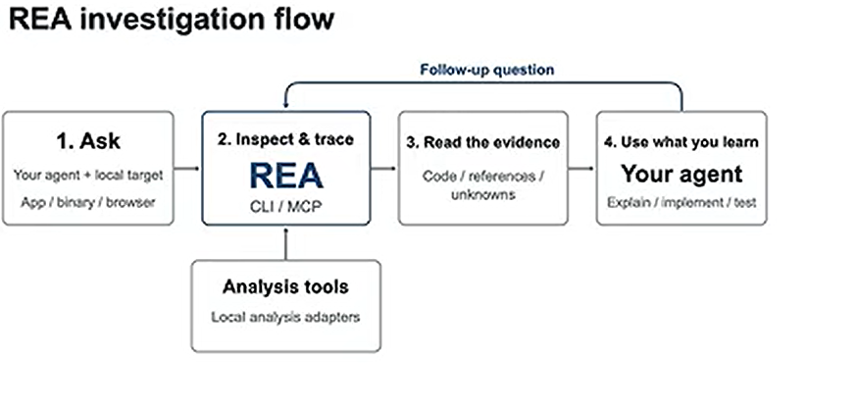
TASK 2:
Installation & Configuration
Install JDK:
Because Ghidra is written in Java, and REA needs javac (the compiler) as well as java.
Install GHIDRA:

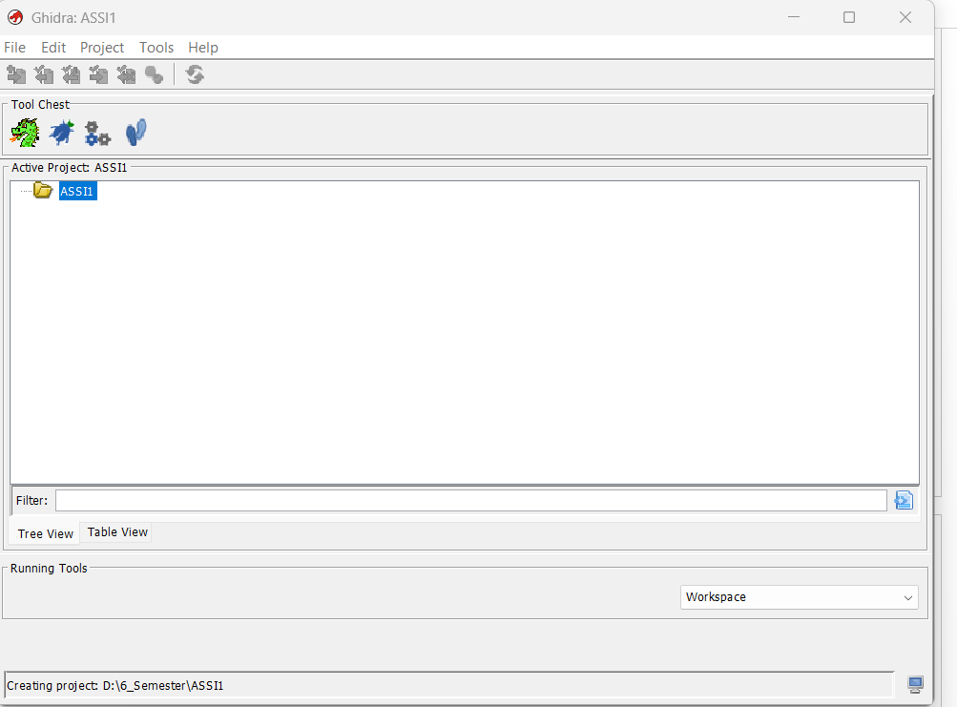

Setting the Paths:
Commands:
$env:GHIDRA_INSTALL_DIR = "C:\tools\ghidra_12.1.4_PUBLIC"
$env:JAVA_HOME = "C:\Program Files\Eclipse Adoptium\jdk-21"
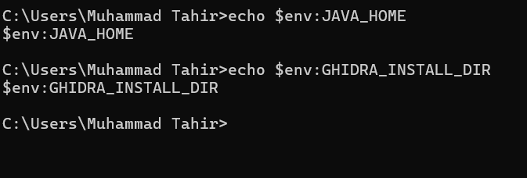

Checking versions of Node & javac:

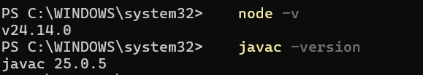

REA SETUP:
Commands:
npm install --global rea-agents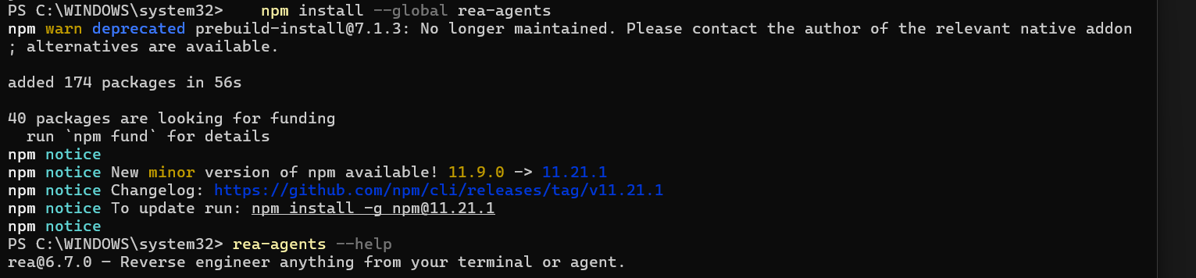

rea setup
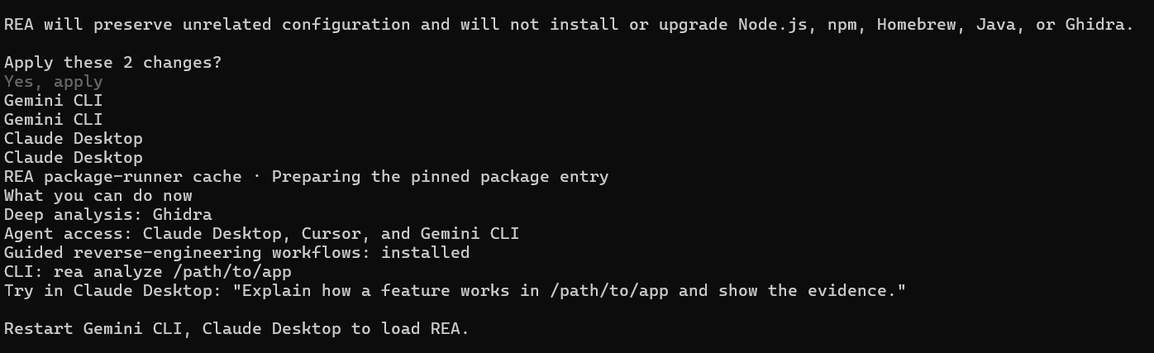
Setting up Claude as the AI agent.

ISSUES FACED:
I installed Ghidra 12.2. REA is too old to accept Ghidra 12.2, because it only works with Ghidra 12.1.x, so there was need to install Ghidra 12.1.4.
Configure REA for claude:
rea setup --client claude_desktop
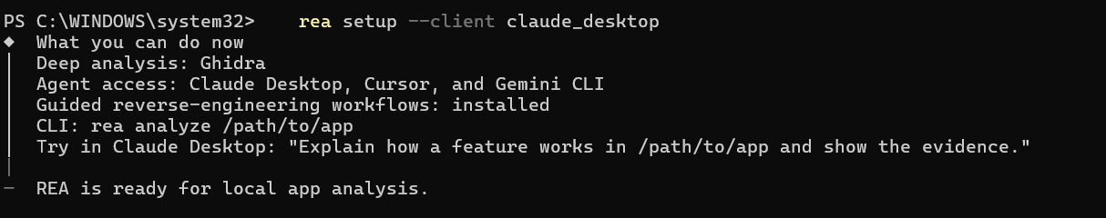

rea doctor --client claude_desktop –json

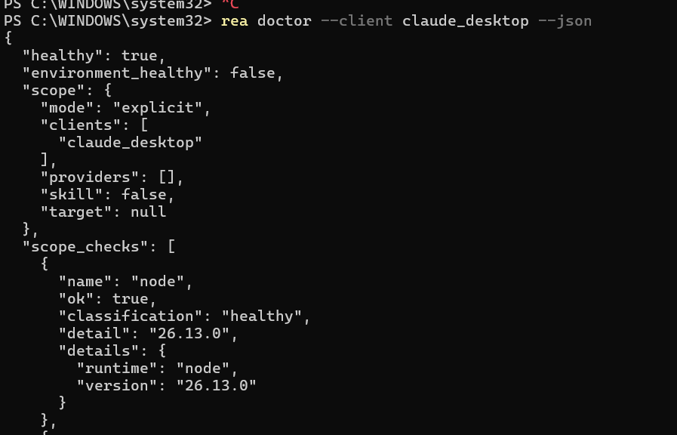

rea setup --client claude_desktop

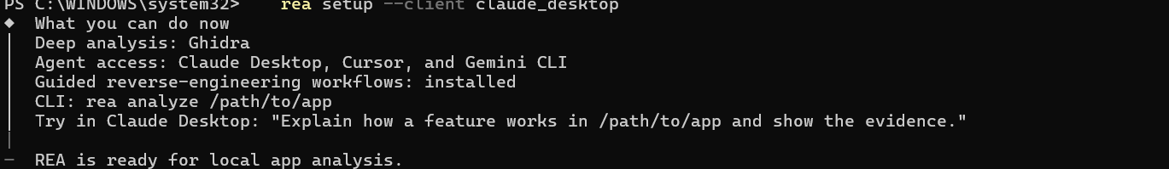
Node Realated Issue I faced:
REA’s setup refused to run because my Node.js (v24.14.0) was older than the required version (24.22.1 or newer), and I fixed it by installing Node.js v26.13.0

TASK 3:
Aplication Selected:
Whisper is the AI speech-recognition model developed by OpenAI.
Whisper.cpp is software for running an AI model called Whisper.

Setting up whisper.cpp:
git clone https://github.com/ggml-org/whisper.cpp
cd whisper.cpp
cmake -B build
cmake --build build -j --config Release
cd whisper.cpp
cmake -B build
cmake --build build -j --config Release
.\models\download-ggml-model.cmd base.en
.\build\bin\Release\whisper-cli.exe -m ggml-base.en.bin -f samples\jfk.wav
Open and try whisper.cpp at http://127.0.0.1:8080/:

.\build\bin\Release\whisper-server.exe -m ggml-base.en.bin --port 8080
I used a .wav file and converted it into text.
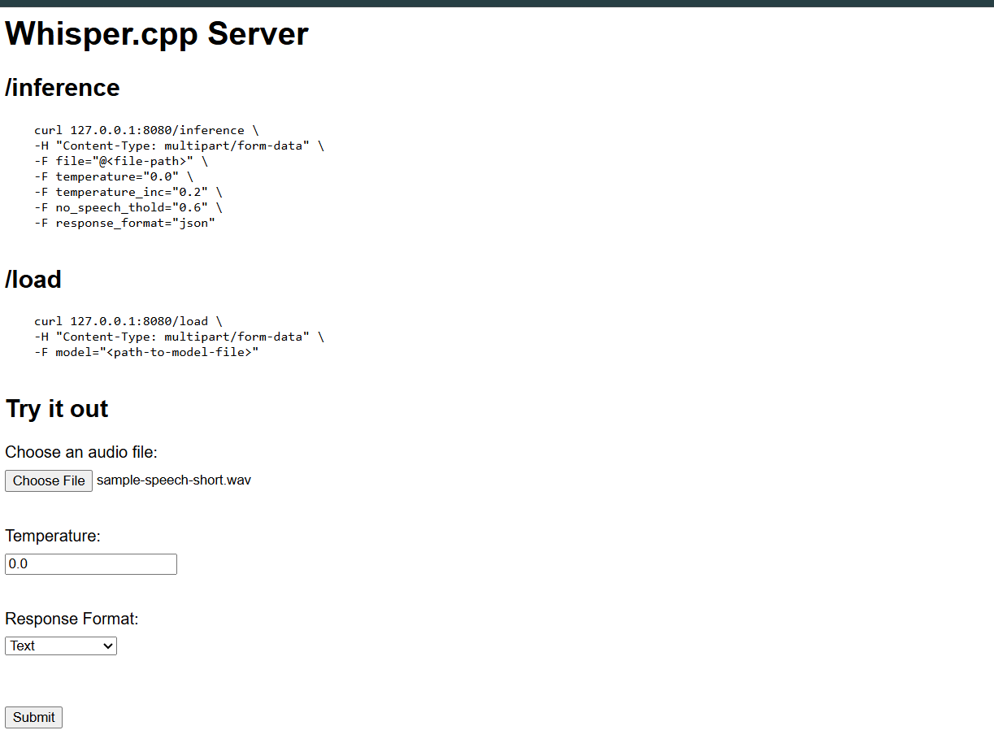

OUTPUT:
Investigation:
Prompt to Claude:
Use the REA tools with the Ghidra provider on:
C:\Users\Muhammad Tahir\OneDrive\Desktop\Assi 2_REA_051\whisper.cpp\build\bin\Release\whisper-cli.exe
Target: whisper.cpp. Feature: saving recognized speech into a .txt file.
Do ALL steps below in one go. Do not stop. Do not ask me questions or for "go". If something is unclear, make a reasonable choice and continue.
- Open the binary and load the REA tools you need.
- Find the strings output_txt, saving output to, failed to open. Show which functions use them.
- Explain the flow from "text is ready" to "file written".
- Create a Word document (.docx) with the investigation: features, design, workflow, technology stack. Name the REA tool behind each fact. Do not guess.
- Give complete C++ source code for the .txt saving feature, with setup instructions, so I can use it in my own project.
Save tokens: keep answers short, run one tool call at a time, do not repeat calls.

Investigation of whisper.cpp: Saving Speech to a .txt File
Target: whisper-cli.exe (whisper.cpp, Windows 64-bit Release build)
Feature studied: saving recognized speech into a .txt file
Tools: REA MCP tools with the Ghidra 12.1.4 provider

1. Introduction
whisper.cpp is an open-source C++ program that turns speech into text. In this work I studied the compiled program whisper-cli.exe. I focused on one feature: saving the recognized speech into a .txt file.
I used REA with Ghidra to look inside the program. Every fact below names the REA tool that found it. The program has no original function names, so Ghidra’s default names are used (for example FUN_140006760).

2. REA tools used
- open_binary: opened whisper-cli.exe.
- binary_overview: showed the sections, 912 functions and 630 strings (ev_752b117d30fe).
- search_strings: found the strings about .txt output (ev_283cd174bce3, ev_4108ac7d4064, ev_da17d067ed10).
- xrefs: showed which code uses each string (ev_87b7ace1e17c, ev_a60ee526fe44, ev_5b4d81c3f552, ev_3bc49c642da9).
- analyze_function: gave a summary of FUN_140006760 (ev_b84d1b44c92d).
- procedure_pseudo_code: showed decompiled code of FUN_140010c20 and FUN_1400095a0 (ev_7c8f4ca1411b, ev_fa6d2ac54a98).
- inspect_pe_imports: listed the DLLs and functions the program uses (ev_44e8f1461012).

3. Technology stack
- File type: 64-bit Windows program (PE32+, x86-64), 479,744 bytes. (binary_overview, inspect_pe_imports)
- Memory layout: image base 0x140000000. The code section (.text) is 386,560 bytes. (binary_overview)
- Language: C++ built with the Microsoft Visual C++ runtime. It uses MSVCP140.dll, VCRUNTIME140.dll and the Windows Universal CRT. (inspect_pe_imports)
- Speech engine: whisper.dll. The program imports 37 functions from it, such as whisper_init_from_file_with_params, whisper_full_parallel, whisper_full_n_segments and whisper_full_get_segment_text. (inspect_pe_imports)
- Math library: ggml.dll. The program imports one function from it, ggml_backend_load_all. (inspect_pe_imports)
- Windows functions: CreateFileA, ReadFile, CloseHandle, SetConsoleOutputCP, LoadLibraryA, GetProcAddress. (inspect_pe_imports)
- File writing: C++ std::basic_ofstream plus C functions such as fopen_s, fwrite, fclose and fflush. (inspect_pe_imports)
- Analysis tool: Ghidra 12.1.4 through the REA provider “rea-workflow”. (binary_overview)

4. Main features of the program

These features were identified using search_strings and procedure_pseudo_code.
- Loads an AI model from a file.
- Reads audio files for speech recognition.
- Can convert speech into text or translate it.
- Supports different languages.
- Provides speaker separation options.
- Saves results in different formats, such as .txt, .vtt, .srt, .csv, and .json.
- Can also display the results on the screen.

5. The selected feature: saving to .txt

5.1 Evidence from strings
Address | Text | What it means
0x140060db8 | “-otxt” | Short command option. Used at 0x14000e351 (argument parsing).
0x140060dc0 | “--output-txt” | Long form of the same option.
0x140061a60 | “-otxt, --output-txt ... output result in a text file” | Help text.
0x140063388 | “output_txt” | Label used at 0x140012d4a inside the main function.
0x140062e98 | “%s: failed to open ‘%s’ for writing” | Error message, used at 0x14000699a in FUN_140006760.
0x140062ec0 | “%s: saving output to ‘%s’” | Success message, used at 0x1400069d7 in FUN_140006760.
0x140063430 | “.score.txt” | A different file for confidence scores. It is not the main transcript.
(Tools: search_strings and xrefs)

5.2 Functions involved
1. FUN_140010c20 – Main Function
- Controls the main program.
- Reads command-line options.
- Loads the AI model.
- Processes audio using whisper_full_parallel.
- Calls other functions to save output.
2. FUN_140006760 – File Opener
- Creates and opens the output file.
- Adds the file extension, such as .txt.
- Shows a success message if the file opens.
- Shows an error message if it fails.
3. FUN_1400095a0 – Text Writer
- Gets the recognized speech segments.
- Reads the text of each segment.
- Writes the text into the .txt file.
- Adds a new line after each segment.
4. Whisper DLL Functions
- whisper_full_n_segments: Gets the total number of speech segments.
- whisper_full_get_segment_text: Gets the text of a segment.
- whisper_full_get_segment_t0/t1: Gets the start and end time of a segment.

5.3 Input and output
- Input to the writer: Recognized speech data, an already-open file, settings, and audio channel information.
- Input to the file opener: File name, .txt extension, and the label output_txt.
- Output: A .txt file containing recognized speech, with each segment on a separate line.
- Messages: Success or error messages are displayed in stderr.
- Return value: The file opener returns true if the file opens successfully.

6. Workflow
- Audio processing: whisper_full_parallel converts audio into recognized speech. If it fails, an error is printed.
- Check option: Main checks whether -otxt is enabled.
- Open file: FUN_140006760 creates a file named audio-name.txt.
- Check file: If successful, it prints saving output to. Otherwise, it prints an error.
- Write text: FUN_1400095a0 writes the recognized speech into the file, one segment per line.
- Speaker labels: If diarization is enabled and there are two audio channels, a speaker prefix may be added. (Inferred from analysis.)
- Close file: The file closes automatically, and the program continues to the next output format or audio file.

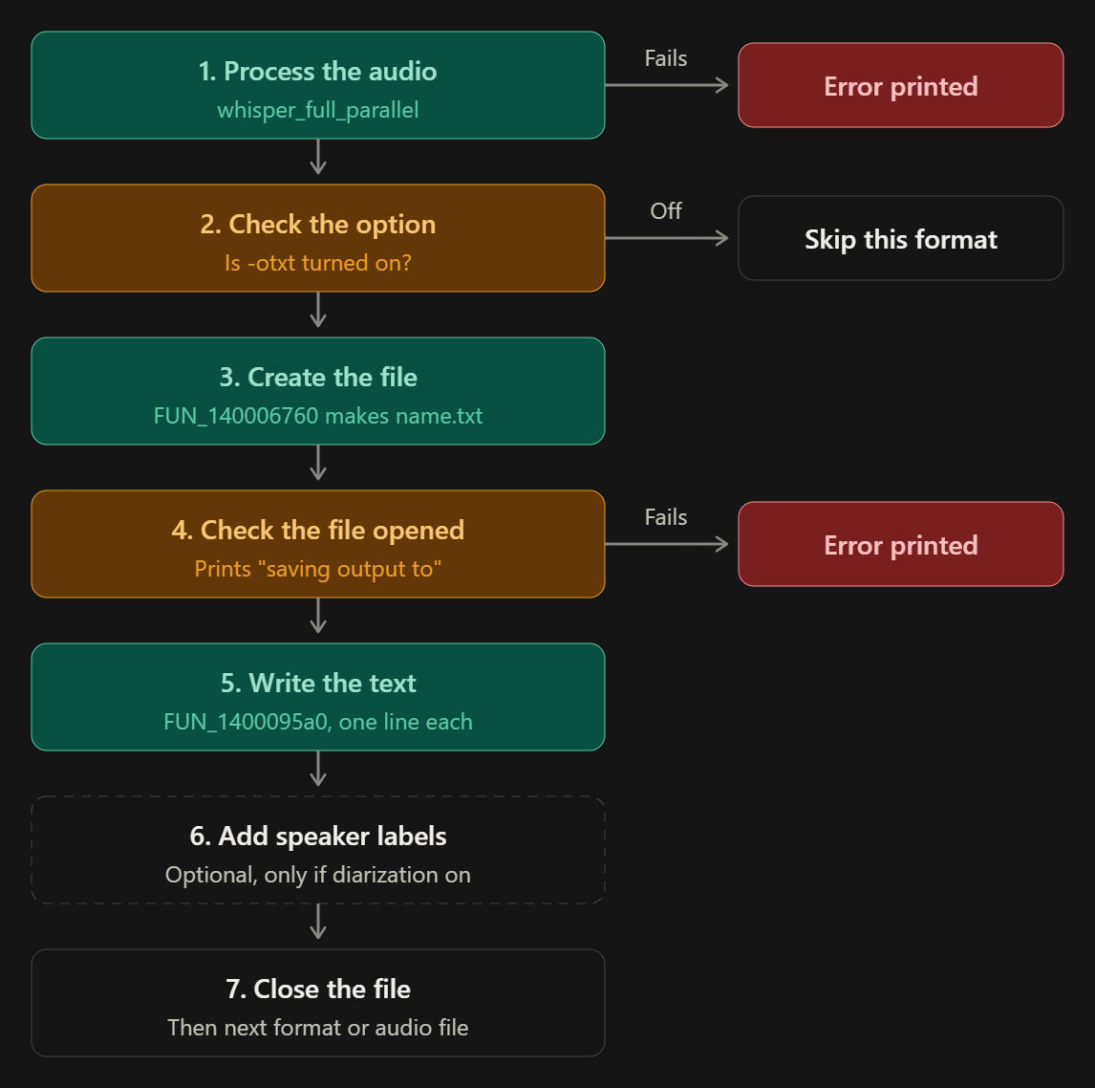

Evidences:
- Opened whisper-cli.exe in Ghidra
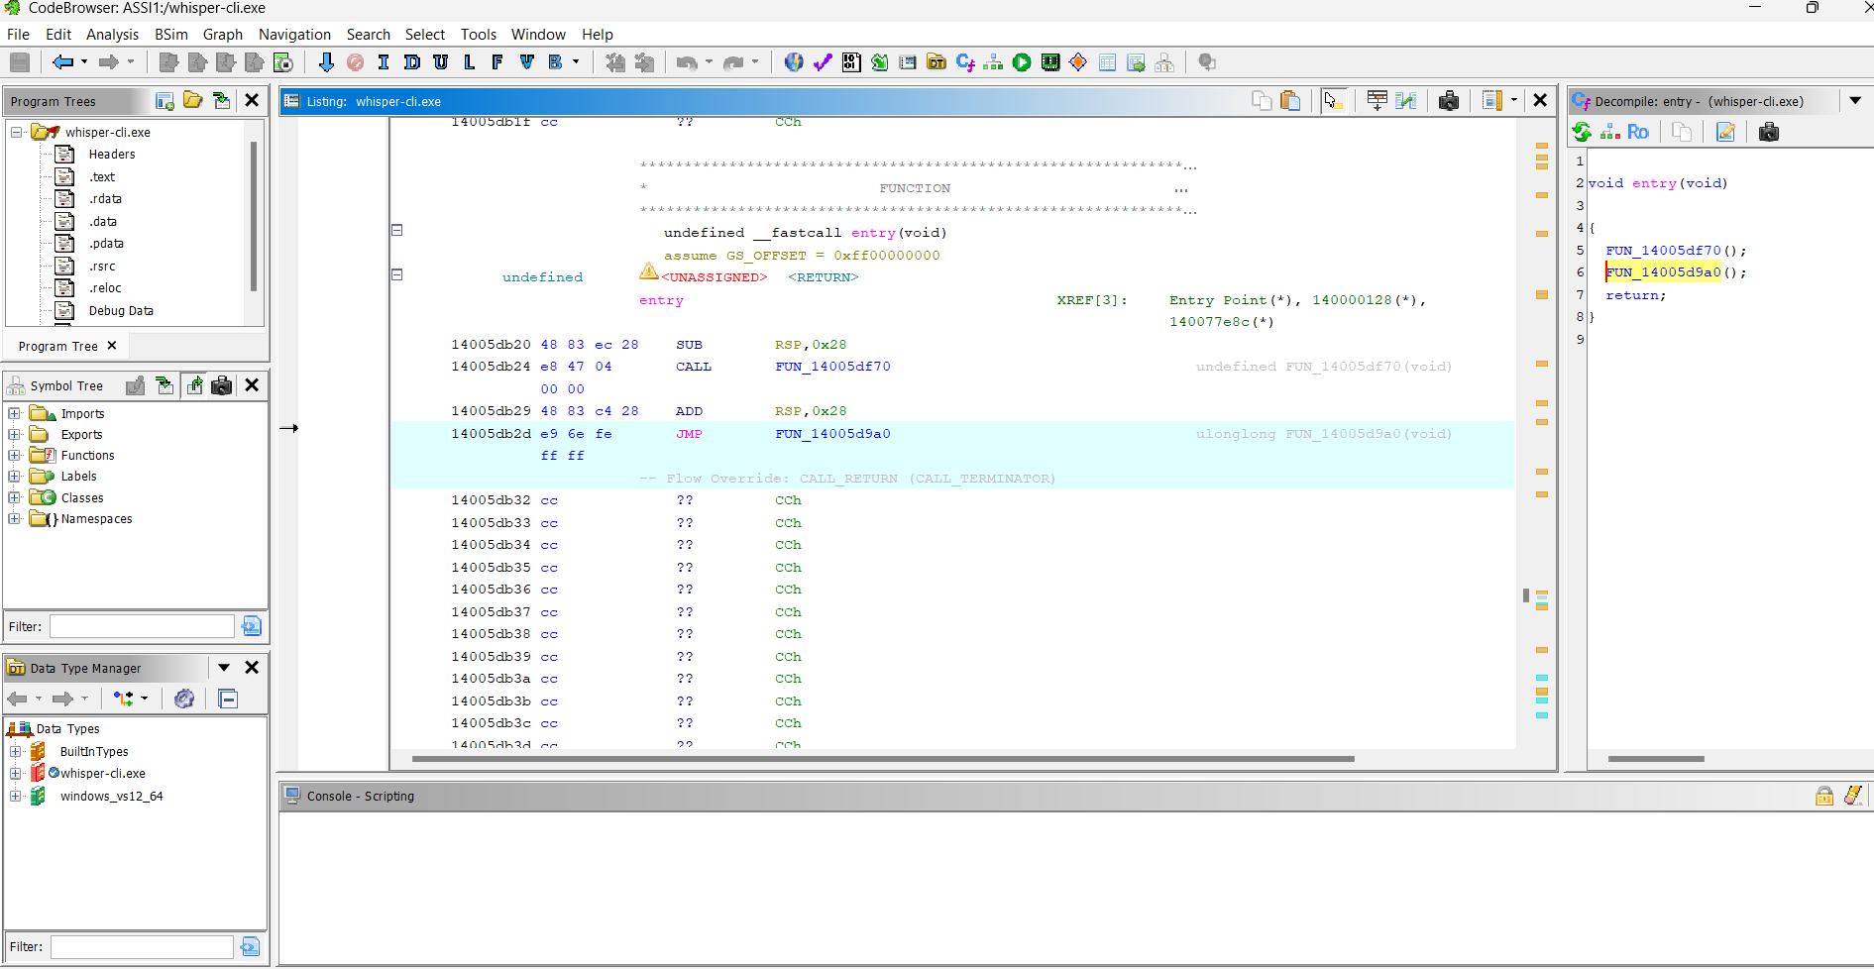

- Program Section:

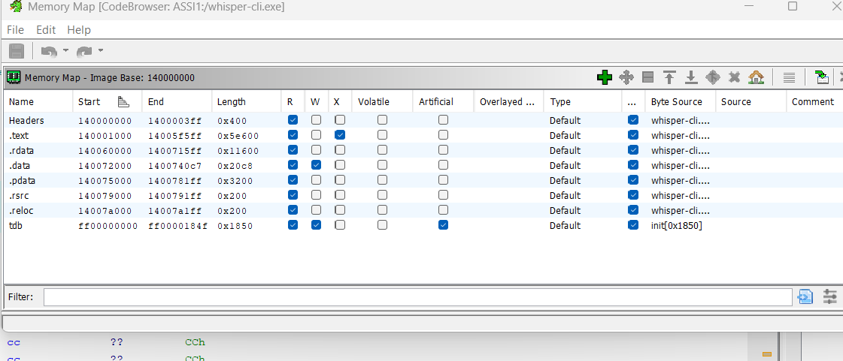
- Found the strings linked to .txt saving:
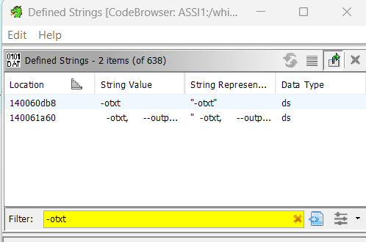
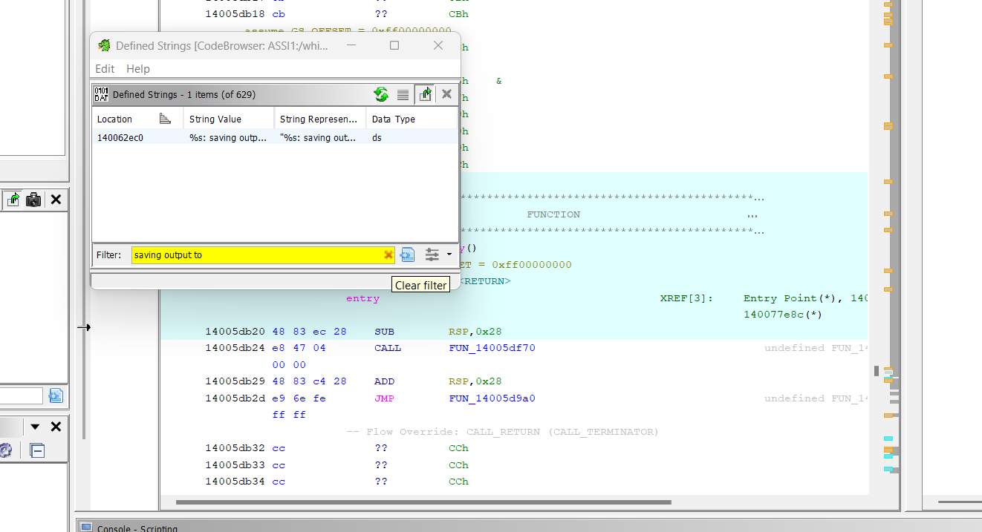

- FUN_140006760: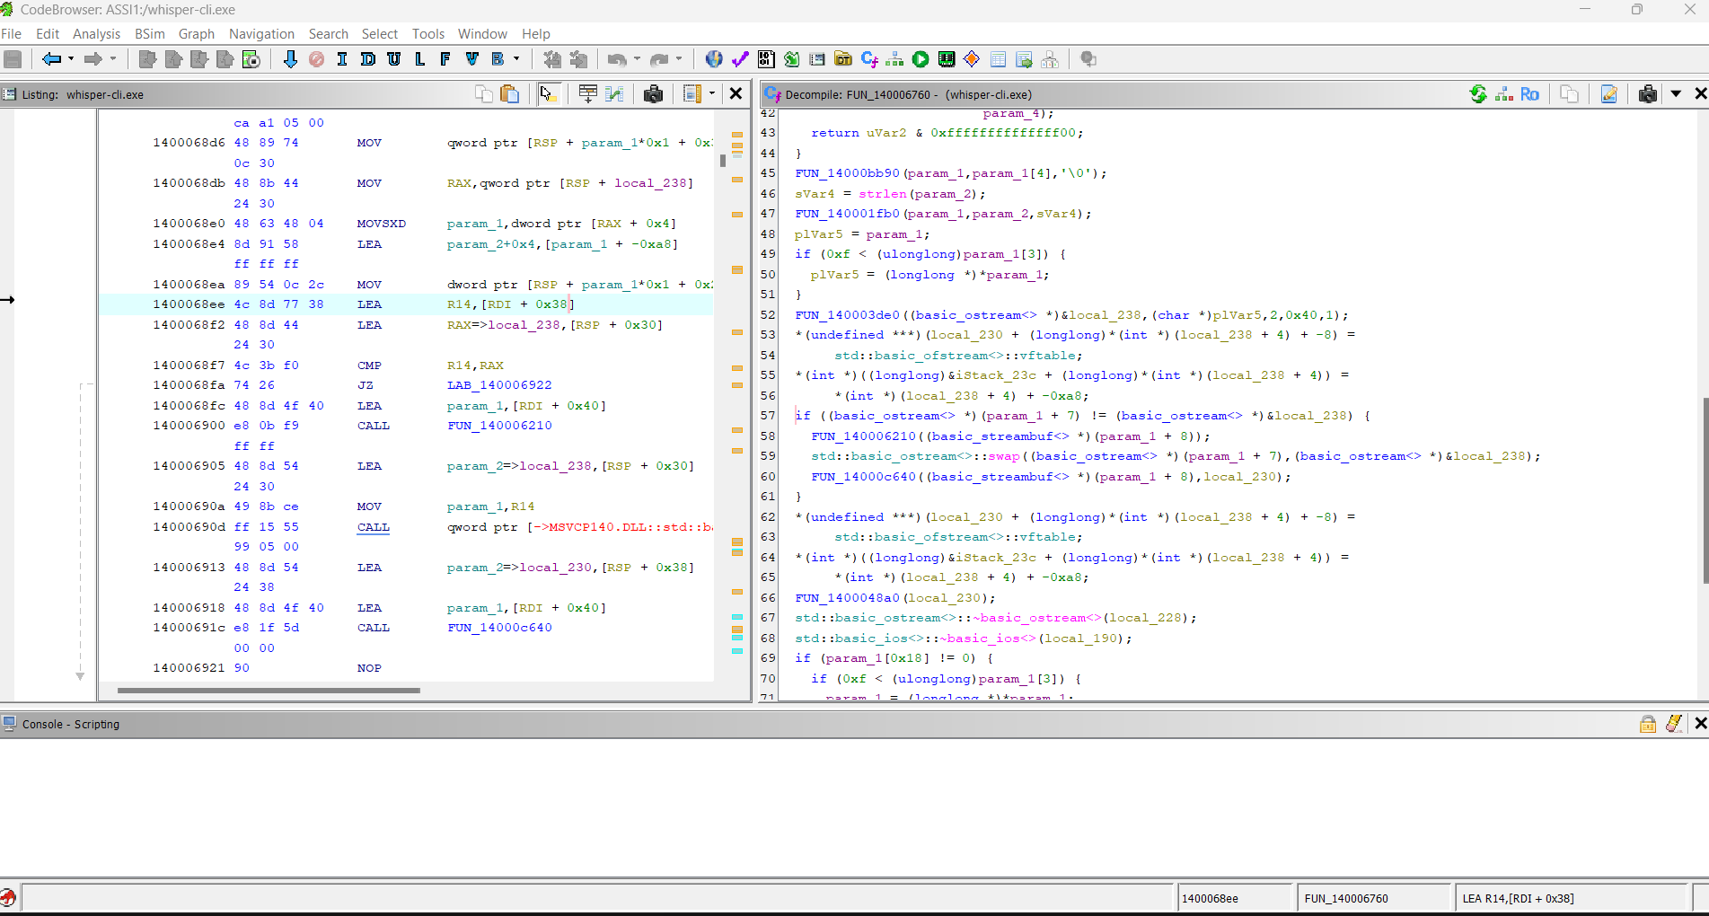
- FUN_1400095a0 (the .txt writer):
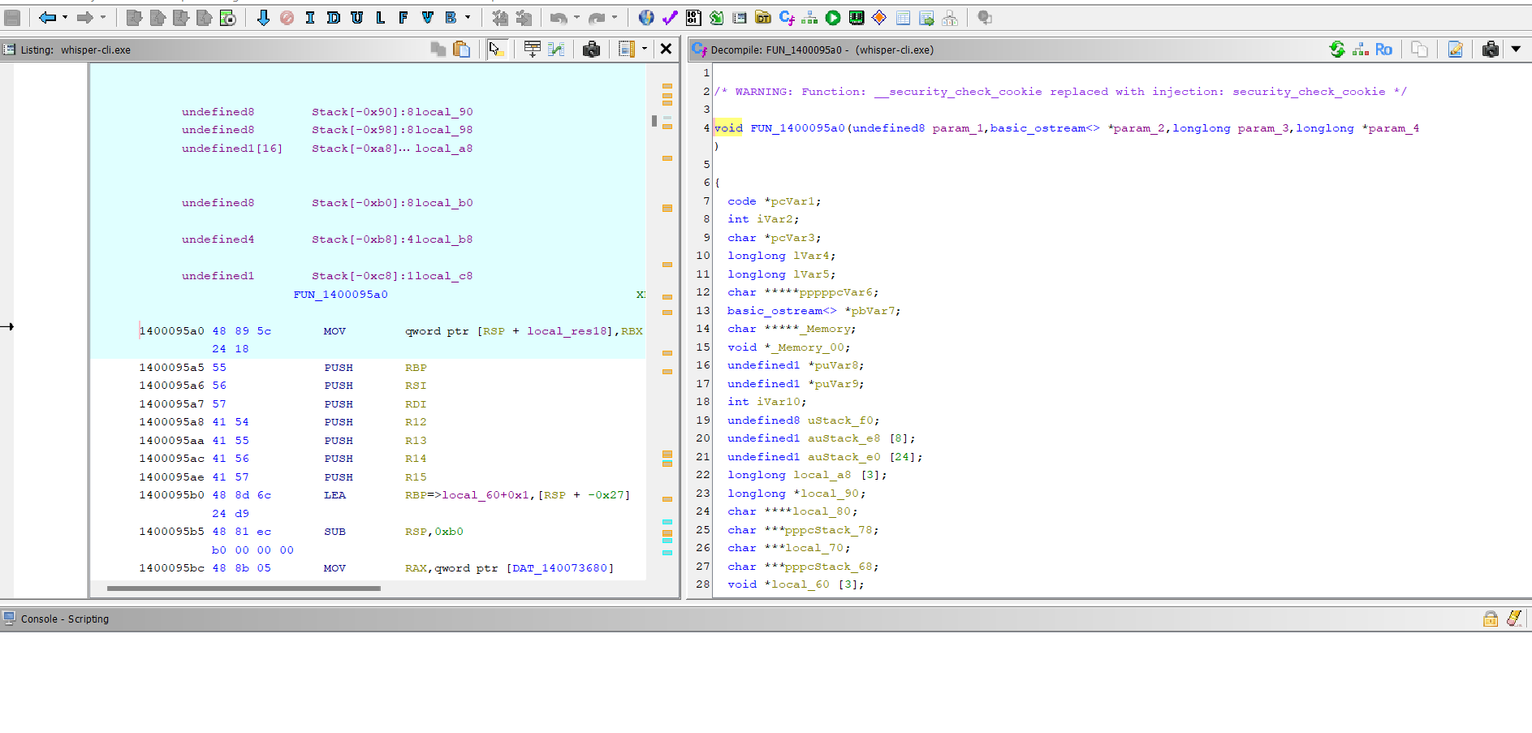
- FUN_140006760 – Listing and Decompiler: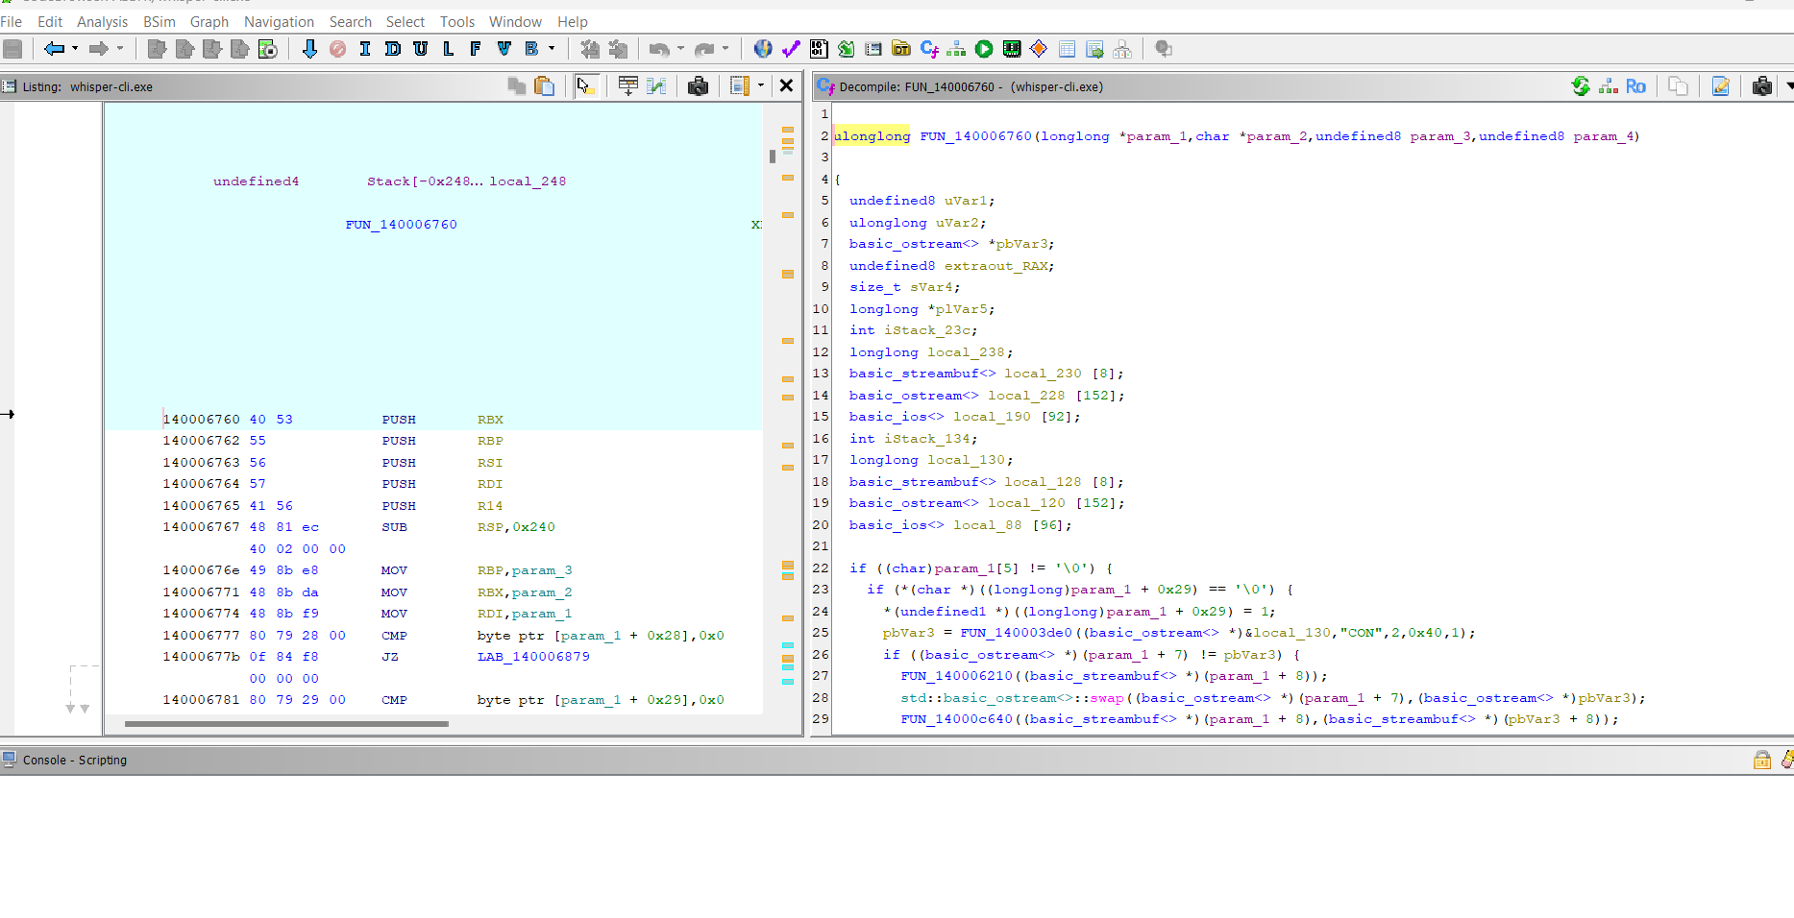
- FUN_1400095a0 – Text writer

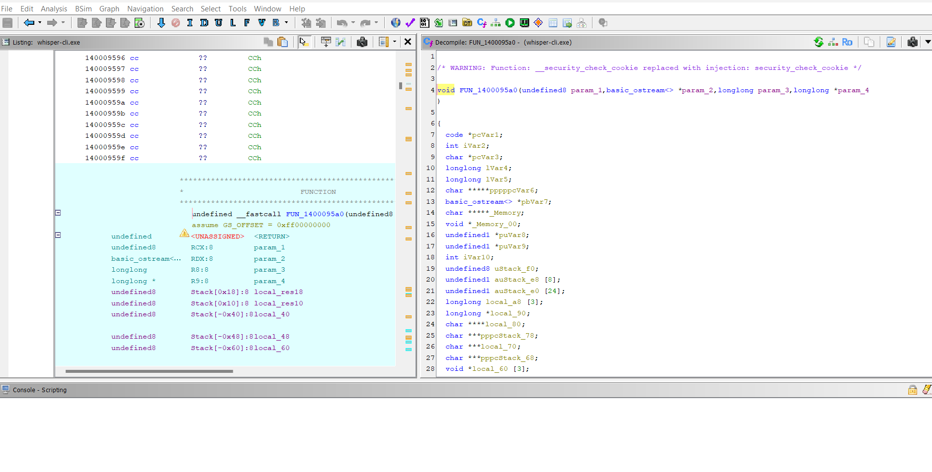
- References / Xrefs – Find where output_txt is used:

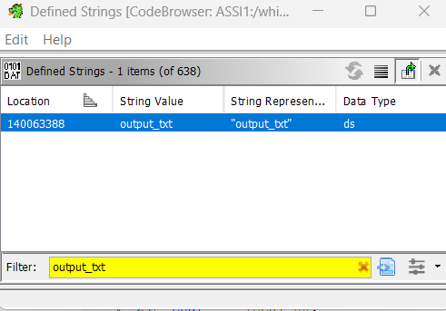

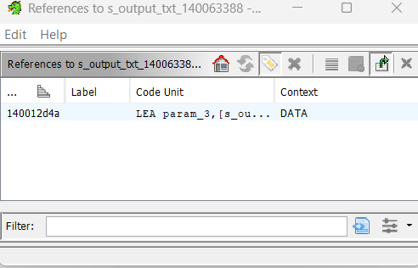

AI Tools and External Resources
- REA GitHub repository: https://github.com/morluto/rea
- Ghidra 12.1.4 for binary analysis.
- Claude Code / ChatGPT for assistance in understanding reverse-engineering results and organizing the report.

