1.Stock Price Trend (Main Graph)
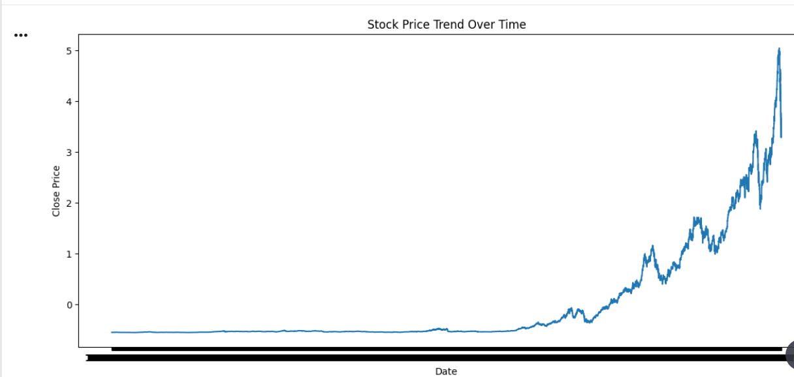
2.Moving Averages (Market Direction)
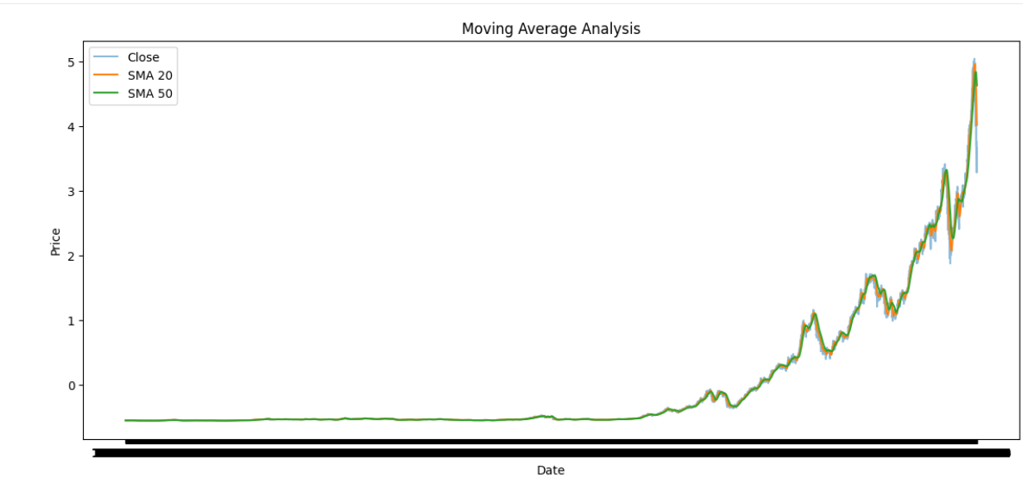

3.Bollinger Bands (Volatility Range)

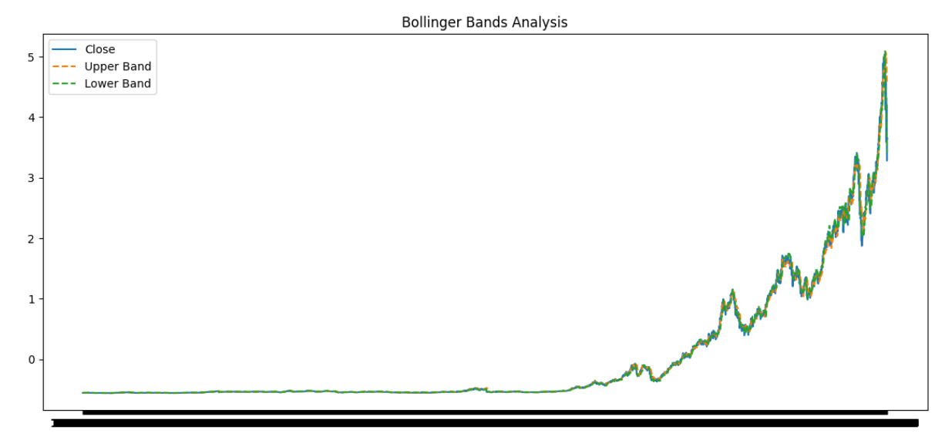
4.RSI Indicator (Overbought / Oversold)
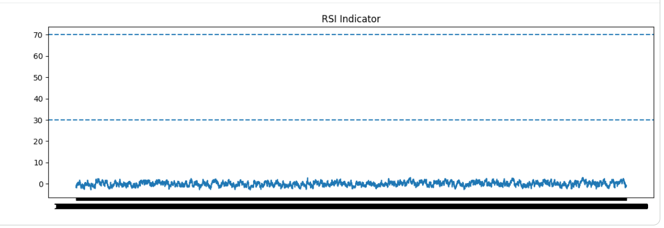

5.MACD Trend
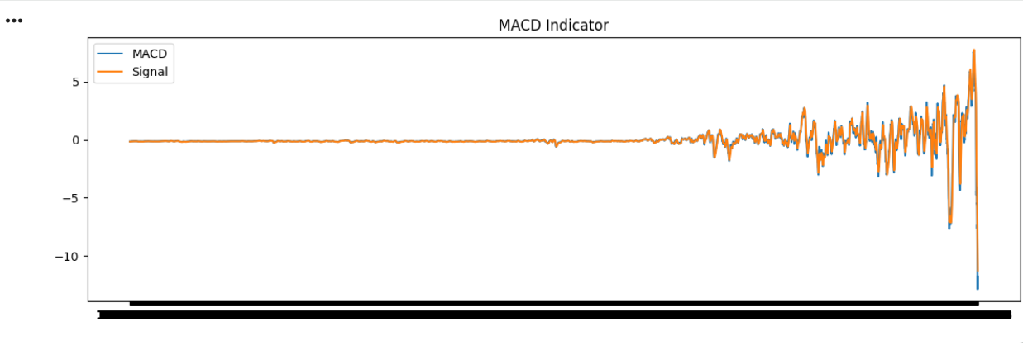
6.Volume Trend
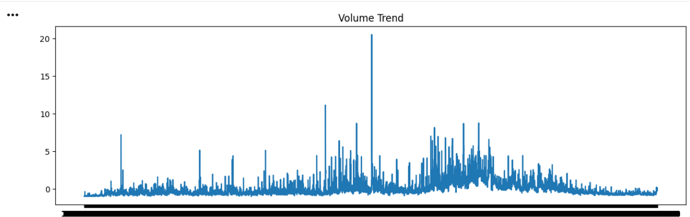

7.Correlation Heatmap
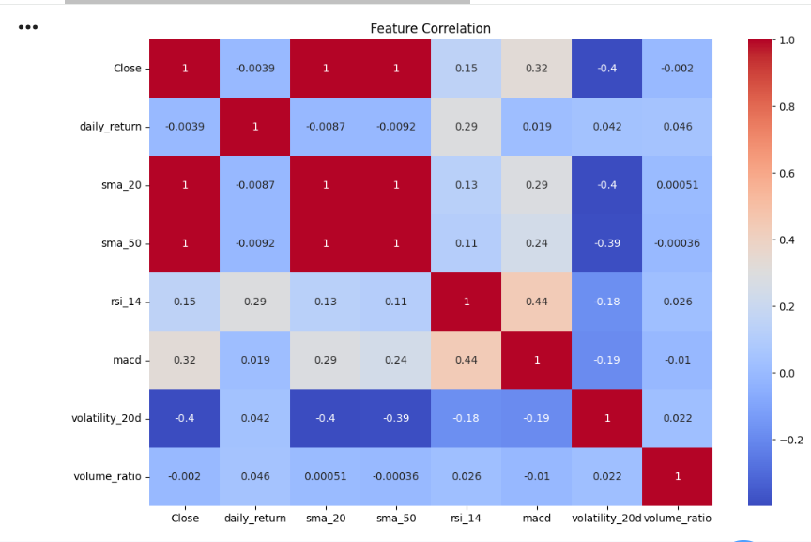

EDA Summary :
The stock price shows noticeable fluctuations with a general long-term trend. Moving averages smooth short-term variations and highlight the overall market direction. Bollinger Bands capture periods of high and low volatility. RSI indicates overbought and oversold market conditions. MACD reflects momentum changes and possible trend reversals. Volume trends show variations in market activity. Correlation analysis reveals strong relationships among price-based features, supporting their usefulness for predictive modeling.

Key Insights (Bullet Points)
- Overall price trend shows market volatility
- Moving averages highlight trend direction
- Bollinger bands show volatility zones
- RSI detects overbought (>70) and oversold (<30) levels
- MACD identifies momentum shifts
- Strong correlation between Close, SMA & EMA features

