**Jaweriya Younus  
2112182  
BSCS 8c  
Devops Project**

Task 1

docker run -d --name jenkins -p 8080:8080 -p 50000:50000 -v jenkins_home:/var/jenkins_home -v //var/run/docker.sock:/var/run/docker.sock -v "%cd%":/workspace jenkins/jenkins:lts



Task 2

terraform apply

azurerm_resource_group.main: Refreshing state... [id=/subscriptions/da5ab692-2309-4390-88f1-30a262c522db/resourceGroups/devops-group]

azurerm_virtual_network.main: Refreshing state... [id=/subscriptions/da5ab692-2309-4390-88f1-30a262c522db/resourceGroups/devops-group/providers/Microsoft.Network/virtualNetworks/vnet]

azurerm_subnet.main: Refreshing state... [id=/subscriptions/da5ab692-2309-4390-88f1-30a262c522db/resourceGroups/devops-group/providers/Microsoft.Network/virtualNetworks/vnet/subnets/subnet]

Terraform used the selected providers to generate the following execution plan. Resource actions are indicated with the following symbols:

+ create

Terraform will perform the following actions:

# azurerm_linux_virtual_machine.main will be created

+ resource "azurerm_linux_virtual_machine" "main" {

+ admin_username = "azureuser"

+ allow_extension_operations = true

+ bypass_platform_safety_checks_on_user_schedule_enabled = false

+ computer_name = (known after apply)

+ disable_password_authentication = true

+ disk_controller_type = (known after apply)

+ extensions_time_budget = "PT1H30M"

+ id = (known after apply)

+ location = "eastus"

+ max_bid_price = -1

+ name = "devops-vm"

+ network_interface_ids = (known after apply)

+ patch_assessment_mode = "ImageDefault"

+ patch_mode = "ImageDefault"

+ platform_fault_domain = -1

+ priority = "Regular"

+ private_ip_address = (known after apply)

+ private_ip_addresses = (known after apply)

+ provision_vm_agent = true

+ public_ip_address = (known after apply)

+ public_ip_addresses = (known after apply)

+ resource_group_name = "devops-group"

+ size = "Standard_B1s"

+ virtual_machine_id = (known after apply)

+ vm_agent_platform_updates_enabled = (known after apply)

+ admin_ssh_key {

+ public_key = <<-EOT

ssh-rsa  jaweriya@DESKTOP-DU4PCT2

EOT

+ username = "azureuser"

}

+ os_disk {

+ caching = "ReadWrite"

+ disk_size_gb = (known after apply)

+ id = (known after apply)

+ name = "myosdisk"

+ storage_account_type = "Standard_LRS"

+ write_accelerator_enabled = false

}

+ source_image_reference {

+ offer = "UbuntuServer"

+ publisher = "Canonical"

+ sku = "18.04-LTS"

+ version = "latest"

}

+ termination_notification (known after apply)

}

# azurerm_network_interface.main will be created

+ resource "azurerm_network_interface" "main" {

+ accelerated_networking_enabled = false

+ applied_dns_servers = (known after apply)

+ id = (known after apply)

+ internal_domain_name_suffix = (known after apply)

+ ip_forwarding_enabled = false

+ location = "eastus"

+ mac_address = (known after apply)

+ name = "nic"

+ private_ip_address = (known after apply)

+ private_ip_addresses = (known after apply)

+ resource_group_name = "devops-group"

+ virtual_machine_id = (known after apply)

+ ip_configuration {

+ gateway_load_balancer_frontend_ip_configuration_id = (known after apply)

+ name = "ipconfig"

+ primary = (known after apply)

+ private_ip_address = (known after apply)

+ private_ip_address_allocation = "Dynamic"

+ private_ip_address_version = "IPv4"

+ public_ip_address_id = (known after apply)

+ subnet_id = "/subscriptions/da5ab692-2309-4390-88f1-30a262c522db/resourceGroups/devops-group/providers/Microsoft.Network/virtualNetworks/vnet/subnets/subnet"

}

}

# azurerm_public_ip.main will be created

+ resource "azurerm_public_ip" "main" {

+ allocation_method = "Static"

+ ddos_protection_mode = "VirtualNetworkInherited"

+ fqdn = (known after apply)

+ id = (known after apply)

+ idle_timeout_in_minutes = 4

+ ip_address = (known after apply)

+ ip_version = "IPv4"

+ location = "eastus"

+ name = "publicIP"

+ resource_group_name = "devops-group"

+ sku = "Standard"

+ sku_tier = "Regional"

}

Plan: 3 to add, 0 to change, 0 to destroy.

Changes to Outputs:

+ public_ip = (known after apply)

Do you want to perform these actions?

Terraform will perform the actions described above.

Only 'yes' will be accepted to approve.

Enter a value: yes

azurerm_public_ip.main: Creating...

azurerm_public_ip.main: Creation complete after 6s [id=/subscriptions/da5ab692-2309-4390-88f1-30a262c522db/resourceGroups/devops-group/providers/Microsoft.Network/publicIPAddresses/publicIP]

azurerm_network_interface.main: Creating...

azurerm_network_interface.main: Creation complete after 9s [id=/subscriptions/da5ab692-2309-4390-88f1-30a262c522db/resourceGroups/devops-group/providers/Microsoft.Network/networkInterfaces/nic]

azurerm_linux_virtual_machine.main: Creating...

azurerm_linux_virtual_machine.main: Still creating... [00m10s elapsed]

azurerm_linux_virtual_machine.main: Still creating... [00m20s elapsed]

azurerm_linux_virtual_machine.main: Creation complete after 21s [id=/subscriptions/da5ab692-2309-4390-88f1-30a262c522db/resourceGroups/devops-group/providers/Microsoft.Compute/virtualMachines/devops-vm]

Apply complete! Resources: 3 added, 0 changed, 0 destroyed.

Outputs:

**public_ip = "20.169.183.133"**

Task 3  
  
Ansible installs and configures apache

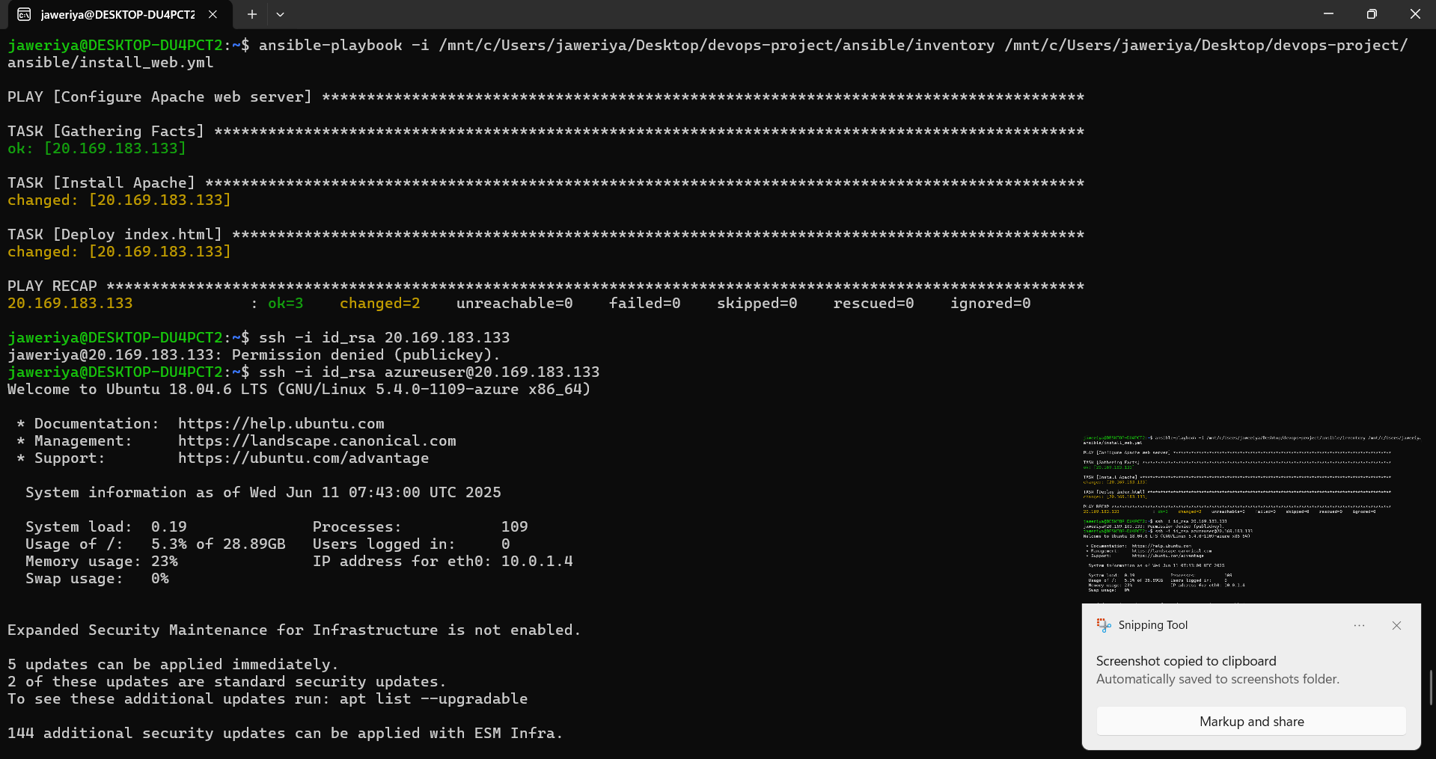

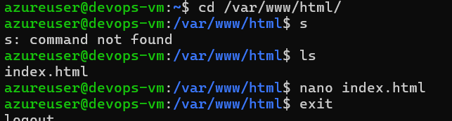

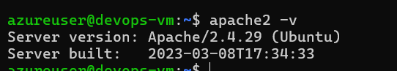

**Task 4**

**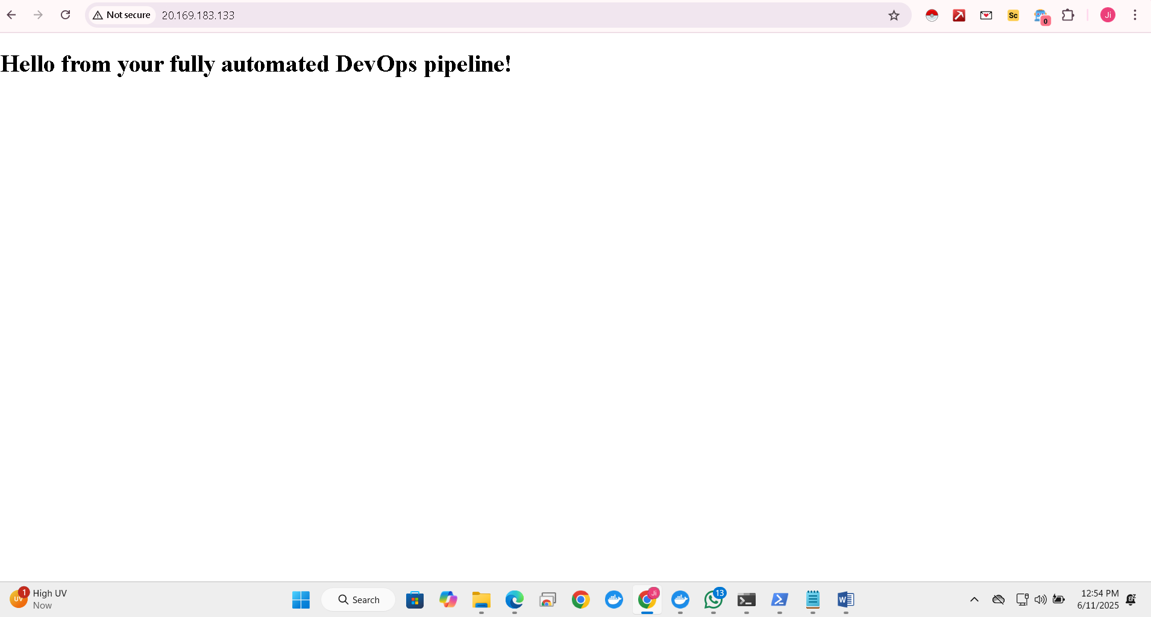  
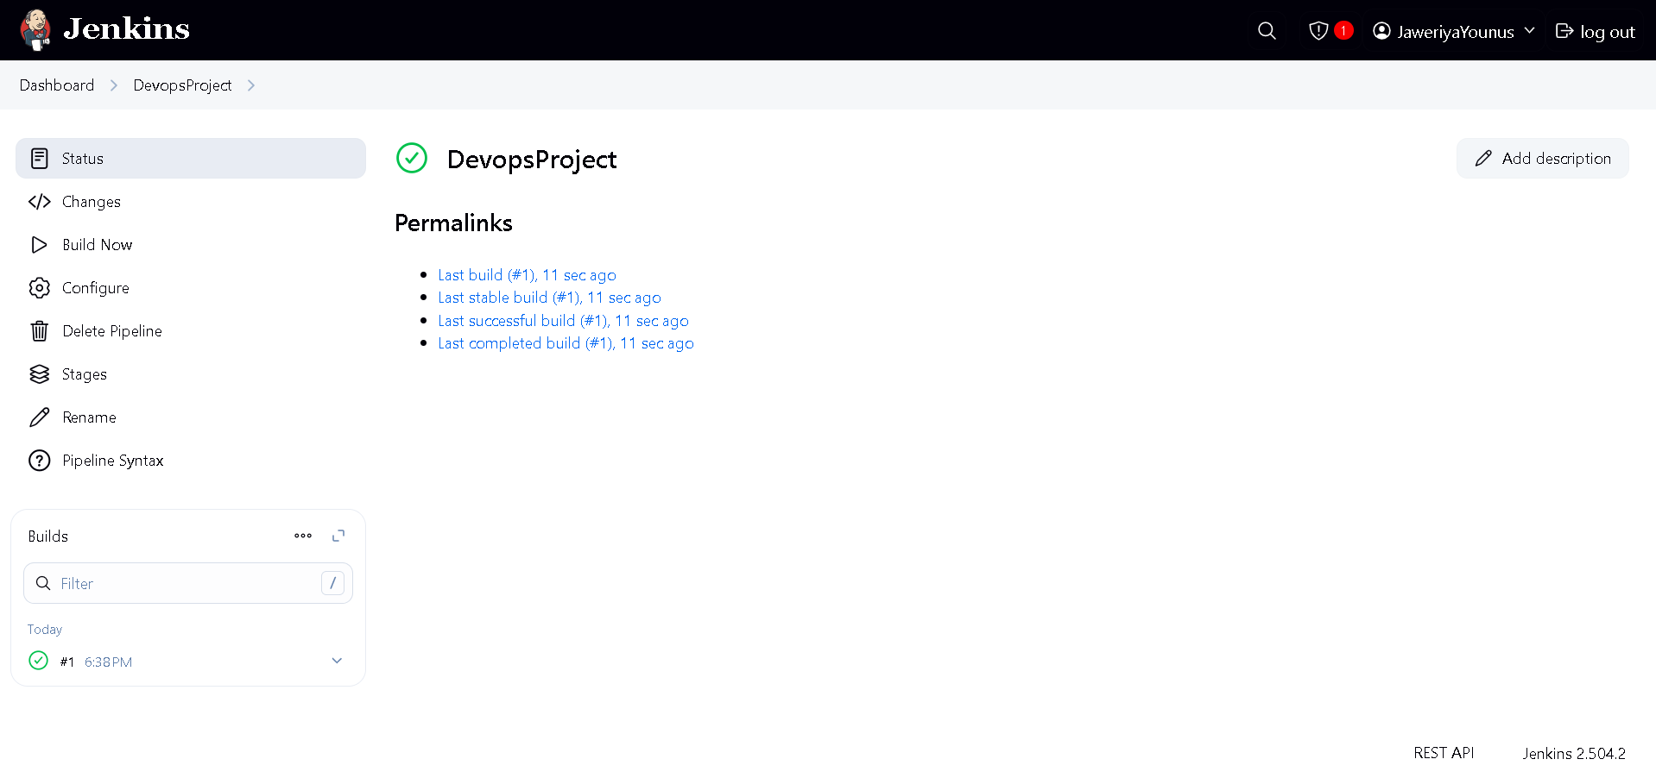**

**Pipeline created successfully!**