Q-1

1. In order to stay on track, deliver on time, and control the work flow of the project, we applied Scrum approach on the project. While scrum falls under an umbrella of project management called agile project management, Scrum is a framework for organizing your work, it is a simple framework for clearly defining roles organizing actionable work so that you’re more effective in prioritizing work and more efficient in completing the work selected.  
   scrum is an iterative, incremental approach. It gives you early empirical evidence of performance and quality.
2. Scrum is agile project management framework with proven results in decreeing time, improving product quality and heightening customer satisfaction all while lowering costs of time and money.  
   scrum is easy to explain, but the application and mastery are often difficult. While scrum does not fix anything, it depends mainly on the team members to do everything. It also requires a good teamwork which makes it essential. If the team members do not cooperate well, the project will face failure.

One main key feature of scrum some may consider it an advantage, other consider it a disadvantage is that bad projects will be delivered sooner and doomed projects will fail faster.

1. With scrum being a framework for and not a process, any tool that helps the team procced and improve the development process can be used. in University Group Chat Application (U.G.C.A.) we used the following tools to keep track of the development and update the sprints regularly based on the feedback we receive.
2. Jira ([www.jira.com](http://www.jira.com)): Jira is an Agile Scrum Project management web application that helps us create a team, create a project, write the product backlog, create sprints, define the sprint details, define the period of each sprint, keep track of what’s done, priorities features and sprints and many more.
3. Trello ([www.trello.com](http://www.trello.com)): Trello is a software for creating boards based on KANBAN by adding lists and cards to a board, assign team members to a card. Which helps us create a board for ideas and keeps track of what’s done and what’s need to be done.
4. Sticky notes, on our weekly based meetings we use sticky notes to write the features, ideas, user scenarios, bugs to be fixed and summarize the discussion we had. Then we move the sticky notes to Trello.
5. Github ([www.github.com](http://www.github.com)): for keeping an updated version between all members of the team.
6. Adobe XD ([www.adobe.com](http://www.adobe.com)): to draw sketches of the UI and present it to the users to get approval or disapproval before continuing and programming the UI as a code.

Q-2

1. The scrum process allows us to adapt changes quickly. The key is the ongoing process of working on the highest-priority items to completion. Each of the highest-priority items gets fully developed and tested through the following steps:
2. Requirement elaboration
3. Design
4. Development
5. Comprehensive testing
6. Integration
7. Documentation
8. Approval

The seven steps to fully build the scope of each requirement are performed for every item. Every requirement taken on during a sprint no matter how small or large, is fully built, tested, and approved or rejected.

1. Changes in any project are something natural and was expected from the start. Yet there are no fundamental changes to the core of project, the project’s main goal was crystal clear, and it is to create a mobile app that helps students and tutors communicate in groups. after collecting data from stakeholders (Admins) we found out that they preferred to use web applications over mobile applications for many reasons; bigger screen, easy to manage and control, and the need to import and export data. So, we had to create a web application to control the mobile application.   
   The second change, which is also not a major change in the concept of our application, our goal was to hide the information of the user from all others except the tutor, which students did not like, so we had to display the first name and last name of the user so that they know who they are chatting with.  
   We are expecting more changes in the near future, but by using Scrum framework we can easily manage those changes without the need to redo the whole project but only a some of its features based on the changes of the environment changes.
2. We finished some parts of the development; for the web application backend we used Laravel framework with MySQL for the database. For the frontend we used HTML, CSS, JavaScript, and Bootstrap library.

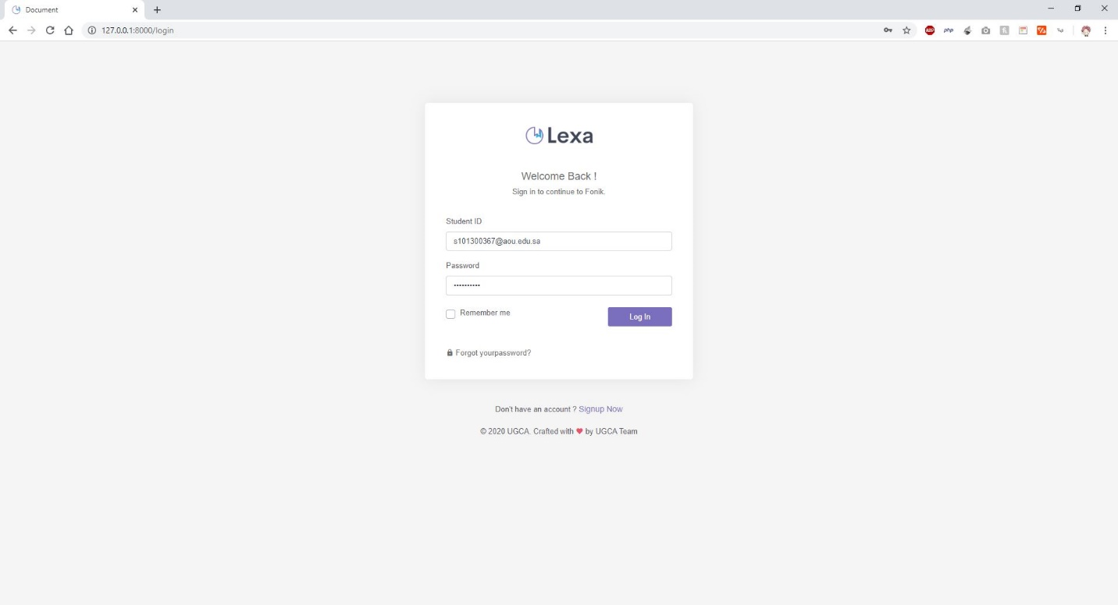

Figure Login page for the admins

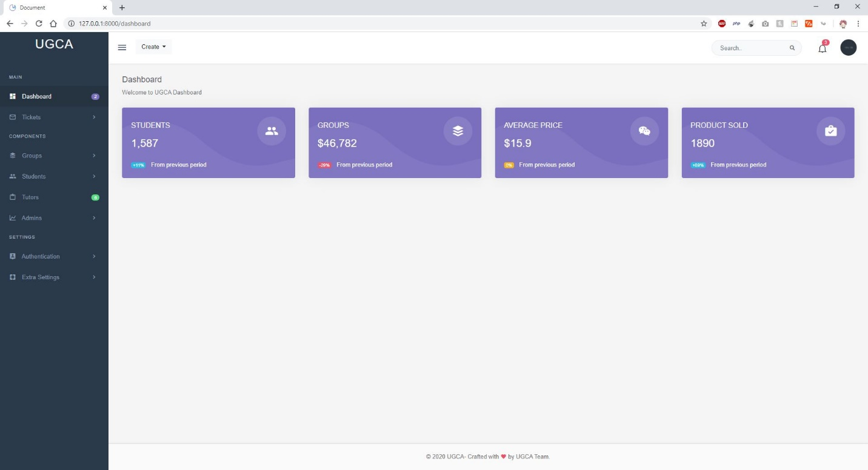

Figure Admin Dashboard

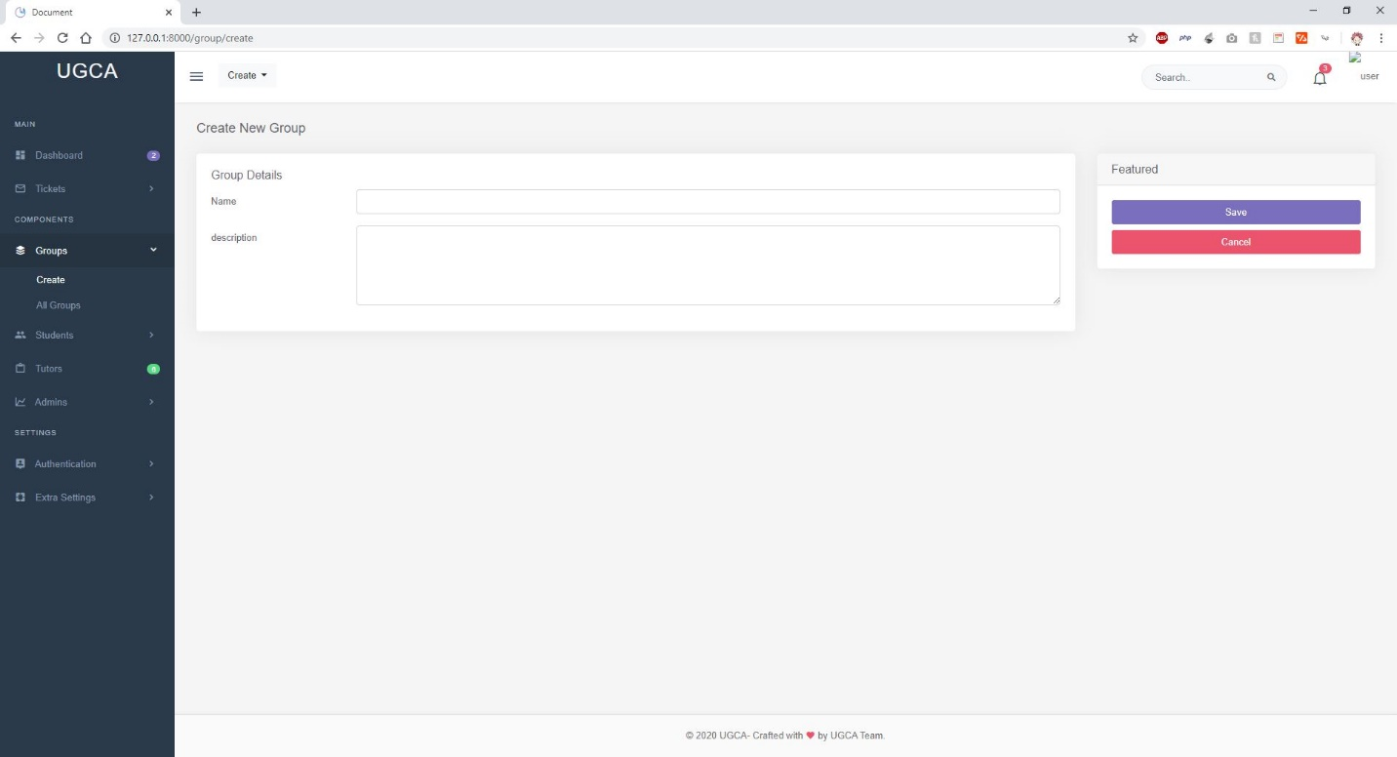

Figure Create Group Page

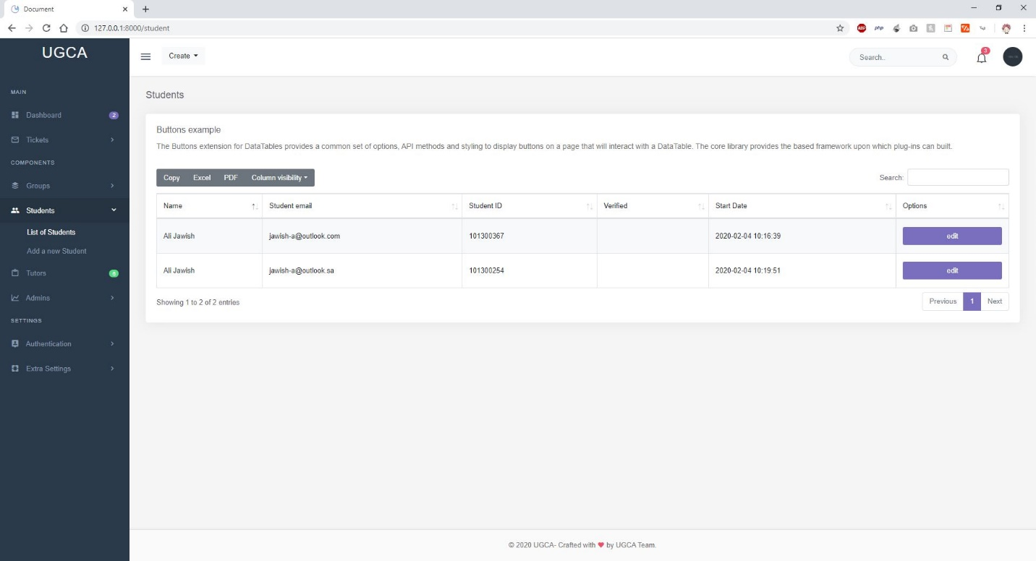

Figure Student List Page

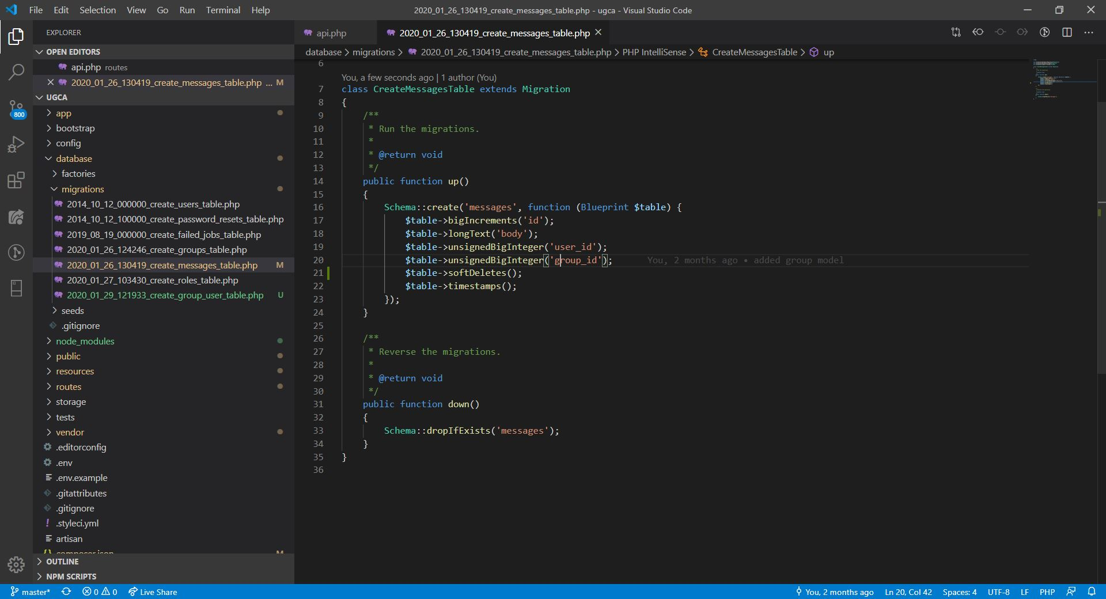

Figure Users Table Schema

Figure UI Sketches of the Mobile App

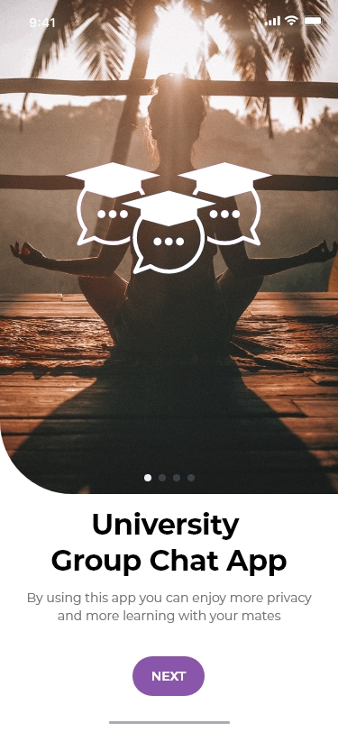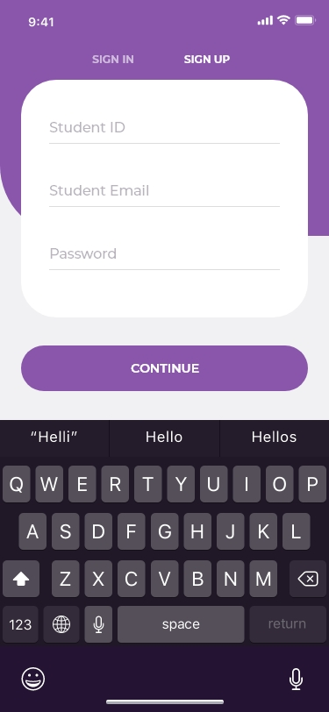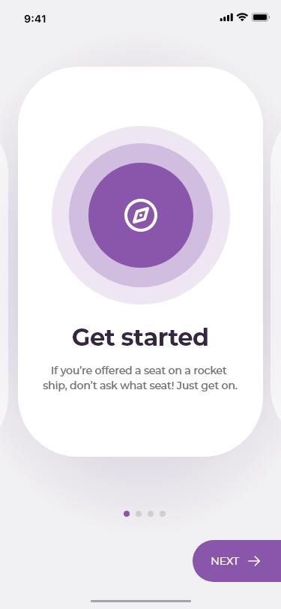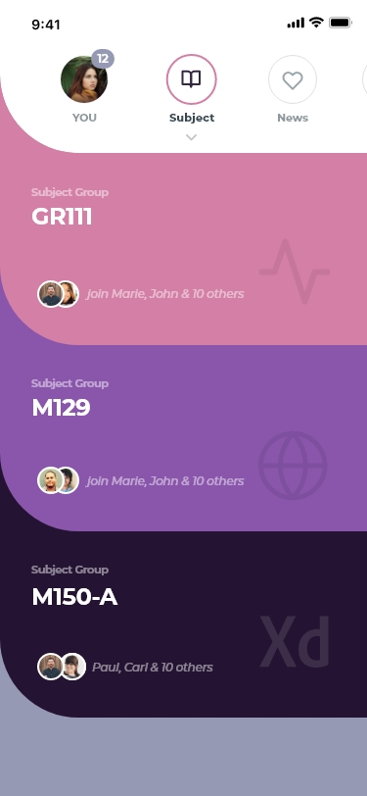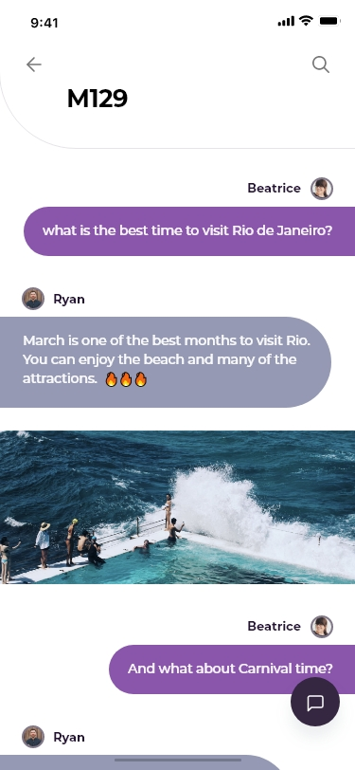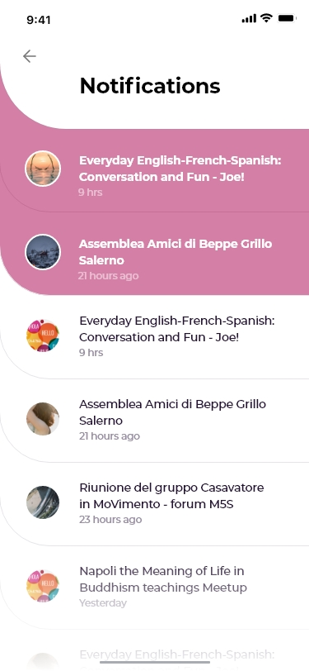

# References

DRUMOND, C. (2020, 04 15). *What is Scrum?* Retrieved from atlassian: https://www.atlassian.com/agile/scrum

Rubin, K. S. (2012). *Essential Scrum: A Practical Guide to the Most Popular Agile Process.* Addison-Wesley Professional.

Scrum.org. (2020, 04 15). *WHAT IS SCRUM?* Retrieved from scrum.org: https://www.scrum.org/index.php/resources/what-is-scrum

Sutherland, K. S. (2017). *The Scrum Guide™.*

TEDxAix (Director). (2014). *Scrum: How to do twice as much in half the time | Jeff Sutherland | TEDxAix* [Motion Picture]. Retrieved from https://www.youtube.com/watch?v=s4thQcgLCqk