GAINZ
Personal Workout Tracking Platform

Team Name: The Audit
Course: eCommerce – Winter 2026
Teacher: Tiago Bortoletto Vaz
Deliverable: 1 of 3

Team Members:
John Michael Pasiolan — 6239041 — Section 00002
Buhaan Bhuiyan — 6239051 — Section 00002
Team Lead for Deliverable 1:
John Michael Pasiolan

Table of Contents
Table of Contents 2
1. Project Overview 3
2. Project Description 3
3. Feature Suite 3
Exercise Library & Categories 3
Workout Session Logging 3
Custom & Built-In Training Programs 3
Progress Tracking & Analytics 4
Bodyweight Tracking 4
Secure User Accounts & 2FA 4
Administrative Management 4
Multi-language Support 4
4. System Design (ERD) 5
5. Deployment Plan 6
Technology Stack & Hosting 6
Development Workflow 6
6. Repository URL 6
Past Contributions: 7
Meetings: 7
Leadership & Area Responsibilities 7
Web Application wireframe 8
Task breakdown 8
Tools and technologies: 10

1. Project Overview
The GAINZ platform is designed to modernize personal fitness tracking. Below are the proposed identity details for the platform launch.
Project Title | GAINZ — Personal Workout Tracking Platform
Potential Domains | gainztracker.app, gainzfitness.io, mygainzlog.com, gainzpro.net

2. Project Description
GAINZ is a specialized web-based fitness management tracker tailored for individuals who prioritize personal growth and data-driven training. Diverging from common social-media-focused fitness apps, GAINZ emphasizes a clean and structured workout documentation. The platform provides users with an infrastructure to plan and analyze their physical activities through an intuitive exercise library and logging tools.
Designed primarily for beginning and intermediate gym-goers, the application balances complexity with usability. Security is handled via robust user and two-factor authentication. Furthermore, the system includes a centralized administrative back-end, allowing for the dynamic management of training resources and bilingual support (English and French), catering to a broad demographic of users aged 16 and older.

3. Feature Suite

Exercise Library & Categories
A curated database of exercises categorized by muscle group (Chest, Legs, etc.) with live filtering for rapid equipment and name searching.

Workout Session Logging
A high-precision logging tool to record sets, reps, and weight. Includes an integrated rest timer and session duration tracking.

Custom & Built-In Training Programs
Support for template-based programs created by admins (e.g., PPL) or custom recurring regimens defined by the user.

Progress Tracking & Analytics
Visualization of performance metrics including Personal Records (PRs), volume per muscle group, and a dot system to show days you’ve workout.

Bodyweight Tracking
A feature that allows users to log and monitor their body weight over time by entering their weight regularly (e.g., daily or weekly).
The system visualizes this data using simple charts or timelines, helping users easily see trends such as weight gain, weight loss, or maintenance.

Secure User Accounts & 2FA
Standard-compliant registration with mandatory age verification (16+) and opt-in TOTP two-factor authentication.

Administrative Management
A mysql for managing exercises, media assets, and training templates effectively.

Multi-language Support
Full localization for English and French audiences, supported by an informative flash message feedback system.

4. System Design (ERD)
The following section outlines the relational structure of the GAINZ platform. The database is designed to handle user data, exercise categorization, and complex historical workout logs efficiently.
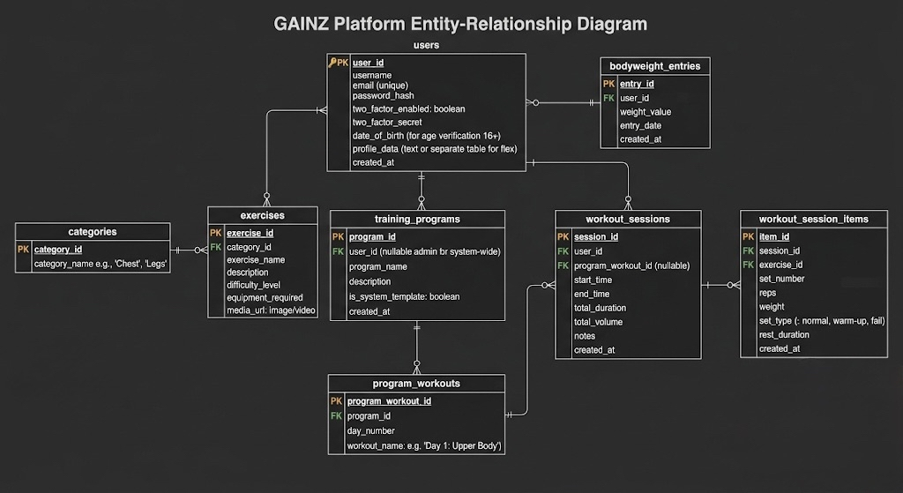
- users: Primary identification, authentication settings (2FA), and profile data.
- categories: Muscle groups and exercise classification labels.
- exercises: Core library items with metadata (difficulty, equipment, images).
- training_programs: Custom or system-wide workout templates.
- program_workouts: Specific workout days assigned to a program.
- workout_sessions: Recorded logs of active training sessions with aggregate stats.
- workout_session_items: Granular data for every set and rep performed during a session.
- bodyweight_entries: Historical tracking of the user's physical weight.

5. Deployment Plan

Technology Stack & Hosting
• PHP 8.2+ Environment (Slim Framework)
• MariaDB for Relational Data
• Composer for dependency management

Development Workflow
- Phase 1: Local Development: Git clones, environment variable configuration, and local MVC scaffolding.
- Phase 2: Version Control: Strict branching strategies with Feature-based branches and Pull Request reviews on GitHub.
- Phase 3: Staging/QA: Deployment to a staging sub-domain for integrated testing and database migration verification.
- Phase 4: Production: Automated deployment to the main environment with continuous logging and backup procedures.

6. Repository URL
All source code and version history are maintained at the following location:
https://github.com/JawnMikel/FitnessProject.git

Past Contributions:
For Deliverable 1, the documentation workload was split evenly between John Michael and Buhaan:
John Michael:
- Proposed the core concept and name for the fitness app.
- Wrote the project description and outlined the features and back-end logic.
- Set up the project GitHub repository.
- Designed the UML diagram using draw.io.
Buhaan:
- Collaborated on writing and formatting the project documentation.
- Suggested feature improvements that were integrated into the project plan.
- Designed and implemented the Entity-Relationship Diagram (ERD).
- Proofread the final document prior to submission.

Meetings:
Primary Meeting Format: Scheduled video calls via Discord for deep-work sessions and collaborative coding.
Frequency: we meet up at least two times a week.
Asynchronous Communication: We use Discord messaging for real-time updates, task hand-offs, and general project coordination.
In-Person Collaboration: We utilize class time and shared breaks to work on the project.

Leadership & Area Responsibilities
So far, we haven’t worked on the implementation of the project, so we only worked on the documentation of the project. We have discussed as a team what tasks each member wants to do to help out each for the project.
- Front-end & Integration: John Michael
- Back-end & Database Setup: Buhaan
- Testing & Deployment: Joint Responsibility
Focus: Both members will perform cross-browser testing, bug fixing, and manage the final deployment workflow together to ensure quality control.

Web Application wireframe
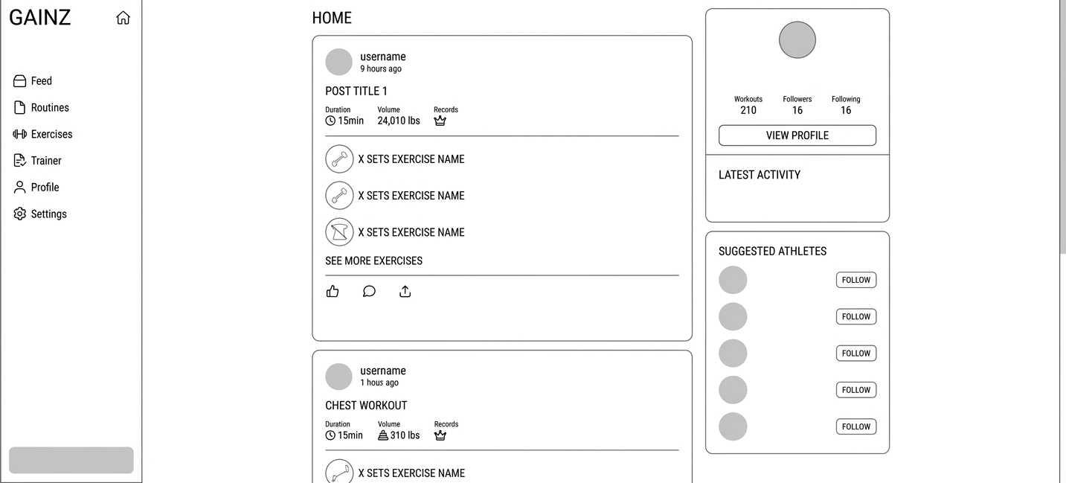

Task breakdown

Task | Description | Team member responsible | Estimated Time
Front-end : Login UI | Designing the login and registration form with css for desktop | John Michael Pasiolan | April 12,2026
Front-end : Navigation SideBar | Implementing a navigation sidebar (Hamburger Icon) on the left side of the page so that the user could navigate through different pages of the application, such as the exercises, the profile, routines etc.  Will be using css and html | John Michael Pasiolan | April 15,2026
Front-end : Exercise Library UI | Building searchable library with live filtering for different muscle groups and equipment  Will be using css and html | John Michael Pasiolan | April 20,2026
Front-end : Workout Session | Designing the active logging tool with integrated rest timer and duration time tracker.  Will be using css and html | John Michael Pasiolan | April 26,2026
Front-end : Profile and Analytics | Implementation of dot system to show day the user has worked out and the volume per muscle group  Will be using css and html | John Michael Pasiolan | May 1 ,2026
Front-end : bodyweight Tracker | Creating a form for body weight entry and the showing of the timeline of progress  Will be using css and html | John Michael Pasiolan | May 4,2026
Integration: Localization (i18n) | Implementation of both english and french language. The use of i18 across all pages.  Will be using css and html | John Michael Pasiolan | May 7,2026
Front end: Responsive Forms | Implementing the page for profile and settings. | John Michael Pasiolan | May 8,2026
Integration : Dark mode and light mode | Implementation of dark mode and night mode of the design  Using css | John Michael Pasiolan | May 9,2026
Testing | Testing of the application by | Joint responsibility | May 15,2026

Tools and technologies:

HTML5 & CSS: Used to construct the structural layout and custom styling of the application. We are focusing on a desktop CSS approach to ensure the workout logging interface is functional on desktops.
PHP: Utilized to handle the application's interactivity, such as the live exercise filtering, the real-time rest timer, and dynamic form validation for user inputs.
JSON-based Localization (i18n): To support full English and French accessibility: all UI text is integrated into organized JSON files. This allows the application to toggle languages instantly without page reloads, ensuring a seamless experience for a bilingual audience.

