Andrew Shahini, Danat Muradov, John Michael Pasiolan

Application Development

Vanier College

USER MANUAL MEDIA DATABASE

Table of Contents

User Guide: 3

Login Frame: 3

Create Acc Frame: 3

PaymentSignUp Form: 6

Main Menu Frame: 6

Profile Frame: 8

Watchlist Frame: 9

Upgrade Payment Frame: 10

Media Load Frame: 12

Crew Member Information Frame: 14

Write a Review Frame: 14

View Reviews Frame: 14

Writing Review for an Actor: 14

Conclusion 14

# User Guide:

## Login Frame:

Starting at the login frame.

1. If you have an account, you can simply put in your username, and password then click login. If you do not have an account, go to step 2. If you have an account, go the Main menu frame to view the next steps.
2. Click on Create Account to make a fresh new account.

## Create Acc Frame:

If you didn’t have an account, this is the second step.

1. Fill, out the First Name text box with your First name as shown in the example above.
2. Fill, in the Last Name text box with your family name.
3. Click on the arrow on the right of the date box.A computer screen shot of a computer screen

   Description automatically generated That should bring you to the calendar:A calendar with numbers and date

   Description automatically generated



1. Click on the date circled in red thrice to bring you to bigger option when putting your date of birth. When you click it twice, it should look like the following: A screenshot of a computer

   Description automatically generated



1. Once you are there, it is as easy as clicking by clicking on the right dates corresponding to your date of birth.
2. Fill in the username text box with a username of your choice
3. Put in a password that you will remember
4. You can either pick the free version (Regular) or get the premium version by clicking one of them.



1. A screenshot of a computer

   Description automatically generated



If you pick Regular, you should see the Create Account button appear. Click it and your account will be done. Go to the Main Menu Frame to follow the next steps.



1. A screenshot of a computer

   Description automatically generated



If you pick the Premium Version, you should see the Pay button, click it and go to the Payment frame to follow the next steps.

## PaymentSignUp Form:

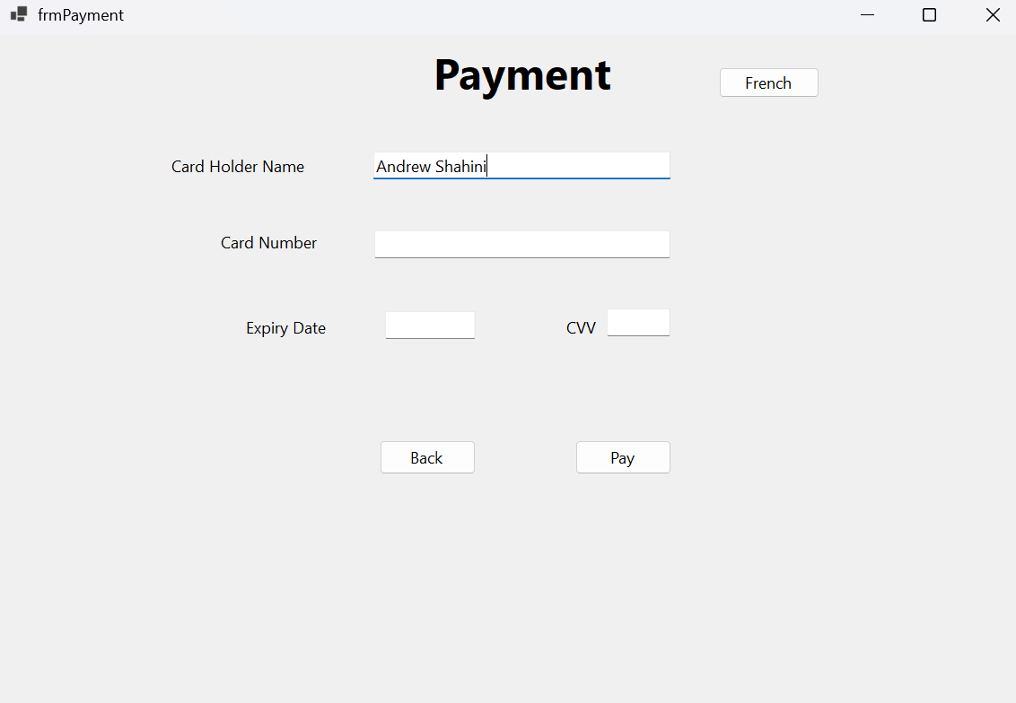

1. Enter your card number, must be 12 digits long.
2. Enter your card’s expiry date, must follow mm/yy format just like how you read it on your card.
3. Enter your CVV, 3 digits long.
4. If everything works, congratulations, you’ve now purchased a premium membership for our media database!

## Main Menu Frame:

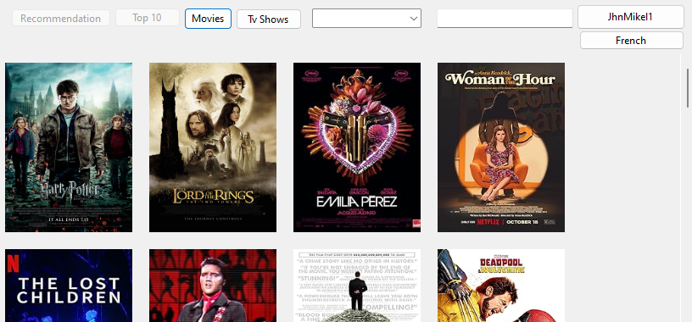



1. In the main menu form, you are welcome to a variety of movies. You can scroll through it and pick a movie you want to view more information on by clicking its image. If you click on the image of the movie, go ahead to the media load frame to view the next steps.
2. A screenshot of a computer

   Description automatically generated



To find a specific genre, click on the little arrow pointing down on the box, and it will give you a variety of different types of genres to pick from.

1. A screenshot of a computer

   Description automatically generatedTo find a specific movie, click on the box pointed by a red arrow, and write down the movie you want to find. If it is the system, you will find it.



1. To switch to TV shows, you need to click on the Tv Shows button, and it will bring you to the following:A screenshot of a movie

   Description automatically generated
2. To view more information on the TV show, all you need to do is click on its image. If you click on it, go ahead to the media load frame to view the next steps.

## Profile Frame:

1. To view your watch list, click on the watch list button and go to the Watchlist Frame to view the next steps.
2. To log out of your account, click on the logout button.
3. (Only if you have the regular version) To upgrade your membership to premium, click on the Upgrade Membership button and go to Payment Frame to view the next steps.
4. If you never added a movie to your watch list, click on the back button to go to the Main Menu Frame and follow the first step.

## Watchlist Frame:



1. This is just to view the movies that you have added in your watchlist.
2. If it is empty, click on the back button and go to the profile form to view the next steps.

## Upgrade Payment Frame:

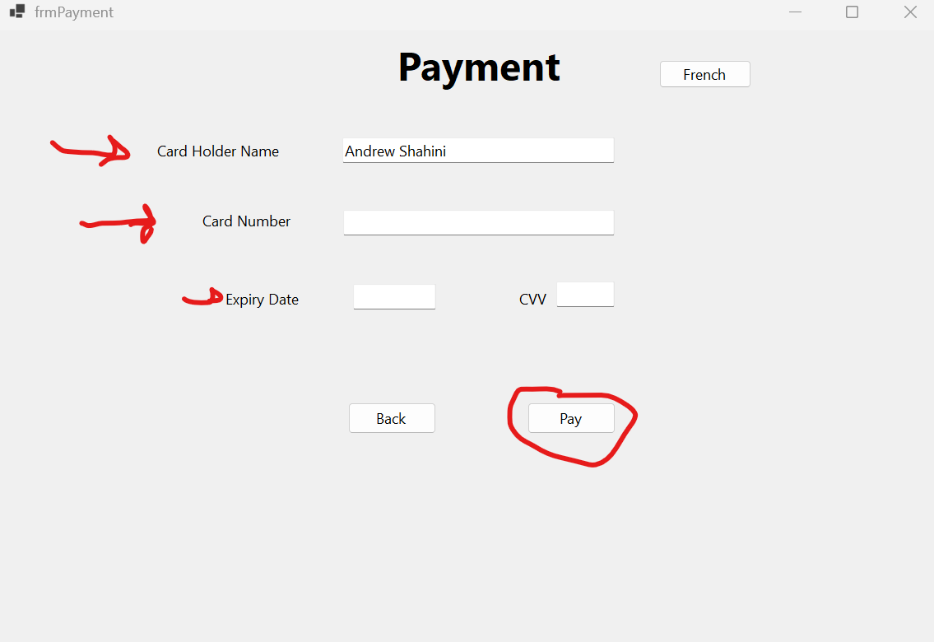

1. Enter your card number into the card number box (it needs to be a total of 12 numbers)
2. Enter the expiry date (Format: MM/YY)
3. Enter the CVV (3 digits long)
4. To pay, click the pay button. When you pay and everything is all good you should get the following:
5. If you change your mind, click on the back button to go back the Profile Frame. Go to Profile Frame to view the next steps

1. If you just upgraded your account, you will go back to the Profile Frame. Go to Profile Frame to view the next steps.

## Media Load Frame:

1. You can view more information of the movie you clicked in the media Load Frame.
2. To leave a review of the movie, you need to click on the write a review button. If you click on it, go to the Write a Review Frame to view the next steps.
3. If you already left a review and you want to view it, click on the View reviews to view them.
4. If you never watched the movie and you want to put it in your watch list. Click on the add to watchlist box. You should get the following if you click it:

The movie is now saved in your watchlist.

1. To remove the movie from your watch list, click on the add to watchlist box and you will get the following:  
   A screenshot of a computer screen

   Description automatically generated
2. To view more information on the actors, click on their photo. If you click on their photo, go to the Crew member information Frame to view the next steps.
3. To view more information on the directors, click on their photo. If you click on their photo, go to the Crew member information Frame to view the next steps.
4. To see other medias with the same genre, click on the genre of choice.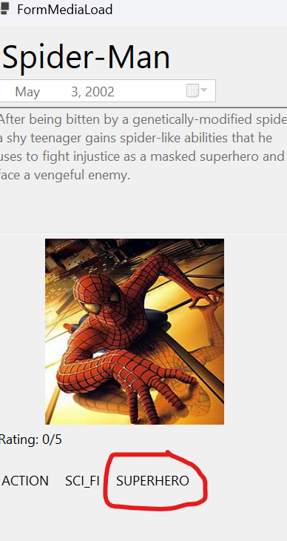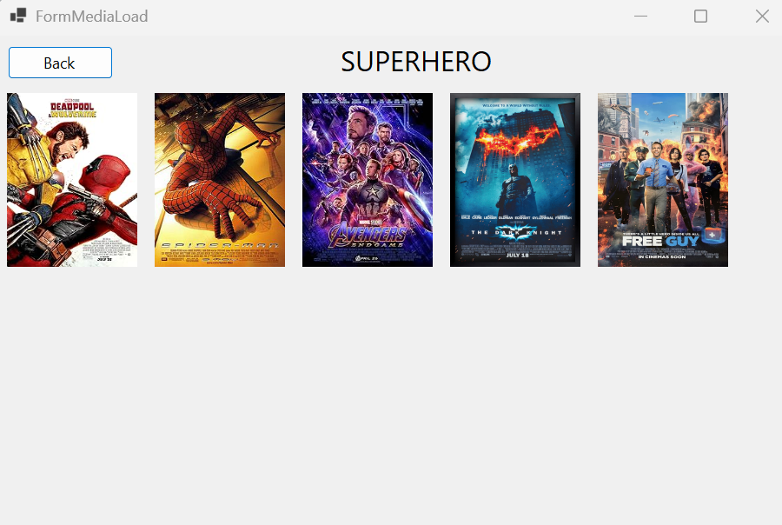
5. To go back to the previous page, click on the back button.



1. This is just to view more information on the actor and to see the movies that they are in.
2. To view your reviews on the movie, click on the view review button. If you click on the button, go to the Write Review Frame to view the next steps. Note: only premium members can write reviews for actors and directors.
3. To go back to the Media Load Frame, click on the back button circled in red.

## Write a Review Frame:

1. To write your review, just fill in the rating box out of 5. Then you can go fill in your comments in the big text box right under the rating box.



1. Once you are done writing your review, click on the post button. If you click on it, you should get the message telling you that your review has been posted:  
   A screenshot of a computer screen

   Description automatically generated
2. Note: Regular user’s only have a MAX 5 reviews. So, choose wisely.
3. To view your review, click on the back button and go to the Media Load Frame to view the next step.

## View Reviews Frame:

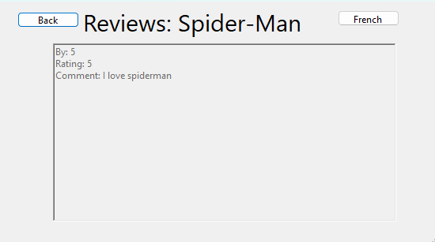



1. This is just to view your review if you already left one.
2. If you do not see anything in the review box, click on the back button and go to Media Load Frame to view the steps to leave a review.

## Writing Review for an Actor:

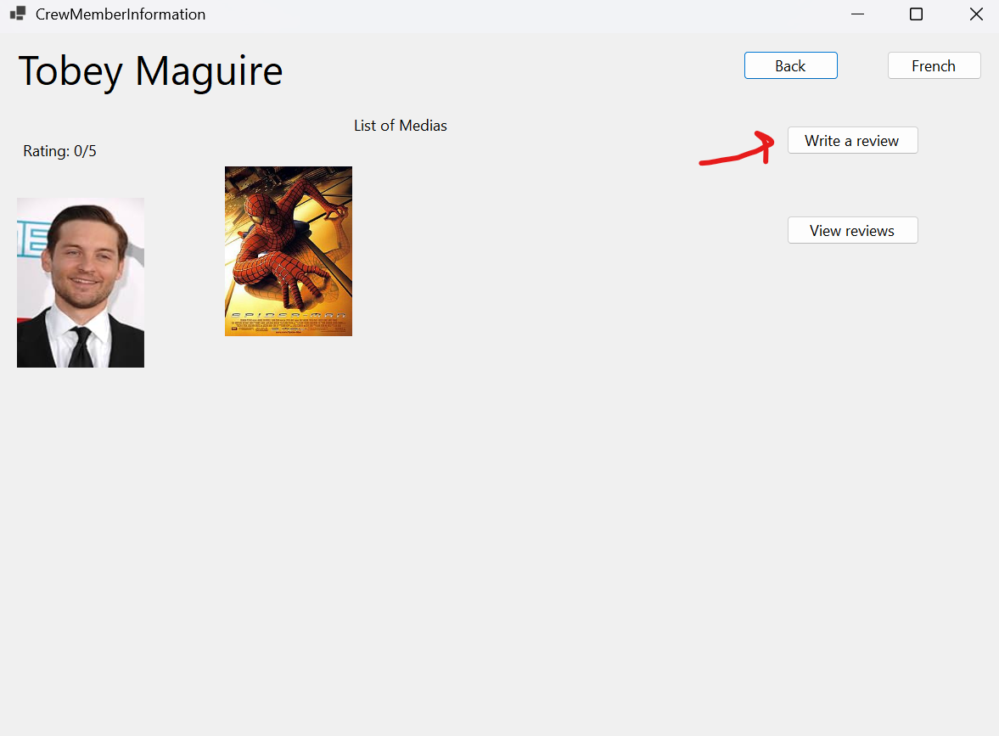

1. Click in “Write a review”. Then the Write review will pop up.

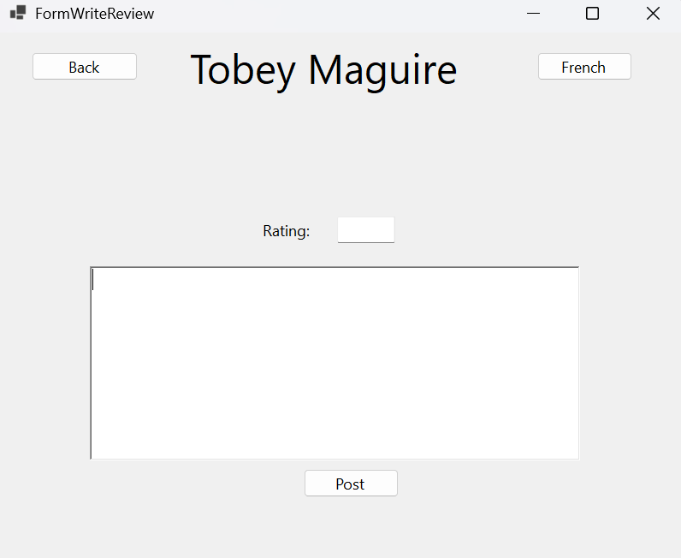

1. Fill out the form to submit a review to your favourite actors, if not there will be a message to warn you.

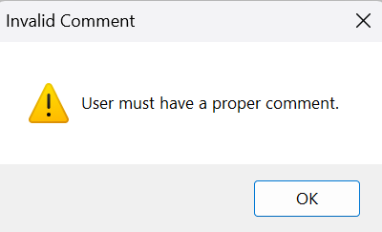

1. The rating can only be between 0-5.
2. After you are done filling out the form, you may post it.

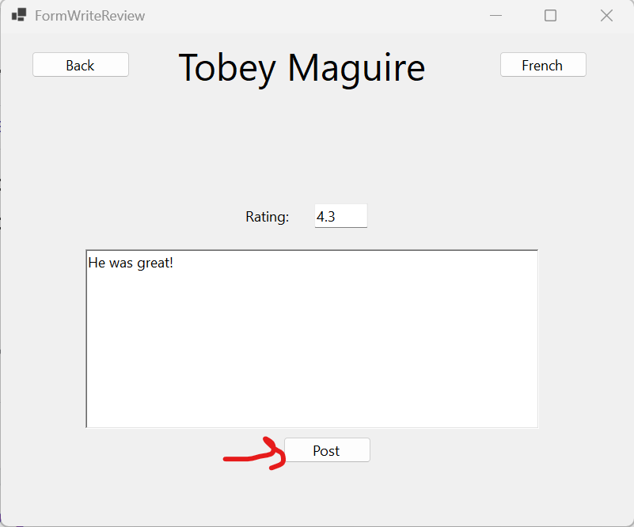

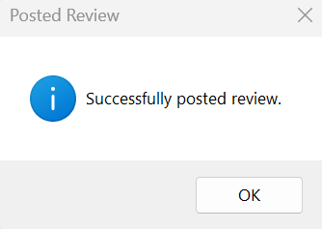

1. Go back now

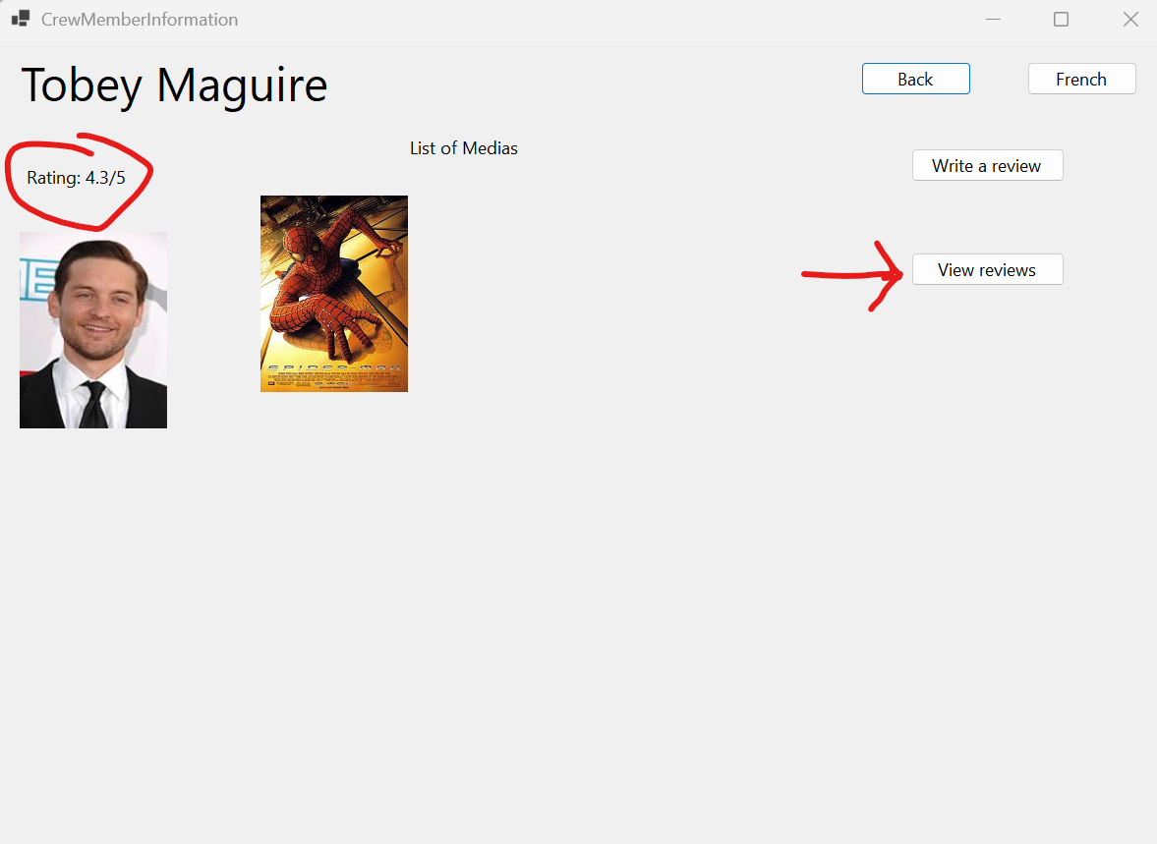

1. The rating has now updated after you posted a review. You may see what you wrote by clicking the “View reviews” button.

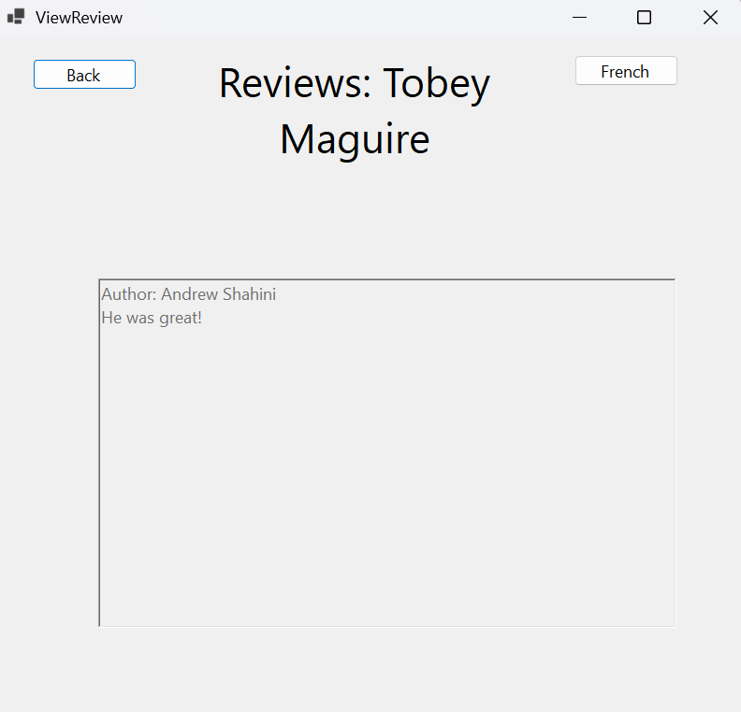

# Conclusion

Thank you for reading our user manual! We hope you got an understanding of how our application works. Whether you’re creating reviews, managing data, or exploring its features, our application is designed to enhance your experience with simplicity and efficiency.

Sincerely,

Andrew, Danat and John