AI-Assisted Development Documentation
Campus Cafeteria POS — Computer-Based Food Ordering and Point-of-Sale System
Students | Aaron Jason F. Lanos  Joren R. Naungayan
Course | IT 415 – Application Development and Emerging Technologies (Practical Examination)
Scenario | Scenario 1 — Campus Cafeteria POS
Technologies | HTML, CSS, and vanilla JavaScript (index.html, style.css, script.js); in-memory data only
AI tool used | Claude (Anthropic)
Date | October 13, 2026
GitHub Link | https://github.com/Jawren/Campus-Cafeteria-POS

Summary of AI Use
The AI tool was used six times at different stages of development. Each use is documented in the sections that follow with the exact prompt, its purpose, a summary of the AI's response, our evaluation, and any modifications made.
# | Stage | Type of use | Result
1 | Initial interface | Building a feature | Correct
2 | Cart, totals, change, receipt | Building a feature | Correct
3 | Payment validation | Building a feature / edge cases | Correct
4 | Review against 12 features | Debugging | Correct (no bugs found)
5 | README.md | Documentation | Correct
6 | UI polish and refactor | Refactoring | Correct

Prompt 1 — Create the Initial POS Interface
Type of use: Building a feature
Prompt used | The exact prompt text is shown in the screenshots below (Figure 1 and Figure 2).
Purpose of the prompt | Generate the initial desktop interface and project structure: the header, the six products with their exact names and prices, Add to Cart buttons, a cart table with column headings, an order summary showing ₱0.00, a cash input with a Confirm Payment button, and a receipt placeholder. No cart, payment, or receipt logic was to be implemented yet.
AI response (summary) | The AI explained the proposed layout (header, menu on the left, cart, summary and payment on the right, receipt across the bottom) and returned:  - complete index.html and style.css  - a minimal script.js that only logs a message to confirm it is linked  - a short explanation of each file, steps to run the page in a browser, and a manual testing checklist  On request, it also packaged the three files into a zip folder.
Our evaluation | Correct. All six products and prices matched exactly, every required section appeared, and the constraints were followed (no frameworks, no transaction logic yet). The AI also stated that it had not tested the page in a browser, as the prompt required.
Modifications we made | No code changes. The files were downloaded as a zip and placed in the Campus-Cafeteria-POS folder.
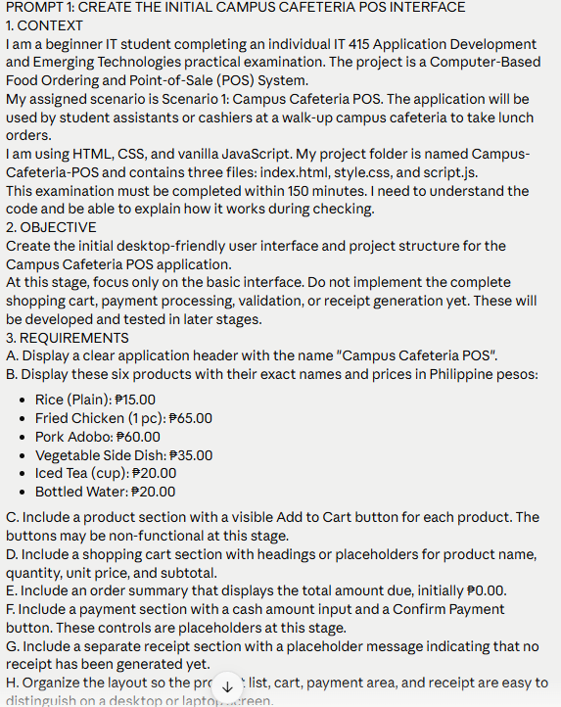
Figure 1. Prompt 1 as entered (part 1 of 2)
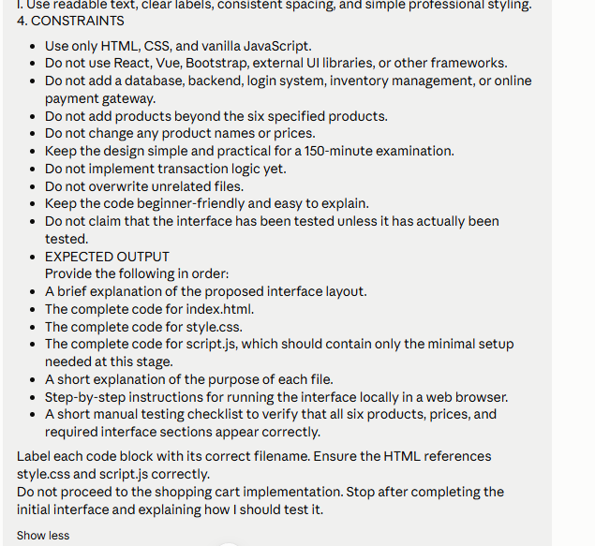
Figure 2. Prompt 1 as entered (part 2 of 2)

Prompt 2 — Cart, Totals, Change, and Receipt
Type of use: Building a feature
Prompt used | The exact prompt text is shown in the screenshots below (Figure 3 and Figure 4).
Purpose of the prompt | Implement one complete transaction: add to cart (merging duplicates), increase/decrease quantity, remove items, live subtotals and total, cash payment, change computation, payment confirmation, a digital receipt with a TXN-0001 transaction number, and a New Transaction button.
AI response (summary) | The AI returned full updated index.html, style.css, and script.js with:  - an in-memory cart array of { id, name, price, qty }  - addToCart, increaseQty, decreaseQty, removeFromCart, computeSubtotal, computeTotal, renderCart, processPayment, renderConfirmation, renderReceipt, and newTransaction  - helpers such as roundMoney, formatPeso, and formatTransactionNumber  - a lock after payment so the same order cannot be paid twice  It also gave a short explanation of each function and step-by-step tests. It ran the worked example in a simulated browser: ₱165.00 total, ₱200.00 paid, ₱35.00 change, then TXN-0002 on the next sale.
Our evaluation | Correct. The worked example matched exactly (2 Fried Chicken + 1 Rice + 1 Iced Tea = ₱165.00; ₱200.00 paid → ₱35.00 change). As the prompt asked, there was no validation yet, so a blank cash amount showed ₱NaN; this was expected and fixed in Prompt 3. The lock after payment went slightly beyond the prompt, but it prevents a double payment, and Prompt 3 later required it.
Modifications we made | No code changes. The three files were replaced with the updated versions (also requested as separate files for easier copy-paste).
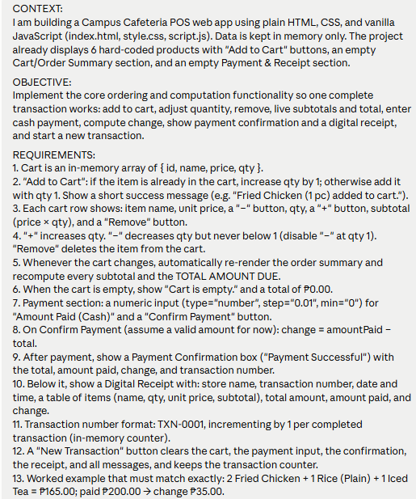
Figure 3. Prompt 2 as entered (part 1 of 2)
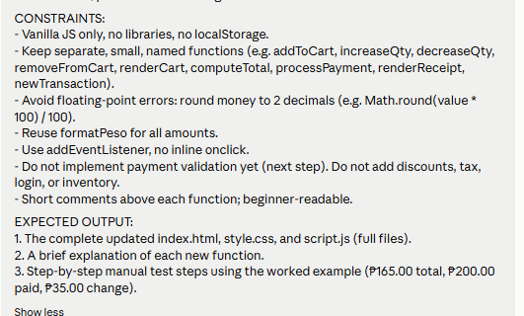
Figure 4. Prompt 2 as entered (part 2 of 2)

Prompt 3 — Payment Validation and Edge Cases
Type of use: Building a feature / handling edge cases
Prompt used | The exact prompt text is shown in the screenshots below (Figure 5 and Figure 6).
Purpose of the prompt | Add payment validation with clear on-screen messages: reject an empty cart, blank, non-numeric, or negative amounts, and insufficient payment; accept exact and decimal payments; never create a receipt or a new transaction number for an invalid payment; lock the cart after payment; and support the Enter key.
AI response (summary) | The AI returned the full updated script.js, plus small additions to index.html (a payment message area) and style.css (a red error style). It added:  - validatePayment(amountInput, total), returning { valid, message, amount } and checking the rules in the required order  - red error and green success messages that clear on the next action  - if (isPaid) return; guard lines so a paid cart cannot change  - Enter key support in the cash input  It also gave a 10-case test table and ran every case in a simulated browser.
Our evaluation | Correct. Each case gave the expected message: blank, "e", and -50 → "Please enter a valid payment amount."; 0 and 100 → "Insufficient payment. Please enter at least ₱165.00."; 165 → change ₱0.00; 165.50 → ₱0.50; 200 → ₱35.00; empty cart → "Your cart is empty. Please add at least one item." Failed attempts did not create a receipt or increase the TXN number.
Modifications we made | No code changes. Chrome does not allow typing "abc" into a number field, so the non-numeric case was tested by typing "e".
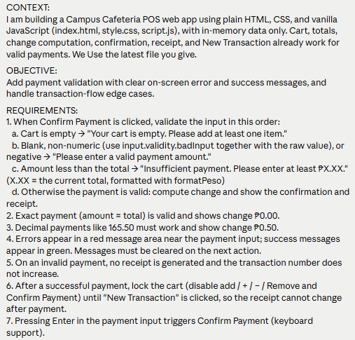
Figure 5. Prompt 3 as entered (part 1 of 2)
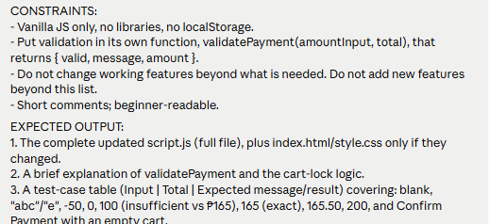
Figure 6. Prompt 3 as entered (part 2 of 2)

Prompt 4 — Review and Debug Against the 12 Required Features
Type of use: Debugging
Prompt used | The exact prompt text is shown in the screenshot below (Figure 7).
Purpose of the prompt | Check the finished app against the exam's 12 required features, the transaction flow, floating-point rounding, and console errors, and fix only real bugs without changing the structure.
AI response (summary) | The AI returned a PASS/FAIL checklist. All 12 features passed, as did the extra checks:  - flow order and the cart lock after payment  - rounding (e.g. 165.30 → ₱0.30 change) and message clearing  - console errors (none found)  It ran 25 automated checks in a simulated browser, found no bugs, and made no code changes. It noted one optional hardening: using isFinite instead of isNaN, so an unrealistic input such as 1e309 cannot show ₱Infinity.
Our evaluation | Correct. The result matched our own manual testing of all requirements, which also found nothing to fix.
Modifications we made | None. The optional isFinite change was not applied, because no cashier would enter such a value and the goal was to keep working behavior unchanged.
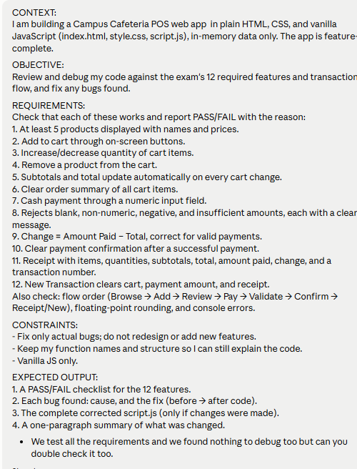
Figure 7. Prompt 4 as entered

Prompt 5 — README for the GitHub Repository
Type of use: Documentation
Prompt used | The exact prompt text is shown in the screenshot below (Figure 8).
Purpose of the prompt | Write a brief README.md with the project title, description, scenario, product list, features, the 7-step transaction flow, validation rules, how to run, technologies used, file structure, and an AI-Assisted Development note.
AI response (summary) | The AI returned a complete README.md under one page with every requested section, including tables for the products and the payment validation rules, and a short AI-Assisted Development note stating that AI was used for code generation and debugging and that the work was reviewed and tested.
Our evaluation | Correct. All required sections were present, no badges or images were used, and the validation messages match the app exactly. Note: Prompt 6 later added an images/ folder, which the README's File Structure section does not yet list.
Modifications we made | No changes were made to the README content.
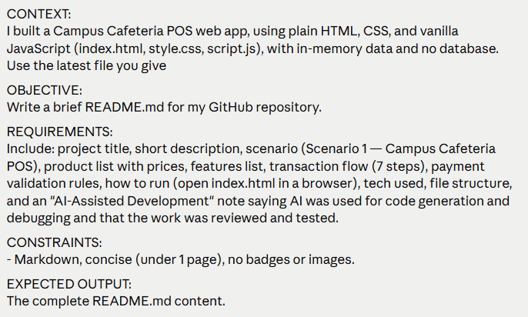
Figure 8. Prompt 5 as entered

Prompt 6 — UI Polish, Product Images, and Refactor
Type of use: Refactoring / UI improvement
Prompt used | The exact prompt text is shown in the screenshot below (Figure 9).
Purpose of the prompt | Polish the interface and add product images with an emoji fallback, make the three sections clearly distinct, make the total, change, and TXN number prominent, and refactor the JavaScript (remove duplicate code, use named constants, one job per function) without changing any behavior or validation message.
AI response (summary) | The AI returned full updated index.html, style.css, and script.js with:  - a PRODUCTS array (id, name, price, image, emoji); renderProducts() now builds the cards, and a missing image shows its emoji  - numbered, color-coded sections (1 Menu, 2 Cart & Order Summary, 3 Payment & Receipt), CSS variables for all colors, rounded cards, soft shadows, and hover effects  - a large total, a green change bar, and a TXN number badge  - named constants (STORE_NAME, CURRENCY, TXN_PREFIX, MESSAGES) and shared helpers (changeQty, setMessage, invalidResult, lineHtml, showReceiptPlaceholder)  - smaller functions split from renderCart, plus createTransaction, init, and setupEventListeners  The main function names were kept. It also gave a list of changes, a 5-step retest checklist, and a screenshot of the new layout.
Our evaluation | Correct. The AI re-ran the earlier 25 checks against the refactored code. Its test caught one small difference it had introduced — the new lineHtml helper dropped the space between a receipt label and its value — and it fixed this before delivering. All checks then passed, and the layout was checked in a headless Chrome browser at laptop size.
Modifications we made | No code changes. The product photos go in the images/ folder using the required file names; any missing photo shows its emoji instead.
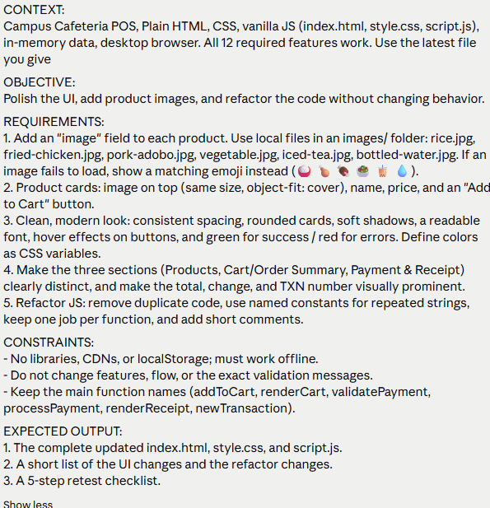
Figure 9. Prompt 6 as entered

Testing and Understanding of AI-Generated Code
After each prompt, the app was opened in Chrome and checked with the testing checklist before moving to the next stage. The main functions we can test and explain during checking are:
- addToCart — adds a product, or raises its quantity by 1 if it is already in the cart.
- increaseQty / decreaseQty / removeFromCart — change a cart item's quantity (never below 1) or delete the item.
- renderCart — redraws the cart table and recomputes every subtotal and the total amount due after any change.
- validatePayment — checks, in order, for an empty cart, a blank, non-numeric, or negative amount, and an amount less than the total; returns { valid, message, amount }.
- processPayment — shows the error for an invalid payment; for a valid one, computes change = amount paid − total, creates the transaction number, shows the confirmation and receipt, and locks the cart.
- renderReceipt — builds the receipt with the items, quantities, subtotals, total, amount paid, change, transaction number, and date and time.
- newTransaction — clears the cart, payment amount, confirmation, receipt, and messages, keeping the transaction counter.
- roundMoney / formatPeso — round money to 2 decimals to avoid floating-point errors and display amounts as ₱0.00.

