Netlabz

13.6

1. The purpose of this lab was to give me more practice installing packages with yum

2. I installed 2 different packages and used the history command to undo one of these installs.

3. I used yum, sudo, history, and remove to do this activity

4. 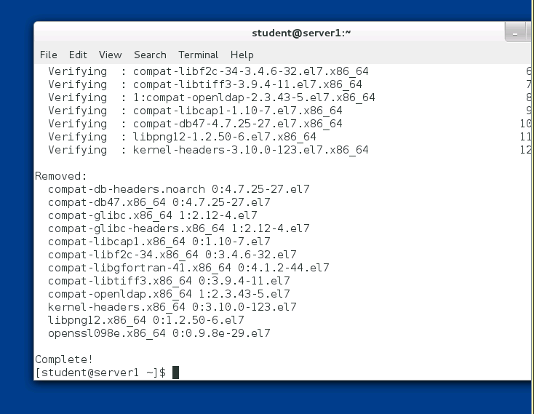

13.8