6.4

1. The purpose of this lab was to show how to secure files from the command line as well as create secure groups.
2. The lab had me redirect text from commands using the redirect symbols ‘>>’ Used chmod to change different permissions on folders, files, and subfolders.
3. One point that could prove change in this lab is that I could not access the files after the permissions were changed on them. The end result of this was a text file that echo’d “text”.
4. 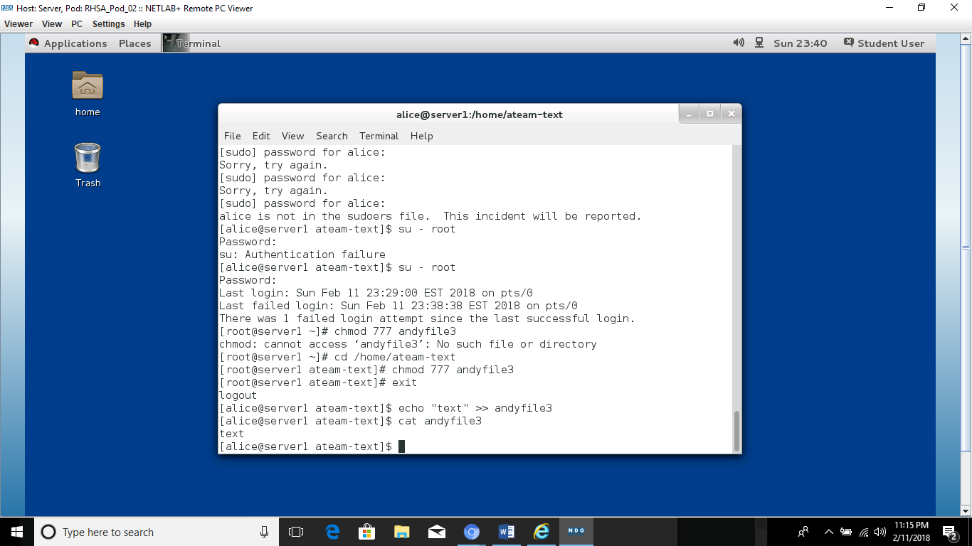
5. I learned that permissions need constant attention and updating.

6.6

1. The purpose of this lab was to teach users how to create and change a umask
2. Changed a users’ umask using the umask command. Umask (numbers) changes umask to the numbers specified. Appended a change to bashrc that enables us to have a umask of 007. Changed permissions on files.
3. Bashrc now enables my umask to be 007 at boot. Relogged to change bashrc and enact the change. Tested by using the umask command to view current umask
4. 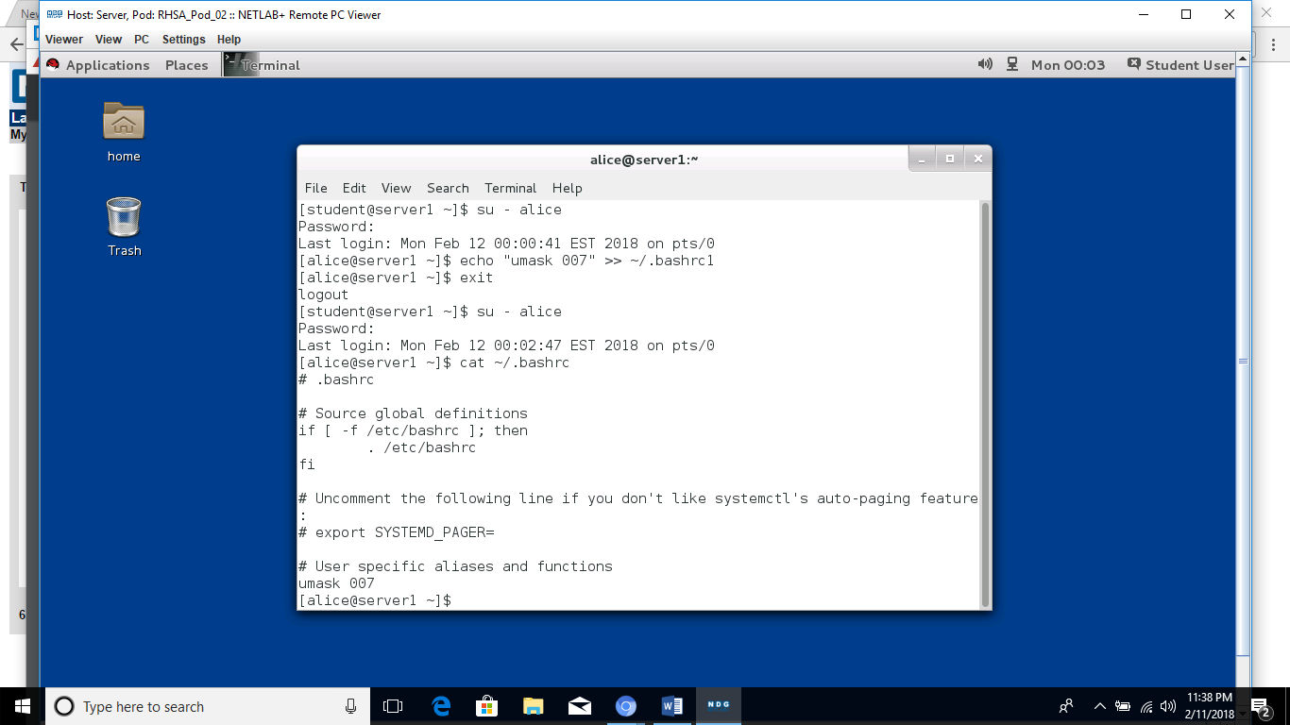
5. I learned how to change umasks on the command line.