Library Online “elibrary.edyu”

**Software Requirements Specification**

Version 1.0



**Group Id: F210273AE8**

**Supervisor Name: Abdul Majid Khokhar (abdulmajid@vu.edu.pk)**

**Revision History**

|  |  |  |  |
| --- | --- | --- | --- |
| **Date (dd/mm/yyyy)** | **Version** | **Description** | **Author** |
| 31-Dec-2021 | 1.0 | E-Library is a digital library website, where users can find books according to their needs by using filters and easily read books. E-Library maintains the information about the books, their authors, members of a library which is very complex to maintain the information manually. E-library helps in many instances of maintenance. It will reduce the manual workload. | BC180408671,  BC180203457 |

**Table of Contents**

1. Scope (of the project)
2. Functional Requirements Non-Functional requirements
3. Use Case Diagram
4. Usage Scenarios
5. Adopted Methodology
6. Work Plan (Use MS Project to create Schedule/Work Plan)

**SRS Document**

**Scope of Project:**

During these days visiting a library is such a hard task and people don’t want to go there and spend their specious time. They just want to stay in their comfort zone and there they want to access everything. To mitigate the issues of conventional and manual methods of reservation and distribution of books to readers from the library, E-Library Management System has been created. E-Library is a completely new library management system.

E-Library is a web-based online library website that is maintained by librarians/Admin. He/she will upload books and maintain the information about the author, category, and date of publication. Students/Users will easily search books and read books online or even download books. They will search books according to their desires by using filters. With this computerized system, there will be no loss of book records or member records which generally happens when a non-computerized system is used. The student will read books where they left. This E-Library will help them in their study and also save their valuable time.

**Functional and Non-Functional Requirements:**

**Functional Requirement:**

**Visitor:**

Requirement:

* Can preview books and see detail about the name, author, date of publishing, category, edition, publisher of the book.
* Can’t read the book without registration.
* Register himself/herself by filling a registration form.
* User search feature to find books.
* Can view categories of books.
* Can log in after registration.
* Log in using email and password after registration

**Reader:**

Requirement:

* Can log in by providing email and password.
* Can add/remove books to/from the personal bookshelf.
* Can search different books using a different filter.
* Can view bookshelf.
* Can reading books from where they left.
* Update password.
* Can logout.

**Administration:**

Requirement:

* Can access admin portal by login authentication.
* Add/Remove/Edit books to the database.
* Add/Delete/Update categories.
* View available book list.
* View readers of the website.
* Update password.
* Manage readers.

**System:**

Requirements:

* Nobody can read books without a login.
* Nobody can log in before registration.
* No one can view can access reader portal without login.
* Searching features based on different filters.
* Categories are available to everyone.
* At least contain 3 books in each category.
* Proper validation of different forms.
* No one can access the admin portal without login authentication.
* Only register users can read and download books.

**Non-Functional Requirement:**

* **Efficiency**

Users easily access searching and load books at a fast speed. Books are available on the main page.

* **Reliability**

The system should accurately perform member registration, member validation, report generation, and search.

* **Usability**

The system is designed for a user-friendly environment so that students and staff of the library can perform the various tasks easily and in an effective way.

* **Security:**

The system must be secure, no one can access authenticated pages without proper login.

* **Lifecycle**:

The system must be designed in such a way that enhancement in the future would be implemented easily.

**Use Case Diagram(s):**

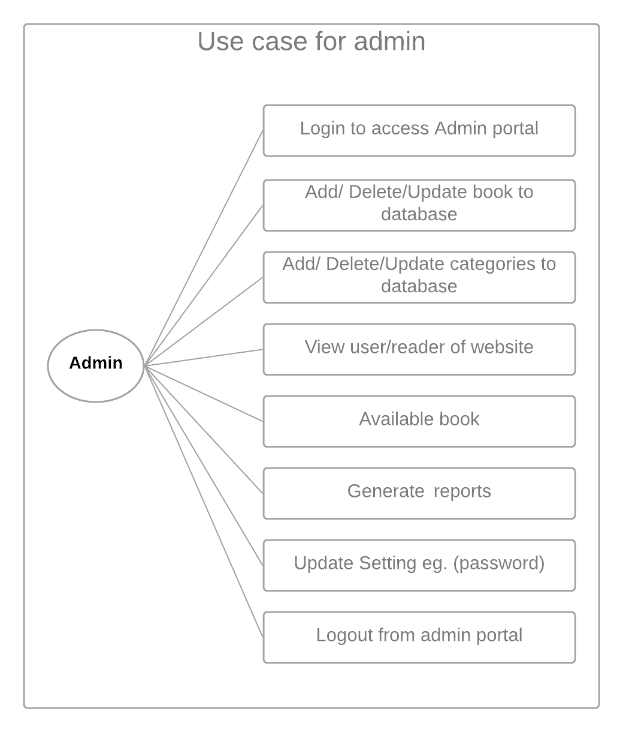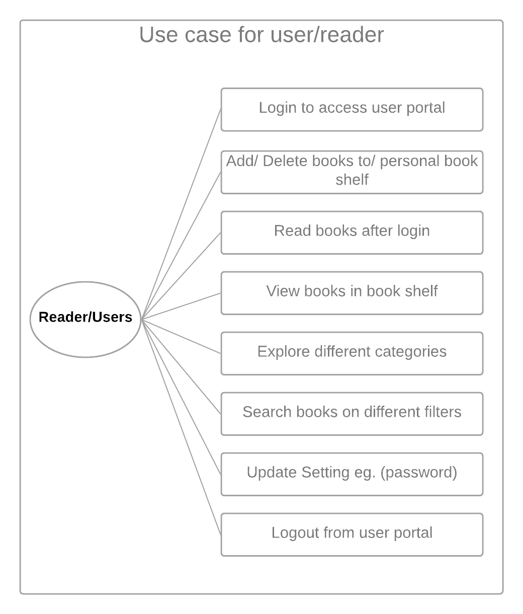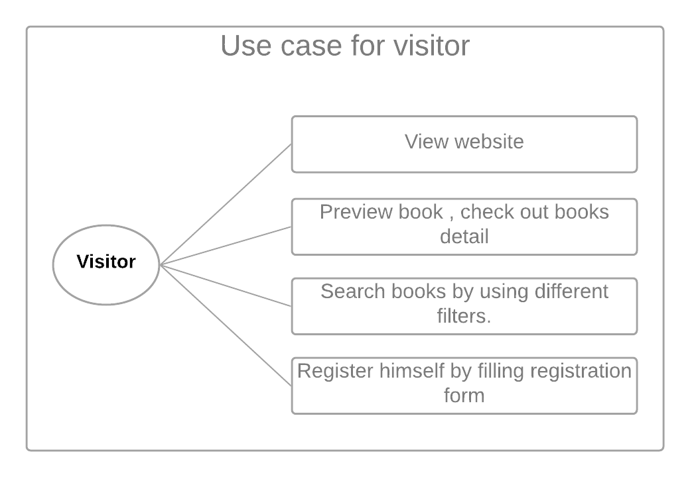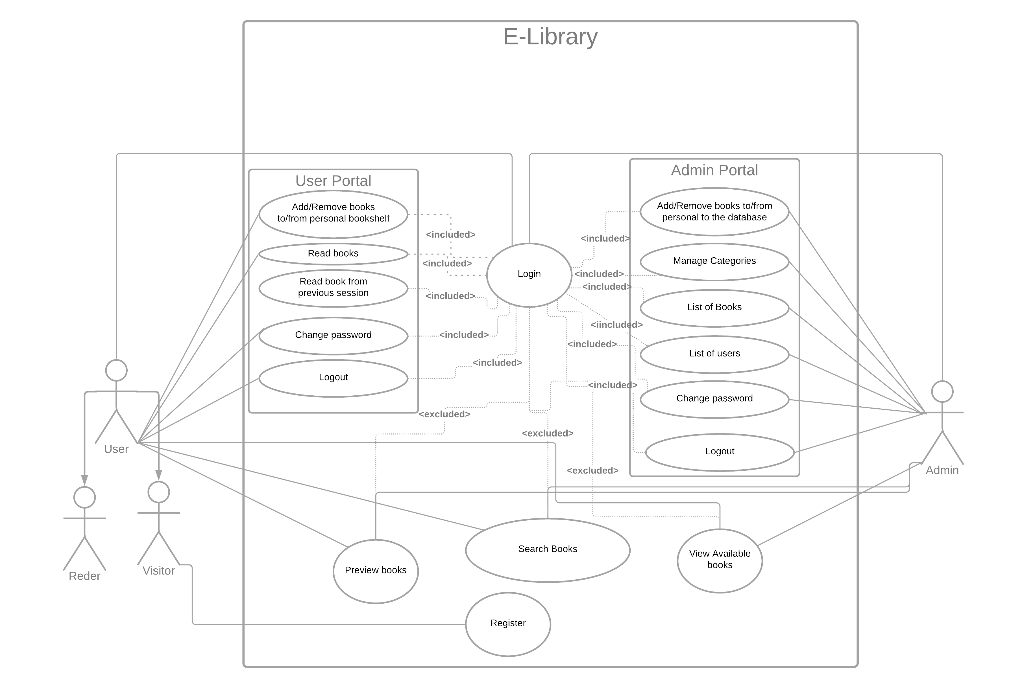

**Usage Scenarios:**

|  |  |
| --- | --- |
| Use Case Title | Registration |
| Use Case Id | ELUS-1 |
| Users | Visitor |
| Actions | A visitor will open the application. Fill the registration form. |
| Description | The visitor opens the application there he finds the login link. If he was not registered yet there will be an option to create an account. He will access that registration page and by providing the required information he will register himself. |
| Pre-Condition | Application is available, the Internet is available, must not be a user with the same email, the registration page is accessible. |
| Post-Condition | Checking of provided information of the user if all correct then return a message or a confirmation message to the user. |
| Exception | Server response provided email id must not be registered already. |

|  |  |
| --- | --- |
| Use Case Title | Login |
| Use Case Id | ELUS-2 |
| Users | Reader/Visitor, Admin |
| Actions | The visitor will open the application. Access login page and log in by email id and password. |
| Description | After opening the application user access the login page. User or admin login himself by providing email and password to access user and admin portal respectively. |
| Pre-Condition | The user must be registered into the application before login in. |
| Post-Condition | Return message or confirmation message. If user/admin login successfully then a user/admin portal is provided to them. |
| Exception | Email and Password must be matched to an existing user. |

|  |  |
| --- | --- |
| Use Case Title | Admin Portal |
| Use Case Id | ELUS-3 |
| Users | Admin |
| Actions | Add/update/delete books, manage/add/delete/update categories, view available books in the database, view users of the application, change password, log out himself. |
| Description | After valid login authentication admin portal will be provided to the admin. Now he can view the user of his E-Library by clicking the user’s button. He can view available books in the library by clicking the book’s button. Here he will all the books in the database with an edit and delete button for editing and deleting any book. There will be add button to add more books to the database. When he click add button add book form will appear and by fill all the required details he will new the book to the database. He can also manage categories by clicking the categories tab. On clicking all the categories available in the database will be shown to him. He will edit, delete or add more categories by providing necessary details. He would change his password by clicking the change password tab. On clicking, the change password form will be shown to him. By providing the current password, new password, and confirmation password he will change his password if all the information is provided correctly. He would log out himself by clicking the logout button. |
| Pre-Condition | Admin must be logged in. |
| Post-Condition | Confirmation message for each action in the admin portal. When admin logout from portal must turn to the login page. |
| Exception | Login must be authenticated. Only show admin portal of the admin is logged in. |

|  |  |
| --- | --- |
| Use Case Title | User/Reader Portal |
| Use Case Id | ELUS-4 |
| Users | User/Reader |
| Actions | Add/remove books to a personal bookshelf, view available books in the database, preview books where he left books, change password, log out himself. |
| Description | After a valid login user/reader portal will be provided to him. Here he will explore different options. He will add available books to his bookshelf. In a personal bookshelf interface, he will be able to remove the book. He will be able to explore available books in the database. He would be able to preview the books where he left before. He would change his password by clicking the change password tab. On clicking, the change password form will be shown to him. By providing the current password, new password, and confirmation password he will change his password if all the information is provided correctly. He would log out himself by clicking the logout button. |
| Pre-Condition | The user must be registered and must be login. |
| Post-Condition | Confirmation message for each action in the user portal. When users log out from the portal must turn to the login page. |
| Exception | Proper authentication, User portal has only shown when the user logged in. |

|  |  |
| --- | --- |
| Use Case Title | Searching Books |
| Use Case Id | ELUS-5 |
| Users | Visitor/Reader, Admin, |
| Actions | Enter keyword and select particular filter. |
| Description | The search box is available for everyone. Anyone can enter keywords related to the book and select a filter to search book on particular criteria. |
| Pre-Condition | Keywords must be entered for searching. |
| Post-Condition | Return books to the visitor who meets the given criteria. Return proper message and none of the books meet the criteria |
| Exception | Keyword must be entered. |

**Adopted Methodology**

Our methodology for this project is the VU process model which is a combination of the Waterfall and Spiral model. Methodology in its simple mining is the approach to complete the project. As we already know that our project is divided into different phases as in waterfall so the VU Process model is considered to be completed in generic sequence. The different phases of the VU process model are.

Requirement Analysis:

In this phase, all the requirement regarding the system that is going to be developed is gathered. In this phase, we consider what the system going to do and what the services, constraints, and goals are accomplished by the user, and how it behaves in different scenarios. All this information is documented in System Requirement Specification (SRS).

Design Phase:

In this phase design of the system is addressed with the help of ERD’s, Use cases, and database design, and interface design. This phase also helps to specify software and hardware requirement. All this information in the VU process model is gathered in the design document.

Implementation:

This is considered to be an important phase all the coding will do in this phase.

Testing Phase:

All the systems will be tested before going to the submission phase.

Final Deliverable:

After the completion of the project. Project source code, presentation of the project, and project report will be submitted.

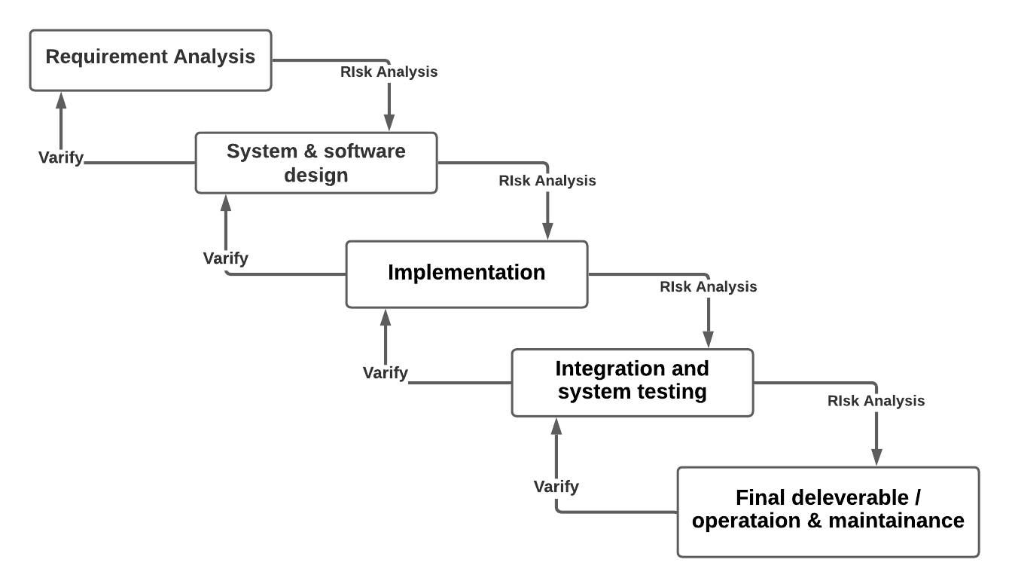

**Work Plan**

