PROFESSIONAL REPORT ON SCRATCH FOUNDATION
Creative Coding, Education and Global Youth Engagement
Prepared for: Technical Writing Assignment
By: Zainab Sogbade
Reporting period: 2024 Annual Report, with current online-presence observations
Source base: Scratch Foundation and Scratch official websites

Executive Summary
Scratch Foundation is a nonprofit organization that supports Scratch, a free creative-coding platform developed from research at the MIT Media Lab. Scratch enables young people to create interactive stories, games, animations and other projects while learning computational thinking, creativity and collaboration. The Foundation raises and manages resources that help keep Scratch free, develop the platform, support educators and expand creative-coding opportunities globally.
The 2024 annual report describes a major year of growth: Scratch welcomed 21.5 million new users, reached more than 140 million children worldwide, celebrated its one-billionth project, and worked with 229 organizations across 49 countries. The Foundation also reported more than 4 million young people reached through partner organizations. Financially, 2024 total support and revenue was $25.75 million, while total expenses were $18.07 million.

1. Company Overview
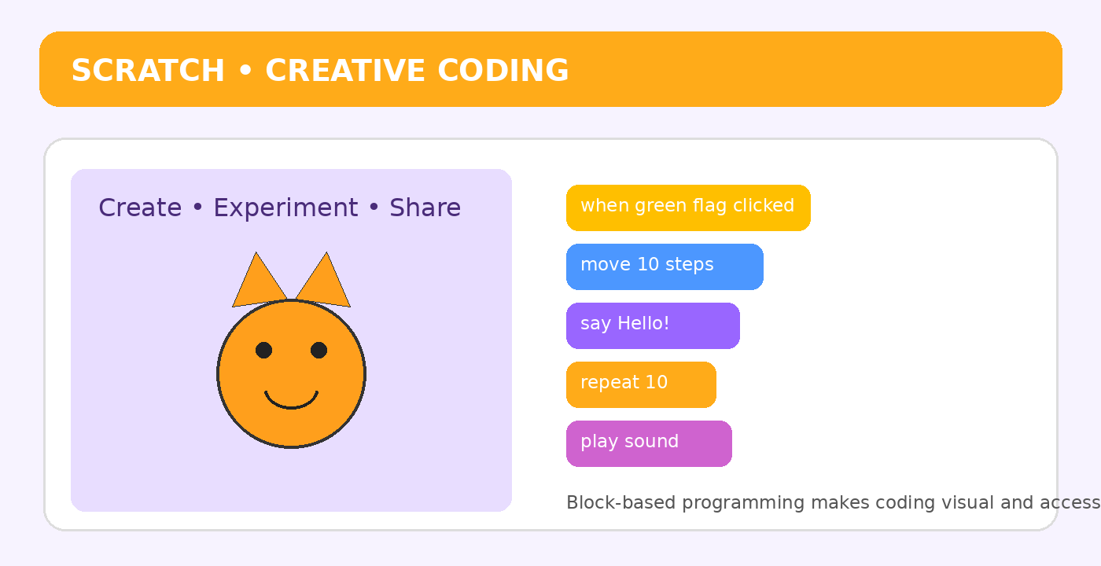
Figure A. Illustrative representation of Scratch's block-based creative-coding approach.
Scratch Foundation is a nonprofit organization founded in 2013. It supports the Scratch ecosystem and works to ensure that Scratch remains free and accessible to young people. Scratch itself is a block-based programming environment in which users can build interactive projects and share them with an online community. The Foundation's role includes fundraising, partnerships, platform development support, educational resources, events and community initiatives.
Item | Details
Organization | Scratch Foundation
Type | Nonprofit organization
Founded | 2013
Headquarters | Boston, Massachusetts, USA
Mission focus | Creative coding and learning for young people
Core platform | Scratch
Primary age group | Especially ages 8–16, while used by people of many ages
Global reach | 150+ million young people according to the Foundation's current impact page

2. Products and Services
Scratch Foundation's work is centered on the Scratch platform and the wider ecosystem that supports creative learning. Unlike a conventional software company, its principal offering is a free public educational platform supported through philanthropy, partnerships and other mission-driven activities.
Product / Service | Description | Primary Benefit
Scratch platform | Block-based environment for creating games, stories, animations and interactive media. | Introduces programming and computational thinking.
Learning resources | Tutorials, lesson materials, activities and educator resources. | Helps teachers, parents and learners use Scratch effectively.
Community | Online space where users share, remix and discuss projects. | Encourages collaboration, peer learning and self-expression.
Events | Scratch Days, Scratch Week, Scratch Camp and educator events. | Creates hands-on opportunities for creative coding.
Partnerships | Collaboration with schools, nonprofits, foundations and other organizations. | Extends Scratch's reach into local communities.
Licensing and partnerships | Mission-aligned licensing and collaboration for organizations using Scratch intellectual property. | Supports sustainable growth while protecting the brand and mission.

3. Target Audience
The direct users of Scratch are primarily young people, especially learners around ages 8–16. However, the organization's wider audience includes educators, parents, schools, libraries, museums, community organizations, donors and corporate or foundation partners.
Audience | Needs / Interests | How Scratch Foundation Serves Them
Children and young people | Creative expression, coding, play, community and problem-solving. | Free platform, projects, community features and events.
Teachers and educators | Curriculum support, classroom activities and professional learning. | Learning Library, educator resources, workshops and events.
Parents and families | Safe, meaningful digital learning experiences. | Free creative platform and family-oriented resources.
Schools and organizations | Scalable computer-science and creative-learning opportunities. | Partnerships, resources, events and implementation support.
Donors and partners | Measurable social and educational impact. | Partnership opportunities, campaigns and impact reporting.

4. Online and Social Media Presence
Scratch Foundation maintains a strong digital presence through its official website, the Scratch platform, its annual report website, news/blog content and professional social media. LinkedIn is particularly relevant for communicating with educators, technology professionals, nonprofit partners and donors. The Scratch platform itself functions as both a product and a large online community.
Channel | Purpose | Observed Role
Official Website | Mission, impact, partnerships, donations and organizational information. | Primary institutional information hub.
Scratch Website | Coding, project creation and community interaction. | Core user-facing platform.
LinkedIn | Professional updates, education stories, hiring and partnership communication. | Strong professional/community channel.
Facebook | Impact, financial and organizational reporting. | Accountability and transparency.
Youtube | Stories, educational ideas, product developments and community updates. | Ongoing engagement and storytelling.
At the time of research, Scratch Foundation's LinkedIn page displayed more than 12,000 followers and regular updates covering educator resources, Scratch Camp, AI experiments, partnerships and community stories.

5. 2024 Annual Report and Financial Performance
The 2024 annual report provides the most recent full-year financial and impact dataset used in this report. It states that Scratch received $25,748,478 in total support and revenue and recorded $18,066,340 in total expenses. The figures below are reported in US dollars.
2024 Financial Item | Amount (USD) | Share / Note
Total support and revenue | $25,748,478 | 100% of reported support and revenue
Contributions and grants | $19,839,581 | Largest reported revenue category
In-kind contributions | $5,729,951 | Non-cash support
Retail revenue | $7,287 | Small revenue category
Other income | $171,659 | Other reported income
Total expenses | $18,066,340 | Reported annual expenditure
Program services | $15,500,236 | Core program expenditure
Management and general | $2,030,684 | Administrative expenditure
Fundraising | $535,420 | Fundraising expenditure
Change in net assets | $7,682,138 | Reported 2024 increase

6. Financial Charts
Figure 1 compares the main support and revenue categories reported for 2024. Contributions and grants accounted for the largest monetary category, while in-kind contributions also represented substantial support.
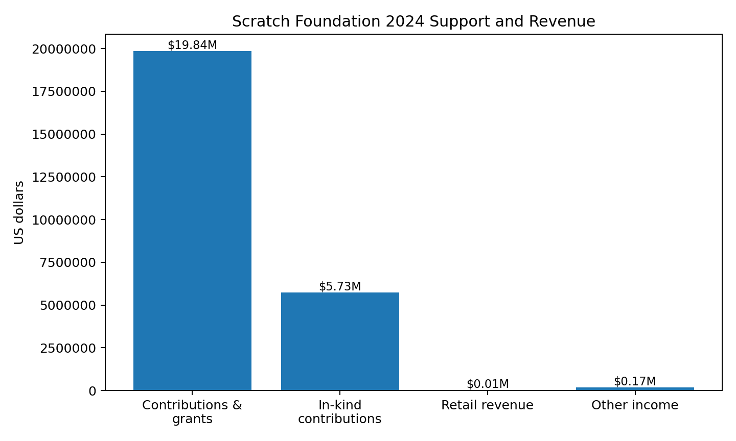
Figure 1. Scratch Foundation 2024 support and revenue by category.
Figure 2 shows the composition of the Foundation's 2024 expenses. Program services represented the largest component of reported expenditure, while management and general costs and fundraising costs made up smaller portions.
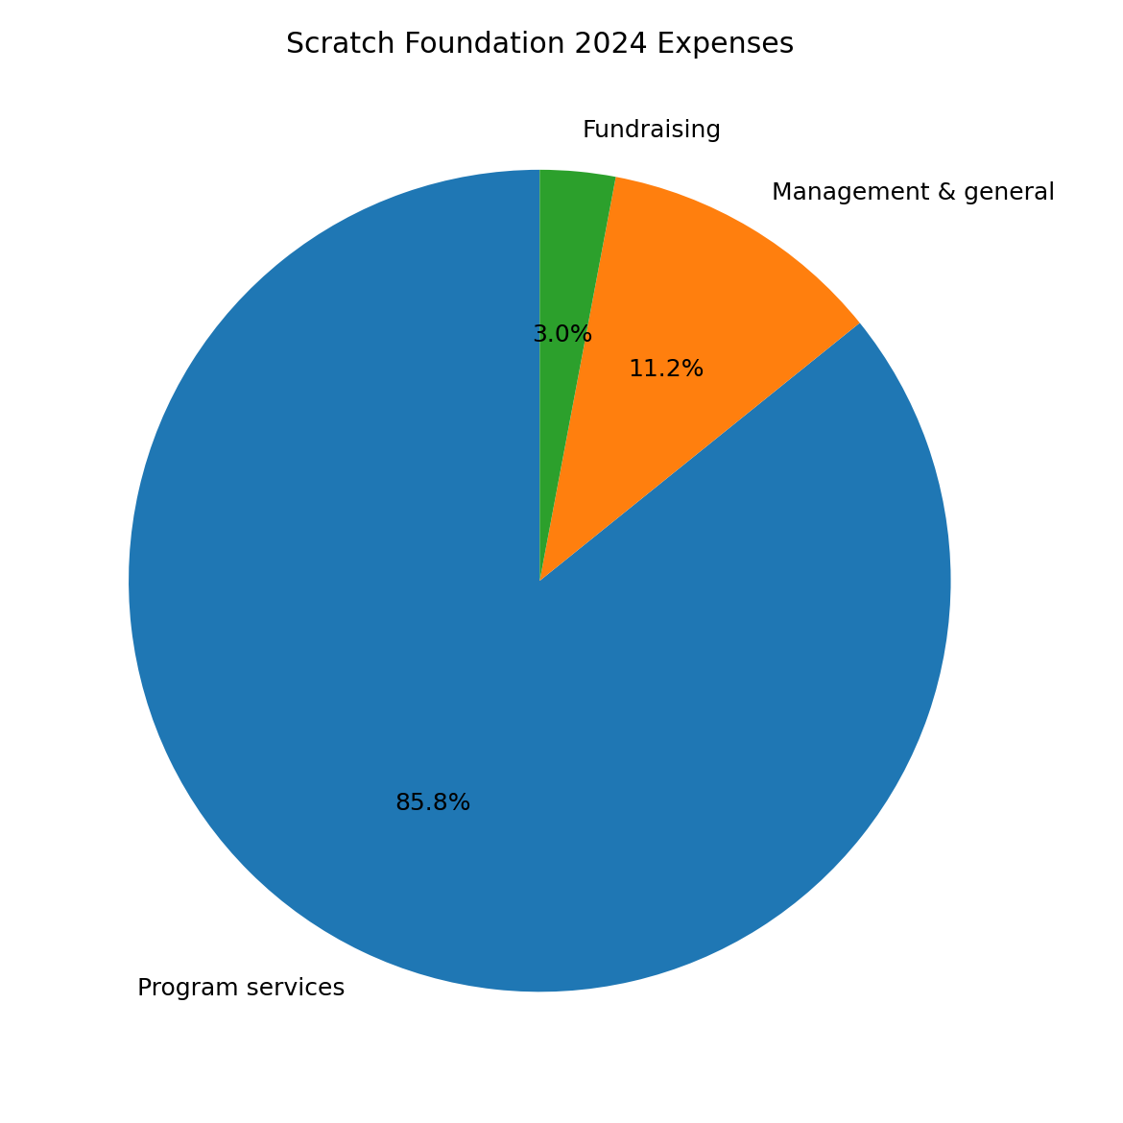
Figure 2. Scratch Foundation 2024 expenses by category.
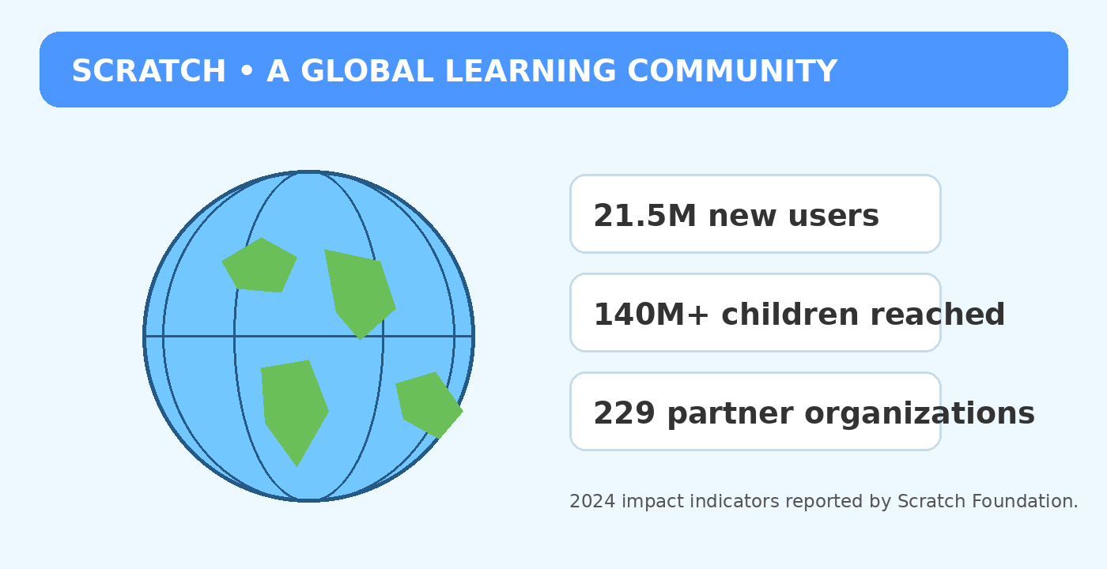
Figure B. Illustrative visualization of Scratch Foundation's global reach and 2024 impact indicators.

7. Key 2024 Impact Indicators
Indicator | 2024 Result
New users | 21.5 million
Children reached worldwide | More than 140 million
Projects milestone | 1 billionth project celebrated
Partner organizations | 229 across 49 countries
Young people reached through partners | More than 4 million
Scratch Days | 820+ events in 30 countries
Scratch Day participants | 100,000+ worldwide
Youth Advisory Board | 50 young people from 14 countries
Scratch Conference | 1,300 educators joined

8. Findings and Analysis
- Global scale: Scratch has moved beyond being a coding tool into a large creative-learning ecosystem with users, educators and partner organizations across many countries.
- Accessibility is central to the model: keeping the platform free reduces the financial barrier to entry for learners and educators.
- Community is a major part of the product: users do not only consume lessons; they create, remix, share and learn from one another.
- The financial model is nonprofit-oriented: the 2024 figures show heavy reliance on contributions and grants, supplemented by in-kind support and smaller income categories.
- Program spending dominates reported expenses, indicating that most expenditure was associated with mission/program activity rather than administration or fundraising.
- The organization is investing in future growth through the 100 Million More campaign and development work associated with Scratch 4.0.

9. Recommendations
- Strengthen regional communication: Publish more country- or region-specific stories and impact figures, particularly for Africa and other rapidly growing digital-learning markets.
- Expand educator-focused content: Continue developing practical lesson plans, classroom guides and short professional-development resources that teachers can immediately use.
- Make impact data easier to understand: Use simple dashboards and recurring visual reports showing users, projects, partnerships, languages and program reach over time.
- Diversify sustainable funding: Continue developing philanthropic partnerships while expanding carefully designed mission-aligned revenue and licensing opportunities.
- Increase youth-led communication: Give more young Scratch users opportunities to tell their own stories through blog posts, videos, events and community showcases.
- Improve social-media measurement: Track engagement rates, audience growth, referral traffic and campaign outcomes across major channels to identify which content formats produce the strongest educational and community response.

10. Conclusion
Scratch Foundation demonstrates how a nonprofit organization can use technology, community and education to expand access to creative coding. The 2024 report shows substantial global reach, strong community activity and significant program expenditure. Its major strategic challenge is sustaining a free platform at very large scale while continuing to develop the technology, support educators and protect a safe, creative community. Continued diversification of funding, stronger regional storytelling, educator support and transparent impact measurement can help the organization maintain and extend its mission.

11. References / Sources
- Scratch Foundation. Scratch 2024 Annual Report. https://annualreport.scratchfoundation.org/
- Scratch Foundation. Impact. https://scratchfoundation.org/impact
- Scratch Foundation. Donate. https://scratchfoundation.org/donate
- Scratch Foundation. Partner With Us. https://scratchfoundation.org/get-involved/partner-with-us
- Scratch Foundation. Scratch and Partners. https://scratchfoundation.org/scratch-and-partners
- Scratch official website. About Scratch. https://scratch.mit.edu/help/about/
- Scratch Foundation. LinkedIn page. https://www.linkedin.com/company/scratchfoundation

Appendix: Notes on Data
The financial figures in this report come from the Scratch Foundation's 2024 Statement of Activities. The impact figures come primarily from the 2024 annual report and the Foundation's current impact/donation pages. Current website figures can change over time; therefore, the report distinguishes the 2024 annual-report period from current online-presence observations. The charts use only reported 2024 financial categories.
Image note: The two visuals above are original illustrative graphics prepared for this report to support visual communication. They are not official Scratch Foundation screenshots or promotional images.

