**Questions | Chapter 3**

1. Uniform-cost search expands the node n with the lowest path cost g(n). What is g(n)?
2. What data structures do BFS, Uniform-cost search, and DFS use?
3. What is the difference between Uniform-cost Search and Greedy Best-first Search?
4. Discuss the two commonly used heuristics for the 8-puzzle game. Use the following diagrams for your calculations.

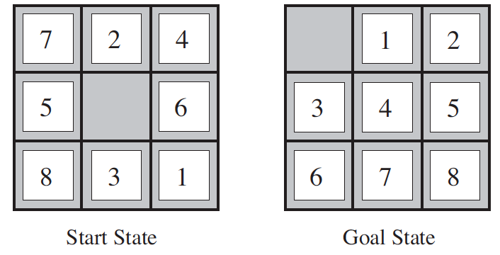

1. Discuss the “Manhattan distance” heuristic for the 8-puzzle game. Use the following diagrams for your calculations.



1. What are the advantages of DFS over BFS? Explain in the context of space complexity.
2. Write the DFS algorithm.
3. If g(n) is the cost to reach the node, and h(n) is the cost to get from the node to the goal, what is the difference between Uniform Cost search and A* search?
4. Given the following map (with the path costs shown) and the table with the heuristic function, we are interested in the stages of the A* search algorithm. Arad is the starting state and Bucharest is the goal state. As the A* search is executed, after Sibiu, the next node to be expanded is Rimnicu Vilcea. With calculations explain why.

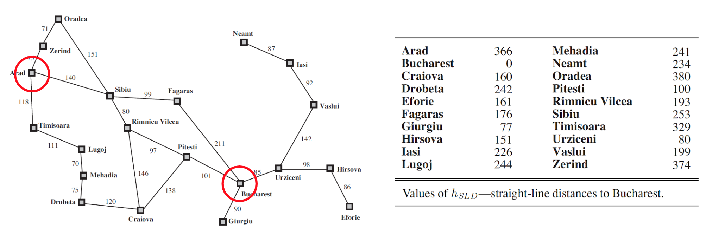

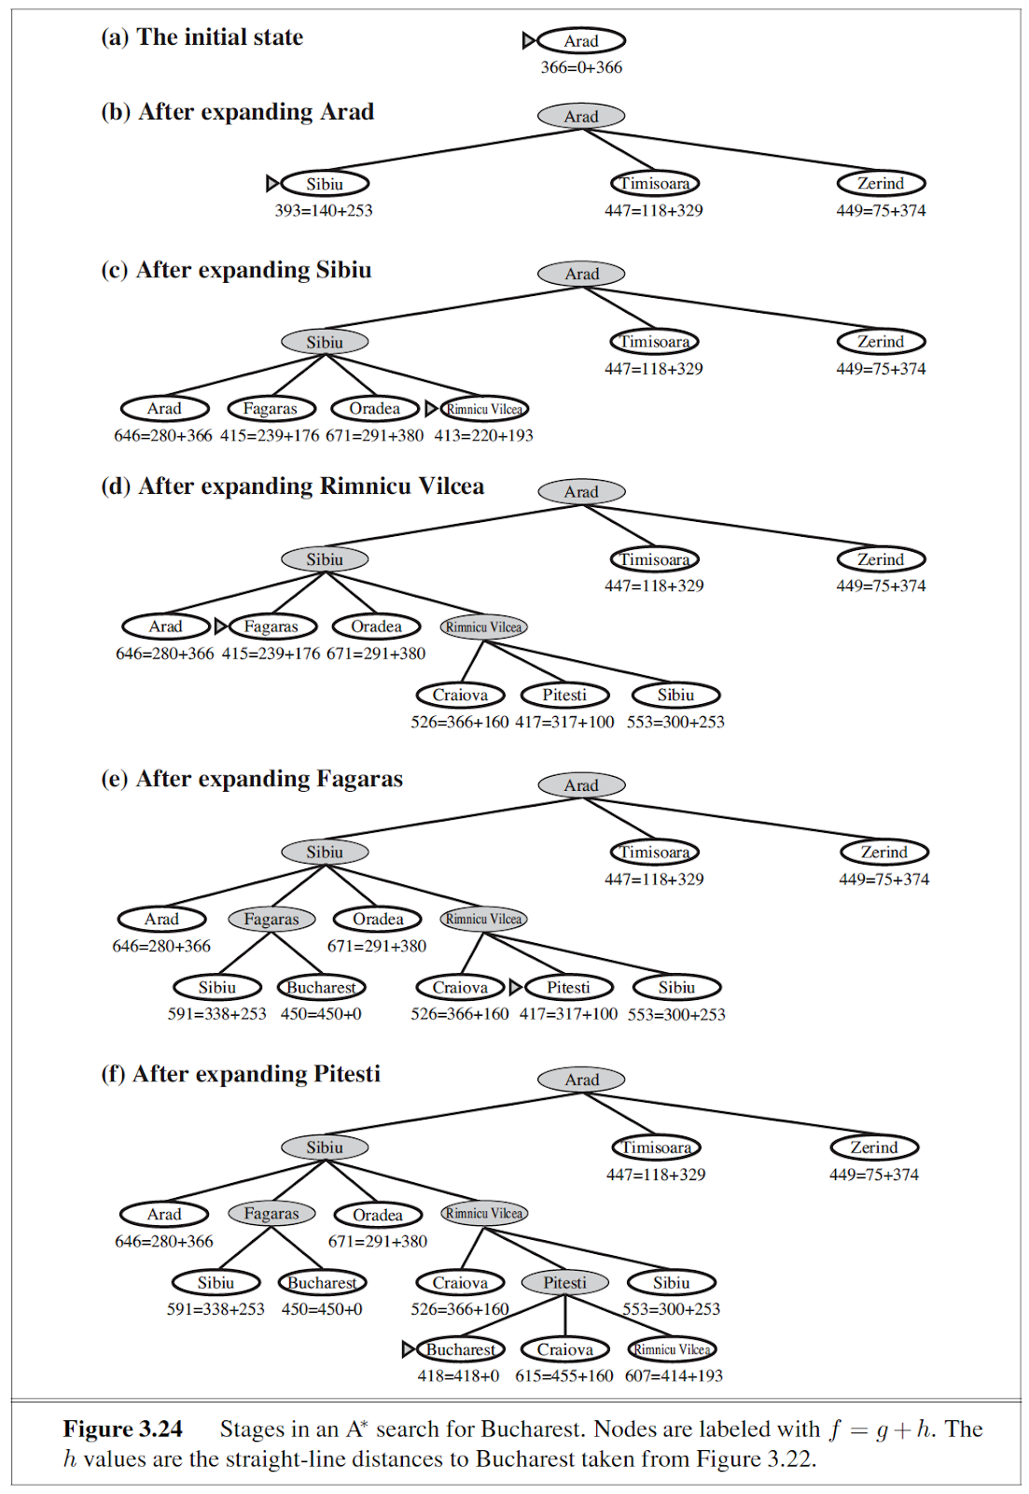

1. Given node A, having child nodes B, C, D with associated costs of (10, 5, 7). After expanding C, we see nodes E, F, G with costs of (40, 50, 60). Which node will be chosen by Uniform-cost search and Greedy best-first search? Explain with the following diagram as reference.

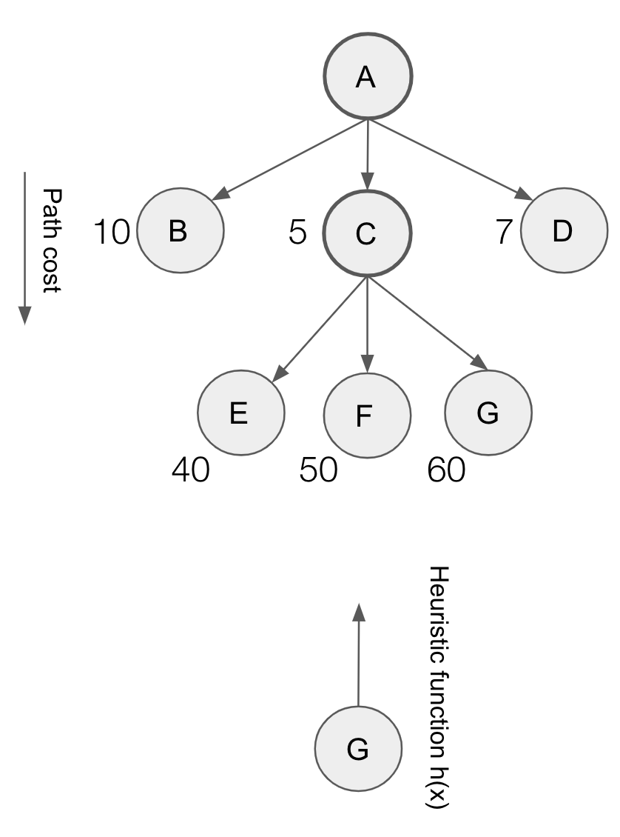

1. For the 8-puzzle game, what actions are possible in a given random state?



1. What will be the contents of the priority queue, as the UCS algorithm proceeds on the following graph? Show the contents of the priority queue, step-by-step.

