**Questions | Chapter 5**

1. Calculate the minimax values at nodes A, B, C, and D for the player MAX given the game tree below. The numbers at the leaf nodes represent the values of  Utility (leafnode, MAX).

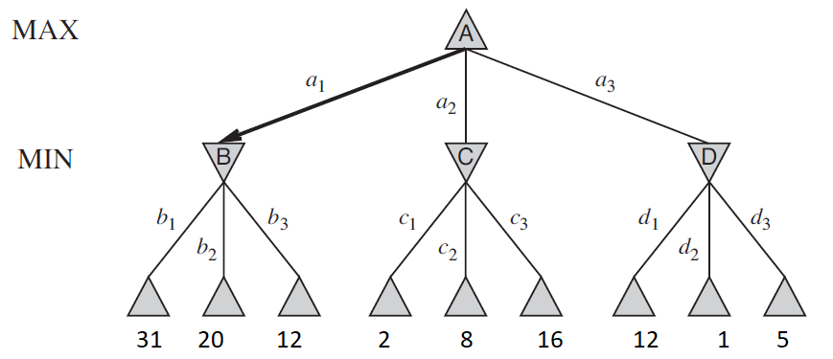

1. In the following tree, apply the Alpha-beta pruning algorithm. Which of the following nodes will be pruned - T, U, V? Assume that the nodes are processed from left to right.

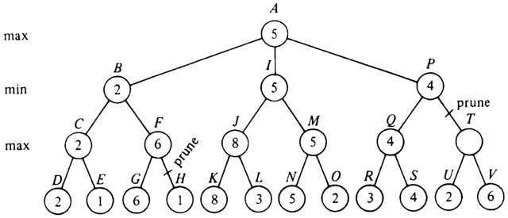

1. What will be the values of “alpha” and “beta” at the nodes J, M, Q, and T after the Alpha-beta pruning is executed on the graph aside? Assume that the nodes are processed from left to right.  
     
   
2. For the following game tree, show which nodes/sub-tree will be pruned by the Alpha-Beta pruning algorithm. Assume that the nodes are processed from left to right.

