**Questions | Chapter 6**

1. A constraint satisfaction problem consists of three components - X, D, and C. What are X, D, and C?
2. For the 9x9 sudoku puzzle discuss X (variables), D (domain), and C (constraints).

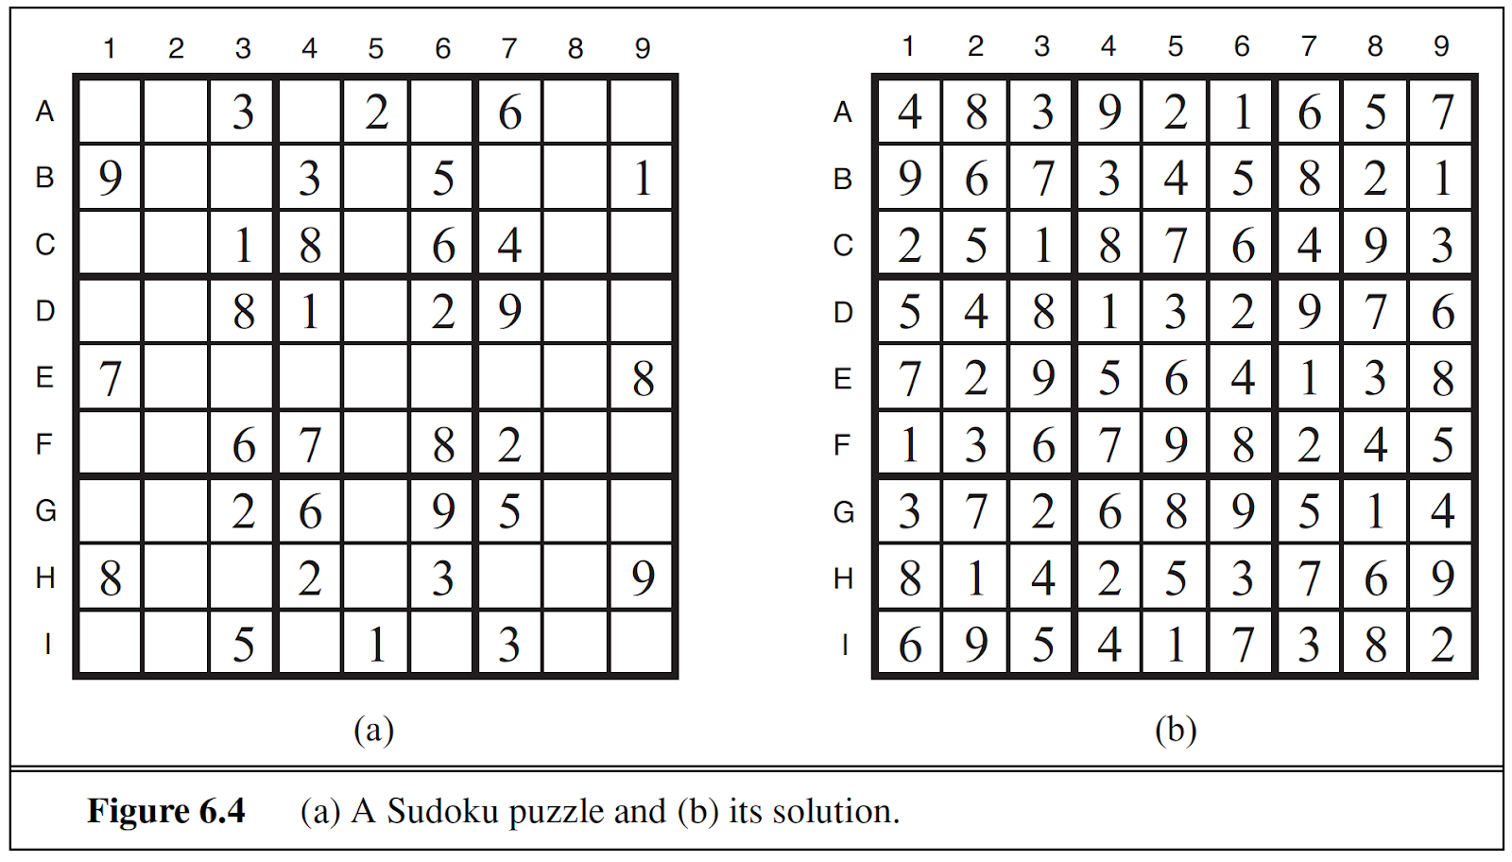

1. Consider a problem of scheduling the assembly of a car. We need to install axles (front and back), affix all four wheels (right and left, front and back), tighten nuts for each wheel, affix hubcaps, and inspect the final assembly. Each task can be modeled as a variable, e.g. install wheel. The values of the variable is the time that the task starts. For example, AxleF = 0 indicates front axle installation begins at time 0. So, in total we have  15 variables, X = {AxleF, AxleB, WheelRF, WheelLF, WheelRB, WheelLB, NutsRF, NutsLF, NutsRB, NutsLB, CapRF, CapLF, CapRB, CapLB, Inspect}. To list all the constraints we need, we would like to produce the following types of constraints: (a) Assert that one task must occur before another (for example, a wheel must be installed before the hubcap is put on) (b) Assert that only so many tasks can go on at once (for example, when sharing tools) (c) Specify that a task takes a certain amount of time to complete. Write out all the relevant constraints if it takes 10 minutes to install an axle.