**Chapter 7 | Questions**

1. Discuss a reasonable performance measure for the “Wumpus World” problem.

Answer: “+1000” for climbing out of the cave with the gold, “–1000” for falling into a pit or being eaten by the wumpus “–1” for each action taken, and “–10” for using up the arrow

1. Given the following generic knowledge-based agent program, what do the methods TELL, ASK, MAKE-PERCEPT-SENTENCE, MAKE-ACTION-QUERY, and MAKE-ACTION-SENTENCE do?

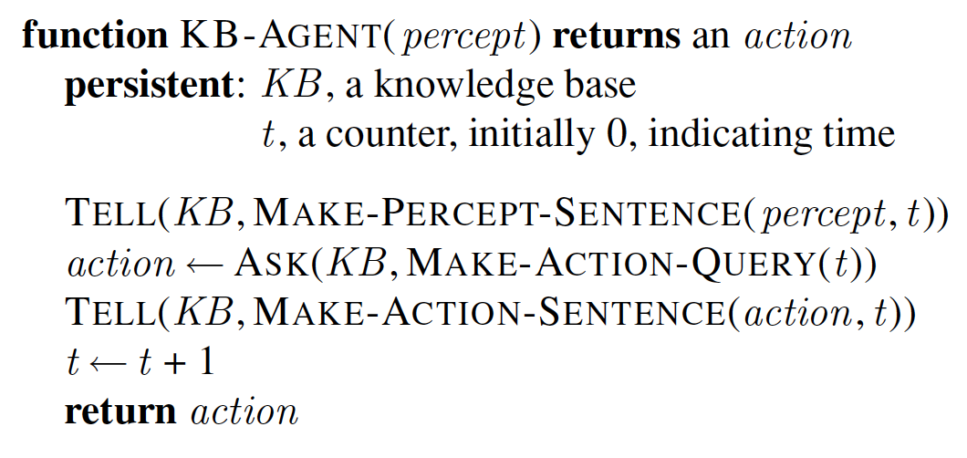

1. ‘x’ men and ‘y’ women are sitting at a table playing bridge. Consider that the sentence α = x + y = 4 is true, i.e. there are four people in total. Describe M(α), the set of all models of α.

Answer: M(“x+y=4”) = {[x=0, y=4], [x=1, y=3], ..., [x=4, y=0]}

1. In the Wumpus world, suppose that the agent lands on square [3,3]. If the format for the percept is [stench, breeze, glitter, bump, scream], what will be the percept at [3,3]?

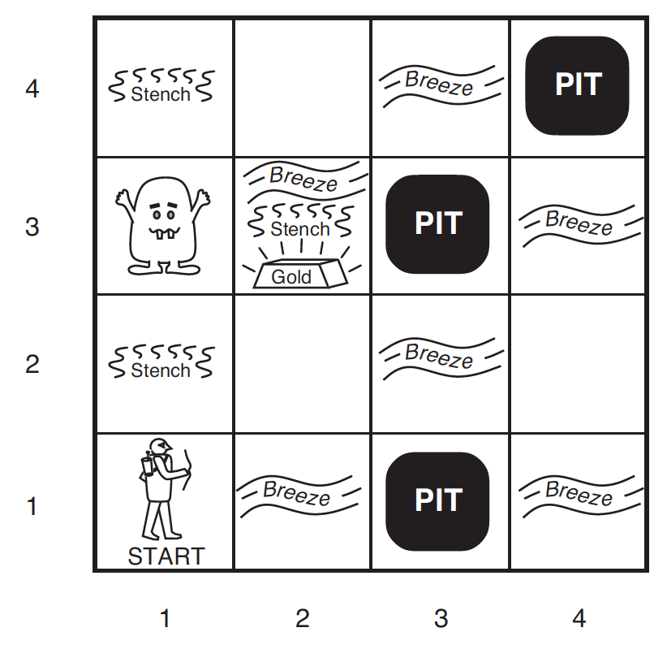

Answer: Undefined - PEAS does not define that anywhere, particularly in the description of agent sensors.

1. In the Wumpus world, suppose that the agent lands on square [2,3]. If the format for the percept is [stench, breeze, glitter, bump, scream], what will be the percept at [2,3]?

Answer: [stench, breeze, glitter, none, none]

1. Define “Logical Entailment” formally if α ⊨ β, where α and β are two sentences.

Answer: α ⊨ β if and only if, in every model in which α is true, β is also true

1. If the sentence x = 0 entails the sentence xy = 0, what is the relationship between a model which satisfies x = 0 and a model that satisfies xy = 0?

Answer: M(x=0)⊆M(xy=0)

1. Slide 18. Use the model checking approach to show M(KB) and M(α1) and discuss how logical entailment may be used to decide if α1 is true or not.
2. In slide 18, say we focus only on two sentences, α2 and α3 (not α1 and α2). (1) In one model space, encircle the models which satisfy α2 with a dashed lines. (2) In a separate model space, encircle the models which satisfy and α3 with a dashed lines. (3) In both of these figures, with a dark like, encircle the models for which the knowledge base (KB) is true. (4) Show, using logical entailment that it is safe for the agent to neither to go [2,2] nor to [3,1]. Note: Practice the variations of this question with α1 & α2 and α1 & α3 as well.
3. Why is “model checking” method of inferencing “sound”?

Answer: Because it uses entailing - sentences such as “there is no pit in [2,2]” are entailed from the KB

1. What is the relationship between Entailment and Inference? Give an example. Entailment can be applied to carry out logical inference. Entailment is like the needle being in the haystack and Inference is like finding it.
2. If the sentences in the knowledge base make use of the proposition symbols W, X, Y, and Z, give two examples of possible models.

Answer: M1 = { W=false, X=true, Y=false, Z=true} (and M2 = … )

1. What are the five connectives in syntax of propositional logic?

See slide 23.

1. Practice the examples on the semantics of Propositional Logic (slide 27). The semantics reference table will NOT be provided in the test.