**Sample Test 2**

Time: 2 hours

**Short questions:**

1. For an agent, what is rational at any given time depends on four things. What are they?
2. A constraint satisfaction problem consists of three components - X, D, and C. What are X, D, and C?
3. If the sentence x = 0 entails the sentence xy = 0, what is the relationship between a model which satisfies x = 0 and a model that satisfies xy = 0?
4. ‘x’ men and ‘y’ women are sitting at a table playing bridge. Consider that the sentence α = x + y = 4 is true, i.e. there are four people in total. Describe M(α), the set of all models of α.
5. What are the disadvantages of building larger n-gram models such as 4-gram or 5-gram word models?
6. Give an advantage and a disadvantage of a holonomic robot.
7. When is the “Reactive control” method for robot movement more appropriate?
8. Why did Dijkstra argue that the question “Can a machine be conscious?” is ill defined?
9. Why do the authors (Russel and Peter) don’t fully agree with philosopher John Searle’s statement - “No one supposes that a computer simulation of a storm will leave us all wet . . . Why on earth would anyone in his right mind suppose a computer simulation of mental processes actually had mental processes?

**Long Questions:**

1. Write the DFS algorithm.
2. What will be the values of “alpha” and “beta” at the nodes J and M after the Alpha-beta pruning is executed on the graph aside? Assume that the nodes are processed from left to right. Algorithm is provided to you.  
     
   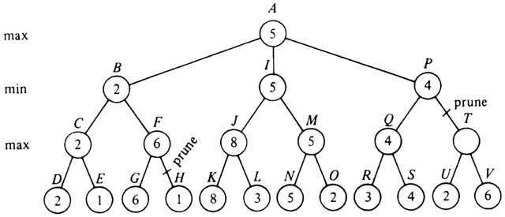
3. We can define the probability of a sequence of characters P(c1:N) under the trigram model by first factoring with chain rule, and then using the Markov assumption. What will be the probability of the the sequence “abc” if P(“a”) = 0.1, P(“b”) = 0.2, P(“c”) = 0.3, P(“b”| “a”) = 0.4, and P(“c” | “ab”) = 0.5?
4. Suppose there are 3 characters in a language L, and we have built a unigram model. The probabilities for the 3 characters are given by the models are P(“A”) = 0.25, P(“B”) = 0.50, and P(“C”) = 0.25. What will be the expression to calculate the perplexity of for the sequences “AAA” and “ABA”?
5. Write out the linear equations for calculating the page ranks of the pages A, B, and C in the following link network. Assume d = 0.7. You don’t need to solve the system of linear equations - just list out the linear equations.

