N741: Exploratory Data Analysis

Melinda K. Higgins, PhD.

January 30, 2017

## HELPUL Links for Graphics and EDA

Here are some helpful links for doing EDA in R and Associated Graphics:

* <http://www.cookbook-r.com/Graphs/>
* [Quick-R Website](http://www.statmethods.net/)
* [EDA Chapter in "R for Data Science"](http://r4ds.had.co.nz/exploratory-data-analysis.html)
* [Code Examples from Practical Data Science with R - see Chapter 3](https://github.com/WinVector/zmPDSwR/tree/master/CodeExamples)

## Worked Example from the UCI Data Repository

The following dataset comes from the [UCI Data Repository](http://archive.ics.uci.edu/ml/). The dataset we'll use is the Contraceptive Method Choice dataset. The information on this dataset is provided at <http://archive.ics.uci.edu/ml/datasets/Contraceptive+Method+Choice>. If you click on the "Data Folder" you can download the RAW data cmc.data which is a comma delimited format dataset (i.e. it is a CSV formatted file) and the description of the data included, the variable names and associated codes for the values included which is in the cmc.names file. See "Data Folder"" at <http://archive.ics.uci.edu/ml/machine-learning-databases/cmc/>

### Read-in data

**NOTE:** Download the 2 files from the UCI Data Repository for the Contraceptive Method Choice and put them in the directory where you have this RMD rmarkdown file.

# read in the comma delimited (CSV) formatted dataset  
# **NOTE**: This dataset does NOT have the column  
# names as the 1st row of the file. We will assign the   
# column names below.  
cmc <- read_csv("cmc.data", col_names=FALSE)

## Parsed with column specification:  
## cols(  
## X1 = col_integer(),  
## X2 = col_integer(),  
## X3 = col_integer(),  
## X4 = col_integer(),  
## X5 = col_integer(),  
## X6 = col_integer(),  
## X7 = col_integer(),  
## X8 = col_integer(),  
## X9 = col_integer(),  
## X10 = col_integer()  
## )

### Apply the codebook - variable names and coding used

Apply variable names to the 10 columns of data in cmc.

# assign new variables names to the 10 columns  
names(cmc) <- c("WifeAge", "WifeEd", "HusbEd", "NumChild",  
 "WifeRel", "WifeWork", "HusbOcc", "SOLindex",   
 "Media", "Contraceptive")

The next code chunk is to add the labels for "factor" levels for some of the variables (i.e. we are creating factors).

**WARNING**: Notice I'm overwriting the variables and changing them from integers to factors which have different properties as you'll see below. If you want to keep the original integer variables, you could simply give the new facotr variable a new name. For example you could write

cmc$WifeEd.f <- factor(cmc$WifeEd,  
 levels = c(1,2,3,4),  
 labels = c("low","med low","med

and this would append a new column onto the cmc dataset that is the "factor" type version of Wife's Education. For now, use the code below to update all of the variables.

# update Wife Education as a factor, assign the   
# levels and the labels for each level  
cmc$WifeEd <- factor(cmc$WifeEd,  
 levels = c(1,2,3,4),  
 labels = c("low","med low","med high","high"))  
  
# do the remaining variables  
cmc$HusbEd <- factor(cmc$HusbEd,  
 levels = c(1,2,3,4),  
 labels = c("low","med low","med high","high"))  
  
cmc$WifeRel <- factor(cmc$WifeRel,  
 levels = c(0,1),  
 labels = c("Non-Islam","Islam"))  
  
# Note: The documentation does state that  
# 0=yes and 1=no which seems incorrect...  
cmc$WifeWork <- factor(cmc$WifeWork,  
 levels = c(0,1),  
 labels = c("Yes","No"))  
  
cmc$HusbOcc <- factor(cmc$HusbOcc,  
 levels = c(1,2,3,4),  
 labels = c("1","2","3","4"))  
  
cmc$SOLindex <- factor(cmc$SOLindex,  
 levels = c(1,2,3,4),  
 labels = c("low","med low","med high","high"))  
  
cmc$Media <- factor(cmc$Media,  
 levels = c(0,1),  
 labels = c("Good","Not Good"))  
  
cmc$Contraceptive <- factor(cmc$Contraceptive,  
 levels = c(1,2,3),  
 labels = c("No-use","Long-term","Short-term"))

### Look at a subset of the data

head(cmc)

## # A tibble: 6 × 10  
## WifeAge WifeEd HusbEd NumChild WifeRel WifeWork HusbOcc SOLindex  
## <int> <fctr> <fctr> <int> <fctr> <fctr> <fctr> <fctr>  
## 1 24 med low med high 3 Islam No 2 med high  
## 2 45 low med high 10 Islam No 3 high  
## 3 43 med low med high 7 Islam No 3 high  
## 4 42 med high med low 9 Islam No 3 med high  
## 5 36 med high med high 8 Islam No 3 med low  
## 6 19 high high 0 Islam No 3 med high  
## # ... with 2 more variables: Media <fctr>, Contraceptive <fctr>

### Print this subset using knitr::kable()

knitr::kable(head(cmc))

|  |  |  |  |  |  |  |  |  |  |
| --- | --- | --- | --- | --- | --- | --- | --- | --- | --- |
| WifeAge | WifeEd | HusbEd | NumChild | WifeRel | WifeWork | HusbOcc | SOLindex | Media | Contraceptive |
| 24 | med low | med high | 3 | Islam | No | 2 | med high | Good | No-use |
| 45 | low | med high | 10 | Islam | No | 3 | high | Good | No-use |
| 43 | med low | med high | 7 | Islam | No | 3 | high | Good | No-use |
| 42 | med high | med low | 9 | Islam | No | 3 | med high | Good | No-use |
| 36 | med high | med high | 8 | Islam | No | 3 | med low | Good | No-use |
| 19 | high | high | 0 | Islam | No | 3 | med high | Good | No-use |

### Summarize the dataset

**NOTICE** that Wife's Age and Number of Children are now the only "numeric" "integer" variables - these are the only ones for which we get summary statistics. All the remaining variables are "factors" so we only get the frequencies for each category.

summary(cmc)

## WifeAge WifeEd HusbEd NumChild   
## Min. :16.00 low :152 low : 44 Min. : 0.000   
## 1st Qu.:26.00 med low :334 med low :178 1st Qu.: 1.000   
## Median :32.00 med high:410 med high:352 Median : 3.000   
## Mean :32.54 high :577 high :899 Mean : 3.261   
## 3rd Qu.:39.00 3rd Qu.: 4.000   
## Max. :49.00 Max. :16.000   
## WifeRel WifeWork HusbOcc SOLindex Media   
## Non-Islam: 220 Yes: 369 1:436 low :129 Good :1364   
## Islam :1253 No :1104 2:425 med low :229 Not Good: 109   
## 3:585 med high:431   
## 4: 27 high :684   
##   
##   
## Contraceptive  
## No-use :629   
## Long-term :333   
## Short-term:511   
##   
##   
##

### Computing stats on factors

Suppose you wanted to know the mean education level of the Huband's in this dataset. We can use the as.numeric() function to convert the variable and then run a mean() on it. We'll do more on facotrs later this semester.

mean(as.numeric(cmc$HusbEd))

## [1] 3.429735

### Cleaning up your tables & Improving Workflow with PIPES (%>%)

# these lines of code use the %>% "pipe" command.  
# It also uses the group_by() function  
# also in the dplyr package. The lines below can be read as  
# "take the XXX (cmc) dataset, THEN summarise the  
# sample size and sample mean.  
  
# initial steps  
cmc %>%  
 summarise(nChild = length(NumChild),  
 meanChild = mean(NumChild))

## # A tibble: 1 × 2  
## nChild meanChild  
## <int> <dbl>  
## 1 1473 3.261371

# look at output - figure out number of columns, add knitr::kable()  
# put in good column names (2 columns) and a TITLE using caption  
cmc %>%  
 summarise(nChild = length(NumChild),  
 meanChild = mean(NumChild)) %>%  
 knitr::kable(col.names=c("N","mean"),  
 caption="Number of Children: Descriptive Stats")

Number of Children: Descriptive Stats

|  |  |
| --- | --- |
| N | mean |
| 1473 | 3.261371 |

# let's add more descriptive stats to our table  
# this means we now have more columns - one per stat  
cmc %>%  
 summarise(nChild = length(NumChild),  
 minChild = min(NumChild),  
 meanChild = mean(NumChild),  
 sdChild = sd(NumChild),  
 medianChild = median(NumChild),  
 maxChild = max(NumChild)) %>%  
 knitr::kable(col.names=c("N","min",  
 "mean","sd","median","max"),  
 caption="Number of Children: Descriptive Stats")

Number of Children: Descriptive Stats

|  |  |  |  |  |  |
| --- | --- | --- | --- | --- | --- |
| N | min | mean | sd | median | max |
| 1473 | 0 | 3.261371 | 2.358549 | 3 | 16 |

# let's do again but BY Wife's Religion (2 groups)  
# group the data BY  
# each continent THEN summarise each continent's mean and sd."  
# I THEN sent the output to the kable function to output  
# there is one more column now for Wife's Religion.  
cmc %>%  
 group_by(WifeRel) %>%  
 summarise(nChild = length(NumChild),  
 minChild = min(NumChild),  
 meanChild = mean(NumChild),  
 sdChild = sd(NumChild),  
 medianChild = median(NumChild),  
 maxChild = max(NumChild)) %>%  
 knitr::kable(col.names=c("Wife Religion","N","min",  
 "mean","sd","median","max"),  
 digits = 2,  
 caption="Number of Children: Stats by Wife Religion")

Number of Children: Stats by Wife Religion

|  |  |  |  |  |  |  |
| --- | --- | --- | --- | --- | --- | --- |
| Wife Religion | N | min | mean | sd | median | max |
| Non-Islam | 220 | 0 | 2.85 | 1.80 | 3 | 11 |
| Islam | 1253 | 0 | 3.33 | 2.44 | 3 | 16 |

### Using and Getting R Code from Rcmdr package (with GUI interface)

OUTSIDE of the RMD file - run library(Rcmdr). We'll load the cmc dataset into the local environment. Then use the GUI in Rcmdr to generate the R code for what you might want.

For example, getting the counts and relative %s for Wife Working categories.

local({  
 .Table <- with(cmc, table(WifeWork))  
 cat("\ncounts:\n")  
 print(.Table)  
 cat("\npercentages:\n")  
 print(round(100*.Table/sum(.Table), 2))  
})

##   
## counts:  
## WifeWork  
## Yes No   
## 369 1104   
##   
## percentages:  
## WifeWork  
## Yes No   
## 25.05 74.95

Table <- with(cmc, table(WifeWork))  
knitr::kable(as.data.frame(Table))

|  |  |
| --- | --- |
| WifeWork | Freq |
| Yes | 369 |
| No | 1104 |

# two-way table % chi-square test

Open Rcmdr and run a two-way table with a Chi-square test of independence between Husband Occupation and Contraceptive use. And run the Rmarkdown - Generate Report from within Rcmdr to see how that report is set-up.

# r packages Rcmdr Rmarkdown uses - you'll need these too  
library(Rcmdr)

## Loading required package: splines

## Loading required package: RcmdrMisc

## Loading required package: car

##   
## Attaching package: 'car'

## The following object is masked from 'package:dplyr':  
##   
## recode

## The following object is masked from 'package:purrr':  
##   
## some

## Loading required package: sandwich

## The Commander GUI is launched only in interactive sessions

library(car)  
library(RcmdrMisc)  
library(rgl)

### capture R code chunks for the two-way table and chi-square stats

library(abind, pos=23)

# the following is the code generated by Rcmdr  
local({  
 .Table <- xtabs(~HusbOcc+Contraceptive, data=cmc)  
 cat("\nFrequency table:\n")  
 print(.Table)  
 cat("\nRow percentages:\n")  
 print(rowPercents(.Table))  
 .Test <- chisq.test(.Table, correct=FALSE)  
 print(.Test)  
})

##   
## Frequency table:  
## Contraceptive  
## HusbOcc No-use Long-term Short-term  
## 1 158 156 122  
## 2 200 79 146  
## 3 258 93 234  
## 4 13 5 9  
##   
## Row percentages:  
## Contraceptive  
## HusbOcc No-use Long-term Short-term Total Count  
## 1 36.2 35.8 28.0 100.0 436  
## 2 47.1 18.6 34.4 100.1 425  
## 3 44.1 15.9 40.0 100.0 585  
## 4 48.1 18.5 33.3 99.9 27  
##   
## Pearson's Chi-squared test  
##   
## data: .Table  
## X-squared = 65.401, df = 6, p-value = 3.573e-12

Let's pull out the code pieces we need and use knitr to make a better table.

# create a Table object for the results from xtabs()  
Table <- xtabs(~HusbOcc+Contraceptive, data=cmc)  
  
# use the rowPercents (from the RcmdrMisc package)  
# to pull these out of the Table  
# make it a data.frame and make a nice table with knitr  
knitr::kable(as.data.frame(rowPercents(Table)),  
 caption = "Contraceptive Use by Husband Occupation")

Contraceptive Use by Husband Occupation

|  |  |  |  |  |
| --- | --- | --- | --- | --- |
| No-use | Long-term | Short-term | Total | Count |
| 36.2 | 35.8 | 28.0 | 100.0 | 436 |
| 47.1 | 18.6 | 34.4 | 100.1 | 425 |
| 44.1 | 15.9 | 40.0 | 100.0 | 585 |
| 48.1 | 18.5 | 33.3 | 99.9 | 27 |

### Chi-square test results

# and run the chi-square test and show the results  
chisq.test(Table, correct=FALSE)

##   
## Pearson's Chi-squared test  
##   
## data: Table  
## X-squared = 65.401, df = 6, p-value = 3.573e-12

### Make Plots with Rcmdr

Clustered Bar plot - side-by-side - Contraceptive Use by Husband Occupation

with(cmc, Barplot(Contraceptive, by=HusbOcc, style="parallel",   
 legend.pos="topright", xlab="Contraceptive", ylab="Frequency"))

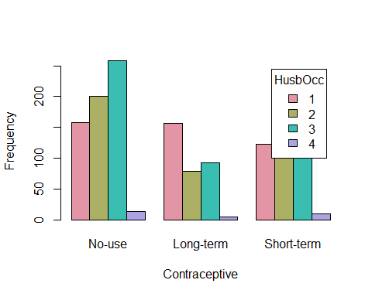

### Make a Clustered Bar plot with ggplot2

using the "dodge" option

ggplot(cmc, aes(x=Contraceptive, fill=HusbOcc)) +   
 geom_bar(position='dodge')

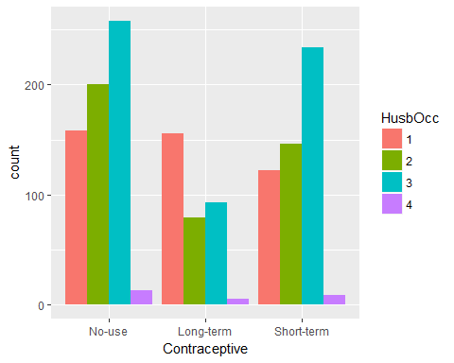

using the "stack" option

ggplot(cmc, aes(x=Contraceptive, fill=HusbOcc)) +   
 geom_bar(position='stack')

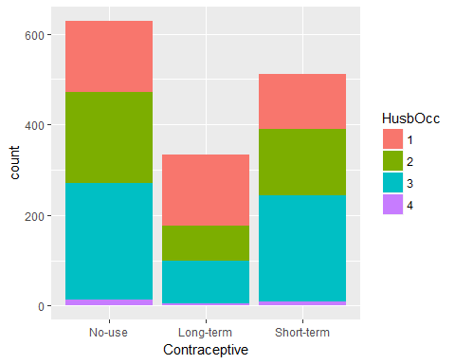

using the "fill" option

ggplot(cmc, aes(x=Contraceptive, fill=HusbOcc)) +   
 geom_bar(position='fill')

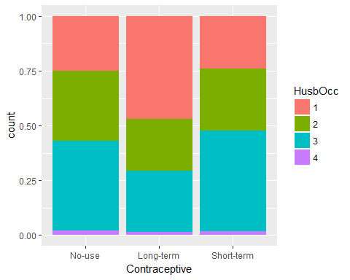

### Scatterplot of Wife's Age and Number of Children

Remember there are 1473 subjects in this dataset.

cmc %>%  
 ggplot(aes(x=WifeAge, y=NumChild)) +  
 geom_point()

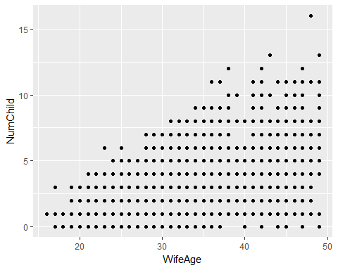

This obviously has a lot of overplotting (points on top of one another). One way to alleviate this issue is to add "jitter" or a little bit of randomness so the points won't lie on top of one another.

cmc %>%  
 ggplot(aes(x=WifeAge, y=NumChild)) +  
 geom_point(position = "jitter")

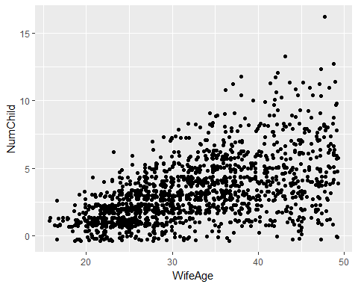

Still another way to "bin" the data in 2 dimensions with a lot of points in a scatterplot is to use the geom_hex() function which basically does a density plot using 2-D bins like a 2-D histogram in a way.

cmc %>%  
 ggplot(aes(x=WifeAge, y=NumChild)) +  
 geom_hex()

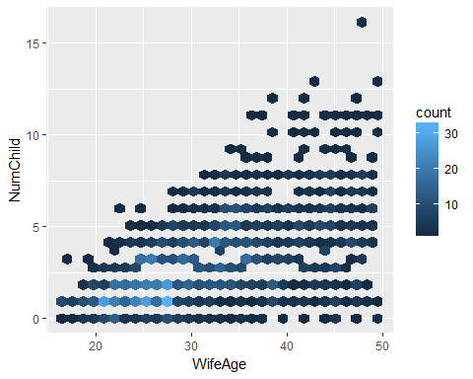

### Boxplot options

# make a boxplot showing the range of Wife Ages by  
# Number of Children - "bin" widths = 1 child  
# we'll use cut_width  
cmc %>%  
 ggplot(aes(x=NumChild, y=WifeAge)) +  
 geom_boxplot(aes(group=cut_width(NumChild, 1)))

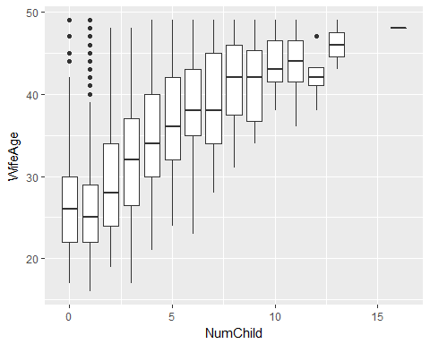

# we could also use a binning option based  
# on n groups of equal Number of Children range  
# let's try 8 intervals using cut_interval  
cmc %>%  
 ggplot(aes(x=NumChild, y=WifeAge)) +  
 geom_boxplot(aes(group=cut_interval(NumChild, 8)))

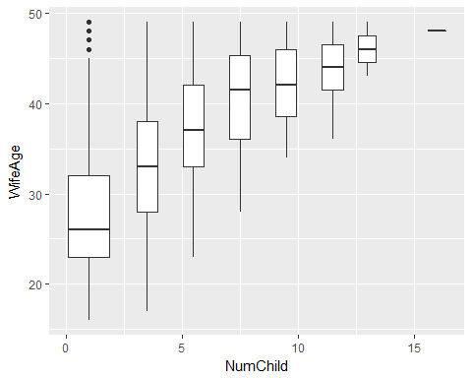

# this time use cut_number and 6 bins  
# so that each bin has about the same # of cases  
cmc %>%  
 ggplot(aes(x=NumChild, y=WifeAge)) +  
 geom_boxplot(aes(group=cut_number(NumChild, 6)))

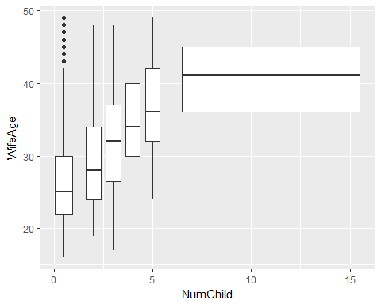

### Histograms and Density estimates of Continuous Data

Let's look at Wife's Age and Number of Children - do you expect these to look normal?

see more at <http://www.cookbook-r.com/Graphs/Plotting_distributions_(ggplot2)/>

cmc %>%  
 ggplot(aes(WifeAge)) +  
 geom_histogram(aes(y=..density..),  
 colour="black",fill="white",  
 binwidth=5) +  
 geom_density()

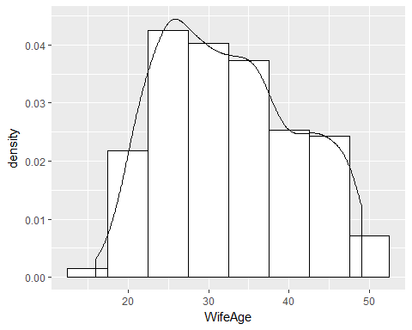

cmc %>%  
 ggplot(aes(WifeAge)) +  
 geom_histogram(aes(y=..density..),  
 colour="black",fill="yellow",  
 binwidth=5) +  
 geom_density(alpha=.2, fill="blue")

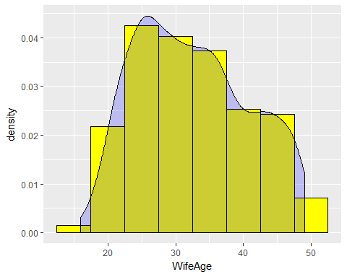

What about overlaying a Normal Curve? Also add some better axis labels and a title

cmc %>%  
 ggplot(aes(WifeAge)) +  
 geom_histogram(aes(y=..density..),  
 colour="black",fill="yellow",  
 binwidth=5) +   
 stat_function(fun = dnorm,   
 args = list(mean = mean(cmc$WifeAge),   
 sd = sd(cmc$WifeAge)),   
 lwd = 1,   
 col = 'red') +  
 labs(title = "Distribution of Wife's Age",  
 x = "Wife's Age",  
 y = "Density")

