Replace with Main Title

Your Name

2017-01-31 14:41:46

> summary(cmc)

WifeAge WifeEd HusbEd NumChild   
 Min. :16.00 low :152 low : 44 Min. : 0.000   
 1st Qu.:26.00 med low :334 med low :178 1st Qu.: 1.000   
 Median :32.00 med high:410 med high:352 Median : 3.000   
 Mean :32.54 high :577 high :899 Mean : 3.261   
 3rd Qu.:39.00 3rd Qu.: 4.000   
 Max. :49.00 Max. :16.000   
 WifeRel WifeWork HusbOcc SOLindex Media   
 Non-Islam: 220 Yes: 369 1:436 low :129 Good :1364   
 Islam :1253 No :1104 2:425 med low :229 Not Good: 109   
 3:585 med high:431   
 4: 27 high :684   
   
   
 Contraceptive  
 No-use :629   
 Long-term :333   
 Short-term:511

> library(abind, pos=22)

> library(e1071, pos=23)

> numSummary(cmc[,c("NumChild", "WifeAge")], statistics=c("mean", "sd", "IQR",  
+ "quantiles"), quantiles=c(0,.25,.5,.75,1))

mean sd IQR 0% 25% 50% 75% 100% n  
NumChild 3.261371 2.358549 3 0 1 3 4 16 1473  
WifeAge 32.538357 8.227245 13 16 26 32 39 49 1473

> numSummary(cmc[,"NumChild"], groups=cmc$Contraceptive, statistics=c("mean",   
+ "sd", "IQR", "quantiles"), quantiles=c(0,.25,.5,.75,1))

mean sd IQR 0% 25% 50% 75% 100% NumChild:n  
No-use 2.934817 2.655462 3 0 1 2 4 12 629  
Long-term 3.738739 2.104406 3 1 2 3 5 13 333  
Short-term 3.352250 2.049675 2 0 2 3 4 16 511

> local({  
+ .Table <- with(cmc, table(Contraceptive))  
+ cat("\ncounts:\n")  
+ print(.Table)  
+ cat("\npercentages:\n")  
+ print(round(100\*.Table/sum(.Table), 2))  
+ })

counts:  
Contraceptive  
 No-use Long-term Short-term   
 629 333 511   
  
percentages:  
Contraceptive  
 No-use Long-term Short-term   
 42.70 22.61 34.69

> local({  
+ .Table <- with(cmc, table(HusbOcc))  
+ cat("\ncounts:\n")  
+ print(.Table)  
+ cat("\npercentages:\n")  
+ print(round(100\*.Table/sum(.Table), 2))  
+ })

counts:  
HusbOcc  
 1 2 3 4   
436 425 585 27   
  
percentages:  
HusbOcc  
 1 2 3 4   
29.60 28.85 39.71 1.83

> with(cmc, tapply(NumChild, list(Contraceptive), median, na.rm=TRUE))

No-use Long-term Short-term   
 2 3 3

> library(nortest, pos=24)

> with(cmc, shapiro.test(NumChild))

Shapiro-Wilk normality test  
  
data: NumChild  
W = 0.91266, p-value < 2.2e-16

> local({  
+ .Table <- xtabs(~Contraceptive+HusbOcc, data=cmc)  
+ cat("\nFrequency table:\n")  
+ print(.Table)  
+ cat("\nColumn percentages:\n")  
+ print(colPercents(.Table))  
+ .Test <- chisq.test(.Table, correct=FALSE)  
+ print(.Test)  
+ })

Frequency table:  
 HusbOcc  
Contraceptive 1 2 3 4  
 No-use 158 200 258 13  
 Long-term 156 79 93 5  
 Short-term 122 146 234 9  
  
Column percentages:  
 HusbOcc  
Contraceptive 1 2 3 4  
 No-use 36.2 47.1 44.1 48.1  
 Long-term 35.8 18.6 15.9 18.5  
 Short-term 28.0 34.4 40.0 33.3  
 Total 100.0 100.1 100.0 99.9  
 Count 436.0 425.0 585.0 27.0  
  
 Pearson's Chi-squared test  
  
data: .Table  
X-squared = 65.401, df = 6, p-value = 3.573e-12

> t.test(NumChild~WifeRel, alternative='two.sided', conf.level=.95,   
+ var.equal=FALSE, data=cmc)

Welch Two Sample t-test  
  
data: NumChild by WifeRel  
t = -3.5059, df = 376.02, p-value = 0.00051  
alternative hypothesis: true difference in means is not equal to 0  
95 percent confidence interval:  
 -0.7631665 -0.2147193  
sample estimates:  
mean in group Non-Islam mean in group Islam   
 2.845455 3.334397

> library(mvtnorm, pos=25)

> library(survival, pos=25)

> library(MASS, pos=25)

> library(TH.data, pos=25)

> library(multcomp, pos=25)

> AnovaModel.1 <- aov(NumChild ~ WifeEd, data=cmc)  
> summary(AnovaModel.1)

Df Sum Sq Mean Sq F value Pr(>F)   
WifeEd 3 332 110.54 20.67 4.06e-13 \*\*\*  
Residuals 1469 7857 5.35   
---  
Signif. codes: 0 '\*\*\*' 0.001 '\*\*' 0.01 '\*' 0.05 '.' 0.1 ' ' 1

> with(cmc, numSummary(NumChild, groups=WifeEd, statistics=c("mean", "sd")))

mean sd data:n  
low 4.421053 2.946603 152  
med low 3.508982 2.484470 334  
med high 3.234146 2.340001 410  
high 2.831889 1.976728 577

> scatterplot(NumChild~WifeAge, reg.line=FALSE, smooth=TRUE, spread=FALSE,   
+ boxplots=FALSE, span=0.5, ellipse=FALSE, levels=c(.5, .9), data=cmc)

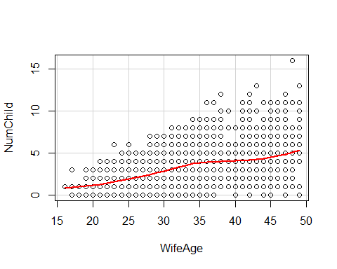

> Boxplot(NumChild~WifeEd, data=cmc, id.method="y")

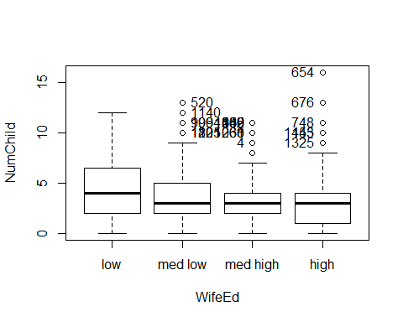

[1] "180" "520" "999" "1064" "1121" "1140" "1205" "250" "486" "562"   
[11] "1002" "1139" "1345" "61" "268" "1030" "4" "445" "654" "676"   
[21] "748" "1153" "1325"