RESEARCH FRAMEWORK
Knowledge Is Not Enough
Epistemic Access Architecture for Reducing Hallucination in Large Language Models
A PhD-level research blueprint inspired by split-brain cognition, knowledge accessibility, evidence integration, and neural arbitration

Core thesis in one sentence
Current LLMs conflate epistemic processing and language generation; separating evidence processing from generation and controlling communication between them may reduce hallucination by preventing unsupported claims from reaching narrative completion.

Status: research hypothesis / architecture proposal — not yet empirically validated.

1. Executive Summary
Dokumen ini mengubah intuisi awal tentang split-brain dan halusinasi LLM menjadi program penelitian yang dapat diuji. Fokus utamanya bukan mengklaim bahwa LLM literally memiliki dua otak, melainkan menguji prinsip computational yang lebih defensible: specialized epistemic processing, selective information access, communication constraints, arbitration, dan generation.
Literatur sampai Oktober 2026 menunjukkan bahwa beberapa bagian dari ide ini sudah memiliki preseden. Penelitian split-brain mendokumentasikan confabulation ketika satu hemisphere harus menjelaskan tindakan yang diprakarsai oleh sistem lain tanpa akses terhadap informasi penyebabnya. Pada LLM, penelitian modern menunjukkan bahwa pengetahuan dapat tersimpan tetapi tidak selalu berhasil dipanggil; informasi yang tersedia di context juga tidak selalu digunakan secara robust; dan confidence/knowledge boundary dapat diperkirakan sebelum generation. RAG, RETRO, Self-RAG, CoVe, FLARE, LLM2, dan HaluSearch sudah mengeksplorasi berbagai bentuk retrieval, verification, atau dual-process generation.
Research gap yang hendak dikejar
Belum cukup untuk sekadar menunjukkan bahwa “reader + generator” bekerja lebih baik. Kontribusi yang lebih kuat adalah menguji secara kausal apakah hallucination meningkat ketika akses ke knowledge/evidence sengaja dibatasi, lalu turun ketika akses dipulihkan, dengan knowledge dan query dikontrol. Arsitektur kemudian dirancang untuk menjadikan access state dan evidence integration sebagai fungsi eksplisit dalam satu cognitive system.

2. Titik Awal Ide: Dari Split-Brain ke LLM

2.1 Fenomena manusia yang menjadi inspirasi
Eksperimen split-brain yang terkait dengan Gazzaniga dan Sperry menunjukkan bahwa setelah komunikasi antarkedua hemisphere dibatasi, informasi dapat tersedia pada satu hemisphere namun tidak dapat diakses hemisphere yang bertugas memberikan laporan verbal. Dalam contoh klasik, stimulus snow scene diproses di right hemisphere dan chicken claw di left hemisphere; tangan kiri dapat memilih snow shovel, sementara sistem verbal dapat membuat penjelasan yang masuk akal tanpa akses terhadap alasan sebenarnya. Fenomena ini dikaitkan dengan gagasan “interpreter” — kecenderungan menghasilkan narasi koheren dari informasi yang tersedia secara parsial.
Catatan ilmiah: split-brain modern tidak boleh diperlakukan sebagai bukti sederhana bahwa manusia mempunyai “dua kesadaran” yang independen. Review modern menyimpulkan adanya breakdown integrasi yang luas tetapi tidak absolut, dan sejumlah kemampuan tetap dapat terkoordinasi. Karena itu, tesis ini meniru prinsip fungsional — specialization + communication + integration — bukan anatomi literal left-brain/right-brain.
Jalur visual juga penting: eksperimen klasik menggunakan lateralized visual fields, bukan sekadar “mata kiri melihat / mata kanan ditutup”. Left visual field terutama diproyeksikan ke right hemisphere, sedangkan right visual field terutama ke left hemisphere.

3. Reframing Teori menjadi Hipotesis Ilmiah

3.1 Hipotesis awal yang terlalu lemah
Jangan jadikan ini tesis utama
“LLM hallucinate because it cannot see all of the training data.” Pernyataan ini tidak cukup tepat karena pretraining mengubah corpus menjadi parameterized representations; training data tidak berfungsi seperti database dokumen yang otomatis dibaca kembali setiap kali inference.

3.2 Hipotesis yang lebih kuat
Knowledge Accessibility Hypothesis
Hallucination is partly driven by a mismatch between knowledge that is encoded or available to the system and evidence that is actually accessible, retrievable, and integrable by the generative process at the moment a claim is produced.

Epistemic Integration Hypothesis
A unified architecture that functionally separates evidence processing from linguistic generation, while maintaining a controlled communication channel and arbitration mechanism, can reduce unsupported claims without requiring the generator to ingest the entire knowledge corpus at generation time.

4. Operational Definitions
Agar penelitian tidak kabur secara definisi, gunakan state knowledge berikut. Ini harus menjadi dasar dataset dan experimental labels.
State | Definition | Observable proxy | Expected risk
Unknown / Not Learned | Fakta tidak pernah tersedia pada training corpus/knowledge source yang dikontrol. | Corpus membership / source audit | High if forced to answer
Known but inaccessible | Evidence/association exists but is not successfully recalled/retrieved/integrated. | Recall probe, knowledge-neuron or hidden-state probe, retrieval intervention | High under generation pressure
Known and accessible | Relevant evidence dapat ditemukan dan masuk ke epistemic state. | Evidence recall + attribution success | Lower
Known but conflicted | Evidence accessible tetapi terdapat sumber/fakta yang bertentangan. | Conflict detection accuracy | High unless arbitration works
Working terminology: “epistemic access” berarti kemampuan sistem untuk memperoleh representasi evidence yang relevan dan menggunakannya sebagai constraint pada generation. Ini lebih luas daripada retrieval recall: evidence harus benar-benar memengaruhi keputusan generator.

5. Literature Landscape dan Posisi Penelitian
Tabel di bawah bukan daftar seluruh literatur hallucination, tetapi peta minimum yang perlu dikuasai sebelum mengunci proposal PhD. Status “close” berarti ide atau mekanismenya beririsan kuat; novelty tidak boleh diklaim hanya dari kolom tersebut.
Work | Core idea | Relation to thesis | What remains | Priority
Gazzaniga / Sperry split-brain | Restricted interhemispheric access; interpreter/confabulation | Biological inspiration for information-access failure | Computational causal mapping to LLMs | Essential
Lewis et al. 2020 RAG | External evidence can augment parametric memory | Supports explicit knowledge access | Does not establish split-brain-like causal mechanism | Essential
RETRO 2022 | Retriever + encoder + cross-attention with huge corpus memory | Shows explicit memory can be integrated into LM | No explicit epistemic arbitration | Essential
Liu et al. 2024 Lost in the Middle | Relevant context can be present yet poorly used | Direct evidence for access ≠ presence | Need causal manipulation tied to hallucination | Essential
Self-RAG 2023 | Adaptive retrieve/generate/critique in one LM | Close to integrated epistemic control | Retrieval/critique not the same as epistemic state with causal access test | Essential
CoVe 2023 | Generate then independently verify | Supports separation of generation and checking | Primarily verification workflow | Baseline
FLARE 2023 | Active retrieval during generation | Shows retrieval can be triggered during generation | Not an explicit reader/workspace architecture | Baseline
Knowledge Neurons 2024 | Factual recall can fail despite internal knowledge signals; manipulation changes performance | Strong support for “known but inaccessible” idea | Need architecture + causal access bottleneck experiment | Critical
Ni et al. 2025 | Internal states predict knowledge boundary before generation | Supports pre-generation epistemic signal | Need explicit reader/arbitrator architecture | Critical
LLM2 2025 | System 1 generator + System 2 verifier | Close architectural precedent | Focuses on reasoning quality, not evidence-access causality | Critical
HaluSearch 2025 | Fast/slow generation with tree search and self-evaluation | Close dual-process precedent | Not a dedicated evidence reader + memory + channel | Baseline
Knowledge Boundary Survey 2025 | Formal taxonomy of LLM knowledge boundaries | Provides vocabulary and benchmark framing | Does not solve architectural integration | Critical
Kusuma et al. 2026 | Uses known pretraining corpus with Pythia to evaluate honesty | Excellent experimental platform for known/unknown control | Potential foundation for access intervention | Critical
NAF 2026 | Conceptual generative vs epistemic modes + interruptive arbitration; split-brain analogy | Very close conceptual prior | Need independent empirical causal validation and concrete architecture | Threat to novelty
Liu et al. 2026 world-model position | Hallucination as inaccurate internal world modeling | Supports world-state framing | Need access/integration mechanism and intervention | Critical

6. Novelty Map: Apa yang Tidak Boleh Diklaim dan Apa yang Bisa Dikejar
Do not claim novelty here
(1) Split-brain analogy itself; (2) “generator + verifier”; (3) RAG reduces hallucination; (4) LLM can estimate uncertainty; (5) dual-process reasoning in general. Semua sudah memiliki prior art yang jelas.

6.1 Candidate original contribution
- Operationalize an “epistemic access bottleneck” variable and distinguish knowledge absence from knowledge inaccessibility under a controlled training-corpus setting.
- Perform causal interventions on the communication/access channel while holding the underlying knowledge state constant.
- Build a unified architecture in which a dedicated reader/evidence processor creates an explicit epistemic state, a shared workspace exposes structured evidence to the generator, and an arbitrator controls whether generation may proceed, must retrieve more, or must abstain.
- Demonstrate that access restoration reduces hallucination after an experimentally induced access failure — stronger than a simple before/after architecture comparison.
- Characterize failure modes: inaccessible evidence, evidence conflict, retrieval miss, grounding failure, narrative closure, and false refusal.

6.2 Suggested novelty statement
Potential thesis novelty statement
This thesis introduces and empirically tests epistemic access bottlenecks as a causal mechanism of hallucination, and develops a unified evidence–arbitration–generation architecture that makes epistemic access an explicit computational variable rather than an implicit side effect of autoregressive attention.

7. Proposed Architecture: Epistemic Access Architecture (EAA)
Nama kerja: Epistemic Access Architecture (EAA). Nama dapat berubah setelah literature review final. Yang penting adalah functional separation: Reader/Knowledge System, Epistemic Memory, Shared Cognitive Workspace, Arbitration, Generator, dan Feedback.
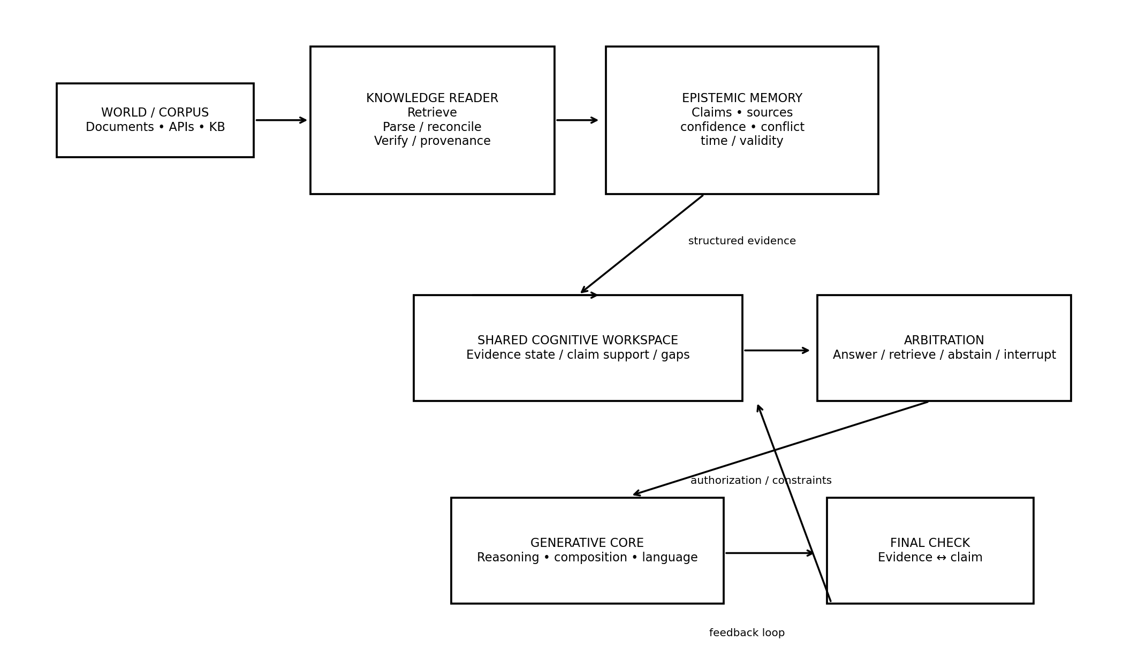
Figure 1. Proposed EAA: one coherent system with specialized subsystems and controlled information flow.

7.1 Functional modules
Module | Primary responsibility
Knowledge Reader | Searches/retrieves source material, parses evidence, reconciles duplicates, tracks provenance and temporal validity.
Epistemic Memory | Stores structured claims, evidence spans, source IDs, confidence, contradictions, and freshness.
Shared Cognitive Workspace | A bounded interface through which the generator receives evidence state rather than arbitrary raw corpus access.
Arbitration Layer | Determines answer / retrieve-more / verify / abstain / interrupt. It can block unsupported narrative closure.
Generative Core | Optimized for reasoning, language composition, and communication. It is not the sole authority on truth.
Final Claim Check | Maps output claims to evidence and can trigger a corrective loop before delivery.

8. Formal Research Model
Gunakan model matematis sederhana terlebih dahulu. Jangan mengklaim theorem sebelum bukti empiris tersedia.
K = total learned knowledge state; x = query; E = evidence accessible to generation; A(K,x) = accessibility function; C = evidence conflict; U = uncertainty; G = generative process.
P(H | x) = f(1 - A(K,x), C, U, generation pressure).
Core causal path: K → Access / Reader → Evidence State → Arbitration → Generation → Output.
Primary intervention: do(Access = blocked) while holding K, x, and model family fixed.
Recovery intervention: do(Access = restored).

8.1 Proposed “epistemic access” score
A practical composite score dapat didefinisikan untuk eksperimen awal:
EA = w₁·retrieval_recall + w₂·evidence_grounding + w₃·claim_attribution + w₄·conflict_resolution + w₅·temporal_validity
Bobot dapat ditentukan melalui validation set atau dipelajari; jangan menjadikan formula ini sebagai kontribusi teoretis utama sebelum divalidasi. Yang lebih penting adalah membandingkan hallucination sebagai fungsi EA dan menguji intervensi akses secara kausal.

9. Research Questions and Hypotheses
RQ | Research question | Hypothesis
RQ1 | Can knowledge presence be experimentally separated from knowledge accessibility in LLMs? | H1: yes; some facts that are objectively in the controlled knowledge/training source will have lower recall or grounding under selected generation conditions.
RQ2 | Does restricting evidence access causally increase hallucination? | H2: access restriction increases unsupported claims, false confidence, and/or narrative closure relative to full-access controls.
RQ3 | Does restoring access recover factuality? | H3: restoration produces a statistically significant recovery in evidence-supported generation.
RQ4 | Does an explicit reader–workspace–arbitration architecture outperform standard RAG and post-hoc verification at matched budget? | H4: EAA improves hallucination rate and calibration without unacceptable loss of answerability.
RQ5 | What are the failure modes under conflicting or temporally stale evidence? | H5: explicit conflict/validity states improve abstention or source selection when evidence conflicts.
RQ6 | Can the effect generalize across models, languages, and task types? | H6: the access effect persists beyond one model/dataset, with effect sizes varying by task and context length.

10. Research Flow: dari Temuan sampai Arsitektur
Phase | Work | Expected contribution
Phase 0 — Literature & benchmark | Systematic review; define hallucination taxonomy; select controlled open model/corpus; build known/unknown/conflict benchmark. | Deliverable: protocol + dataset + preregistered hypotheses.
Phase 1 — Phenomenon | Measure knowledge presence, recall, grounding, and generation under controlled conditions. | Deliverable: evidence that presence ≠ accessibility.
Phase 2 — Causal intervention | Block, compress, mask, reorder, or route evidence; then restore it. Keep knowledge/query/model fixed. | Deliverable: causal estimate of access effect on hallucination.
Phase 3 — Architecture | Implement Reader + Epistemic Memory + Workspace + Arbitration + Generator. | Deliverable: EAA prototype + ablations.
Phase 4 — Comparative evaluation | Compare against vanilla LLM, RAG, Self-RAG, verifier, active retrieval, dual-process baselines under matched budgets. | Deliverable: statistically rigorous comparative results.
Phase 5 — Generalization | Other model sizes, languages, long-context settings, conflicting/stale evidence, high-stakes simulated tasks. | Deliverable: boundary conditions and theory refinement.
Phase 6 — Synthesis | Unify causal findings into theory; specify what the architecture explains and what it cannot. | Deliverable: thesis + papers + reproducible artifacts.
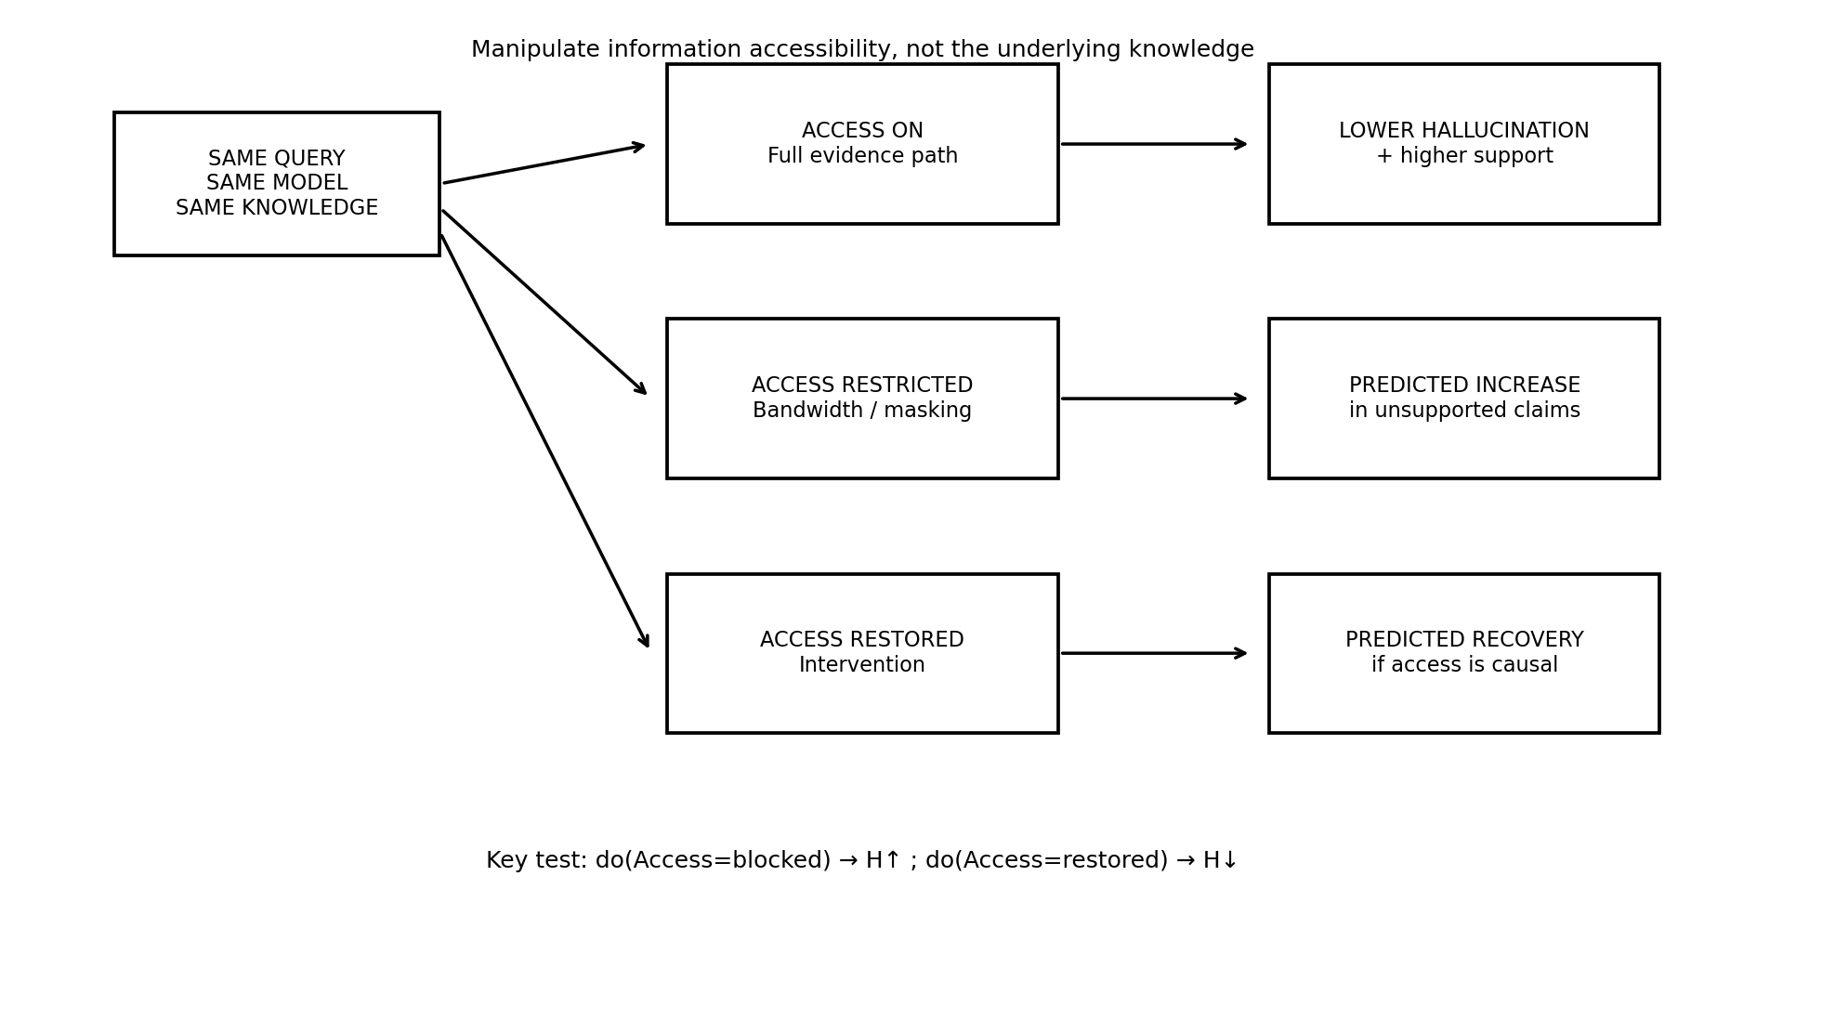
Figure 2. Core causal experiment: manipulate access while holding knowledge constant.

11. Core Experimental Program

11.1 Model and corpus strategy
Gunakan Pythia atau model open-weight lain yang memiliki training data atau data provenance yang cukup dapat diaudit. Paper ACL Findings 2026 tentang retrieval of pretraining data secara eksplisit menggunakan Pythia karena pretraining data tersedia secara publik; ini membuat separation antara “not learned” dan “learned” lebih defensible daripada benchmark biasa.
Untuk tahap awal, gunakan satu model family dan satu corpus domain sehingga causal inference sederhana. Setelah efek terlihat, barulah perluas model dan domain.

11.2 Four epistemic regimes
Regime | Corpus presence | Reader access | Generator evidence | Expected
A: Unknown | No | No | No | Abstain or uncertainty
B: Known–blocked | Yes | No/blocked | Weak/none | Test hallucination/access gap
C: Known–accessible | Yes | Yes | Yes | Answer with support
D: Conflicted | Yes | Yes | Conflicting | Detect conflict / qualify / abstain

11.3 Access manipulation
- Position manipulation: place evidence in easy vs difficult locations in context.
- Information masking: hide selected evidence spans while leaving all other context fixed.
- Bandwidth limitation: pass only a controlled number of evidence units through the workspace.
- Retrieval quality manipulation: hold corpus fixed, vary top-k and relevance to separate retrieval miss from reasoning failure.
- Communication ablation: allow Reader to know the answer but block the structured evidence packet from the Generator.
- Restoration: re-enable the evidence channel without changing underlying weights or query.

11.4 Metrics
Metric | Definition
Hallucination rate | Proportion of unsupported or contradicted atomic claims.
Evidence-supported claim rate | Claims correctly entailed by evidence.
Calibration | Expected calibration error, Brier score, or related confidence-vs-correctness metrics.
Abstention quality | Correct unknown detection vs false refusal.
Evidence utilization | Whether retrieved evidence actually changes/controls output.
Attribution precision/recall | Quality of mapping claims to supporting evidence.
Conflict resolution accuracy | Ability to detect and handle contradictory sources.
Access sensitivity | Delta in outcome under access interventions.
Efficiency | Tokens, retrieval calls, latency, compute budget.

12. Baselines dan Ablation Matrix
System | Generator | Reader/Retrieval | Epistemic control | Purpose
Vanilla LLM | Single autoregressive core | Parametric only | Minimal | Lower bound
Standard RAG | LM | Retrieve once | Minimal | External evidence baseline
RETRO-like | Generator + retrieval encoder | Integrated retrieval memory | No explicit arbitration | Explicit memory baseline
Self-RAG | LM | Adaptive retrieval | Reflection tokens | Integrated RAG baseline
CoVe | LM | Verification questions | Post-generation verification | Verifier baseline
LLM2 | Generator + verifier | Optional | System 2 verifier | Dual-process baseline
HaluSearch | Generator + search | Active search | Fast/slow switch | Search-based reasoning baseline
EAA-full | Generator | Dedicated Reader + memory | Arbitration + workspace | Proposed full system
EAA-no-arbitration | Generator | Reader + memory | No gate | Ablation
EAA-no-reader | Generator | No dedicated reader | Arbitration from internal state | Ablation
EAA-no-workspace | Generator | Reader | Direct raw context | Ablation
Critical fairness condition: compare systems under matched parameter budget where possible, and report retrieval tokens, total inference tokens, number of model calls, and latency. Otherwise an apparent advantage may simply reflect more computation or more evidence.

13. Falsification Criteria dan Negative Results
A strong PhD proposal harus mendefinisikan kondisi yang akan membuat teori gagal. Gunakan kriteria berikut sebagai guardrail.
- If blocking access does not increase hallucination, the causal access hypothesis is weakened.
- If restoring access does not recover factuality, the failure may be retrieval-independent or generated by model priors/conflicts.
- If a vanilla RAG or verifier with matched compute consistently dominates EAA, the architecture is not justified by the proposed mechanism.
- If the observed effect disappears under simple context reordering or disappears after controlling for retrieval quality, the “access bottleneck” may be a narrower attention/context phenomenon rather than a general mechanism.
- If the architecture sharply increases false refusals, it has traded hallucination for unusability; the objective must include both truthfulness and answerability.
- If the effect exists only in one model family, the thesis should be framed as a model-specific mechanism rather than a general law.

14. Threats to Validity and How to Handle Them
Risk | Mitigation
Confounding by context length | Position/bandwidth manipulation changes token count. Use matched-length controls and separate position, masking, and bandwidth experiments.
Parametric contamination | Model may have memorized the answer outside the auditable corpus. Use models/corpus with known training exposure and report uncertainty.
Reader leakage | Reader may solve the task independently; then improvement is not evidence of communication architecture. Use staged controls where reader output is deliberately bottlenecked.
Verifier circularity | Verifier can repeat generator errors. Use independent source evidence where possible and measure evidence-to-claim support.
Human analogy overreach | Do not claim neural equivalence. Present neuroscience as inspiration for a testable information-integration principle.
Metric gaming | A system can lower hallucination by refusing everything. Jointly optimize hallucination, calibrated abstention, and answer utility.

15. Suggested PhD Thesis Structure
Chapter | Purpose
Chapter 1 — Introduction | Hallucination problem; motivation; split-brain analogy; precise problem statement; contributions.
Chapter 2 — Literature Review | Hallucination taxonomy; knowledge boundary; retrieval; explicit memory; verifiers; dual process; cognitive architecture; split-brain evidence.
Chapter 3 — Theory of Epistemic Access | Definitions; knowledge states; conceptual model; predictions; causal assumptions.
Chapter 4 — Measuring Knowledge Accessibility | Known/unknown benchmark; access metrics; baseline experiments; internal-state/recall evidence.
Chapter 5 — Causal Access-Bottleneck Experiments | Blocking/restoration interventions; statistical analysis; effect sizes; boundary conditions.
Chapter 6 — EAA Architecture | Reader, epistemic memory, workspace, arbitration, generator; training/inference objective; implementation.
Chapter 7 — Evaluation and Ablations | Baselines; model families; domains; long-context; conflicts; multilingual/generalization.
Chapter 8 — Theory Refinement | What the evidence supports/does not support; relation to world-model views; limitations.
Chapter 9 — Conclusion | Scientific and engineering contributions; open problems.

16. Publication Strategy
Program yang baik dapat dipecah menjadi beberapa publikasi independen, bukan satu paper yang mencoba membuktikan semuanya sekaligus.
- Paper 1 — Knowledge Accessibility: empirical separation of “learned” vs “accessible” knowledge under controlled corpus conditions.
- Paper 2 — Causal Access Bottleneck: intervention study showing whether blocking/restoring evidence communication changes hallucination.
- Paper 3 — EAA Architecture: reader–epistemic memory–workspace–arbitration–generator system with strong baselines and ablations.
- Paper 4 — Generalization: long context, conflict, multilinguality, and robustness; refine theory rather than just add more benchmarks.

17. Prototype Development Plan

17.1 Minimal viable research system
- Open-weight instruct model (start small: 1B–8B class if resources are limited).
- Vector database or BM25/FAISS retrieval for evidence access.
- Pydantic/JSON structured epistemic state schema.
- Lightweight reader model or same backbone in a separate functional path.
- Arbitration model/rule layer implementing answer / retrieve / abstain / interrupt.
- Claim decomposition + evidence attribution evaluator.
- Experiment runner with fixed seeds, intervention configurations, and reproducible logging.

17.2 Example epistemic state schema
EpistemicState = { query, claims[], evidence_spans[], sources[], confidence, contradictions[], temporal_validity, access_status, recommended_action }
Recommended actions: ANSWER, RETRIEVE_MORE, VERIFY, QUALIFY, ABSTAIN, INTERRUPT. The generator receives only the allowed evidence/constraints, not unrestricted access to all intermediate retrieval artifacts.

18. Decision Logic for the Proposed Architecture
- Parse query into atomic claims/questions.
- Reader searches controlled knowledge sources and builds candidate evidence.
- Reconciliation step identifies duplicate, stale, and conflicting evidence.
- Epistemic Memory stores claims + provenance + confidence + conflict state.
- Arbitration estimates whether evidence is sufficient for the requested answer.
- If insufficient: retrieve more or abstain; do not permit unsupported completion.
- If sufficient: Generator composes answer under evidence constraints.
- Final claim checker maps generated claims back to evidence; if unsupported, trigger correction loop.
- Store failure state as learning signal for future calibration or training.

19. Expected Scientific Findings (with explicit uncertainty)
Expected but not assumed
The project expects to find that some hallucinations arise even when relevant knowledge is present, because the generative pathway does not access or integrate it reliably. This is a prediction to test, not a known fact.

- Context-position effects will likely reveal access sensitivity, but this alone does not prove a general access-bottleneck mechanism.
- Known-but-inaccessible examples are expected to be particularly valuable because they break the false dichotomy of “model knows” vs “model does not know”.
- A dedicated epistemic state should improve calibration and evidence attribution, but could increase latency and false refusals.
- Conflict handling may become as important as retrieval quality: a reader that cannot reconcile sources can transfer uncertainty into generation.
- The final architecture may not eliminate all hallucination. A defensible goal is to reduce unsupported factual claims while preserving answer utility.

20. One-Page Research Blueprint
Problem
LLMs can produce coherent answers without reliably distinguishing evidence that is absent, inaccessible, stale, or conflicting.

Insight
Knowledge availability is not equivalent to knowledge accessibility or evidence utilization.

Mechanism to test
An epistemic access bottleneck between knowledge processing and generation increases unsupported narrative completion.

Causal experiment
Hold knowledge and query fixed; block access → measure hallucination; restore access → measure recovery.

Architecture
Reader → Epistemic Memory → Shared Workspace → Arbitration ↔ Generator → Final Claim Check.

Scientific contribution
A causal account and measurable framework for knowledge accessibility, plus a unified architecture that operationalizes it.

Failure condition
If access interventions do not causally alter hallucination, revise or abandon the central mechanism.

21. Key References (Verified for this framework)
1. Asai, A., Wu, Z., Wang, Y., Sil, A., & Hajishirzi, H. (2023). Self-RAG: Learning to Retrieve, Generate, and Critique through Self-Reflection. https://arxiv.org/abs/2310.11511
2. Borgeaud, S., et al. (2022). Improving Language Models by Retrieving from Trillions of Tokens. ICML. https://proceedings.mlr.press/v162/borgeaud22a.html
3. Cheng, X., Li, J., Zhao, W. X., & Wen, J.-R. (2025). Think More, Hallucinate Less: Mitigating Hallucinations via Dual Process of Fast and Slow Thinking. Findings of ACL 2025. https://aclanthology.org/2025.findings-acl.417/
4. Dhuliawala, S., et al. (2023). Chain-of-Verification Reduces Hallucination in Large Language Models. https://arxiv.org/abs/2309.11495
5. Farquhar, S., Kossen, J., Kuhn, L., & Gal, Y. (2024). Detecting hallucinations in large language models using semantic entropy. Nature 630, 625–630. https://doi.org/10.1038/s41586-024-07421-0
6. Gazzaniga, M. S. (1967). The Split Brain in Man. Scientific American, 217(2), 24–29. https://www.scientificamerican.com/article/the-split-brain-in-man/
7. Gazzaniga, M. S., Eliassen, J. C., Nisenson, L., Wessinger, C. M., Fendrich, R., & Baynes, K. (1996). Collaboration between the hemispheres of a callosotomy patient. Brain, 119(4), 1255–1262. https://pubmed.ncbi.nlm.nih.gov/8813288/
8. Huang, L., et al. (2025). A Survey on Hallucination in Large Language Models: Principles, Taxonomy, Challenges, and Open Questions. ACM TOIS. https://doi.org/10.1145/3703155
9. Jiang, Z., et al. (2023). Active Retrieval Augmented Generation. EMNLP 2023. https://aclanthology.org/2023.emnlp-main.495/
10. Kusuma, C. A., Qorib, M. R., & Ng, H. T. (2026). Parametric Knowledge is Not All You Need: Toward Honest Large Language Models via Retrieval of Pretraining Data. Findings of ACL 2026. https://aclanthology.org/2026.findings-acl.1935/
11. Lewis, P., et al. (2020). Retrieval-Augmented Generation for Knowledge-Intensive NLP Tasks. https://nlp.cs.ucl.ac.uk/publications/2020-05-retrieval-augmented-generation-for-knowledge-intensive-nlp-tasks/
12. Li, M., et al. (2025). Knowledge Boundary of Large Language Models: A Survey. ACL 2025. https://aclanthology.org/2025.acl-long.256/
13. Liu, E., et al. (2026). Position: We Need A Unified Definition of Hallucination (It’s The World Model, Stupid!). ICML 2026 / PMLR. https://proceedings.mlr.press/v306/liu26gu.html
14. Liu, N. F., et al. (2024). Lost in the Middle: How Language Models Use Long Contexts. TACL, 12, 157–173. https://direct.mit.edu/tacl/article/doi/10.1162/tacl_a_00638/119630/Lost-in-the-Middle-How-Language-Models-Use-Long
15. Ni, S., et al. (2025). Towards Fully Exploiting LLM Internal States to Enhance Knowledge Boundary Perception. ACL 2025. https://aclanthology.org/2025.acl-long.1184/
16. Pinto, Y., et al. (2020). Split-Brain: What We Know Now and Why This is Important for Understanding Consciousness. Neuropsychology Review, 30, 224–233. https://pubmed.ncbi.nlm.nih.gov/32399946/
17. Saavedra, V. (2026). Neural Arbitration Framework: A Conceptual Architecture and Research Agenda for Epistemic Arbitration in Large Language Models. SSRN Working Paper. https://papers.ssrn.com/sol3/papers.cfm?abstract_id=6668638
18. Wang, Y., et al. (2024). Unveiling Factual Recall Behaviors of Large Language Models through Knowledge Neurons. EMNLP 2024. https://aclanthology.org/2024.emnlp-main.420/
19. Yang, C., et al. (2025). LLM2: Let Large Language Models Harness System 2 Reasoning. NAACL 2025. https://aclanthology.org/2025.naacl-short.15/

22. Recommended Next Research Gate
Sebelum menginvestasikan waktu untuk melatih architecture baru, lakukan literature review sistematis dan replication-style experiment pada model open-weight dengan training provenance yang dapat diaudit. Gate pertama adalah membuktikan “known-but-inaccessible” secara operational. Gate kedua adalah causal access intervention. Hanya jika kedua gate ini lolos, EAA layak diposisikan sebagai central architectural contribution.
Research principle
Jangan memaksa data agar membenarkan metafora split-brain. Biarkan eksperimen menentukan apakah analogi tersebut berguna secara computational. Bila iya, kita mempunyai teori baru; bila tidak, kita tetap memperoleh temuan penting tentang knowledge accessibility pada LLM.

