RESEARCH INITIATION PROTOCOL

Epistemic Access Architecture
Pilot Study, Causal Research Program, and Researcher-Contact Strategy
for Hallucination in Large Language Models
Working Research Document — Version 0.1
5 October 2026
Core research intuition
A model may possess relevant knowledge without being able to access and integrate that knowledge at the moment of generation. The first goal of this research is to establish whether manipulating access — while holding the underlying knowledge fixed — causally changes hallucination.

1. Executive Research Position
The proposed research should not begin by claiming that large language models hallucinate because “they cannot see the whole training corpus.” That formulation is too strong and does not map cleanly to how modern models store and use knowledge. The defensible starting point is a distinction between knowledge presence and knowledge accessibility.
The working theory is that hallucination can arise when relevant evidence is either absent, inaccessible, poorly integrated, or in conflict — while autoregressive generation continues to produce a fluent answer. The research therefore treats hallucination as an epistemic-control problem rather than only an output-quality problem.
Research layer | Question | Expected contribution
Phenomenon | Can knowledge be present but inaccessible to the generation process? | Operational distinction between unknown, accessible, and inaccessible knowledge.
Causal mechanism | Does restricting/restoring access change hallucination while knowledge remains fixed? | Causal evidence for an access bottleneck.
Architecture | Can a dedicated reader/epistemic system regulate access to a generator? | Epistemic Access Architecture (EAA).
Evaluation | Can we measure evidence use, calibration, and abstention separately from accuracy? | Benchmark and metrics for epistemic control.
Generalization | Does the effect survive across model scales, tasks, and knowledge regimes? | Evidence that the mechanism is not a benchmark artifact.

Decision rule for the project
Do not scale the architecture before the access hypothesis survives a controlled pilot. A null result is scientifically useful: it tells us that “knowledge access” is not sufficient as the central explanation and forces the theory to be revised.

2. What the Existing Literature Already Establishes
The literature makes the research idea plausible, but it also defines the novelty boundary. Several lines of work already show that information can be stored, retrieved imperfectly, ignored, verified, or governed by separate mechanisms.
Line of work | What is already known | Implication for this thesis
Split-brain neuroscience | Callosotomy can disrupt functional integration across hemispheres, while some functions remain unified. Classic work also documented cases in which language-based interpretation lacked access to information available elsewhere. | Use neuroscience as a functional inspiration for communication/integration, not as a literal brain-to-Transformer mapping.
Pythia / open training dynamics | Pythia provides models trained on public data in the same order, with many checkpoints and tools for reconstructing the training dataloader. | Makes “was this knowledge in training?” experimentally auditable.
Lost in the Middle | Relevant information can be present in long contexts yet be used poorly, especially when placed in the middle. | Supports the distinction: presence of evidence is not equivalent to effective accessibility.
Knowledge neurons / knowledge recall | Studies show factual knowledge can be represented internally while recall/utilization can fail; manipulating recall can change task performance. | Supports a knowledge-access mechanism rather than pure knowledge absence.
Self-RAG / verifier architectures | Retrieval, reflection, and verification can be interleaved with generation. | Shows that modular epistemic control is feasible, but does not by itself prove the access-bottleneck hypothesis.
LLM2 / dual-process approaches | A generator can be paired with a process verifier that provides feedback during generation. | Important baseline; a separate verifier alone is not novel enough.
NAF 2026 | A working paper explicitly links split-brain/confabulation to an epistemic-vs-generative architecture and gives epistemic monitoring interruptive authority. | This is the closest prior art; the thesis must differentiate through measurable access states, causal intervention, and architecture-level evidence.

Primary sources: [R1]–[R9] in the References section. The table is a research-positioning summary, not a systematic literature review; before proposal submission, expand it into a formal PRISMA-style or scoping review if required by the target program.

3. Research Problem, Questions, and Falsifiable Claims

3.1 Problem statement
Current generative language systems combine knowledge representation, evidence access, reasoning, uncertainty handling, and linguistic realization in tightly coupled computation. This coupling makes it difficult to determine whether a false statement arises because the model lacks the relevant knowledge, cannot access it, fails to integrate it, or generates despite uncertainty.

3.2 Primary research question
RQ1. When relevant knowledge is held constant, does reducing its accessibility to the generation process increase hallucination?

3.3 Secondary questions
- RQ2. Can knowledge states be operationally separated into unknown, known-but-inaccessible, known-and-accessible, and conflicted?
- RQ3. Is the relationship between access and hallucination monotonic, thresholded, or task-dependent?
- RQ4. Does a dedicated evidence/epistemic processor reduce hallucination more reliably than ordinary RAG or post-hoc verification under matched knowledge budgets?
- RQ5. Does giving an epistemic controller interruptive authority improve calibration and abstention without causing excessive false refusals?
- RQ6. Which components are necessary: reader, epistemic memory, arbitration, shared workspace, final claim checking, or some combination?

3.4 Core falsifiable hypotheses
Hypothesis | Prediction | Potential falsifier
H1 — Access effect | At fixed knowledge and fixed query, lower evidence accessibility increases unsupported-claim rate. | No reliable increase across controlled access interventions.
H2 — Restoration | Restoring access after restriction reduces hallucination toward the full-access condition. | No recovery, or recovery is fully explained by extra tokens/compute.
H3 — State distinction | Known-but-inaccessible behaves differently from never-known on at least one epistemic metric. | The two states are indistinguishable after controlling for task/model factors.
H4 — Arbitration | An epistemic controller that can interrupt generation reduces unsupported claims beyond a post-hoc verifier with similar compute. | No incremental benefit under matched compute/knowledge conditions.
H5 — Generalization | The access effect persists across more than one model scale and task family. | Effect disappears outside one narrow benchmark.

Important methodological guardrail
“Knowledge exists” must be operationalized. For Pythia-style experiments, use auditable pretraining data/checkpoints where possible. For external knowledge, record an immutable evidence source. Never infer training exposure solely from a correct answer.

4. Pilot Study #1 — Known Does Not Necessarily Mean Accessible
This is the first experiment to run. Its purpose is not to prove the final architecture; it is to establish whether an experimentally controllable access gap is associated with hallucination while holding the underlying knowledge source constant.

4.1 Recommended platform
Primary recommendation: the Pythia model suite. Pythia was designed for controlled study across training and scaling, uses public data in the same order, and provides many checkpoints plus tooling for reconstructing training dataloaders. This is unusually valuable for distinguishing “the model never saw the fact” from “the model saw the relevant training material.” [R1]

4.2 Minimal experimental conditions
Condition | Knowledge status | Access mechanism | Purpose
A — Unseen | Fact not present in audited knowledge source | None | Baseline for genuine unknowns.
B — Seen / closed-book | Fact present in training corpus or known state | No external retrieval at inference | Measures latent/parametric knowledge behavior.
C — Seen / accessible | Same fact source | Full relevant evidence path | Best estimate of accessible knowledge.
D — Seen / restricted | Same fact source | Masked, bandwidth-limited, misplaced, or selectively filtered evidence | Key intervention.
E — Seen / restored | Same fact source | Restricted path restored | Key restoration test.

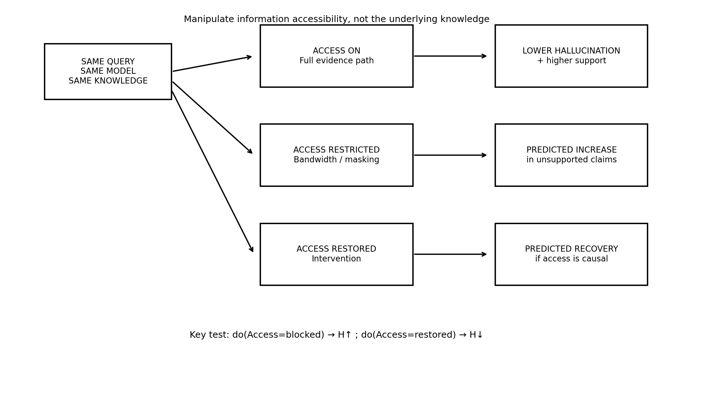
Figure 1. Causal intervention logic: manipulate access, not the underlying knowledge source.

5. Experimental Design in Detail

5.1 Independent variables
- Knowledge exposure: unseen vs seen in audited data.
- Access condition: full, restricted, or restored.
- Access position: beginning / middle / end of a controlled context, where applicable.
- Access bandwidth: full evidence packet vs compressed evidence summary vs partial evidence.
- Conflict state: consistent vs intentionally conflicting evidence.
- Model scale: at least two Pythia scales once the minimal pilot is stable.

5.2 Dependent variables
Metric | Definition | Why it matters
Unsupported claim rate | Claims not entailed/supported by ground-truth evidence. | Primary hallucination outcome.
Truthfulness / accuracy | Whether answer content is correct. | Separates wrong answers from merely unsupported wording.
Evidence attribution | Fraction of answer claims traceable to available evidence. | Measures whether the model actually uses the reader state.
Abstention precision | Among abstentions, fraction where evidence was genuinely insufficient/conflicted. | Avoids “solve hallucination by saying I don’t know.”
False refusal rate | Correctly answerable cases that the system refuses. | Measures utility cost of epistemic caution.
Calibration | Agreement between stated/implicit confidence and correctness. | Tests whether uncertainty becomes meaningful.
Access sensitivity | Change in outcomes across access interventions. | Directly tests the central mechanism.
Latency / token / FLOPs budget | Resource cost for each condition. | Prevents hidden compute advantages.

6. Pilot Protocol: Step-by-Step
- Construct a fact set with evidence provenance. Prefer facts whose source can be frozen and independently checked.
- Label whether each fact is present in the audited training/data source. For Pythia, preserve the exact dataset/version and checkpoint used.
- Create questions in at least two forms: direct factual QA and compositional/relational QA that requires using more than one fact.
- Run a closed-book baseline to estimate parametric performance.
- Run a full-access evidence condition where the relevant source is clearly available.
- Create a restricted-access condition without changing the underlying fact: move evidence, mask critical spans, compress evidence, or cap the evidence channel.
- Run the restoration condition with access restored using the same question and underlying evidence.
- Collect raw generations, token/log-probability outputs when available, evidence packets, access masks, and metadata.
- Evaluate claims rather than only whole-answer correctness. A single unsupported clause can be a hallucination even when the rest of the answer is correct.
- Run statistical analysis with paired comparisons because the same underlying questions can be evaluated under multiple access conditions.
Pilot discipline
Do not use an adaptive method that decides the access level based on the answer before measuring the outcome. The intervention must be specified before inference so that the comparison remains causal rather than circular.

7. Causal Analysis Plan
The research should treat access as an intervention. The core contrast is not “method A vs method B”; it is “the same knowledge under different accessibility regimes.”

7.1 Conceptual causal graph
A minimal causal model is:
Knowledge source → Accessible evidence → Generation → Unsupported claims
Confounders to record: model checkpoint, prompt template, evidence token budget, task difficulty, retrieval recall, temperature/decoding policy, and compute budget.

7.2 Recommended analysis
- Use paired tests or mixed-effects models because the same question should appear under multiple access conditions.
- Report effect sizes and confidence intervals, not only p-values.
- Pre-register primary outcomes and exclusions before looking at the final intervention results.
- Use multiple seeds / decoding settings when stochastic generation is part of the pipeline.
- Perform ablations that separate “less information” from “same information but harder to access.”
- For the strongest causal claim, compare full → restricted → restored on the same underlying evidence and questions.

7.3 Strongest evidence pattern
Pattern | Interpretation
Full access < Restricted access in hallucination | Evidence consistent with an access effect.
Restricted > Restored access in hallucination | Evidence that restoring access recovers performance.
Same token budget across conditions | Reduces “more tokens = better” explanation.
Same underlying evidence across conditions | Reduces knowledge-content confounding.
Effect replicates across tasks/scales | Supports a general mechanism rather than a benchmark artifact.
Effect survives retrieval-recall controls | Strengthens the case that integration/access, not retrieval failure alone, matters.

Causal claim threshold
Do not call the mechanism causal after a single cross-sectional RAG comparison. Reserve “causal” for a design with pre-specified intervention and restoration evidence, plus sensitivity analyses against token-count, retrieval-quality, and compute confounds.

8. Falsification, Failure Modes, and Threats to Validity

8.1 What would make the theory weaker?
- Access restriction does not increase hallucination once evidence amount and task difficulty are controlled.
- Restoring access does not recover performance.
- The “known-but-inaccessible” state behaves no differently from genuinely unknown cases.
- The effect exists only for one model family, one prompt format, or one synthetic benchmark.
- A simple reranker or prompt-position heuristic eliminates the effect, suggesting a narrower context-utilization problem rather than a general epistemic mechanism.
- The proposed EAA improves results only because it consumes substantially more context, model calls, or compute.

8.2 Major threats
Threat | Example | Control
Information quantity confound | Restricted condition simply contains fewer tokens. | Keep token budget constant where possible.
Retrieval confound | Reader failed to retrieve evidence; the “access” intervention was actually retrieval failure. | Log retriever recall and create oracle-access conditions.
Prompt confound | One condition has better prompt wording. | Use templated prompts and blinded evaluation.
Knowledge confound | Facts differ in difficulty or frequency. | Match fact sets and stratify by frequency.
Decoding confound | Different temperature/beam settings. | Freeze decoding policy.
Evaluator bias | LLM judge favors verbose answers. | Use claim-level evidence checks and human audit on a sample.
Architecture confound | EAA gets extra compute. | Report parameter/call/token/FLOP budgets and matched baselines.
Neuroscience overreach | Brain analogy is treated as proof. | Frame neuroscience as functional inspiration only.

9. From Pilot Result to the Proposed Architecture
Only after the access hypothesis is supported should the project introduce the full Epistemic Access Architecture (EAA). The core design principle is functional separation with continuous coordination: a knowledge/evidence processor determines what can be supported; a generative core determines how to express it; an arbitration mechanism controls when generation must pause, retrieve, revise, or abstain.
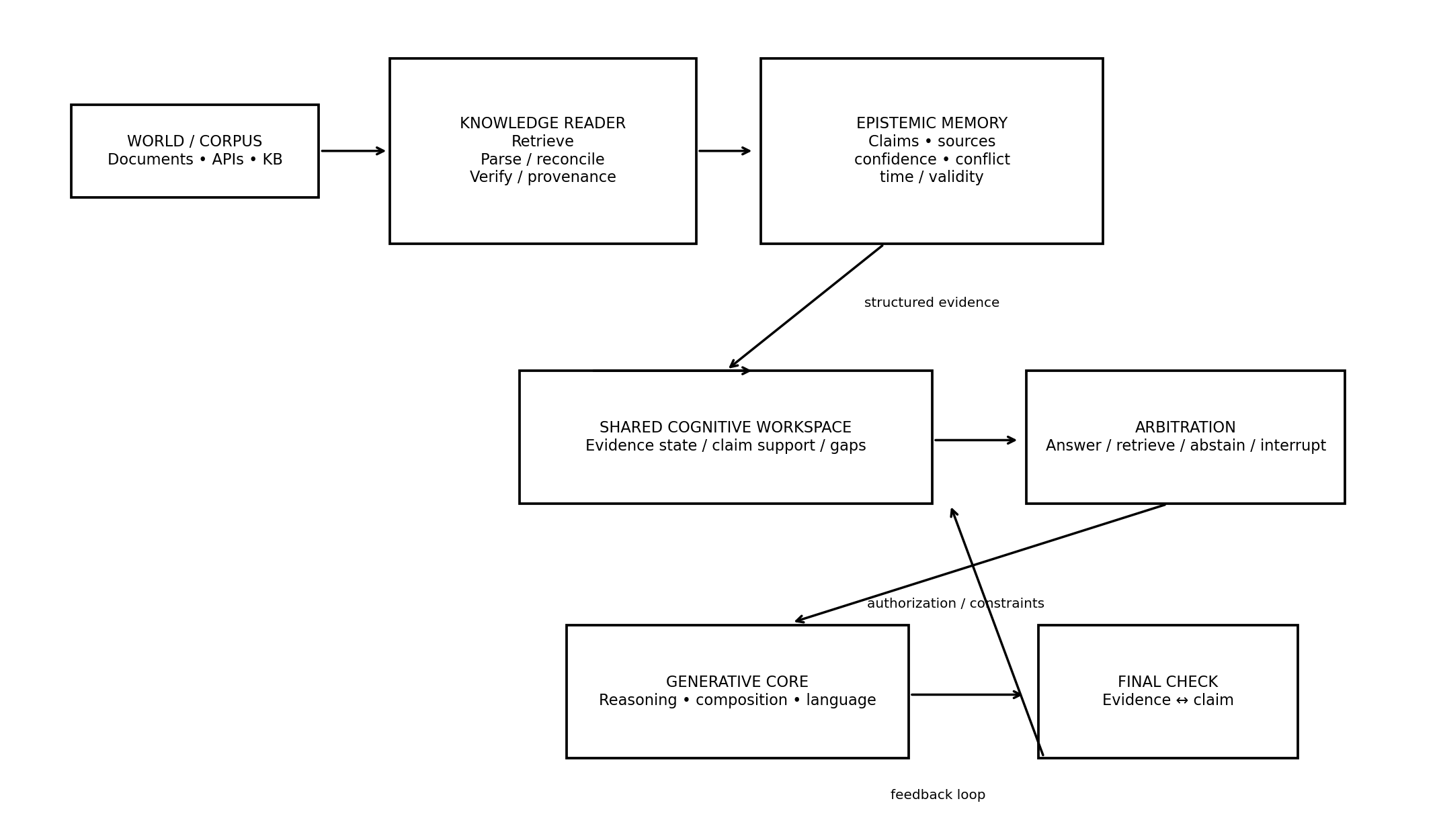
Figure 2. Proposed Epistemic Access Architecture (EAA), version 0.1.
Module | Responsibility | Novel research question
Knowledge Reader | Retrieve, parse, reconcile, and verify evidence. | What representation best preserves evidence identity and provenance?
Epistemic Memory | Store claims, source, confidence, temporal validity, and conflicts. | Can a structured state outperform raw context for evidence-grounded generation?
Shared Workspace | Expose current evidence state to the rest of the system. | What information must cross the communication bottleneck?
Arbitrator | Permit answer, retrieve more, interrupt, revise, or abstain. | Can epistemic authority prevent narrative closure?
Generative Core | Reason, compose, and express the answer. | Can generation be constrained without losing flexibility?
Final Claim Check | Check claim ↔ evidence consistency before output. | What errors remain after upstream epistemic control?

Key distinction from ordinary RAG
The proposed Reader is not merely a document retriever. Its output is an explicit epistemic state: claims + evidence + provenance + confidence + conflicts + temporal validity. The Generator consumes that state through a controlled communication channel rather than treating retrieved text as an undifferentiated prompt.

10. Architecture Research Program — Ablation Ladder
Build the architecture incrementally so that every component can be attributed to an empirical contribution.
Stage | Architecture | Question
S0 | Vanilla generator | Baseline hallucination and calibration.
S1 | Generator + ordinary RAG | How much comes from simply exposing external evidence?
S2 | Generator + structured evidence packet | Does explicit provenance/state help beyond raw passages?
S3 | Reader + generator | Does separating evidence processing from generation help?
S4 | Reader + epistemic memory + generator | Does persistent epistemic state improve consistency?
S5 | Add arbitration | Does interruptive authority reduce unsupported generation?
S6 | Add feedback loop | Can the system recover from access failures/conflicts?
S7 | Full EAA | Can the architecture generalize without unacceptable utility/latency costs?

10.1 Training objective sketch
The final loss should not be defined only over next-token likelihood. A research prototype can define a multi-objective training/evaluation scheme around evidence-grounded claim generation:
L = L_language + λ₁ L_support + λ₂ L_attribution + λ₃ L_calibration + λ₄ L_abstention + λ₅ L_conflict
This is a conceptual objective, not yet a validated training recipe. The exact formulation should be chosen after the pilot identifies which signals correlate with the causal access effect.

10.2 Information-flow principle
The central design claim is that the “communication channel” should be explicit enough to intervene on. That allows the research to define and manipulate an access variable, rather than merely observing attention patterns after the fact.

11. Who to Contact, and When
Yes, contacting researchers is useful — but only after you have a concise research memo and, ideally, a pilot result. The first contact should be a request for scientific feedback, not a request for funding or a claim that a new architecture is already proven.

11.1 Priority contact categories
Priority | Who | Why
1 | Potential PhD supervisor in LLM/interpretability/reasoning/uncertainty | Can turn the idea into a defensible dissertation and publication strategy.
2 | Researchers working on auditable pretraining / knowledge boundaries | Directly relevant to the known-vs-inaccessible experimental substrate. The 2026 Pythia/RETAIN work is especially aligned. [R2]
3 | Researchers in hallucination detection / calibration | Useful for measurement and evaluator design; semantic entropy is a relevant precedent. [R8]
4 | Split-brain / cognitive neuroscience researcher | Use for a methodological sanity check on the neuroscience analogy, not as evidence that the AI architecture is biologically correct. [R9]

Closest prior art to acknowledge explicitly
NAF (2026) is particularly close because it already connects split-brain/confabulation to generative and epistemic functions and gives epistemic monitoring interruptive authority. Your differentiation should be empirical and causal: operational access states, intervention/restoration, matched budgets, and an explicit reader-to-generator communication mechanism.

11.2 Researchers/papers worth approaching for feedback
Researcher(s) | Relevant work | What to ask
Christopher Adrian Kusuma; Muhammad Reza Qorib; Hwee Tou Ng | Parametric Knowledge is Not All You Need (ACL Findings 2026). [R2] | Would “known-but-inaccessible” be measurable using Pythia’s auditable pretraining data/checkpoints?
Víctor Saavedra | Neural Arbitration Framework (working paper, 2026). [R6] | Where does an access-intervention research program materially differ from an epistemic-arbitration framework?
Nelson F. Liu and coauthors | Lost in the Middle (TACL 2024). [R3] | Which existing controlled context-access results can be adapted into a causal access benchmark?
Yifei Wang and coauthors | Knowledge recall / Knowledge Neurons (EMNLP 2024). [R4] | How should “accessibility” be operationalized when the relevant knowledge is internal rather than retrieved?
Michael S. Gazzaniga / split-brain literature community | Split-brain research and hemispheric integration. [R9] | Is the neuroscience analogy framed as specialization + communication + integration, rather than simplistic left-brain/right-brain mapping?

12. Contact Strategy and Email Template

12.1 What to send
- A 1-page research memo containing the hypothesis, nearest prior art, pilot design, and the exact question you want feedback on.
- A 1–2 page figure showing the causal intervention and the EAA concept.
- Only after results exist: a short pilot-results table or one figure with effect sizes and uncertainty.
- A link to code/reproducibility materials once they are clean enough for another researcher to inspect.

12.2 Suggested email
Subject: Research question on knowledge accessibility and LLM hallucination
Dear Prof./Dr. [Name],
I am investigating whether LLM hallucination can partly arise from a gap between knowledge that is present/learned and knowledge that is accessible to the generation process. My working hypothesis is that, with the underlying knowledge held constant, controlled restriction of the evidence pathway should increase unsupported claims, while restoring access should recover performance.
I am designing a Pythia-based pilot because the model suite provides auditable training data/checkpoints. I am also considering a unified architecture that separates evidence processing from language generation while maintaining an explicit communication/arbitration channel.
I found your work on [paper/topic] particularly relevant. I would be grateful for a brief scientific critique of whether the proposed pilot distinguishes itself from existing work and whether the “known-but-inaccessible” state is a meaningful experimental construct.
I have attached a 2-page research memo/figure.
Best regards,
[Name]

The goal of the first email is to invite critique. Avoid phrases such as “I have solved hallucination” or “I discovered that LLMs are split-brain.” The more useful framing is a falsifiable research question plus a controlled experiment.

13. Research Artifact Checklist
Artifact | Minimum contents | Ready-to-share test
Research memo | Problem, hypothesis, novelty boundary, pilot design, key references. | A researcher can understand the proposal in 5 minutes.
Dataset card | Question IDs, facts, evidence sources, training-exposure labels, difficulty strata. | Another researcher can audit why each item belongs to a condition.
Experiment config | Model checkpoint, prompt, decoding, access mask, token budget, random seed. | Same config produces a reproducible run.
Raw output store | Every generation + metadata. | No manual transcription of outputs.
Evaluation script | Claim extraction + evidence support + accuracy + calibration metrics. | Can be rerun without hand edits.
Causal analysis notebook | Paired contrasts, effect sizes, uncertainty, ablations. | Primary result can be reproduced from raw outputs.
Architecture prototype | Reader, memory, arbitration, generator interfaces. | Each module can be ablated independently.
Research log | Hypotheses, failed experiments, revisions, decisions. | Every major change has a timestamp and rationale.

13.1 Suggested repository structure
project/
00_docs/ # proposal, preregistration, literature matrix
01_data/ # immutable source manifests + dataset cards
02_prompts/ # frozen prompt templates
03_models/ # checkpoint references / configs
04_experiments/ # intervention configs
05_outputs/ # raw generations + metadata
06_evaluation/ # claim-level metrics
07_analysis/ # statistics + plots
08_architecture/ # EAA modules and ablations
09_reports/ # pilot report and manuscripts
README.md

14. First 30 Days — Concrete Research Sprint
Phase | Deliverable | Exit criterion
Days 1–5 | Literature matrix + 1-page hypothesis | At least 10–20 closest papers categorized; novelty claim rewritten after prior-art review.
Days 6–10 | Audited fact/question set + Pythia setup | Every sample has a knowledge-source status and reproducible metadata.
Days 11–17 | Closed-book vs full-access baseline | Reliable baseline; evaluator agreement audited on a human-sampled subset.
Days 18–23 | Restricted-access intervention | At least one access manipulation shows a directional effect or a clear null result.
Days 24–27 | Restoration experiment + confound checks | Restricted → restored comparison completed with token/compute controls.
Days 28–30 | 2–5 page research memo + contact shortlist | Result, limitations, closest prior art, and next experiment written in researcher-ready form.

Do not wait for “perfect results” to contact a supervisor
A good point of contact is often after the first credible pilot, even if the result is null. A supervisor can help decide whether the null result means the hypothesis is wrong, the intervention was weak, or the measurement is inadequate.

15. Publication / PhD Trajectory
Potential paper | Core contribution | What must be true
Paper 1 — Accessability benchmark | Operationalize unknown vs known-but-inaccessible vs accessible. | Auditable knowledge exposure + robust evaluation.
Paper 2 — Causal access experiment | Show intervention/restoration effect on hallucination. | Strong control of knowledge/token/compute confounds.
Paper 3 — EAA architecture | Reader + epistemic memory + arbitration + generator. | Ablations demonstrate which mechanisms matter.
Paper 4 — Generalization | Cross-model, cross-task, conflict/temporal knowledge, long-context. | Effect survives across regimes.
Dissertation | Unify mechanism and architecture under epistemic access theory. | Clear causal story from phenomenon → mechanism → system.

A realistic PhD contribution is not “an AI that never hallucinates.” A stronger scientific claim is: “we identify and experimentally characterize a measurable access bottleneck, establish when it contributes to hallucination, and demonstrate an architecture that controls the bottleneck under defined conditions.”

16. The Research Flow on One Page
Step | Stage | Research action
1 | Observation | LLMs can produce fluent answers even when relevant evidence is not effectively used.
2 | Literature grounding | Context-use, factual-recall, uncertainty, RAG, verifier, and split-brain work establish related phenomena — but not the entire causal chain.
3 | Hypothesis | Knowledge presence and knowledge accessibility are distinct variables.
4 | Pilot | Use auditable knowledge and manipulate access while holding the knowledge constant.
5 | Causal test | Full → restricted → restored access; measure unsupported claims, attribution, calibration, and abstention.
6 | Mechanism | If the effect survives controls, formalize the epistemic access bottleneck.
7 | Architecture | Build Reader → Epistemic Memory → Workspace → Arbitration → Generator → Claim Check.
8 | Ablation | Remove modules one by one to locate the actual source of benefit.
9 | Generalization | Test scale, task family, conflicts, temporal drift, and long-context settings.
10 | PhD contribution | A causal account + an experimentally validated architecture, with neuroscience serving as functional inspiration rather than literal biological mapping.

Current one-sentence thesis candidate
“Large language model hallucination is partly driven by a mismatch between knowledge that is available to the system and knowledge that is accessible to the generation process; explicit epistemic processing and controlled communication can make this mismatch measurable and, under defined conditions, reducible.”

References and Core Reading Set
[R1] Biderman et al. (2023). Pythia: A Suite for Analyzing Large Language Models Across Training and Scaling. arXiv:2304.01373. https://arxiv.org/abs/2304.01373
[R2] Kusuma, Qorib, & Ng (2026). Parametric Knowledge is Not All You Need: Toward Honest Large Language Models via Retrieval of Pretraining Data. Findings of ACL 2026. https://aclanthology.org/2026.findings-acl.1935/
[R3] Liu et al. (2024). Lost in the Middle: How Language Models Use Long Contexts. TACL 12, 157–173. https://direct.mit.edu/tacl/article/doi/10.1162/tacl_a_00638/119630/Lost-in-the-Middle-How-Language-Models-Use-Long
[R4] Wang et al. (2024). Unveiling Factual Recall Behaviors of Large Language Models through Knowledge Neurons. EMNLP 2024, 7388–7402. https://aclanthology.org/2024.emnlp-main.420/
[R5] Dai et al. (2022). Knowledge Neurons in Pretrained Transformers. ACL 2022, 8493–8502. https://aclanthology.org/2022.acl-long.581/
[R6] Saavedra (2026). Neural Arbitration Framework: A Conceptual Architecture and Research Agenda for Epistemic Arbitration in Large Language Models. Working paper. https://victorsaavedra.com/naf.html
[R7] Asai et al. (2024). Self-RAG: Learning to Retrieve, Generate, and Critique through Self-Reflection. ICLR 2024. https://research.ibm.com/publications/self-rag-learning-to-retrieve-generate-and-critique-through-self-reflection
[R8] Farquhar et al. (2024). Detecting hallucinations in large language models using semantic entropy. Nature 630, 625–630. https://www.nature.com/articles/s41586-024-07421-0
[R9] Gazzaniga & Sperry (1967). Language after section of the cerebral commissures. Brain 90(1), 131–148; and related split-brain reviews. https://pubmed.ncbi.nlm.nih.gov/6023071/
[R10] Gazzaniga (1975). Review of the split brain. Journal of Neurology 209, 75–79. https://pubmed.ncbi.nlm.nih.gov/51054/
[R11] Gazzaniga (2005). Forty-five years of split-brain research and still going strong. Nature Reviews Neuroscience 6, 653–659. https://pubmed.ncbi.nlm.nih.gov/16062172/
[R12] Pinto, Neville, & Oppenheim et al. / modern split-brain review (2020). Split-Brain: What We Know Now and Why This Is Important for Understanding Consciousness. Neuropsychology Review 30, 224–233. https://pubmed.ncbi.nlm.nih.gov/32399946/
Source note: web sources were checked on 5 October 2026. Claims in this document are intentionally framed conservatively; the central causal hypothesis remains unproven until the proposed intervention/restoration experiments are run.

