Lilly Technical Challenge Documentation
Approach
When I started the project, the first thing I did was to create my own version called “gears” like rough sketch. This helped me understand how the code worked from scratch and gave me clarity on how the routes functioned and how to check if my code was working. The backend (Python) part was quick to finish, but I initially forgot to account for null values in my Average function. When I compared my version with the Lilly project, I noticed that my returns for all functions did not return a dictionary, which required adjustments.
Once the backend was stable, I moved to the frontend (JavaScript and HTML). Since I wasn’t very familiar with JavaScript, I relied heavily on W3Schools Online Web Tutorials, Stack Overflow, Google searches, and YouTube. This helped me learn the basics of await, fetch, and how forms pass data into JS from HTML.
Objectives – Innovative Solutions
- I implemented an Average function that not only calculates the average of valid values but also counts invalid ones. It outputs the average along with the number of valid and invalid inputs. If the display button is clicked with an empty name, it returns “Unknown Medicine.”
- For the Delete function, I added a confirmation step using confirm() before executing the deletion, which improved usability.
- I changed the way the system returns messages: instead of displaying them on the webpage, I used alert() popups for clearer feedback.
- I cleaned up unnecessary code and grouped my HTML more logically, improving readability and maintainability.
- I added form validation:
  - Inputs that required integers rejected anything else.
  - Prices had to be greater than 0.
  - Required fields could not be left empty — otherwise an error message was shown via alert().
This ensured the frontend was robust and user-friendly.

Problems Faced
- Backend issues: I initially forgot to handle null values in the Average function, which caused errors. I solved this by using Python’s isinstance() to validate data types before calculations.
- Frontend challenges: I encountered errors from missing semicolons, mismatched names, and incorrect syntax. The Delete function was particularly tricky until I found a Stack Overflow solution explaining how to pass data in JS using the DELETE method.
- Layout issues: Buttons and displays sometimes didn’t work as expected due to mismatched IDs or function names. Careful debugging fixed these.
- Git and virtual environments: I struggled with Git and venv setup at first. Using W3Schools tutorials helped me understand venv better, and I gradually learned Git commands to manage commits and cleanup.
- Return types mismatch: My JS functions expected a message, but the backend returned dictionaries. I fixed this by adjusting the return format and aligning frontend expectations.

Evaluation
Overall, the challenge was a strong learning experience.
- The backend was straightforward and enjoyable, especially learning how to validate inputs with isinstance().
- The frontend was the biggest learning curve, but I gained confidence with JS, especially using alert() and confirm() for user interactions.
- CSS was the easiest part; I enjoyed tinkering with layout and styling and cleaning up my HTML structure.
- I ran the Average function independently in Thonny to confirm it worked correctly, which gave me confidence in my solution.
If I had more time, I would refine the frontend further, polish the UI, and explore more advanced JS features. The biggest takeaway was how much I learned about JavaScript and how backend and frontend communicate.

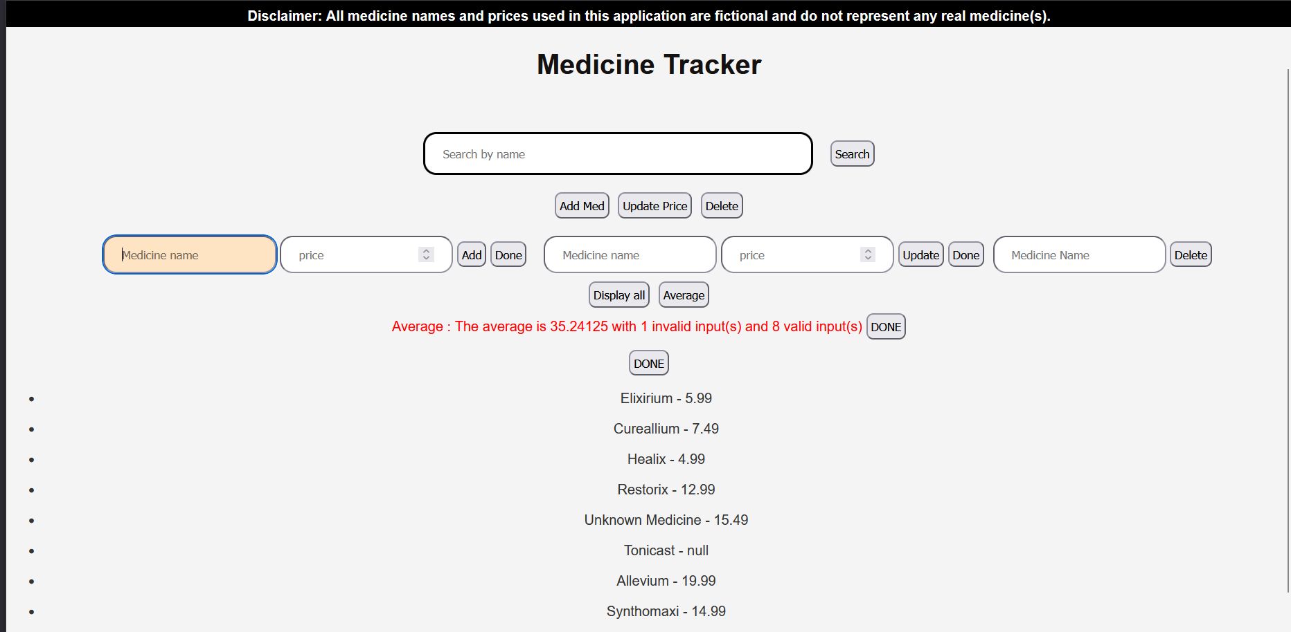
Front-end of the finished project
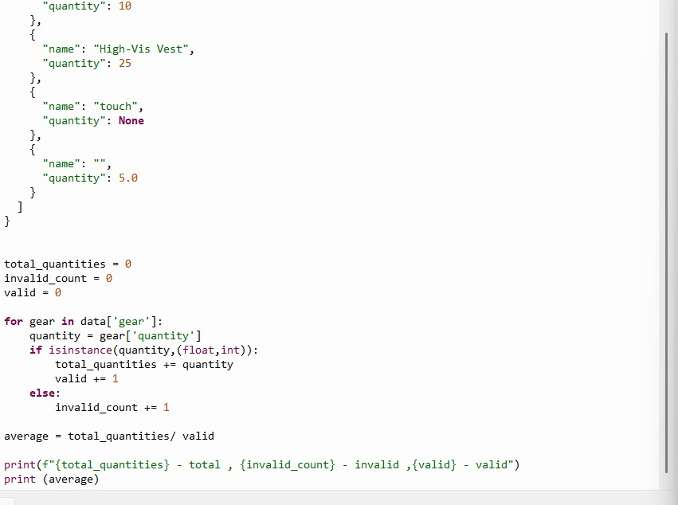
Average function in Thonny – where I learnt that python receives null values as None. From a Json file

