Aarogya Sathi (आरोग्य साथी) — AI-Powered Health Companion

An Interim Report Submitted in partial fulfilment of the requirement for the award of the degree of
Bachelor of Technology
in
Artificial Intelligence and Machine Learning
by
Jayesh Patil (C233)
Abhijit Patil (C263)
Ritesh Pawar (C276)
under the guidance of
Dr. Atul V. Dusane

SVKM’s NMIMS,
Mukesh Patel School of Technology Management & Engineering,
Shirpur Campus (M.H.)
2026-27

Abstract
India's vast urban population currently faces a dual crisis: a severe lack of accessible, affordable healthcare and rapidly deteriorating environmental conditions, particularly air quality. With over 60% of urban Indians earning under ₹50,000 per month, regular medical consultations are often financially prohibitive. Concurrently, environmental factors such as severe Air Quality Index (AQI) fluctuations create overlapping respiratory and metabolic health risks. Existing digital health solutions are fragmented; telemedicine applications lack proactive, daily guidance, while general-purpose Large Language Models (LLMs) like ChatGPT suffer from severe medical hallucinations and possess no native grounding in Indian medical protocols.
Aarogya Sathi (आरोग्य साथी) addresses these critical gaps by providing a mobile-first, AI-powered health companion operating seamlessly in vernacular languages (Hindi, Marathi, and English). The proposed system diverges from traditional vector-based Retrieval-Augmented Generation (RAG) by utilizing a novel hybrid architecture. It combines Google's Open Knowledge Format (OKF) for the deterministic retrieval of structured Indian Council of Medical Research (ICMR) clinical guidelines, backed by a Corrective Retrieval-Augmented Generation (CRAG) safety loop to evaluate relevance and eliminate hallucinations.
To date, the project has achieved 55% completion. Since Review-I, the team has moved from architecture design into active development. The complete CRAG pipeline is operational: the OKF Navigator traverses 45 structured ICMR concept files, the relevance grader filters retrieved documents, and Llama 3.1 8B generates grounded responses streamed via Server-Sent Events. The FastAPI backend serves four endpoints with integrated Bhashini translation (Hindi/Marathi), Semantic Router safety classification, and real-time AQI data from WAQI and Open-Meteo. The Flutter frontend has five screens including a working chat interface with SSE streaming. Health Connect SDK integration is underway, with 23 wearable data types defined and permissions configured. The remaining work includes contextual memory for multi-turn conversations, Qdrant vector fallback, RAGAS evaluation across 100 gold-standard QA pairs, and full Health Connect device testing.

Chapter 1: Introduction

1.1 Background of the Project
The healthcare infrastructure in India is under severe strain. The World Health Organization (WHO) recommends a doctor-to-population ratio of 1:1000, a target that remains elusive in many Indian urban and semi-urban sectors. This scarcity drives up the cost of private consultations, rendering basic preventative care inaccessible to a majority of the workforce. Simultaneously, urban India is battling an environmental crisis; cities frequently record AQI levels exceeding 300 (Hazardous), which directly exacerbates chronic non-communicable diseases (NCDs) such as Asthma, COPD, and Type-2 Diabetes.
While Artificial Intelligence has emerged as a potential equalizer, deploying it in healthcare requires extreme caution. Standard LLMs operate probabilistically and are notorious for "hallucinating" plausible-sounding but clinically incorrect medical advice. Furthermore, these global models are not inherently trained on localized protocols, such as the clinical guidelines published by the Indian Council of Medical Research (ICMR).

1.2 Motivation and Scope
The core motivation driving Aarogya Sathi is the widening access of preventative healthcare through safe, localized, and context-aware AI. By leveraging recent advancements in Agentic AI, the project aims to build an assistant that understands the user's specific chronic conditions in the context of their immediate physical environment (weather and air quality).
Scope: The Minimum Viable Product (MVP) focuses on proactive health awareness, vital tracking (Blood Pressure, Blood Sugar), symptom logging, environmental alerts, and AI-assisted medical report interpretation via OCR. It explicitly excludes generating medical prescriptions, offering definitive medical diagnoses, or replacing emergency human medical intervention.

1.3 Problem Statement
To engineer and deploy a mobile-first, multilingual AI health companion that dynamically correlates real-time environmental data (AQI, temperature, humidity) with personalized patient health profiles. The system must operate strictly within the bounds of ICMR clinical protocols, employing an OKF-CRAG hybrid pipeline to guarantee zero-diagnosis and zero-prescription safety, while providing seamless vernacular interaction for the Indian demographic.

1.4 Objectives of the Project
1. Architect a Hybrid AI Pipeline: Implement Google's Open Knowledge Format (OKF) alongside a Corrective RAG (CRAG) architecture using Llama 3.1 8B to ensure deterministic, hallucination-free retrieval of ICMR guidelines.
2. Context-Aware Environmental Integration: Aggregate real-time data from the WAQI API and Open-Meteo to inject hyper-local environmental parameters into the LLM context window.
3. Vernacular Accessibility: Integrate the Bhashini API to enable seamless Hindi, Marathi, and English interaction (Text-to-Speech and Speech-to-Text) with zero additional GPU VRAM overhead.
4. Biomarker Extraction: Utilize Google Cloud Vision OCR to digitize physical medical reports, allowing the LLM to extract and interpret biomarkers against ICMR standard ranges.
5. Strict Medical Guardrails: Deploy a sub-100ms Semantic Router to intercept and block high-risk queries (emergencies, prescription requests) before they reach the generative model.
Relevant Sustainable Development Goals (SDGs):
- SDG 3 (Good Health and Well-being): By promoting preventative healthcare and making medical guidelines accessible.
- SDG 11 (Sustainable Cities and Communities): By raising awareness of urban air pollution (AQI) and mitigating its impact on citizen health.

Chapter 2: Literature Review / Market Survey

2.1 Overview of Existing Work
The digital health market is currently split into two segments. On one side are traditional telemedicine platforms like Practo and Apollo 24/7. While these platforms offer high reliability by connecting patients directly to human doctors, they operate on a high-cost, per-visit model and do not offer continuous, AI-driven monitoring or environmental correlation. On the other side are generative AI models like OpenAI's ChatGPT and Anthropic's Claude. While these models possess vast medical knowledge, their application in direct-to-consumer healthcare is heavily criticized due to the risk of medical hallucinations [1]. Furthermore, transmitting sensitive Personal Identifiable Information (PII) to global cloud providers violates the stringent data residency and privacy mandates of India's Digital Personal Data Protection (DPDP) Act of 2023.
Recent academic advancements have proposed solutions to LLM hallucinations. Yan et al. (2024) introduced Corrective Retrieval-Augmented Generation (CRAG), which employs an evaluator to grade retrieved documents, significantly improving the robustness of generation [2]. Concurrently, Google introduced the Open Knowledge Format (OKF) in mid-2026, pivoting away from probabilistic vector searches (which fragment documents) toward structured, deterministic traversal of markdown files [3].

2.2 Identified Research Gap
A critical analysis of the literature reveals a distinct void: There is no existing framework that successfully merges real-time environmental intelligence (AQI) with vernacular, chronic disease management using a deterministic retrieval architecture.
Existing AI tools rely on probabilistic vector embeddings, which are prone to retrieving out-of-context medical chunks. By adopting an OKF-based deterministic traversal mechanism, backed by a CRAG safety net and the Bhashini translation layer, Aarogya Sathi fills this precise gap, offering a highly contextualized, safe, and privacy-compliant health companion tailored specifically for urban India.

Chapter 3: System Design / Methodology

3.1 Full Agentic RAG Pipeline Flow
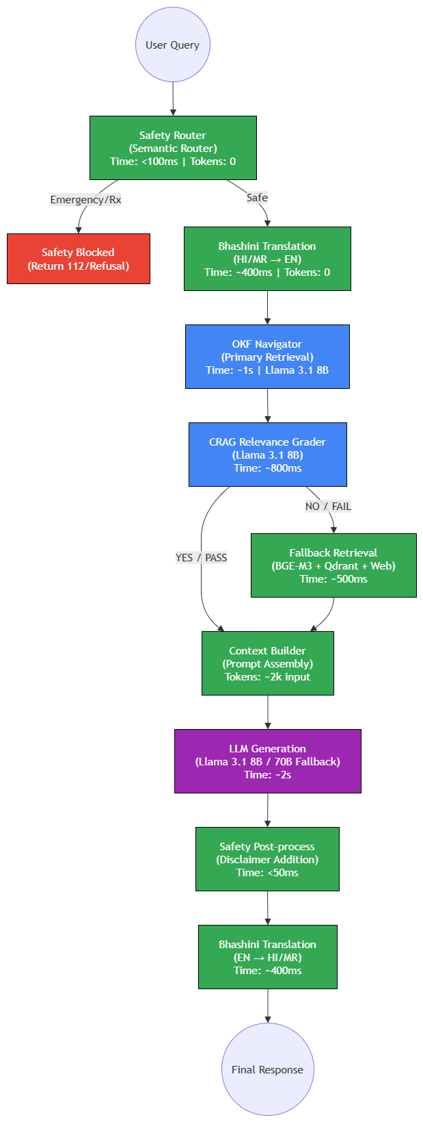
Detailed Explanation: The Agentic RAG pipeline diverges from traditional linear generation by employing a highly modular, 9-node routing architecture. The process initiates with a Semantic Router that classifies the user intent in under 100 milliseconds. If the intent is flagged as an emergency or a prescription request, the pipeline is immediately terminated, and a safe fallback response is issued. Safe queries proceed to the Bhashini API for vernacular translation (Hindi/Marathi to English). The translated query is fed into the OKF Navigator for primary retrieval. A Llama 3.1 8B instance acts as the CRAG Grader, evaluating the retrieved context. If deemed insufficient, a secondary vector-based fallback (Qdrant + BGE-M3) is triggered. The final context is assembled and passed to the generation model, ensuring the final output is robust, cited, and accurate.

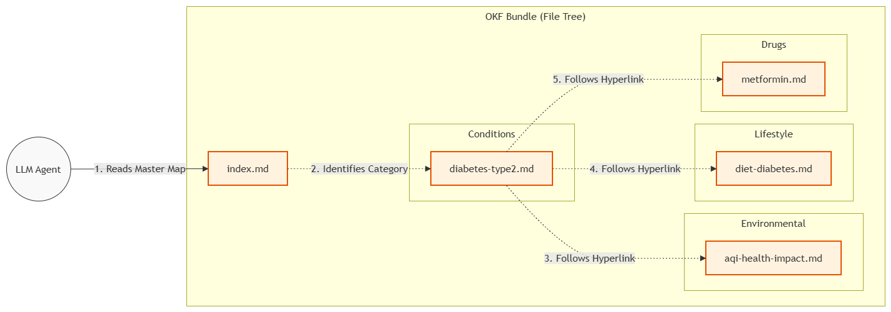
3.2 OKF Navigator Traversal

Detailed Explanation: This diagram visualizes the deterministic retrieval paradigm enabled by Google's Open Knowledge Format (OKF). Unlike vector databases that fragment documents into isolated 500-token chunks, the OKF Navigator acts as an autonomous agent traversing a structured file tree. Starting at the master 'index.md', the agent identifies the relevant clinical category (e.g., 'diabetes-type2.md'). Crucially, it then follows embedded markdown hyperlinks to associated environmental guidelines (e.g., 'aqi-health-impact.md') and lifestyle recommendations. This guarantees that complex medical tables, dosages, and interconnected protocols remain intact, entirely bypassing the semantic mismatch errors common in cosine-similarity searches.

3.3 CRAG Decision Flowchart
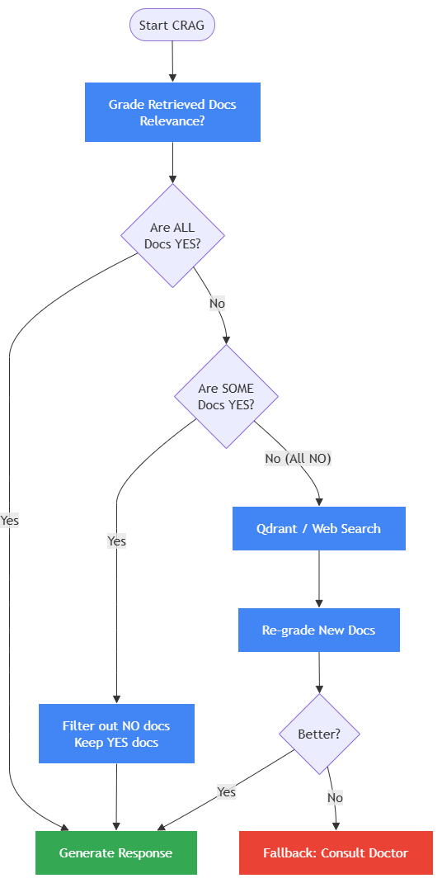
Detailed Explanation: The Corrective Retrieval-Augmented Generation (CRAG) algorithm ensures the LLM does not hallucinate. It grades the retrieved documents with a simple YES/NO binary. If 'YES', generation proceeds. If 'NO', the system aggressively filters out irrelevant chunks and triggers a fallback loop to Qdrant or a web search, acting as a self-correcting safety mechanism.

3.4 LangGraph State Machine
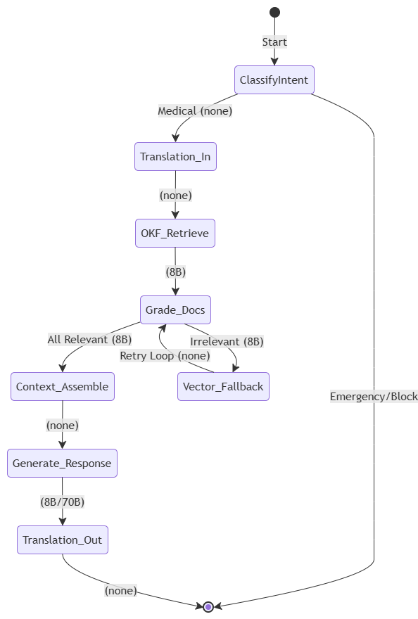
Detailed Explanation: The state machine formally defines the execution logic and compute allocation across the application. Nodes are color-coded to denote compute requirements: green nodes indicate lightweight API or deterministic tasks (requiring zero LLM inference), while blue/purple nodes require the Llama 3.1 8B or 70B models. This architecture allows the system to conserve precious GPU VRAM on the T4 instance by only invoking the LLM when strictly necessary (grading and generation), handling translation and intent classification via external APIs or lightweight algorithms.

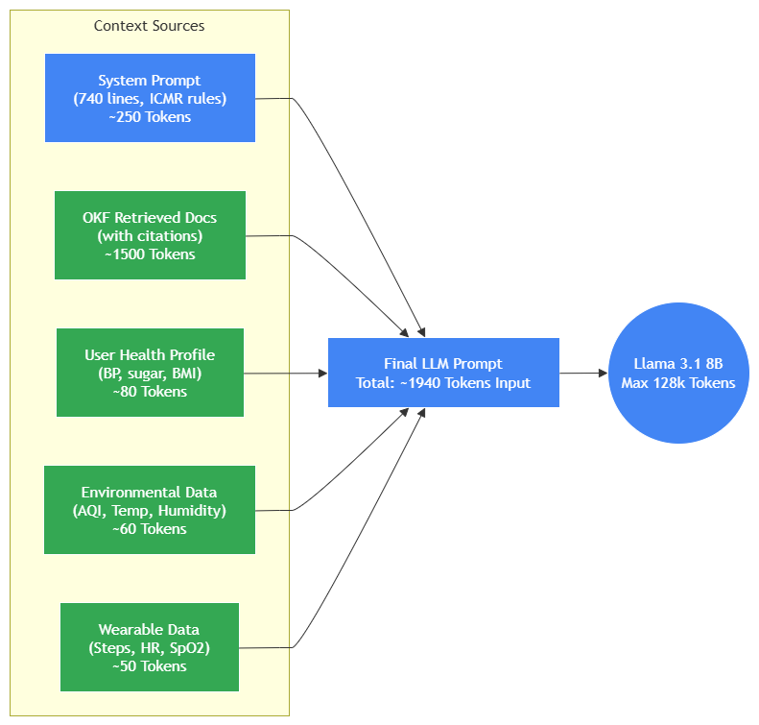
3.5 Context Assembly Breakdown

Detailed Explanation: The context assembly phase is the critical bottleneck in any RAG system. This diagram breaks down the specific token budget allocated to the LLM prompt. The payload is synthesized from five distinct data streams: (1) a rigid 740-line System Prompt enforcing ICMR rules and safety guardrails, (2) the highly relevant OKF documents retrieved in the previous step, (3) the user's localized health profile fetched from SQLite, (4) live AQI and weather data, and (5) wearable metrics. Yielding a total input of approximately 1,940 tokens, this assembly fits effortlessly within the Llama 3.1 model's massive 128K context window, leaving ample room for comprehensive generation.

3.6 Multi-Provider LLM Cascade
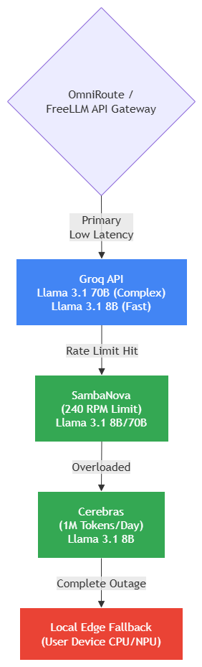
Detailed Explanation: To guarantee high availability without cloud expenses, inference calls cascade through free API providers. Groq serves as the primary low-latency endpoint. If rate limits are exceeded, requests failover to SambaNova (240 RPM), then to Cerebras, and ultimately to local edge processing on the user's device CPU/NPU, ensuring the health companion is never offline.

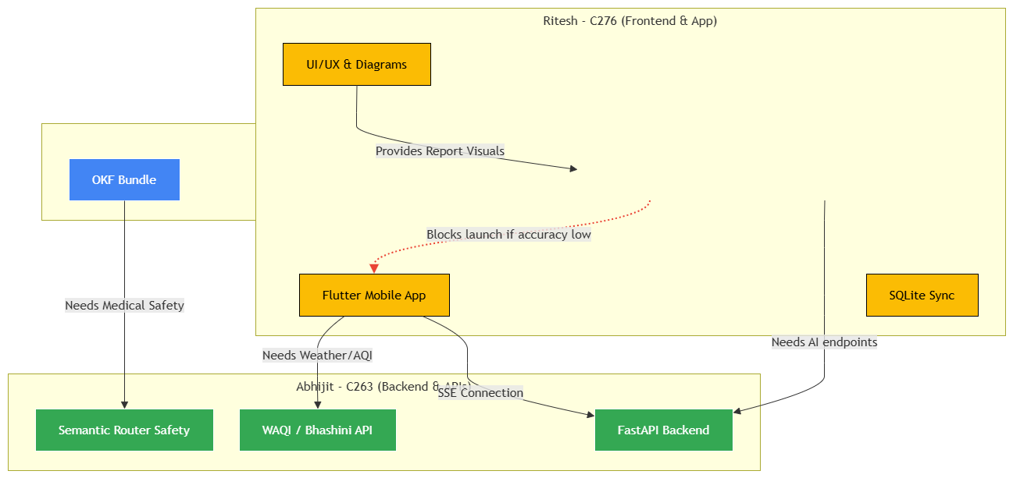
3.7 Component Dependency Map

Detailed Explanation: The dependency map delineates the separation of concerns among the team. Jayesh oversees the RAG pipeline and evaluation. Abhijit manages the backend APIs and safety layers. Ritesh handles the Flutter app, SSE integration, and UI/UX diagrams. Red arrows denote blocking paths, highlighting areas requiring cross-functional synchronization.

Chapter 4: Implementation Status and Interim Results
Progress Achieved Till Date: 55% of the implementation completed. Since Review-I, the project has transitioned from design to active development. The OKF knowledge bundle, CRAG pipeline, backend API, safety layer, translation service, and Flutter UI are all operational. The Gantt chart below reflects the updated timeline.

4.1 RAG Pipeline & OKF Knowledge Bundle (Completed)
The retrieval pipeline constitutes the core AI module. Jayesh built the OKF knowledge bundle by converting ICMR clinical PDFs into 45 structured Markdown concept files with YAML frontmatter, organized across five directories: conditions (12 files), drugs (7 files), lifestyle (7 files), environmental (5 files), and emergency (7 files). Each file includes cross-references via Markdown hyperlinks, enabling the OKF Navigator — a 385-line Python agent — to traverse the knowledge graph by reading index.md, selecting relevant files via LLM-guided link analysis, and drilling into concept files up to a configurable depth. The CRAG pipeline, built with LangChain LCEL, implements a three-tier retrieval strategy: (1) OKF deterministic navigation as the primary method, (2) Qdrant + BGE-M3 vector search as fallback for ambiguous queries, and (3) Google Search as a last resort for out-of-scope questions. Each tier uses a binary relevance grader to decide whether to proceed to generation or escalate to the next retrieval method [2]. Abhijit built the FastAPI server with four endpoints (/chat, /aqi, /health, /safety) and SSE streaming. The Bhashini API wrapper handles HI↔EN and MR↔EN translation for both input queries and output responses. The Semantic Router classifies user intent in under 100 milliseconds, routing emergencies to 112 advice, blocking prescription requests, and redirecting non-medical queries. Real-time AQI data is fetched from WAQI (1,000 requests/day) and weather data from Open-Meteo (10,000 requests/day), both free APIs.

4.2 Frontend Mobile Application & Health Connect (In Progress)
Ritesh built the Flutter application with five primary screens: (1) Home Dashboard featuring animated health score rings, real-time AQI strips, and metric cards for steps, heart rate, and blood glucose; (2) Chat Interface with SSE streaming that displays AI responses token-by-token; (3) Health Dashboard showing wearable data visualizations; (4) Profile Setup for collecting age, gender, chronic conditions, medications, and language preference, stored in on-device SQLite; (5) Settings screen with theme toggle and notification preferences. The Health Connect SDK service is built with read access to 23 data types across six categories: activity (steps, calories, distance), sleep (REM, deep, light phases), vitals (heart rate, resting HR, HRV, SpO2, blood pressure, body temperature, respiratory rate), body metrics (blood glucose, weight, height, body fat), and nutrition. Write-back support allows manual logging of blood pressure, blood glucose, and weight readings directly to Health Connect, making data available to other connected apps. The service handles duplicate removal from overlapping wearable sources and aggregates daily summaries that are included in each chat request as contextual health data for the LLM.

Chapter 5: Technical Requirements
1. Hardware Specifications:
- Development Environment: Standard developer workstations equipped with a minimum of 16GB RAM and multi-core processors.
- Deployment Environment: Cloud-based virtual machines featuring an Nvidia T4 GPU (16GB VRAM) to efficiently host the quantized Llama 3.1 8B Instruct model via Ollama.
2. Software Ecosystem:
- Mobile Framework: Flutter SDK (version 3.x) with Dart.
- Backend Framework: Python 3.10+, utilizing FastAPI for asynchronous HTTP handling.
- Databases: PostgreSQL 15 (Relational), Redis 7 (Caching/Rate Limiting), Qdrant (Vector storage for fallback retrieval), and SQLite (On-device offline caching).
- Containerization: Docker and Docker Compose for reproducible environment orchestration.
3. Datasets and APIs:
- Medical Corpus: Indian Council of Medical Research (ICMR) Clinical Practice Guidelines 2024, manually curated and converted into the Open Knowledge Format (OKF).
- External Services: WAQI API (Air Quality), Open-Meteo (Weather), Bhashini API (Translation), and Google Cloud Vision (OCR).
4. Regulatory Standards:
- Data Privacy: Strict adherence to India's Digital Personal Data Protection (DPDP) Act 2023, ensuring user health records are stored primarily on-device, with any cloud telemetry anonymized and encrypted via AES-256 at rest.

Chapter 6: Future Work and Extensions
Immediate Work (Prior to Final Review):
1. Contextual Memory: Store conversation history in SQLite with session IDs to enable multi-turn dialogue. The LLM currently processes each query independently; adding memory will allow it to reference earlier questions in the same session.
2. Qdrant Vector Fallback: Index the OKF bundle with BGE-M3 embeddings (dense + sparse hybrid) in Qdrant for handling ambiguous or misspelled queries where deterministic file navigation fails.
3. RAGAS Evaluation: Execute the evaluation script against 100 gold-standard QA pairs (50 already created). Target metrics: Faithfulness ≥ 0.80, Answer Relevancy ≥ 0.80, Context Precision ≥ 0.75.
4. Health Connect Device Testing: Validate wearable data flow on physical devices with Fitbit, Samsung Health, and Google Fit connected to Health Connect.
5. OKF Bundle Expansion: Add 15 additional condition files and drug interaction cross-references to improve retrieval coverage.
Future Extensions:
- ABDM Integration: Connect to Ayushman Bharat Health Account (ABHA) for centralized health record access [42].
- OCR Medical Report Parsing: Camera-based lab report interpretation using multimodal RAG, following the MMed-RAG architecture [23].
- QLoRA Fine-tuning: Experiment with fine-tuning Llama 3.1 8B on 2,000 ICMR question-answer pairs to evaluate accuracy gains.
- iOS Support: Extend Flutter app to iOS with Apple HealthKit integration.
- Regional Language Expansion: Add Bengali, Tamil, and Telugu via Bhashini.

References
[1] T. Vos et al., "Global burden of 369 diseases and injuries in 204 countries and territories, 1990-2019," The Lancet, vol. 396, no. 10258, pp. 1204-1222, Oct. 2020. doi: 10.1016/S0140-6736(20)30925-9.
[2] S. Yan et al., "Corrective Retrieval Augmented Generation," arXiv preprint arXiv:2401.15884, 2024.
[3] Google Cloud, "Open Knowledge Format (OKF) Specification v0.2," GitHub, Jun. 2026. [Online]. Available: https://github.com/GoogleCloudPlatform/knowledge-catalog
[4] G. A. Roth et al., "Global Burden of CVD and Risk Factors, 1990-2019," JACC, vol. 76, no. 25, pp. 2982-3021, Dec. 2020. doi: 10.1016/j.jacc.2020.11.010.
[5] GBD 2021 Diabetes Collaborators, "Global burden of diabetes, 1990-2021, with projections to 2050," The Lancet, vol. 402, no. 10397, pp. 203-234, Jul. 2023. doi: 10.1016/S0140-6736(23)01301-6.
[6] GBD 2019 Risk Factors Collaborators, "Global burden of 87 risk factors in 204 countries, 1990-2019," The Lancet, vol. 396, no. 10258, pp. 1223-1249, Oct. 2020. doi: 10.1016/S0140-6736(20)30752-2.
[7] J. Lelieveld et al., "The contribution of outdoor air pollution sources to premature mortality," Nature, vol. 525, pp. 367-371, Sep. 2015. doi: 10.1038/nature15371.
[8] I. Manisalidis et al., "Environmental and Health Impacts of Air Pollution," Frontiers in Public Health, vol. 8, art. 14, Feb. 2020. doi: 10.3389/fpubh.2020.00014.
[9] K. Skivington et al., "New framework for complex interventions: MRC guidance update," BMJ, vol. 374, art. n2061, Sep. 2021. doi: 10.1136/bmj.n2061.
[10] R. Masters et al., "Return on investment of public health interventions: a systematic review," J. Epi. Community Health, vol. 71, no. 8, pp. 827-834, 2017. doi: 10.1136/jech-2016-208141.
[11] A. Acosta et al., "Multimodal biomedical AI," Nature Medicine, vol. 28, pp. 1773-1784, Sep. 2022. doi: 10.1038/s41591-022-01981-2.
[12] L. Laranjo et al., "Conversational agents in healthcare: a systematic review," JAMIA, vol. 25, no. 9, pp. 1248-1258, Sep. 2018. doi: 10.1093/jamia/ocy072.
[13] S. Siriwardhana et al., "Improving Domain Adaptation of RAG Models," TACL, 2022. arXiv: 2210.02627.
[14] S. Anuyah et al., "Domain-Specific Knowledge Graphs in RAG-Enhanced Healthcare LLMs," arXiv preprint, Jan. 2026. arXiv: 2601.15429.
[15] P. Xia et al., "MMed-RAG: Versatile Multimodal RAG System for Medical Vision Language Models," in Proc. ICLR, 2025. arXiv: 2410.13085.
[16] M. P. Priola, "Addressing Hallucinations with RAG in Healthcare Chatbots," arXiv preprint, Dec. 2024. arXiv: 2412.04235.
[17] AI4Bharat, "IndicTrans2: High-Quality Machine Translation for 22 Indian Languages," arXiv preprint, 2023. arXiv: 2305.16307.
[18] "CLINIC: Evaluating Multilingual Trustworthiness in Healthcare LMs," arXiv preprint, 2025. arXiv: 2512.11437.
[19] "Human-Guided Agentic AI for Multimodal Clinical Prediction," arXiv preprint, 2026. arXiv: 2602.19502.
[20] "HealthFlow: Self-Evolving AI Agent for Autonomous Healthcare Research," arXiv preprint, 2025. arXiv: 2508.02621.
[21] "Caging the Agents: Zero Trust Security for Autonomous AI in Healthcare," arXiv preprint, 2026. arXiv: 2603.17419.
[22] Government of India, "Digital Personal Data Protection Act, 2023," Gazette of India, Aug. 2023.
[23] National Health Authority, "Ayushman Bharat Digital Mission (ABDM)," abdm.gov.in, 2024.
[24] Ministry of Health, "eSanjeevani Telemedicine Platform," esanjeevani.mohfw.gov.in.
[25] Central Pollution Control Board (CPCB), "National Air Quality Index," cpcbccr.com.

