Visda-C
Source-only-testing

1. OPDA
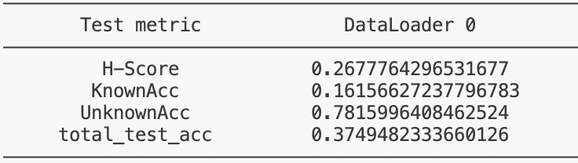

2. PDA
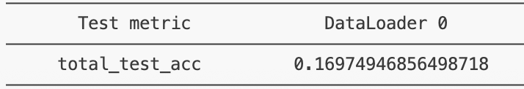

3. ODA
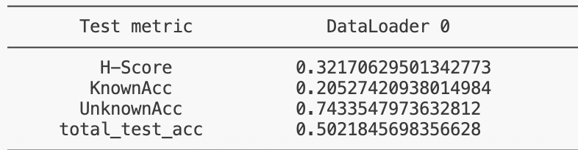

Domainnet

1. OPDA
a. R2C
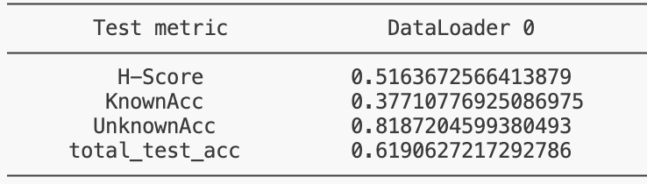
b. R2P
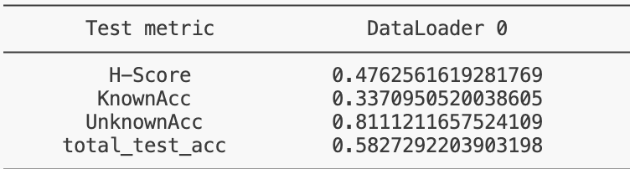
c. R2S
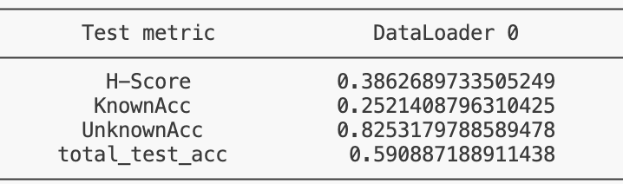
d. C2R
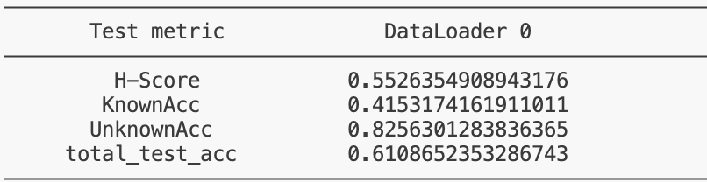
e. C2P
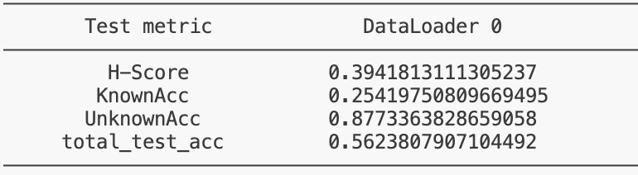

f. C2S
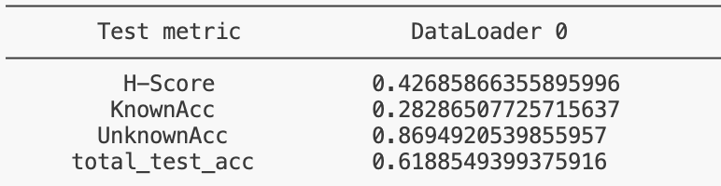
g. P2R
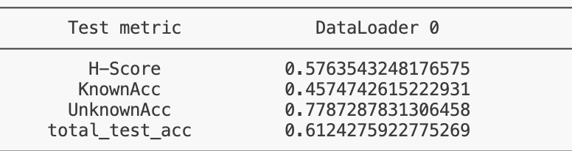
h. P2C
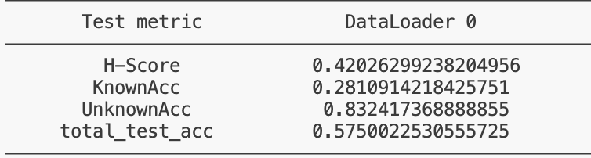
i. P2S
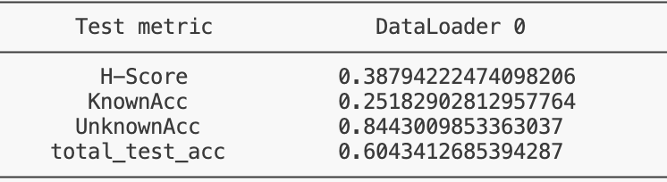
j. S2R
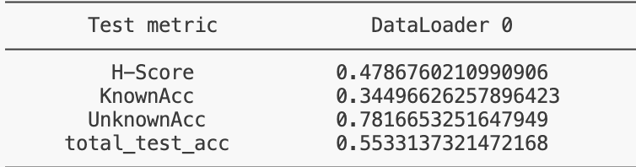
k. S2C
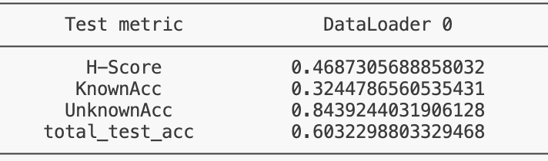
l. S2P
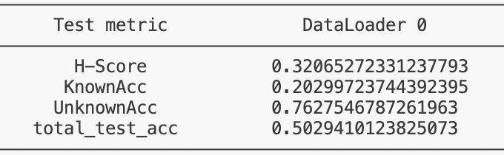

2. PDA Scenario
a. R2C
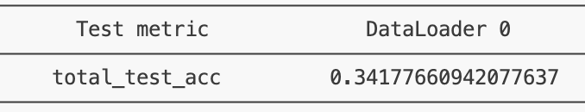
b. R2P
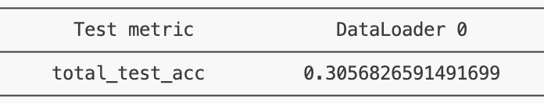

c. R2S
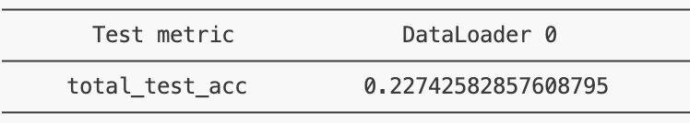

d. C2R
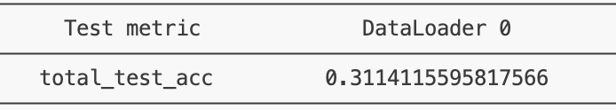

e. C2P
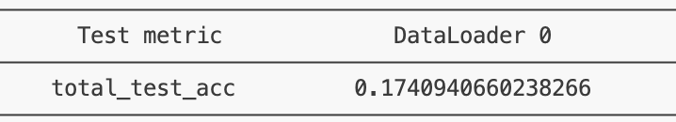

f. C2S
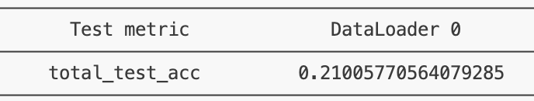

g. P2R
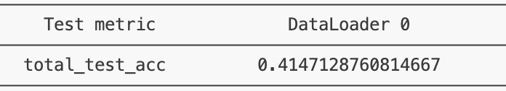

h. P2C
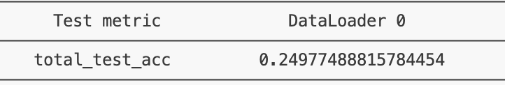

i. P2S
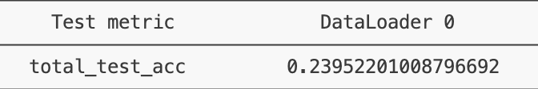

j. S2R
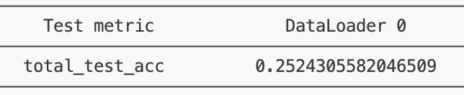

k. S2C
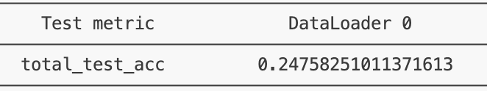

l. S2P

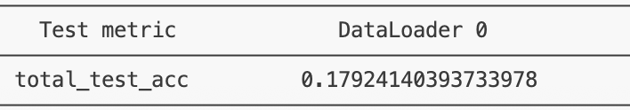

3. ODA Scenario
a. R2C
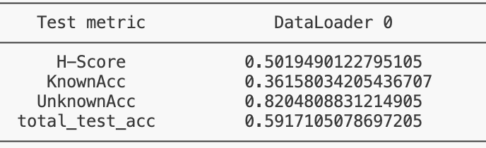
b. R2P
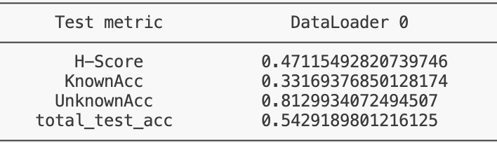

c. R2S
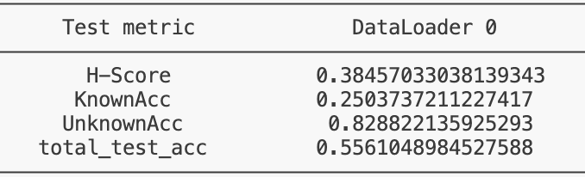

d. C2R
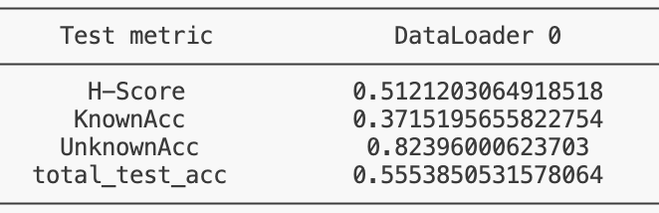

e. C2P
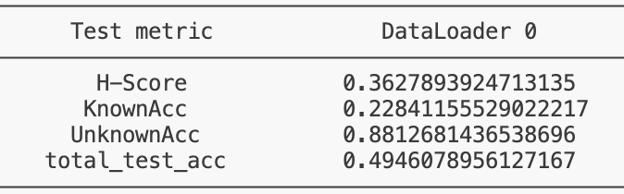

f. C2S
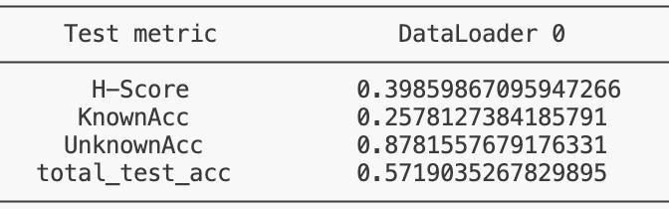

g. P2R
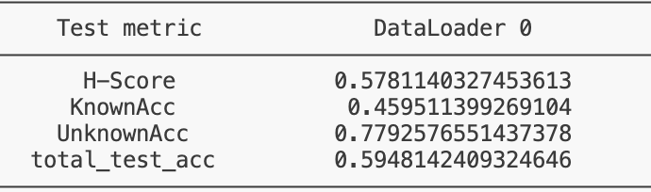

h. P2C
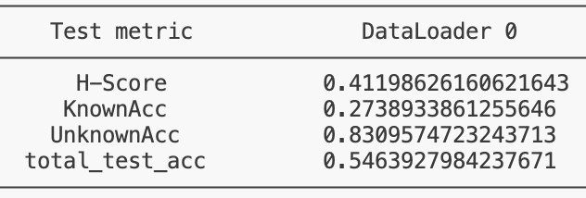

i. P2S
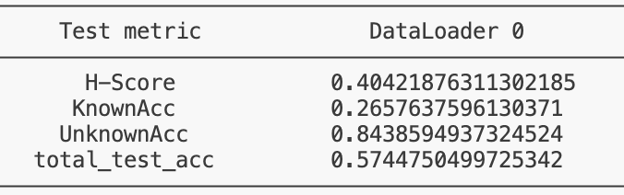

j. S2R
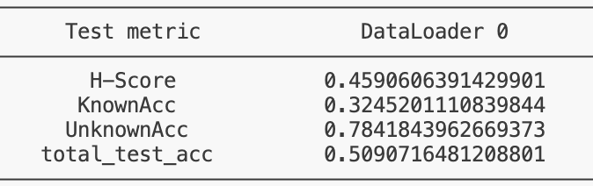

k. S2C
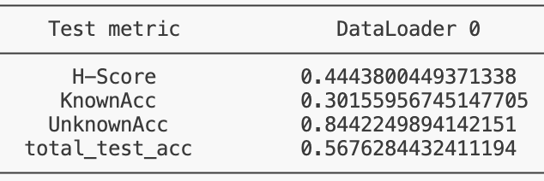

l. S2P
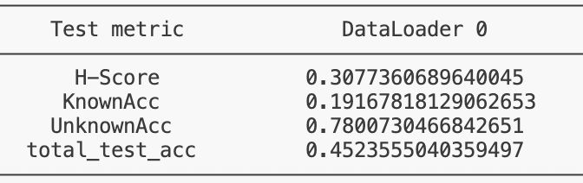

Training Adaptation

A. Domainnet:
1. OPDA
a. R2C
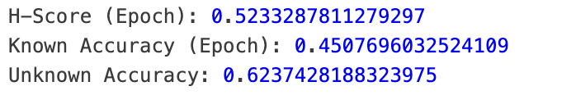

b. R2P
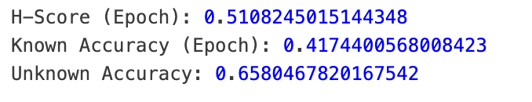
c. R2S
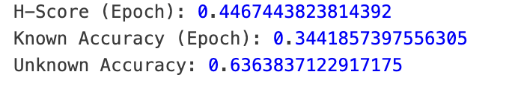

d. C2R
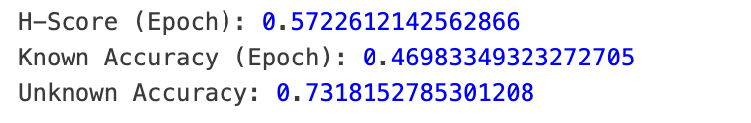

e. C2P
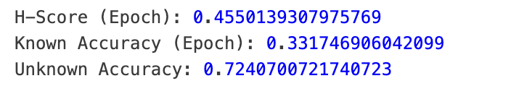

f. C2S
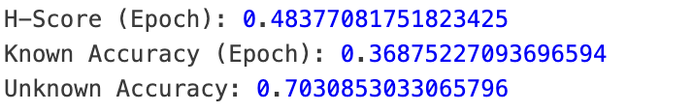

g. P2R
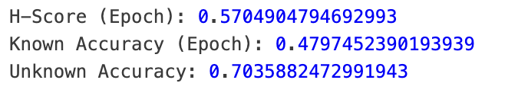

h. P2C


i. P2S
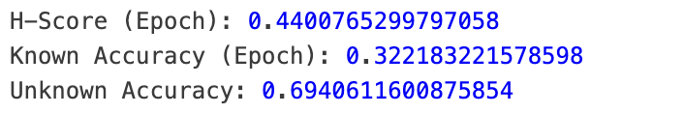

j. S2R
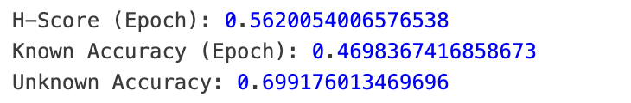

k. S2C
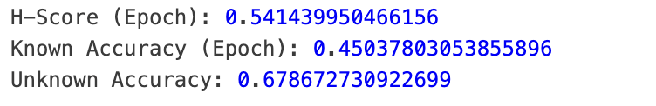

l. S2P
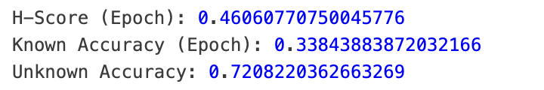

2. ODA Scenario
a. R2C


b. R2P


c. R2S
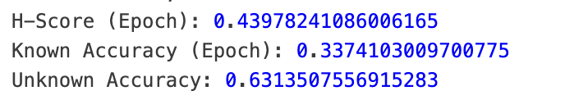

d. C2R
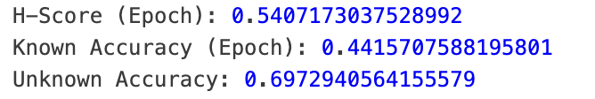

e. C2P
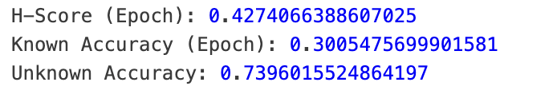

f. C2S
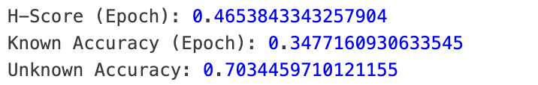

g. P2R
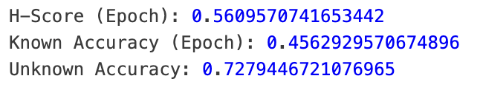

h. P2C
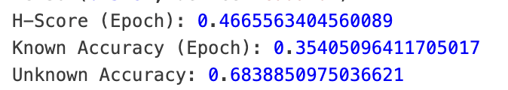

i. P2S
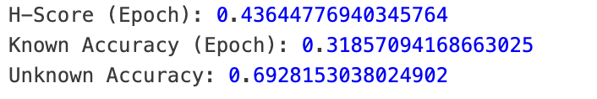

j. S2R
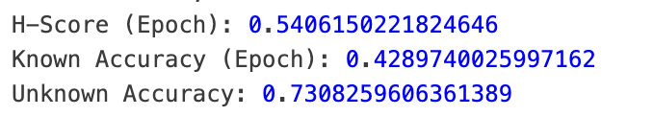

k. S2C
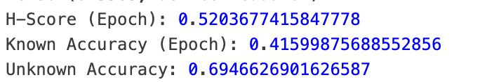

l. S2P
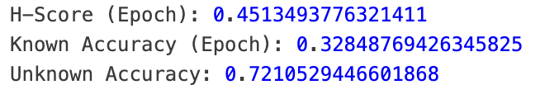

3. PDA Scenario
a. R2C

[04:37<00:00, 1.44it/s, v_num=88, train_loss_step=-31.4, train_acc_step=0.190, tta_acc_step=0.328, train_loss_epoch=-42.5, train_acc_epoch=0.345, tta_acc_epoch=0.]

b. R2P
[06:46<00:00, 1.68it/s, v_num=89, train_loss_step=-18.4, train_acc_step=0.167, tta_acc_step=0.422, train_loss_epoch=-45.2, train_acc_epoch=0.297, tta_acc_epoch=0.395]
c. R2S
[06:43<00:00, 1.32it/s, v_num=90, train_loss_step=-39.7, train_acc_step=0.273, tta_acc_step=0.266, train_loss_epoch=-59.0, train_acc_epoch=0.354, tta_acc_epoch=0.335]

d. C2R
[20:22<00:00, 1.32it/s, v_num=91, train_loss_step=-21.9, train_acc_step=0.143, tta_acc_step=0.266, train_loss_epoch=-30.0, train_acc_epoch=0.203, tta_acc_epoch=0.379]

e. C2P
[08:14<00:00, 1.38it/s, v_num=92, train_loss_step=-26.7, train_acc_step=0.195, tta_acc_step=0.297, train_loss_epoch=-36.1, train_acc_epoch=0.228, tta_acc_epoch=0.280]

f. C2S
[06:31<00:00, 1.36it/s, v_num=93, train_loss_step=-11.5, train_acc_step=0.100, tta_acc_step=0.172, train_loss_epoch=-37.1, train_acc_epoch=0.259, tta_acc_epoch=0.320]

g. P2R
[19:41<00:00, 1.37it/s, v_num=94, train_loss_step=-44.5, train_acc_step=0.176, tta_acc_step=0.344, train_loss_epoch=-33.1, train_acc_epoch=0.241, tta_acc_epoch=0.449]

h. P2C
[04:59<00:00, 1.33it/s, v_num=95, train_loss_step=-17.8, train_acc_step=0.122, tta_acc_step=0.344, train_loss_epoch=-40.3, train_acc_epoch=0.310, tta_acc_epoch=0.344]

i. P2S
[05:21<00:00, 1.66it/s, v_num=96, train_loss_step=-28.2, train_acc_step=0.160, tta_acc_step=0.250, train_loss_epoch=-39.4, train_acc_epoch=0.271, tta_acc_epoch=0.340]

j. S2R
[18:18<00:00, 1.47it/s, v_num=97, train_loss_step=-28.3, train_acc_step=0.190, tta_acc_step=0.359, train_loss_epoch=-35.5, train_acc_epoch=0.234, tta_acc_epoch=0.395]

k. S2C
[04:59<00:00, 1.33it/s, v_num=98, train_loss_step=-11.7, train_acc_step=0.111, tta_acc_step=0.391, train_loss_epoch=-43.0, train_acc_epoch=0.350, tta_acc_epoch=0.416]

l. S2P
[07:36<00:00, 1.50it/s, v_num=99, train_loss_step=-24.7, train_acc_step=0.194, tta_acc_step=0.406, train_loss_epoch=-44.8, train_acc_epoch=0.287, tta_acc_epoch=0.343]

VISDA – C
Training Adaptation

OPDA
H-Score (Epoch): 0.6089703440666199
Known Accuracy (Epoch): 0.4864407181739807
Unknown Accuracy: 0.8140286803245544

ODA
H-Score (Epoch): 0.6006873250007629
Known Accuracy (Epoch): 0.5156699419021606
Unknown Accuracy: 0.7192862629890442

PDA
[01:53<00:00, 3.98it/s, v_num=8, train_loss_step=-160., train_acc_step=0.377, tta_acc_step=0.453, train_loss_epoch=-125., train_acc_epoch=0.339, tta_acc_epoch=0.409]

Visda – C

OPDA after normalization:


