Advanced Data Visualization (ADV) Lab

Exp 1

Jay Nadkarni

2021300081

BE COMPS B

ADV Batch D

**Problem Statement:** Create basic charts using Tableau / Power BI / R / Python / D3.js to be performed on the dataset of Ecommerce field

* Complete all plots on practice dataset and reproduce on e-commerce dataset.
* Basic - Bar chart, Pie chart, Histogram, Timeline chart, Scatter plot, Bubble plot
* Calculate Product wise sales, region wise sales
* Write observations from each chart

**Software Used:** PowerBi (for charts), Pandas (for product and region wise sales)

**Dataset Used:** <https://www.kaggle.com/datasets/jaynadkarni/e-commerce-sales-data-india>

* **Visualizations with Observations**

**1. Bar Chart**

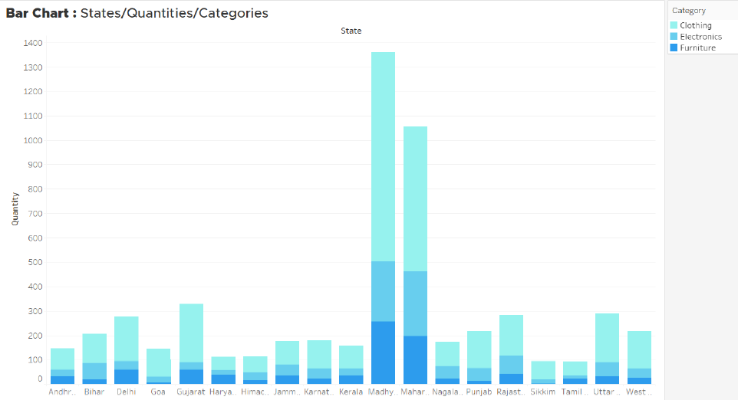

* A clear trend emerges, with Madhya Pradesh and Maharashtra leading the way in terms of quantity ordered, significantly outpacing other states.
* Across all states, clothing is the most sought-after category, followed closely by electronics in most cases.
* However, some exceptions stand out, such as Delhi, Haryana, and Tamil Nadu, where furniture takes the second spot.

**2. Pie Chart**

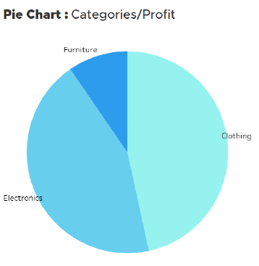

* Clothing and Electronics are equally contributing to profit, indicating a balanced demand for both categories.
* However, profit margins vary across states, with Furniture contributing significantly less to profit in some states, highlighting regional differences in consumer preferences and purchasing habits.

**3. Histogram**

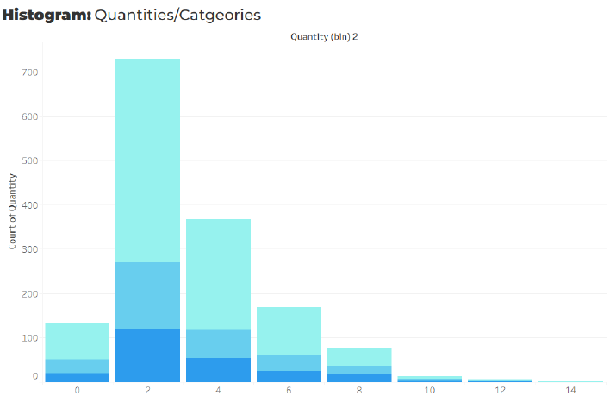

* The data reveals that people typically purchase products in quantities of 2-4 items, followed by 4-6 items, indicating a sweet spot for consumer demand.
* The distribution of purchase quantities follows a normal curve, suggesting a natural and expected pattern of consumer behavior, with most purchases clustering around the average quantity and tapering off at the extremes.

**4. Timeline Chart**

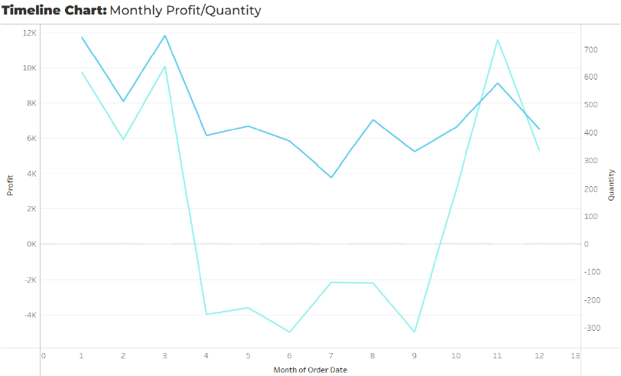

* A significant decline in order quantities occurs during the months of April to September, necessitating a strategic revision to counteract this trend and boost sales.
* Profit closely follows the order quantity trend, with sharp peaks in early March and late October presenting opportunities for growth and increased profitability, while the seasonal slump requires targeted strategies to mitigate its impact

**5. Scatter Plot**

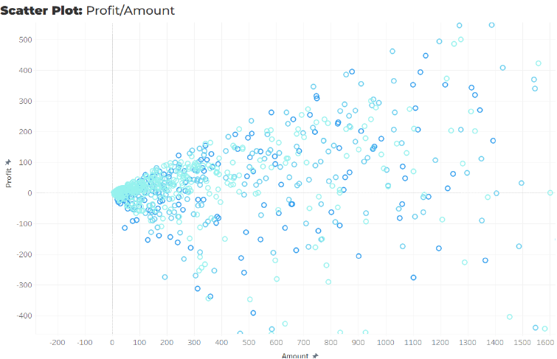

* A strong linear correlation exists between the amount and profit/loss, with a direct proportional relationship between the two, indicating that as the amount increases or decreases, the profit or loss also follows a similar trajectory.
* However, the clothing category deviates from this trend, showing a relatively lower correlation with profit/loss, suggesting that other factors may influence the profitability of clothing sales, making it a unique case compared to other categories.

**6. Bubble Plot**

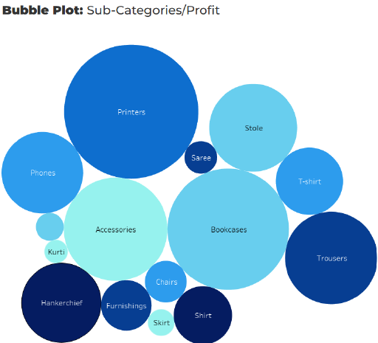

* Printers, Bookcases, and Accessories emerge as the most profitable sub-categories, generating the highest profit margins.
* To leverage this potential, sales and marketing efforts should be intensified and optimized for these sub-categories, ensuring they receive the necessary attention and resources to maximize their profitability and drive business growth.

**7. Product Wise Sales**

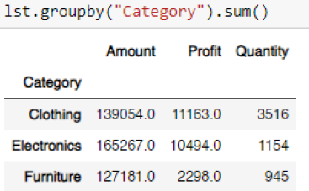

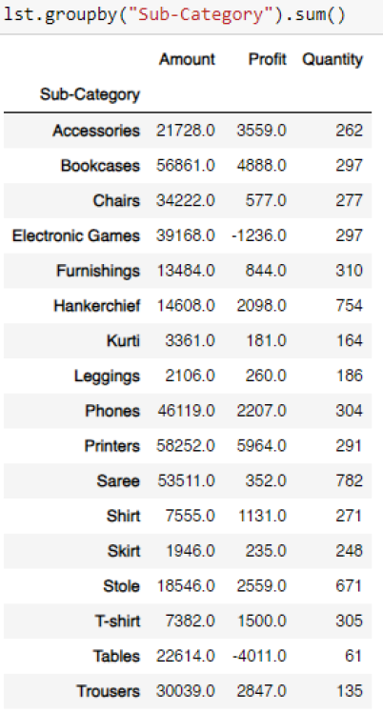

* Electronic Games and Tables show losses, while Printers, Bookcases, and Accessories have high profit margins.
* Sarees sell most units but rank 5th in revenue; Phones generate high revenue from fewer units.

12. Region wise sales:

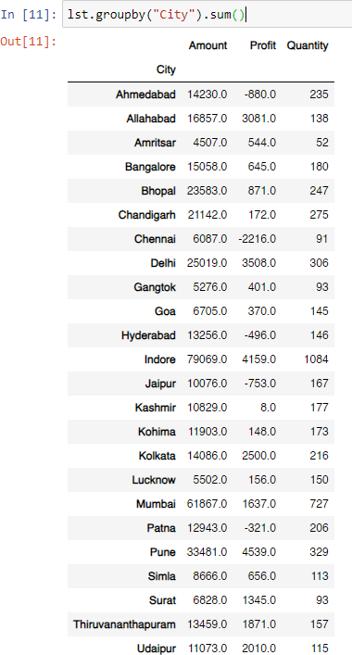

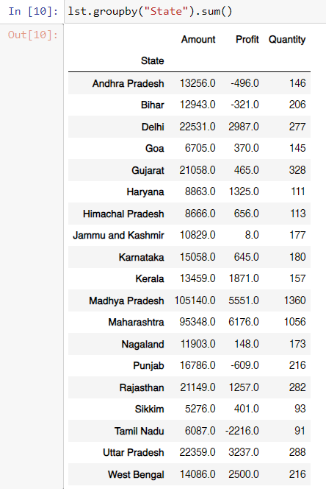

* Madhya Pradesh and Maharashtra have high quantities and profits, but Gujarat has high quantity with low profit.
* Major cities like Delhi and Mumbai show high sales amounts, but some struggle with profitability (e.g., Chennai, Ahmedabad).