### Oracle修改序列

SELECT * from user_sequences WHERE SEQUENCE_NAME LIKE '%BILLLOG%';

ALTER sequence BILLLOGS INCREMENT BY 217;

ALTER SEQUENCE BILLLOGS INCREMENT BY 1;

### Oracle设置主键自增长

1. 创建表

CREATE TABLE user (

id int NOT NULL,

username varchar(50) default NULL,

password varchar(50) default NULL,

PRIMARY KEY (id)

);

create sequence J_USERS; --创建序列

1. 创建触发器

CREATE OR REPLACE TRIGGER T_J_USER

BEFORE INSERT ON user FOR EACH ROW WHEN(new.id is NULL)

begin

select J_USERS.nextval into :new.id from dual;

end;

(begin

if :new. id is null then

select J_USERS.nextval into :new. id from dual;

end if;

end)

1. 测试用例

INSERT into J_USER(USERNAME,PASSWORD) VALUES('a','a');

INSERT into J_USER(USERNAME,PASSWORD) VALUES('b','b');

INSERT into J_USER(USERNAME,PASSWORD) VALUES('c','c');

INSERT into J_USER(USERNAME,PASSWORD) VALUES('d','d');

INSERT into J_USER(USERNAME,PASSWORD) VALUES('e','e');

1. 验证

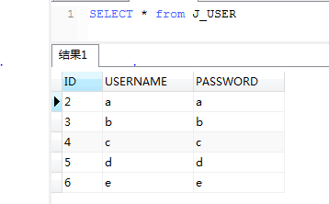

### 模糊查询中通配符关键字ESCAPE

SELECT

*

FROM

J_USER J

WHERE

J.USERNAME LIKE '%\_B%' ESCAPE '\' ;

### 两表联合更新

UPDATE (

SELECT

A .checkmode AS ac,

c.checkmode AS cc

FROM

accountinfo A,

custominfo c

WHERE

A .CUSTOMNO = c.CUSTOMNO

AND c.SIGNFLAG = 1

)

SET ac = cc