
ENGR-E516
Engineering Cloud Computing

Prof. Fengguang Song

Designing a Cloud-Based Data Pipeline Architecture
for Analyzing Amazon Product Sales

Final-Project Report
Fall 2024

Submitted by:

- Jayanand Hiremath
- Kasturi Disale
- Supreeth

Introduction
Problem Statement:
Processing large, diverse datasets on local systems poses challenges related to scalability, fault tolerance, and efficiency. A cloud-based architecture addresses these limitations, enabling advanced analytics and streamlined workflows.
Objective:
Design a scalable and efficient data pipeline using Google Cloud Platform (GCP) to analyze Amazon product sales data, providing insights into pricing, discounts, and product performance.
Project Overview:
Amazon has transformed online shopping with its vast product selection, competitive pricing, and efficient delivery systems. Its personalized recommendation algorithms significantly enhance customer satisfaction and loyalty.
Using data-driven insights, Amazon optimizes consumer offerings and logistics to ensure superior order fulfillment. Analyzing datasets such as the Amazon Product Sales dataset provides valuable information on market trends and consumer preferences, enabling businesses, including small stores and suppliers, to improve inventory management, pricing strategies, and demand forecasting.
This project employs Google Cloud Platform (GCP) services to analyze Amazon Product Sales data effectively. Key tools include Cloud Storage for data hosting, Google Compute Engine for ETL processes, BigQuery for analysis, and Looker Studio for visualization. These technologies work together to uncover actionable insights into product performance, supporting strategic growth and informed decision-making in the retail industry.
Scope:
Build an end-to-end data pipeline using GCP for data preprocessing, storage, querying, and visualization. The current scope focuses on static datasets, but the design is adaptable for future scalability and real-time data integration.
Why use GCP?
GCP was selected for its ability to support production-ready pipelines with key features like:
Scalability: Handles large datasets without infrastructure upgrades.
Redundancy: Ensures failover support and automatic retries.
Collaboration: Enables real-time monitoring and shared visualizations.
Automation: Supports dynamic data sources for continuous processing.
This approach aligns with industry best practices, leveraging GCP tools like Cloud Functions, BigQuery, and Looker Studio for production-scale data engineering.
Methodology:
Data Pipeline Overview
- Data Ingestion: Load raw data into Google Cloud Storage.
- Preprocessing: Clean and transform data using Python (Pandas) and PySpark.
- Storage: Store cleaned data in BigQuery for querying and analysis.
- Visualization: Build interactive dashboards using Looker Studio.
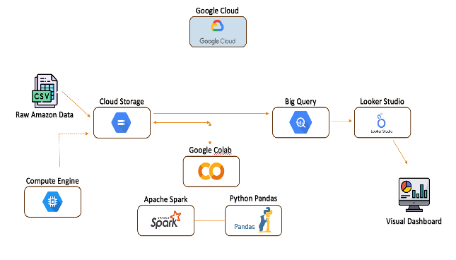
The pipeline integrates GCP services to ensure scalability, efficiency, and production readiness.

Motivation:
- Need for Scalable Data Pipelines: Traditional local data processing systems struggle with large datasets, limiting scalability, fault tolerance, and automation. This project aims to overcome these challenges using a cloud-based pipeline.
- Demand for Data-Driven Decision Making: Businesses increasingly rely on data insights to optimize pricing, inventory, and customer engagement. Analyzing Amazon product sales data offers valuable insights for suppliers, retailers, and market analysts.
- Industry Relevance: GCP-based data pipelines align with modern industry practices, preparing for real-world data engineering roles that require experience with ETL, cloud storage, and visualization tools.
- Hands-On Learning: This project serves as a practical learning experience in cloud data engineering, showcasing proficiency in GCP services like Cloud Storage, BigQuery, and Looker Studio.
- Future Expansion: By designing a scalable pipeline, this project provides a foundation for handling real-time data streams, supporting more advanced analytics and continuous data integration.
Background:
- Cloud-Based Data Pipelines: Modern data pipelines leverage cloud platforms like GCP, AWS, and Azure to process, store, and visualize large datasets. Unlike local systems, cloud pipelines offer scalability, redundancy, and automation.
- GCP Ecosystem: GCP offers essential tools for data engineering, including Cloud Storage for ingestion, Compute Engine for processing, BigQuery for storage and querying, and Looker Studio for visualization. Each tool plays a role in building scalable, production-ready pipelines.
- Retail Data Analytics: Analyzing product sales data enables businesses to identify trends, optimize pricing, and predict demand. This approach supports decision-making for suppliers, retailers, and market analysts, offering a competitive advantage in the retail industry.
Related Work:
Data processing and analysis pipelines have become central to extracting valuable insights from large datasets. Traditional ETL pipelines (Extract, Transform, Load) are commonly employed to automate the flow of data from multiple sources into a data warehouse for analysis. Tools like Apache NiFi, AWS Glue, and Talend provide comprehensive ETL solutions, focusing on real-time data extraction, transformation, and loading to support business intelligence applications.
However, not all projects require real-time data processing. Many workflows, like the one in this project, prioritize data collection, preprocessing, and exploratory data analysis (EDA) over full ETL pipelines. In cases involving static datasets, the focus is on cleaning, transforming, and analyzing data to extract insights for visualization, without the need for continuous data ingestion. Tools such as Pandas and PySpark are widely used for data preprocessing tasks, while platforms like Looker Studio and Tableau help visualize and communicate the findings.
Moreover, EDA is vital in understanding the data's structure, identifying patterns, and driving further analysis. This approach is especially useful in data science projects focused on gaining actionable insights from historical data rather than on building real-time pipelines.
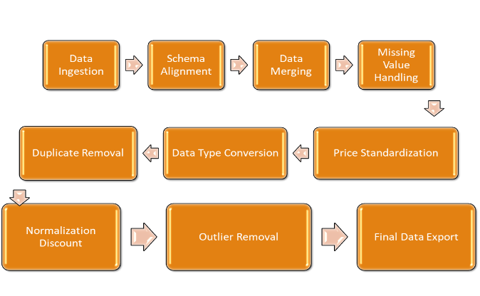
As businesses increasingly rely on cloud-based solutions, Google Cloud Services provide the necessary infrastructure to scale such data processing workflows. With services like BigQuery, Google Cloud Storage, and Looker Studio, this project exemplifies how cloud technologies can facilitate data analysis without the constraints of traditional infrastructure. Additionally, as Data Analysis as a Service (DAaaS) becomes more prevalent, organizations are able to leverage cloud platforms to gain valuable insights without managing complex hardware or software systems themselves.
Cloud for Big Data Analytics Trends
DATA ANALYTICS AND ITS IMPACT
Data Overview:
The dataset, obtained from Kaggle and UCSD Data Reviews, contains millions of records across over 140 categories. It includes product details such as names, prices, ratings, and discounts. However, issues like missing values, duplicates, and inconsistencies required thorough preprocessing to ensure the data's accuracy and reliability.
Data Cleaning and Preprocessing
The following steps were performed to prepare the data for analysis:
- Schema Alignment: Standardized schema for CSV files with minor deviations.
- Data Merging: Combined multiple CSV files into a single DataFrame.
- Handling Missing Values:
- Removed rows with missing product prices and names.
- Imputed missing ratings and discount prices with zero values.
- Removing Duplicates: Removed repeated records.
- Standardization:
- Converted prices to a common currency.
- Unified date formats.
- Normalized numerical data for consistency.
- Outlier Removal: Removed records with discount percentages over 98.5%.
While Pandas was used for local processing, PySpark was explored for its cloud integration with Google Cloud Platform (GCP), enabling larger-scale processing with seamless connectivity to BigQuery and Cloud Storage. This setup enhanced scalability and efficiency for cloud-based analytics.

Challenges
- Data Quality Issues:
- Challenge: Missing values, duplicates, and inconsistent formats (e.g., dates, prices).
- Resolution: Used Pandas to standardize formats, remove duplicates, and clean missing data. Prices were dropped, while missing ratings and discounts were set to zero.

- Handling Large Datasets:
- Challenge: Inconsistent values in key columns like product name, price, and discount.
- Resolution: Cleaned data with Pandas and PySpark. Removed rows with missing prices, set missing discount prices to zero, and filtered out records with discounts over 98.5%.

Exploratory Data Analysis:
Techniques Used:
EDA was performed using Pandas and Seaborn, focusing on:
- Descriptive Statistics: Summary metrics for prices and ratings.
- Visual Analysis: Distribution plots, bar charts, and heatmaps to explore category and price trends.
- Discount Analysis: Examined discount patterns across categories.
Insights:
- Category Distribution: Accessories and Appliances were the most common categories.
- Discount Trends: Women's Clothing, accessories and Appliances had the highest discounts, suggesting targeted marketing.
- Correlation: Higher discounts were linked to better ratings and more reviews, indicating greater customer engagement.
Challenges in EDA:
- Inconsistent Price Formats: Standardized prices for consistency.

- Handling Large Data: Used efficient Pandas operations to process millions of records.
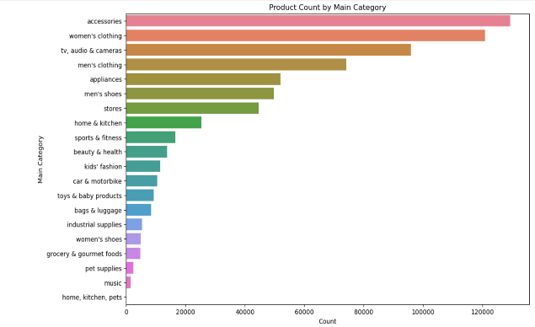

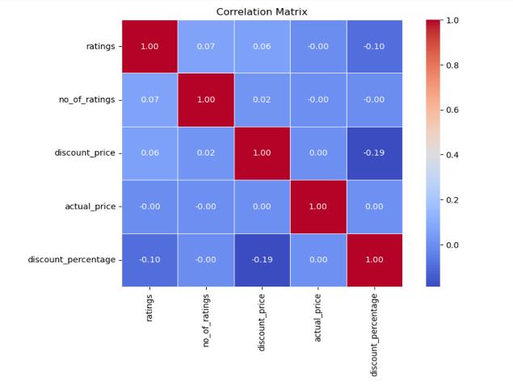

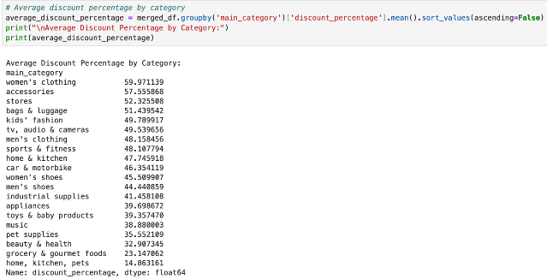

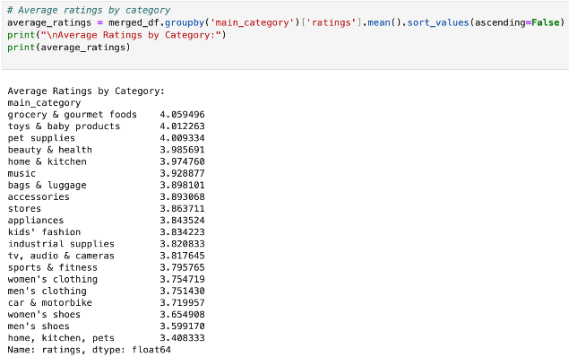
Implementing and Testing EDA in BigQuery
To validate the Python-based EDA, key analyses were translated into SQL and executed in BigQuery.
Activities Performed:
- Translated Python logic into SQL queries to analyze sales and discount trends by category.
- Queried the cleaned dataset in BigQuery to calculate metrics such as average sales per category and discount percentages.
- Visualized the results by converting BigQuery outputs into Pandas DataFrames and charting them with Seaborn.
Key Insights:
- The dominance of categories like Accessories and Appliances was confirmed through SQL queries.
- Trends identified in Python were replicated in BigQuery, ensuring consistency across both platforms.
Challenges:
- Query Optimization: Initial queries were resource-intensive and required optimization to improve performance.
- Cross-Platform Consistency: Ensured alignment between insights derived from Python and SQL results for consistency.

Google Cloud Implementation
- Google Cloud Setup: The setup involved creating a project, enabling necessary APIs, and configuring IAM permissions. Data was ingested into BigQuery through Cloud Storage.
- Google Cloud Storage: A scalable service for storing and retrieving large datasets, used for data ingestion before processing in tools like BigQuery.
- BigQuery Integration: SQL queries were used to analyze category-wise sales and discount trends. These results were cross-validated with insights derived from Python-based EDA.
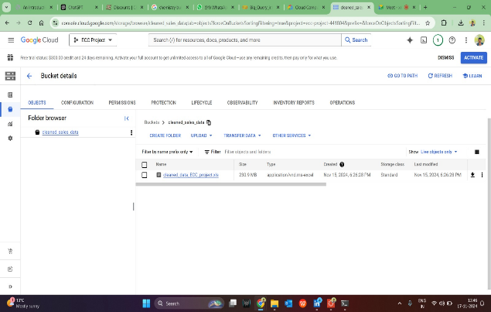
- Looker Studio Visualizations: Interactive dashboards were created in Looker Studio to visualize key metrics, including product discounts and ratings.

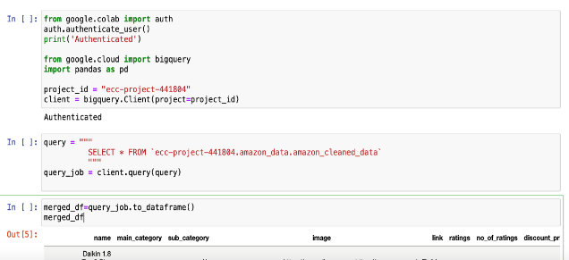

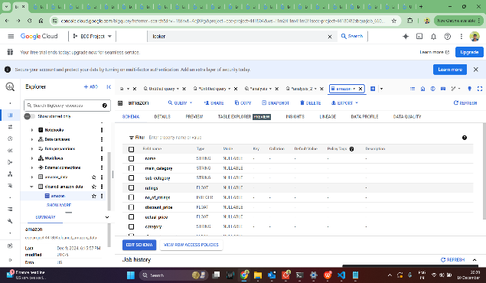
Google Cloud Storage and bigquery integration: csv file successfully loaded into bigquery.

Created a dataset and table named amazon to store the csv file data.
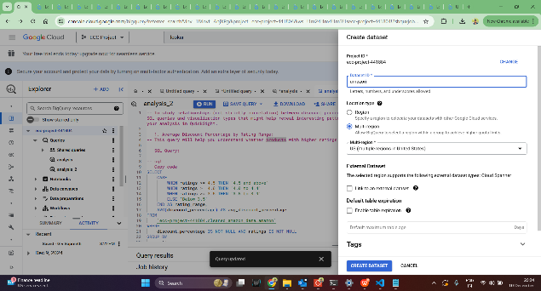

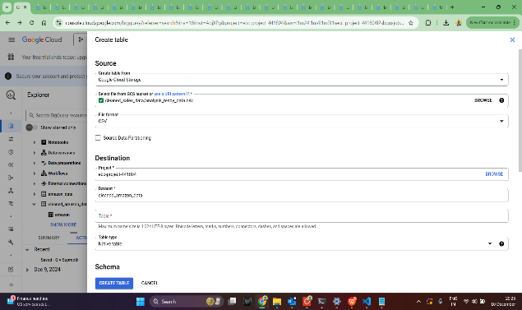

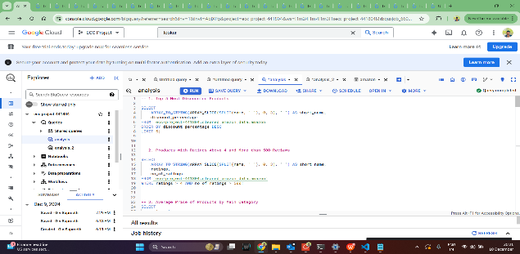

The process of loading data into BigQuery, creating the required datasets and tables, and running SQL queries was seamless. However, we encountered data type mismatch errors, which were subsequently resolved.
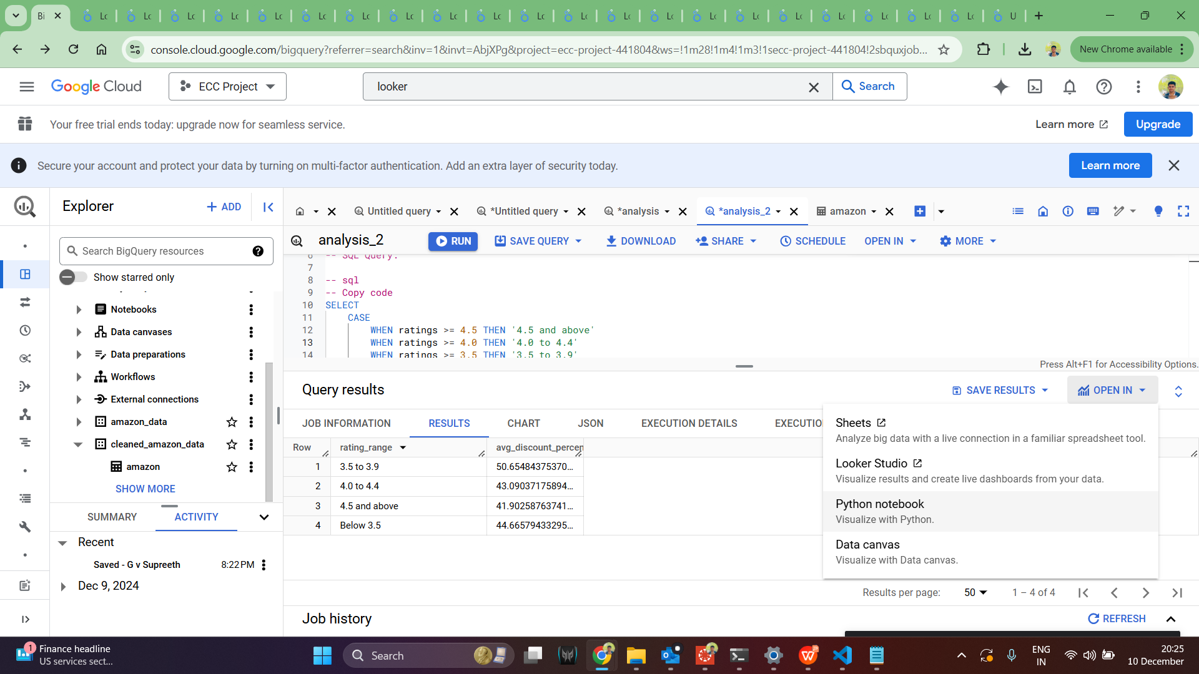
The BigQuery results were connected to Looker Studio, as illustrated in the image below.

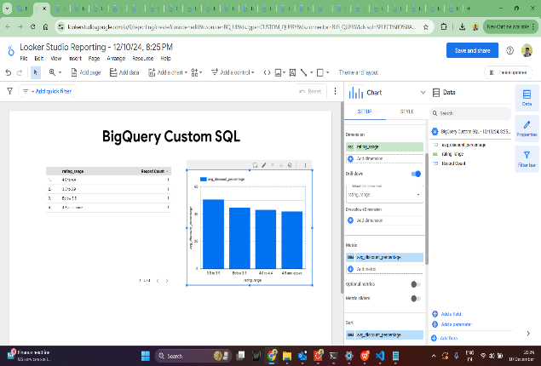

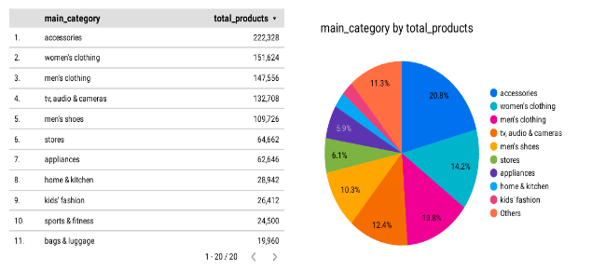

Challenges and Resolutions
- Data Quality Issues:
- Problem: Missing values, duplicates, and inconsistent formats.
- Resolution: Data preprocessing using Python (Pandas) and PySpark.
- BigQuery Query Optimization:
- Problem: Initial slow query performance.
- Resolution: Refined SQL logic and optimized column selection for better performance.
- Authentication and Permissions:
- Problem: Issues with authenticating Colab with GCP.
- Resolution: Implemented OAuth authentication and assigned appropriate IAM roles.
- Consistency Across Platforms:
- Problem: Aligning SQL and Python results.
- Resolution: Conducted iterative validation and cross-checking to ensure consistency.

Interactive Visualizations and Insights from Looker Studio:
- Unreviewed Yet Highly Rated Products: Displays products with high ratings but no reviews, indicating potential data anomalies or new product entries.
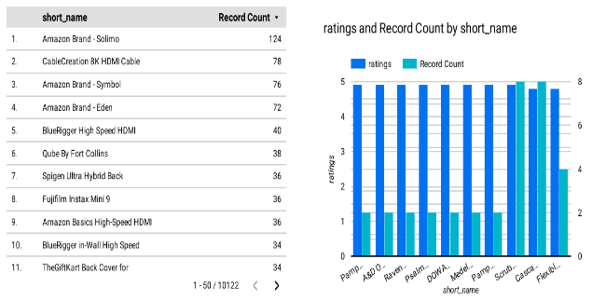

- Slices of Selection: Product Share by Category: Visualizes the distribution of products across various categories, highlighting the share each category holds in the overall dataset.

- Total Number of Products by Brand:
Displays the count of products offered by each brand, revealing the most and least represented brands in the dataset.
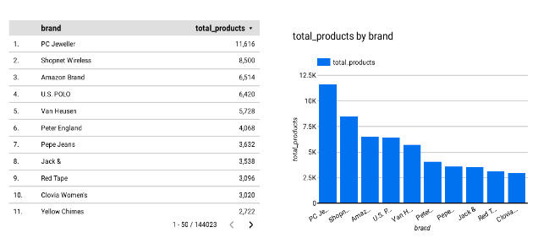

- Average Price Analysis Across Product Categories: Shows the average product prices for each category, highlighting price variations and identifying premium vs. budget-friendly categories.
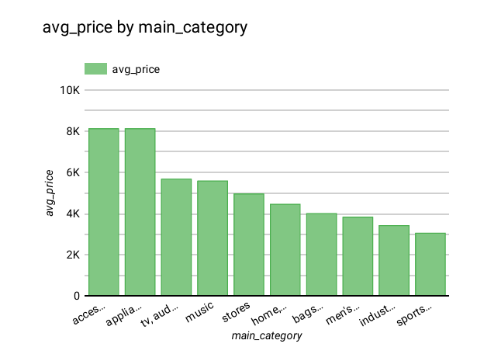

- Top-Rated Products with Over 500 Reviews:
Highlights highly rated products with significant customer feedback, indicating popular and well-reviewed items.

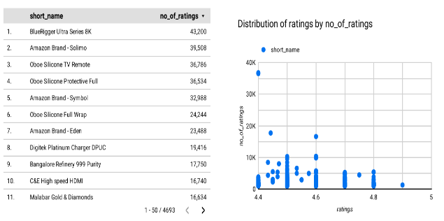

- Rating vs. Discount: Uncovering the Value Equation: Visualizes the relationship between product ratings and discount percentages, revealing how discounts influence customer satisfaction.
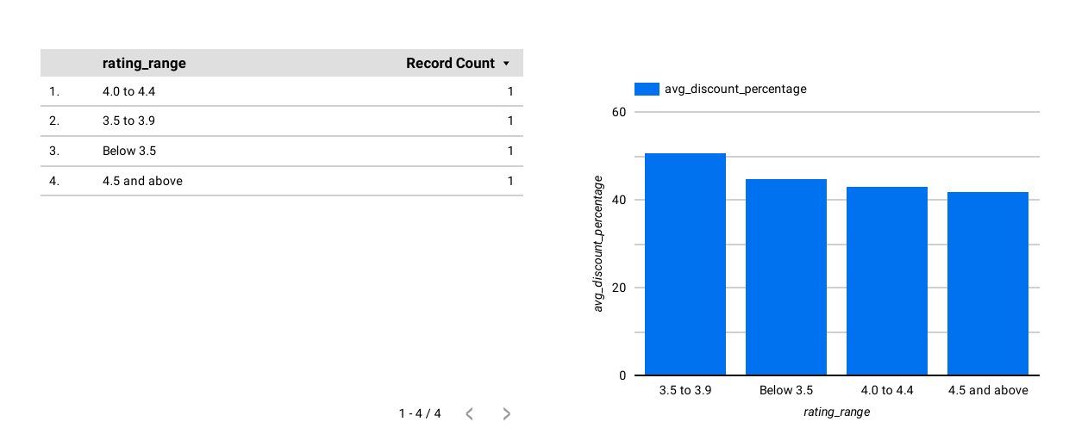

- Best-Rated Products with Highest Discounts
Highlights top-rated products that offer the most significant discounts, showcasing value-driven purchase opportunities.
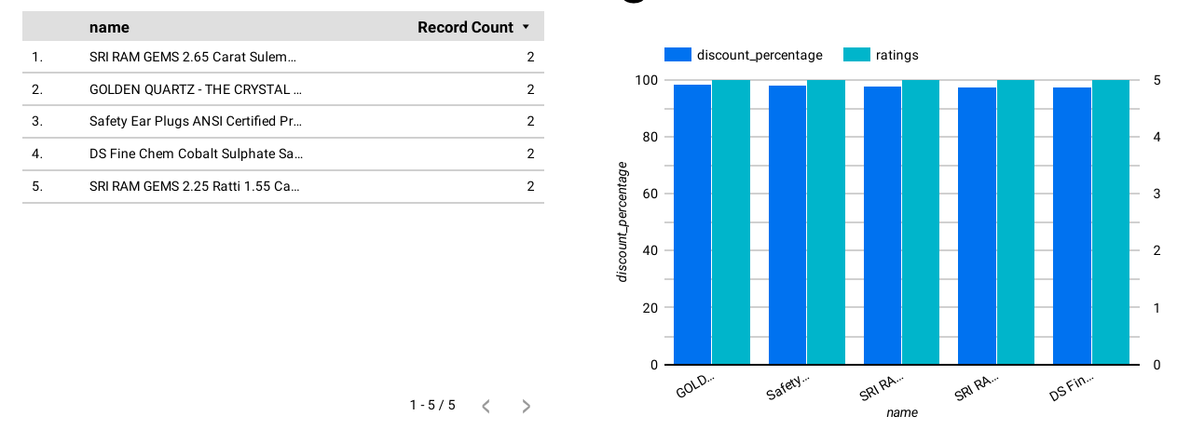

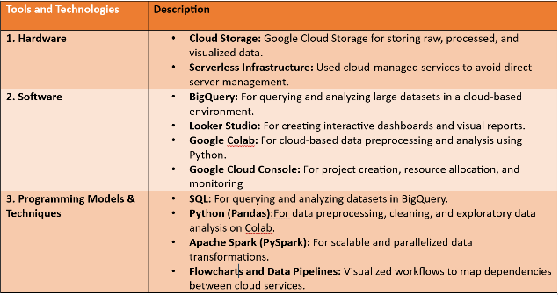
Tools and Technologies:

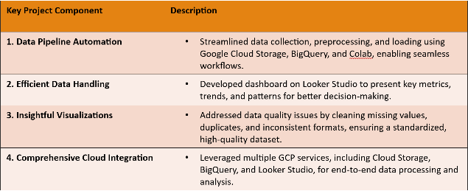
Project Highlights:

Project Evaluation:
The project involved collecting, processing, and analyzing a large product dataset to uncover insights into product pricing, ratings, and discount trends, utilizing tools such as Python, PySpark, BigQuery, and Looker Studio. The main objectives were to clean the data, perform exploratory data analysis (EDA), and visualize findings to help identify patterns and trends in product sales and promotions.
- Goal Achievement:
The project achieved its goals by cleaning data, performing EDA, and generating visualizations to identify trends in categories, discounts, and ratings. Key insights were derived, such as dominant categories and the correlation between discounts and ratings. Cloud services, especially GCP, facilitated scalable data processing with BigQuery and enabled interactive visualizations in Looker Studio.
- Effectiveness:
- The combination of Python (Pandas) and PySpark for preprocessing, coupled with BigQuery for scalable analysis, ensured that even large datasets were processed efficiently.
- The use of Looker Studio for interactive dashboards facilitated better presentation and understanding of complex data insights, making the project highly effective for visual storytelling.
- Efficiency:
Data processing was efficient with Python and PySpark, and SQL queries in BigQuery were optimized for performance. Looker Studio enabled quick dashboard creation, aiding time efficiency.

- Data Accuracy:
- The data preprocessing steps, such as handling missing values, removing duplicates, and standardizing formats, ensured that the data used for analysis was accurate and consistent.
- The cross-validation between Python and BigQuery results ensured consistency across platforms and enhanced the reliability of insights.
- Outcome Assessment:
- Key Insights: The project provided valuable insights, such as identifying product categories that dominate the dataset (Accessories and Appliances), understanding discount patterns, and recognizing correlations between product ratings and discounts.
- The visualizations effectively communicated these findings and helped uncover deeper insights into product sales trends, discount strategies, and customer engagement.
- Challenges and Solutions:
- Data Quality: Missing values and duplicates were handled effectively through preprocessing.
- BigQuery Optimization: Slow queries were improved with refined SQL logic.
- Authentication: OAuth and proper IAM roles solved authentication issues between Colab and GCP.

Discussion:
The project successfully utilized GCP’s BigQuery for large-scale data processing and Looker Studio for interactive visualizations, offering insights into product categories, discounts, and ratings. However, challenges were encountered in data preprocessing, query optimization, and cross-platform consistency between Python and SQL-based analyses.

Limitations:
- Limited by the availability of static data, preventing real-time data analysis.
- Some inconsistencies in data formats and missing values required extensive preprocessing.
- Cloud service limitations, such as the learning curve with new platforms, hindered initial progress.

Next Steps:
Future improvements could focus on refining the data preprocessing pipeline, exploring more advanced query optimization techniques in BigQuery, and integrating real-time data sources for more dynamic insights. Additionally, expanding the scope to include other platforms like AWS or Azure for comparison could further enhance scalability and efficiency.

Conclusion:
This project effectively demonstrated the power of cloud technologies, particularly Google Cloud Platform (GCP), for handling large datasets and generating insightful analyses. By leveraging BigQuery for data processing and Looker Studio for visualization, we were able to uncover key patterns and trends in product categories, discounts, and ratings. Despite challenges in data quality and query optimization, the project successfully provided valuable insights into the relationships between product features and customer engagement. Moving forward, there is potential to expand the scope by incorporating real-time data and further optimizing the pipeline for enhanced scalability. Overall, this project highlights the importance of cloud-based tools in modern data analysis and visualization workflows, offering a robust foundation for future data-driven decision-making.

Key Project Contributions:
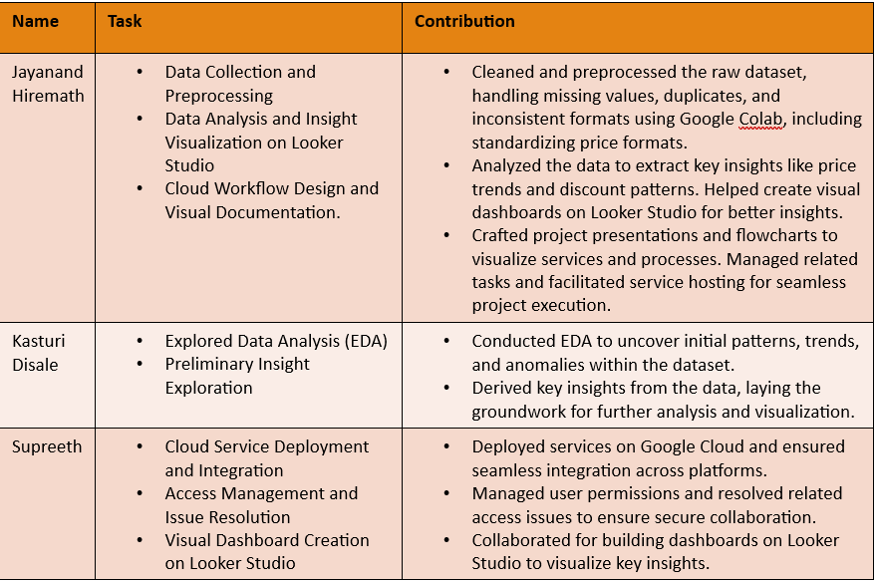

References

