Project Report

ENR305- Sensors, instruments and experimentation

RFId based Access Control System

# 

Group - 8

Nihaar Patel - AU2040182

Soham Jagrit - AU2040060

Aadya Chinubhai - AU2040232

Nitya Panchal - AU2040249

Jay Shapariya - AU2040208

# Synopsis:

Radio Frequency Identification (RFID), is a low-cost technology that may be used for many purposes, including access control and security. The main goal of this project is to develop and deploy a security system that may be installed in a restricted area into which only authorised individuals are allowed. In order to develop a security system with door locking capabilities that can activate, verify, and validate the user in real time while also unlocking the door for secure access, we used passive RFID technology. When a user places their tag in touch or close to the to the reader, the door instantly opens as the door locking mechanism operates in real time. Here, we have used a small box asour locker for the automatic door lock system for our project purposes.

## List of components:

| Sr No. | Component Name | No of Item | Price(Rs) |
| --- | --- | --- | --- |
| 1 | Arduino Uno R3 | 1 | 385/- |
| 2 | Servo motor | 1 | 100/- |
| 3 | MRFC522 RFID sensor | 1 | 260/- |
| 4 | Male/Female Jumper Wires | 12 | 24/- |
| 5 | Thin connecting wires | 1 | 30/- |
| Total Amount |  |  | 799/- |

# 

# 

# 

# 

# Block diagram:

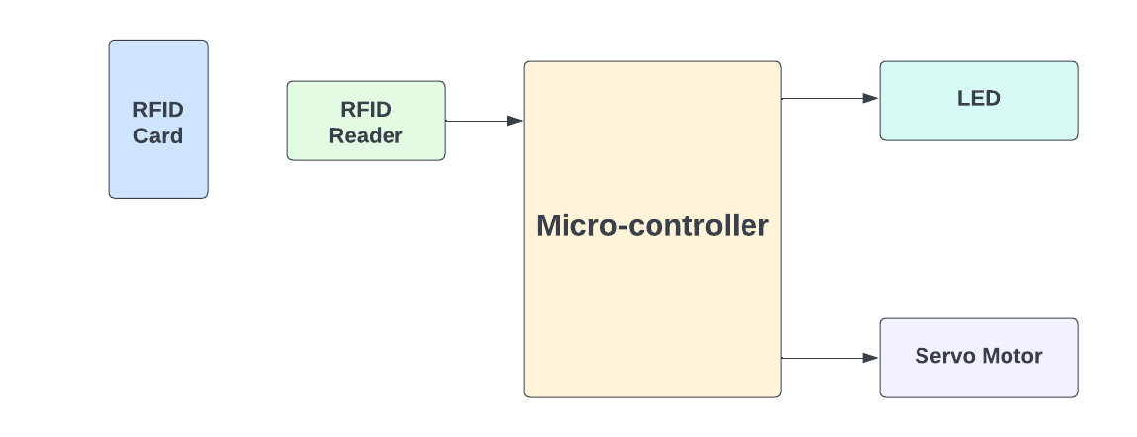

Here the RFID reader is the input device and the LED and Servo Motor are the output devices. The user scans the RFID card on the reader which sends the signal to the microcontroller. The microcontroller then detects the legitimacy of the card and sends the output accordingly. If the RFID card is valid then the LED blinks and the servo motor rotates and unlocks the lock with “Authorized Access” as a message on the serial monitor. If the RFID card is invalid then “Access Denied” is displayed on the serial monitor and no output is generated.

# Theory:

We have used MFRC-522 as our RFId reader which is a two way radio transmitter receiver reader.MFRC-522 has 8 pins which are connected as:

* SDA: Digital 10
* SCK: Digital 13
* MOSI: Digital 11
* MISO: Digital 12
* IRQ: unconnected
* GND: GND
* RST: Digital 9
* 3.3V: 3.3V

For the door opening, we have used a servo motor which is connected to the digital pin 2 of the arduino. The servo motor rotated about an angle of 90 degrees which will open the lock of the box. After a delay of 10 seconds, the servo motor will come back to its original place and the user can manually lock the box again. A LED is connected to the digital pin 2 of the arduino which will make the user aware that the lock is open.

# Circuit Images:

Below are the images of the mechanism of the system and the associated circuit:

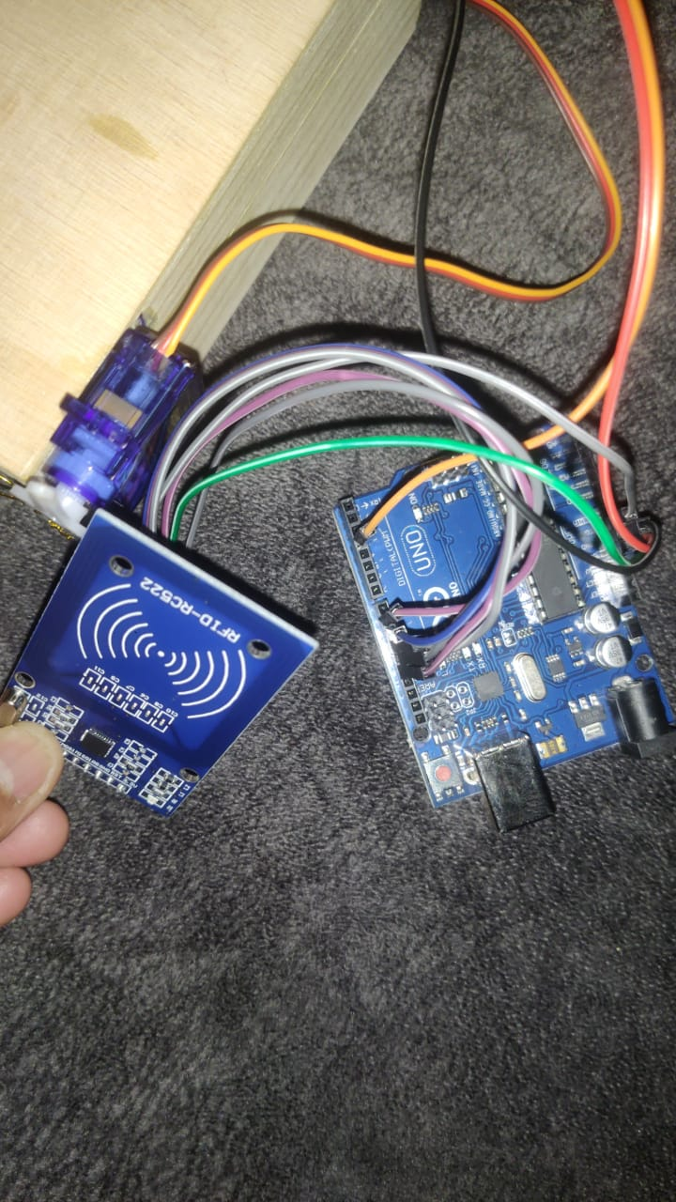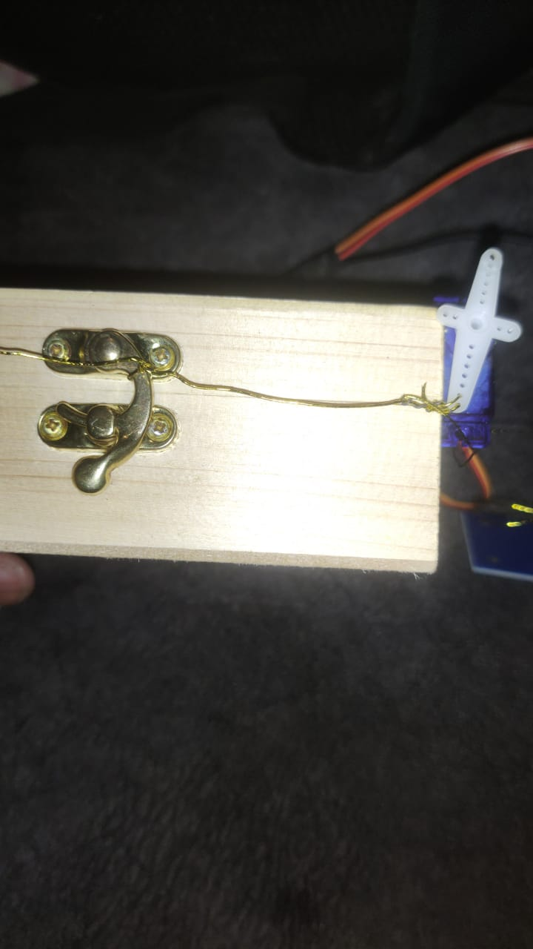

# Algorithm used:

* Int RFID_tags[size] = { hex RFIDs }
* Check RFIDs when a new entry instance is created by looping through rfids.
* If new rfid in RFID_tags:
  + Grant-access.
  + Light LED till the access is granted.
  + Use an arduino servo module for access.
* Else:
  + Don’t grant access.
* Re-Start the process.

# Method of testing and results:

Method of testing is done in the following ways :

We took a 13*13*8 box and attached a servo motor to its opening edge, which is then connected to RFID sensors using arduino and jumper wires. The RFID tag will control the opening of the box by triggering it with a thin wire. The user will have close the manually after the locker is used.

* We put random RFIDs into the code to verify that the lock should not open.
* Then , we used a key with the correct RFID into our MFRC522 sensor and verified that it unlocks or not. We performed a similar experiment with the wrong RFID too and saw that it doesn’t open.
* We have used small locks and RFIDs to lock it.

# Code:

#include <SPI.h>

#include <Keyboard.h>

#include <MFRC522.h>

#include <Servo.h>

#define SS_PIN 10

#define RST_PIN 9

#define SERVO_PIN 3

Servo myservo;

#define ACCESS_DELAY 2000

#define DENIED_DELAY 1000

MFRC522 mfrc522(SS_PIN, RST_PIN); // Create MFRC522 instance.

void setup()

{

Serial.begin(9600); // Initiate a serial communication

SPI.begin(); // Initiate SPI bus

mfrc522.PCD_Init(); // Initiate MFRC522

myservo.attach(SERVO_PIN);

// myservo.write( 70 );

// delay(5000);

// myservo.write( 0 );

Serial.println("Put your card to the reader...");

Serial.println();

}

void loop()

{

// Look for new cards

if ( ! mfrc522.PICC_IsNewCardPresent(

))

{

return;

}

// Select one of the cards

if ( ! mfrc522.PICC_ReadCardSerial())

{

return;

}

//Show UID on serial monitor

Serial.print("UID tag :");

String content= "";

byte letter;

for (byte i = 0; i < mfrc522.uid.size; i++)

{

Serial.print(mfrc522.uid.uidByte[i] < 0x10 ? " 0" : " ");

Serial.print(mfrc522.uid.uidByte[i], HEX);

content.concat(String(mfrc522.uid.uidByte[i] < 0x10 ? " 0" : " "));

content.concat(String(mfrc522.uid.uidByte[i], HEX));

}

Serial.println();

Serial.print("Message : ");

content.toUpperCase();

if (content.substring(1) == "D1 AE 6F 24") //change here the UID of the card

{

digitalWrite(2, HIGH);

Serial.println("Authorized access");

Serial.println();

myservo.write( 180 );

digitalWrite(2, HIGH);

delay(2000);

myservo.write( 90 );

digitalWrite(2, LOW);

}

else {

Serial.println(" Access denied");

delay(DENIED_DELAY);

}

}

# References:

* <https://randomnerdtutorials.com/security-access-using-mfrc522-rfid-reader-with-arduino/>
* <https://www.digikey.in/htmldatasheets/production/993456/0/0/1/mfrc522.html?utm_adgroup=General&utm_source=google&utm_medium=cpc&utm_campaign=Dynamic%20Search_EN_Product&utm_term=&productid=&gclid=Cj0KCQiA7bucBhCeARIsAIOwr-_iSg2IHJuPgKCtdapL_8XQ1impbYFYYjPR7nm_u0-6yGdsyfQRR20aAjO5EALw_wcB>
* <https://www.arduino.cc/reference/en/libraries/mfrc522/>
* <https://github.com/miguelbalboa/rfid>
* <https://steemit.com/utopian-io/@drencolha/mfrc522-rfid-reader-arduino-library-setup-and-functions-usage-shown-with-an-example-project-tutorial>
* <https://electronoobs.com/eng_arduino_MFRC522.php>