**Name: Cameron Justice**

**CITC 1303 – SQL Lab 2 (30 points)**

**Note: This is the second lab in a series of related labs so must be completed before subsequent labs can be attempted.**

**** If you have not tried to install SQL Developer to access the Oracle server from off campus, I encourage you to do so ASAP to verify that it works for you so that you can work on these labs from home. Use the D2L/Brightspace Discussion board to ask for help.

**Download this instruction file to your class disk.** You will use it to paste proof that you have completed each of the specified tasks. **Add your name to the top of this document**.

1. In SQL Lab 1, you created an EMP_1 table for a construction company by following the instructions in Problem#1 at the end of Chapter 7 of your DB Systems textbook (p. 295). For this part of the lab, we will add data to that table by continuing with Problem#2 on p. 295.   
   1. Use the SQL Developer Worksheet’s *Add Row* icon to add all of the rows of data from the textbook Figure P7.2 on p. 295 to the EMP_1 table. Be sure to click the *commit* icon when you’re done. If you complete these inserts correctly, you should have 9 rows as shown in Figure P7.2.

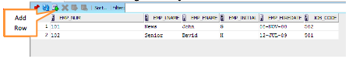

1. Run an appropriate *SELECT* statement to show all of the data that you entered into your EMP_1 table in step 1 above. Insert a screen shot of your *SELECT* statement and the output here:

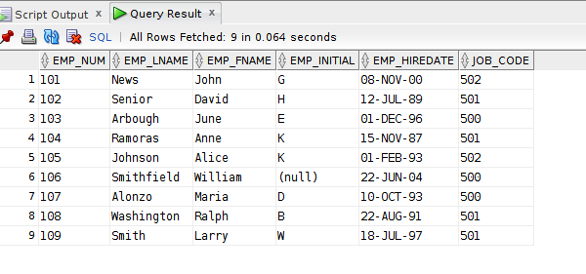

1. During lab 1, you should have successfully created the VENDOR and PRODUCT tables. Reminder: You can verify the table structure using the *describe*  command or use the SQL Developer navigation pane. In this lab, you will use the VENDOR and PRODUCT tables to step through many of the practice statements in Chapter 7 of your DB Systems textbook. **READ the pages of the book as you try the commands** because the next exam will assess your understanding of these commands.
2. **Read ALL of the instructions for this step BEFORE attempting to complete any of the tasks.** Section 7.3.1 (pp.254-255) of your DB Systems textbook explains how to insert records into a table.
   1. Type and run the statement ***set define off;*** in your SQL Developer worksheet. This turns off the special ampersand (&) character so that it is not interpreted as a command.
   2. Examine the INSERT statements for the VENDOR table at the top of the section (page 254). Use the SQL Developer Worksheet’s *Add Row* icon to add those first 2 rows of data to your vendor table. After you’ve successfully inserted the first 2 rows of data, download the VENDOR load script from the online [Course Content]→ [Labs] section and copy the file contents from my script to your SQL Worksheet. Run all commands as a single script. These commands will load the rest of the vendor data. You will need to import **all** of the *Vendor* data first before you enter data into the Product table because the foreign key must exist before it can be used in the related (PRODUCT) table. This is an example of enforced *referential integrity*.
   3. Study the 3 INSERT statements for the PRODUCT table in section 7.3.1 (pp. 254-255). Then use the SQL Developer Worksheet’s *Add Row* icon to add the first 3 rows of data to your product table. After you’ve successfully inserted those 3 rows of data, extract the PRODUCT load script that will be used to load the rest of the *Product* data. Copy the file contents from my script to your SQL Worksheet. Run all commands as a single script.
   4. Save the table contents by including the *COMMIT* command after you have successfully run all of the INSERT statements. In our version of SQL (Oracle), you will simply type the word *commit* followed by a semi-colon. You cannot enter the name of a table.

Make note of when you need single quotes or the NULL keyword. Do not attempt to enter data for any rows that have been previously entered. Repeating inserts will result in error messages caused by duplicate primary keys.

1. Use a select statement of your choice to verify that you have entered 17 rows of product data. Use a select statement of your choice to verify that you have entered 11 rows of vendor data. This will serve as proof that you have completed the insert statements correctly; insert a screen shot of your *SELECT* statements and the output here:

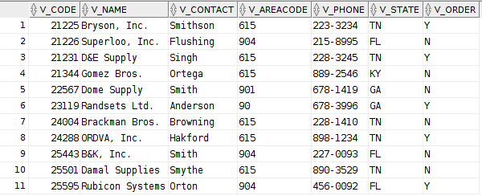 Select: SELECT * FROM VENDOR;

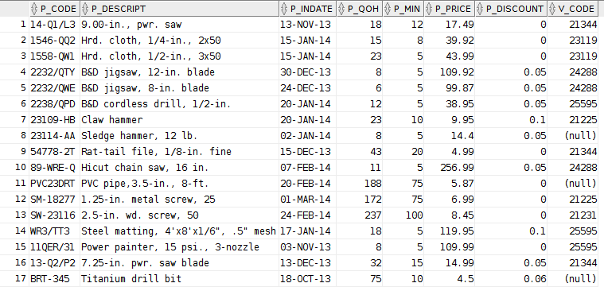Select: SELECT * FROM PRODUCT;

1. **In a clean SQL Developer Worksheet, type** the following SQL statements at the top to start a script file that will be used to complete the setup for the session:

**select sysdate from dual;** -- this will print today’s date

**set echo on;** -- this causes your SQL statements and comments to echo in the script output window

**set define off;** -- this turns off the special ampersand (&) character so that it is not interpreted as a command

Insert your name, lab number and course name by typing the following comment statements:

**--** *your name*

**--** SQL Lab 2 Textbook Practice Commands

-- CITC 1303

**As you continue below, be sure to use a comment that includes the step number and/or page# so that it’s easier to follow your script for grading and future reference. For example:**

**-- #9 page 256-257 practice**

1. Read section 7.3.3. (pp. 256-257). Try ALL sample SELECT statements in that section. Add these statements to your textbook practice script file. Read the book as you go along to gain an understanding of what you are doing. Answer the following 5 questions here:

-- 7a. What is the purpose of the column list that appears after the keyword *SELECT* in the commands

-- you have tried? To allow for code completion.

-- 7b. What is the purpose of the *FROM* clause? Designate for the DBMS which area to look in for the parameterized columns.

-- 7c. Is the FROM clause required in an Oracle SQL SELECT statement? Yes.

-- 7d. In an INSERT statement, when are single quotes required? Whenever you are entering data into a num-numeral field.

-- 7e. Which statement requires a COMMIT, SELECT or INSERT (or both) and why? Insert, because it affects the data within the database.

1. Read about and try all SELECT query examples in Section 7.4 (pp. 260-270). Read ahead before running each command so that you understand whether or not it is expected to work and to get an idea of what the output should look like. Stop when you get to section 7.5. Add these statements to your textbook practice script file. Note that there are errors (as discussed during lecture) in the textbook sections that discuss the BETWEEN operator. Answer the following 5 questions here:

-- 8a. What is the purpose of the *WHERE* clause in a SELECT statement? To provide criteria for data retrieval.

-- 8b. What is the purpose of the *BETWEEN* operator in a WHERE clause? To narrow the search to items between the with GIVEN_FIELD between both given values.

-- 8c. Does the BETWEEN criteria include the endpoints of the range? Yes.

-- 8d. What is the purpose of the *ON* operator in a WHERE clause? There is no ON operator. Although, the IN operator allows you to provide an array of values for the DBMS to compare to the field value, and determine whether to present the data or not.

-- 8e. What is the purpose of the LIKE operator in a WHERE clause? Allow for type-matching within non-standard fields by the given criteria.

1. When you have finished this lab:
   1. Erase the **BOTTOM only** output window. Save and rerun **all** of the statements in your SQL Developer Worksheet window. Be sure there is a *set echo on* statement at the beginning of the script.
   2. Save the script output (in the bottom window of the SQL Developer worksheet screen) using the name *SQL_Lab2Results_yourname.txt*. Open it in Notepad to examine errors, etc. and clean it up by deleting major errors and extra white space. Be sure your name is at the top of the file. You might want to print this file for use on the SQL quiz.
2. Upload & Submit your *SQL_Lab2Results_yourname.txt* output file and this *SQL_Lab2_Fall2016.docx* file (which should contain a few screen shots and responses to all questions) to the online Dropbox. **Two files are required to be submitted for this lab.**