Student Name: Jay Varshney |  |  |  | UID: 24BDA70206
Branch: AIT-CSE |  |  |  | Section/Group: 24AIT_KRG-G2
Semester: 5
Subject Name: Computer Network Subject Code: 24CSH-337

Experiment 2 – Study the basic network command and Network configuration commands.
Aim
Study the basic network command and Network configuration commands like ping, variations of ip config, tracert, nslookup, netstat, arp, rarp, hostname, pathping and basic networking commands.

Objective
- To understand the purpose and usage of basic network diagnostic and configuration commands in Windows 11.
- To study the working of networking commands such as Ping, IPConfig, Tracert, NSLookup, Netstat, ARP, Hostname, PathPing, Route, and Net Use.
- To learn how these commands are used for network configuration, connectivity testing, and troubleshooting.
- To interpret the output of various networking commands for analyzing and diagnosing network-related issues.Software Requirements
Software
- Windows PowerShell
- Windows Operating System

Practical / Experiment Steps
Step -1
Open Windows PowerShell

Step 2
Type Various Commands and analyse their output.

1 – ping command
- ping www.google.com
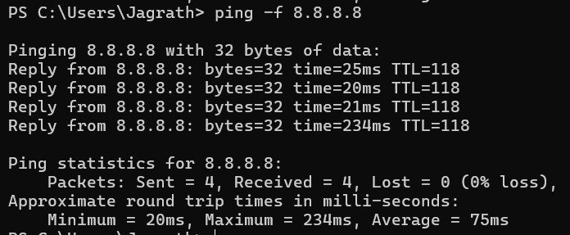
- ping -n 2 www.google.com
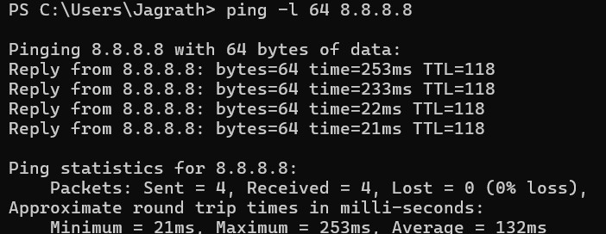

- ping -l 64 8.8.8.8
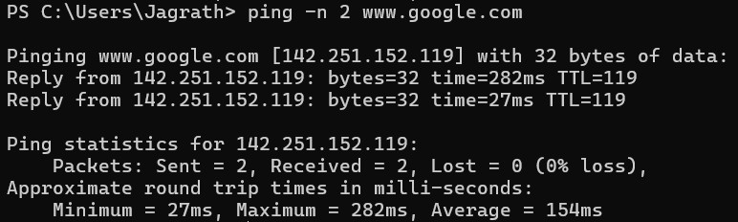
- ping -f 8.8.8.8
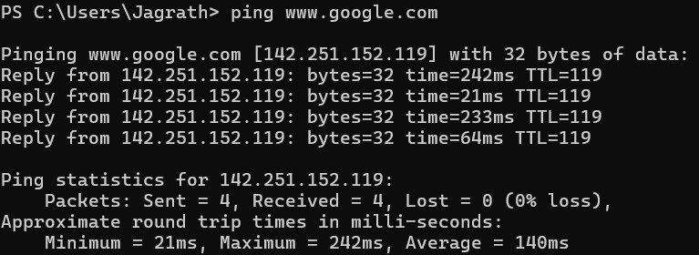

2 – ipconfig
- ipconfig
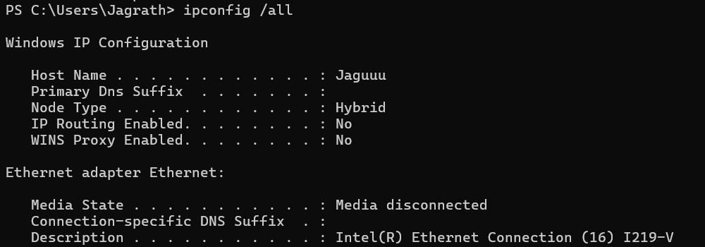

- ipconfig /all
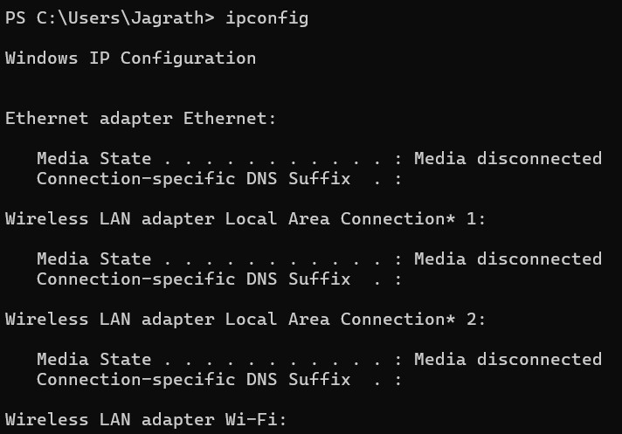
- ipconfig /release

- ipconfig /renew

-Note: commands C) and D) release and get the new IP address respectively and may output a error if not all network media are connected, this error can be ignored.

3- tracert
- tracert 8.8.8.8
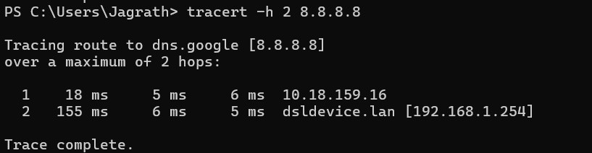

- tracert -h 8.8.8.8
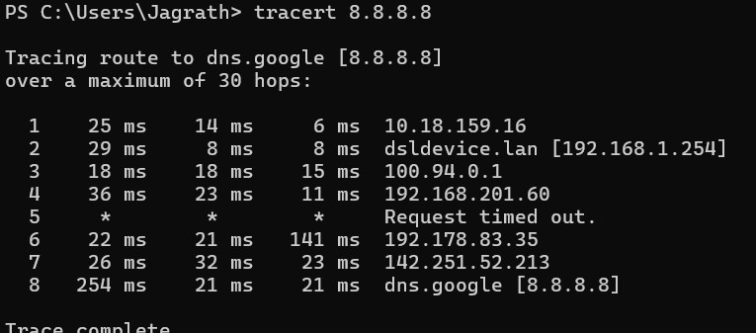
- tracert -d 8.8.8.8
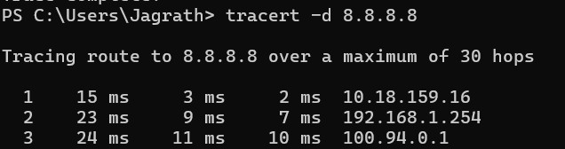

4- nslookup
- nslookup www.google.com
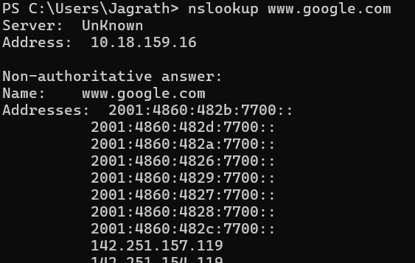

- nslookup 8.8.8.8
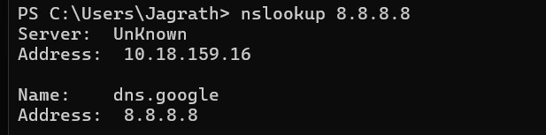

- nslookup -type=A 8.8.8.8
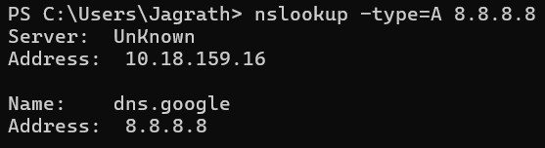
- nslookup -type=AAAA 8.8.8.8
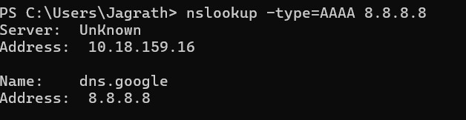

5- netstat
- netstat

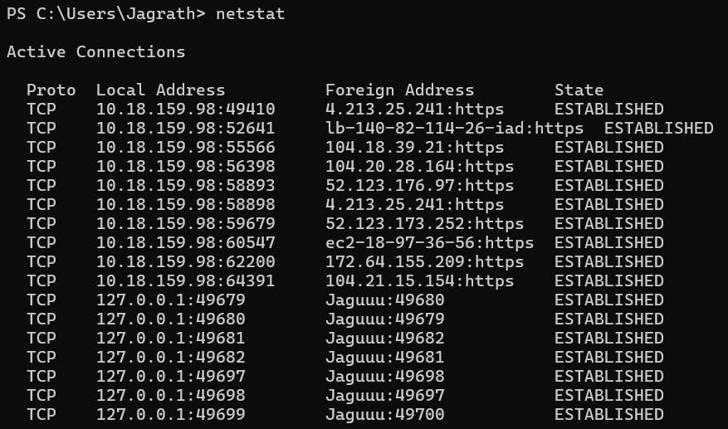
- netstat -n
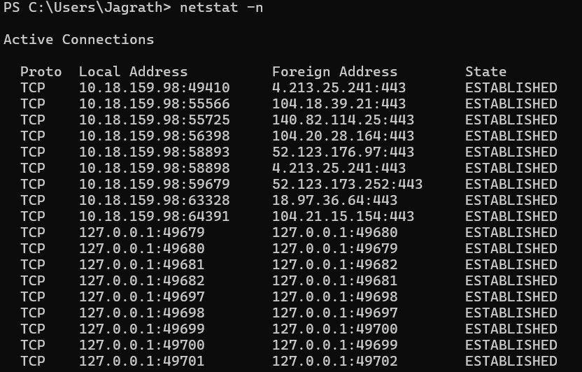

- netstat -p TCP

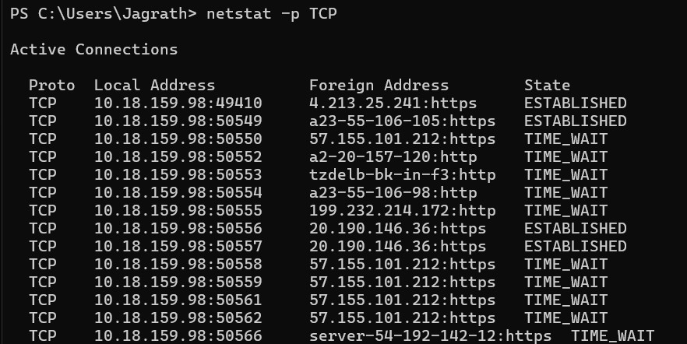
- netstat -p UDP
6-arp
- arp -a
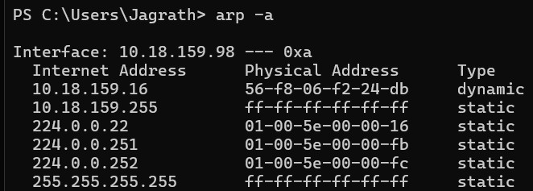
- arp -d *
Note: arp -d will delete the entries so don’t run this command unless you REALLY know what you are doing.
7 – hostname
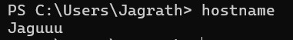
8- pathping

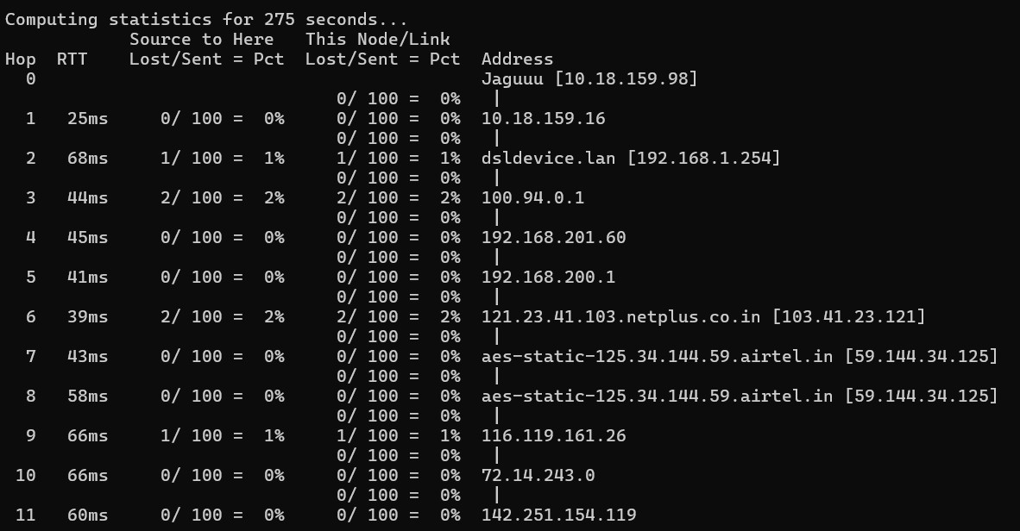

Learning Outcome
After completing this experiment, the learner will be able to:
- Execute basic network configuration and diagnostic commands in a Windows 11 environment.
- Interpret the output of commands such as Ping, IPConfig, Tracert, NSLookup, Netstat, ARP, Hostname, PathPing, Route, and Net Use.
- Identify and troubleshoot basic network connectivity and configuration issues using command-line tools.
- Explain the purpose and practical applications of commonly used networking commands.

