Step 1: Connect 6 PCs and 1 switch in the topology as shown in the Pic
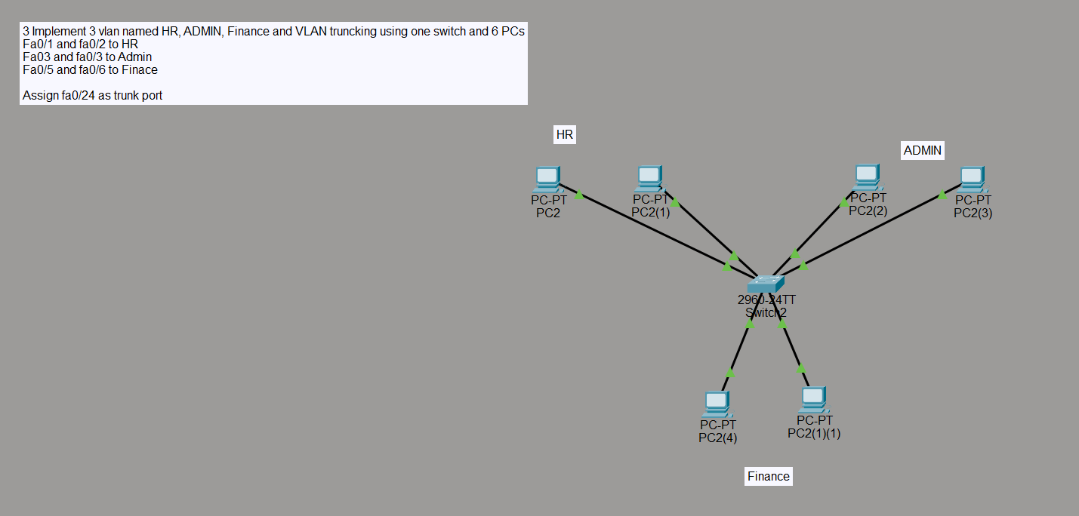
Step 2: Create vlan HR, ADMIN, and Finance with vlan IDS 10,20, and 30 respectively using the following commands in the privileged config mode
- vlan <Vlan Id>
- name <Enter Vlan Name>
for example
vlan 10
name ADMIN

Step 3:Assign HR vlan to fa0/1, and fa0/2 , and Admin vlan to fa0/3, fa0/4, and Finance fa0/5, and fa0/6 using the following commands in privileged config
- interface <interface for ex fa0/1>
- switchport mode access
- switchport mode vlan <vlan id>
for example
- interface fa0/1
- switchport mode access
- switchport mode vlan 10
Run the following commands as shown in below Pic to assign respective vlan(s) to the respective interface
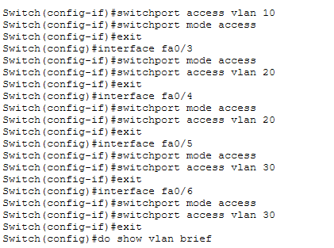
Step 4: Give fa0/24 trunk mode access
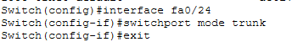

Step 5: ensure the vlan is as shown in the given fig
