Student Name: Jay Varshney UID: 24BDA70206
Branch: AIT-CSE (FSD) Section/Group: 24AIT_KRG2
Semester: 4
Subject Name: Database Management System Subject Code: 24CSH-298

Experiment 3 – PL/SQL Salary and Bonus Calculation
Experiment
Experiment 3: Calculating employee salary and applying a bonus using PL/SQL. This experiment demonstrates variable declaration, arithmetic operations, and displaying output using DBMS_OUTPUT.PUT_LINE.
Aim
The aim of this experiment is to practice writing PL/SQL blocks that perform calculations on employee data, calculate bonuses, and display results in a structured format.
Objective
- To declare variables in PL/SQL.
- To perform arithmetic calculations on employee salary.
- To calculate a bonus amount based on a percentage of salary.
- To display employee details and salary information before and after applying the bonus.
Software Requirements
- Database: Oracle XE or Oracle Live SQL
Practical / Experiment Steps
- Declare variables for employee ID, name, and salary.
- Calculate a 10% bonus on the employee salary.
- Calculate the total salary after adding the bonus.
- Display employee details and salary information before and after bonus.
- Take screenshots of outputs for documentation.
Procedure of the Experiment
- Start the system and log in.
- Open Oracle XE or Live SQL.
- Connect to the database.
- Declare variables for employee details and bonus calculation.
- Write the PL/SQL block to calculate bonus and total salary.
- Execute the PL/SQL block and verify outputs in the console.
- Take screenshots of the outputs (s1 and s2).
Input / Output Details
Input
- Employee details:
  - emp_id NUMBER
  - emp_name VARCHAR2(50)
  - emp_salary NUMBER
- Bonus calculation: 10% of employee salary
Output
- Step 1: Display employee details and original salary.
- Step 2: Display bonus amount and total salary after applying 10% bonus.
- Screenshots of outputs (s1 and s2) are attached.
Step 1 Output
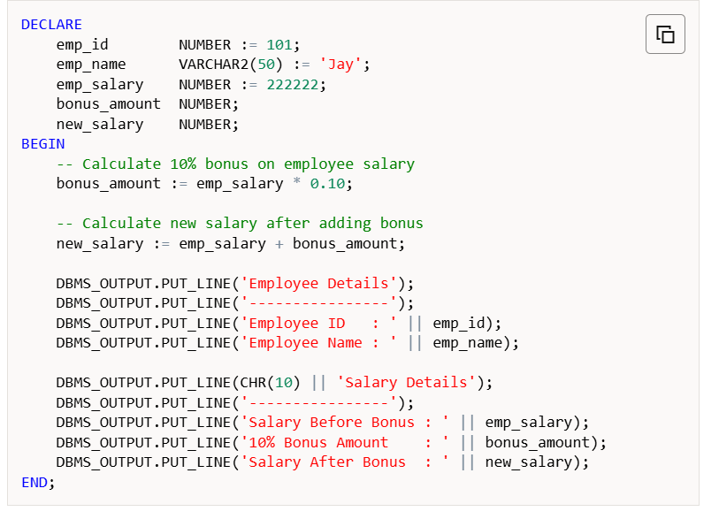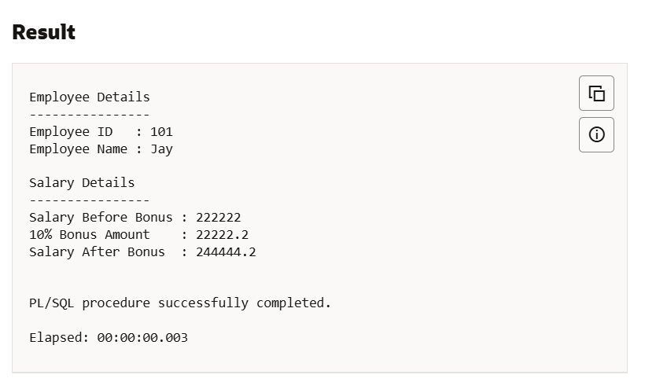
Employee Details
Employee ID : 101
Employee Name : Jay
Salary Before Bonus : 222222
Step 2 Output
Screenshot: Step 2 – Salary After Bonus
Salary Details
Salary Before Bonus : 222222
10% Bonus Amount : 22222.2
Salary After Bonus : 244444.2
Learning Outcome
After completing this experiment, the student will be able to:
- Declare and use variables in PL/SQL.
- Perform arithmetic operations for salary calculations.
- Calculate bonuses based on a percentage of salary.
- Display structured outputs using DBMS_OUTPUT.PUT_LINE.
- Understand the workflow of PL/SQL blocks for practical data operations.

