Project 2: Develop a Chess Board Game with Redux
Title: Chess Board Game

Task Description
This task was to create a Chess board game using Redux. The board alternates between white and black squares. Upon clicking a white square, it changes to yellow; when clicking a black square, it changes to red.

Task Output Screenshot
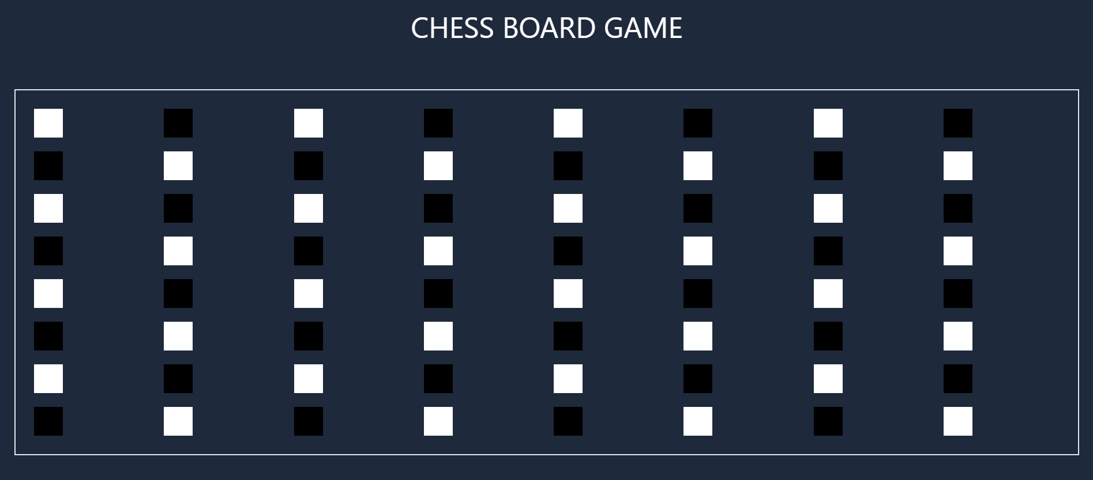
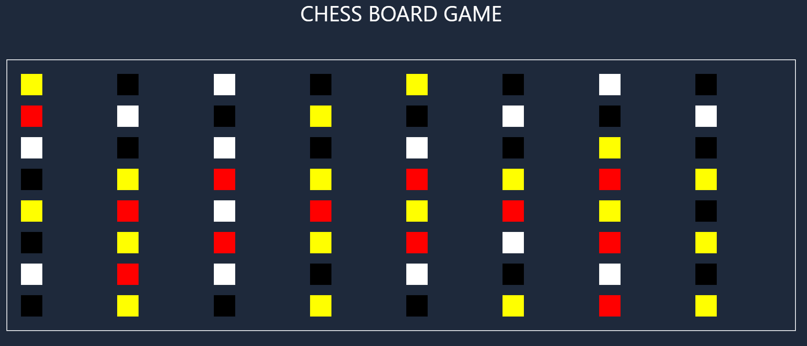

Widgets/Algorithm Used in Task
- Redux: Manages the state of the board, handling clicks and the color change functionality.
- React Components: Used to create the chessboard structure.
- State Transitions: The logic for color changes upon clicks is handled through state transitions in Redux.

