Project 4: Create a Custom Input Component Using Formik
Title: Formik
Task Description
This task involved creating a custom common input component using Formik that supports all kinds of form validation.

Task Output Screenshot
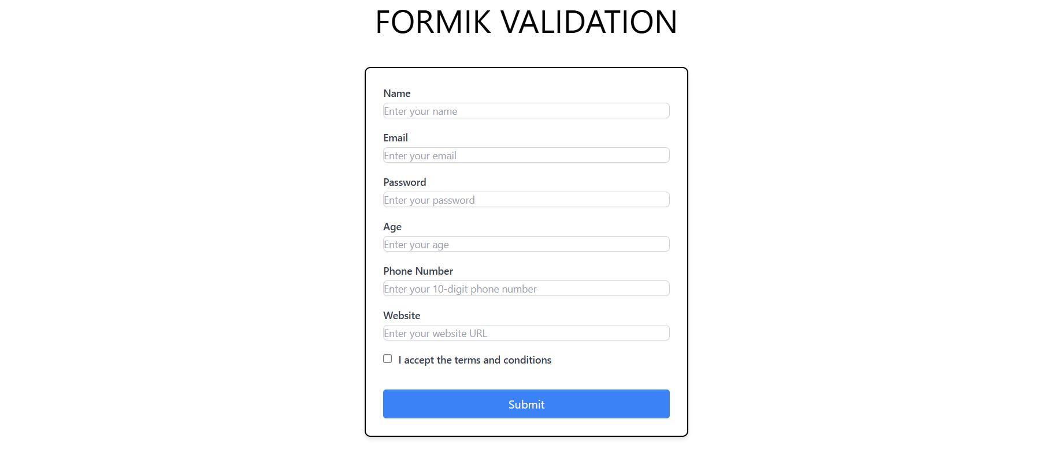
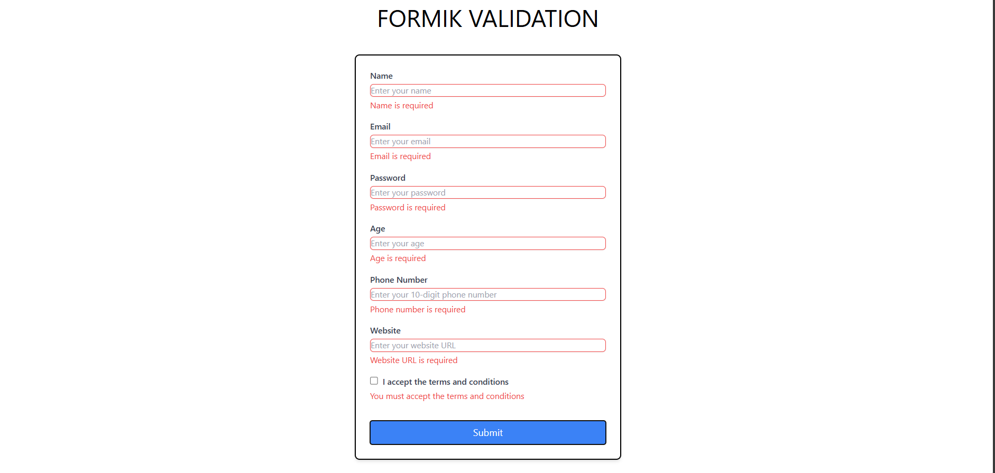
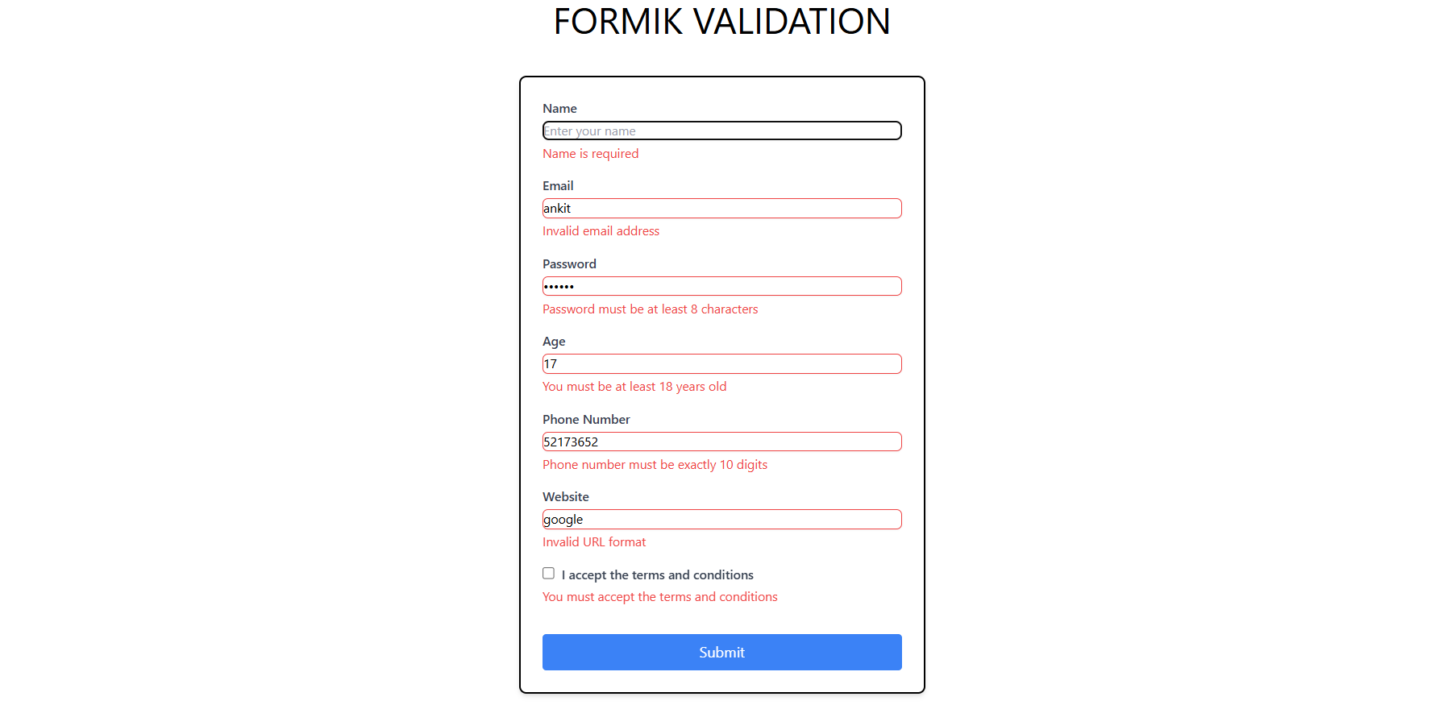

Widgets/Algorithm Used in Task
- Formik: Used for form state management and validation handling.
- Yup: A schema builder for form validation to handle various validation types (e.g., required fields, email formats).
- Custom Input Component: Created a reusable component to handle different input types (text, email, etc.) with built-in validation.

