Project 3: Create Pagination for a Table of Dummy Data

Task Description
This project involved creating pagination for a table containing dummy data fetched from an API. The table has 'Previous' and 'Next' buttons, along with three middle buttons, representing pages, with ellipses before and after the buttons.

Task Output Screenshot
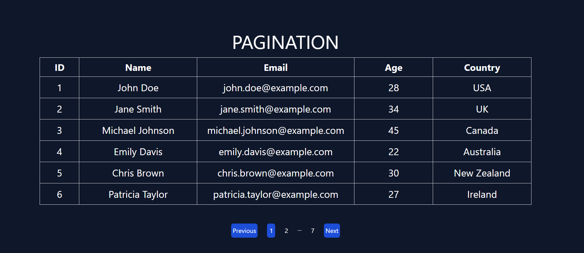
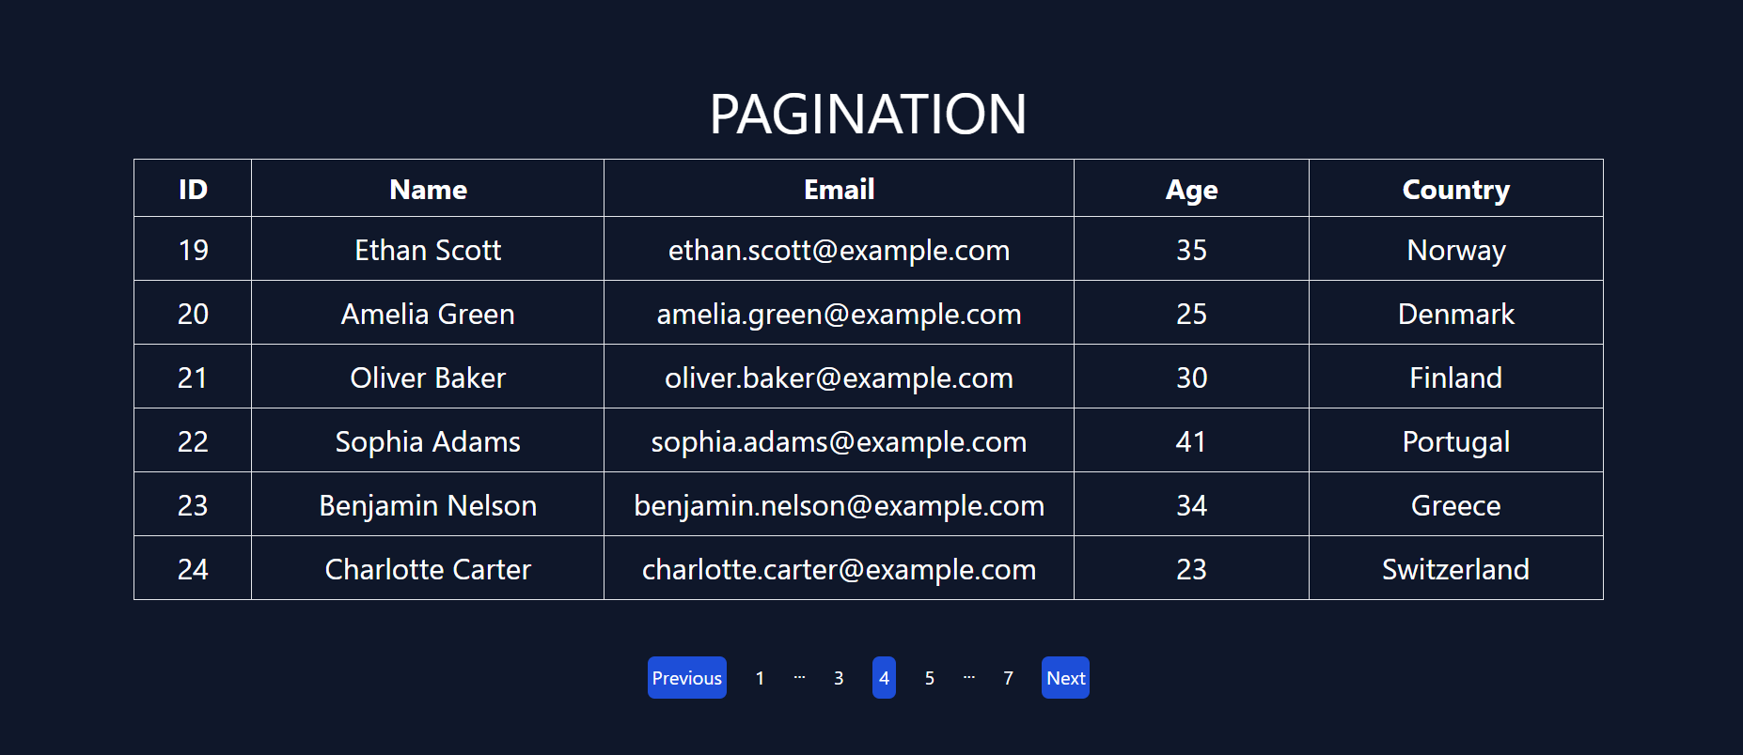

Widgets/Algorithm Used in Task
- Redux: Used for managing global state related to the fetched data and the current page of the table.
- Context API: Used alongside Redux to handle additional state management, such as managing the pagination state within different components of the app.
- API Integration: An API was used to fetch the dummy data, which is dynamically loaded based on the current page.
- Table Component: Used to render the data fetched from the API.
- Pagination Logic: Custom pagination logic was implemented to dynamically generate page numbers and ellipses based on the total number of pages, updating the table content with each page change.

