**Project 1: Develop a Todo List App with Redux**

**Title: Todo list app**

**Task Description**  
 The goal of this task was to develop a todo list application that allows users to add, remove, and mark tasks as complete. Redux is used to manage the application's state for task handling.

**Task Output Screenshot**  


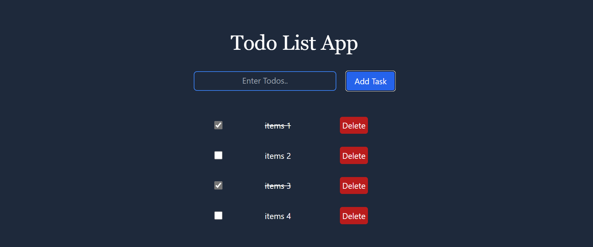

**Widgets/Algorithm Used in Task**

* **Redux:** Used for state management to handle adding, removing, and updating tasks.
* **React Components:** Used to create the UI structure for adding and displaying tasks.
* **Action Creators and Reducers:** Created for managing the addition and deletion of tasks, and for toggling the completion state.