**Develop a linear regression model for forecasting time series data.**

**EX:No.5**

**DATE:29/3/2025**

**AIM:**

To develop a linear regression model for forecasting time series data.

**ALGORITHM:**

1. Import Required Libraries
2. Load and Prepare the Time Series Data
3. Convert Time Index to Numerical Format
4. Split Data into Features (X) and Target (y)
5. Train the Linear Regression Model
6. Create Future Time Points for Forecasting
7. Predict Future Values Using the Model
8. Visualize Historical and Forecasted Data
9. Evaluate Model Performance .

**CODE:**

import pandas as pd

import numpy as np

import matplotlib.pyplot as plt

import statsmodels.api as sm

from statsmodels.tsa.stattools import adfuller

from statsmodels.tsa.seasonal import seasonal_decompose

import statsmodels.graphics.tsaplots as tsaplots

from sklearn.linear_model import LinearRegression

from sklearn.metrics import mean_squared_error

# Load data

filepath = 'C://Users//Jayashrinidhi V//OneDrive//Documents//VScode//TimeSeriesAnalysis//globaltemp.csv'

df=pd.read_csv(filepath)

df.set_index('Year', inplace=True)

# Remove duplicate indices

df = df[~df.index.duplicated(keep='first')]

# Ensure column selection for plotting

if 'Mean' not in df.columns:

    raise ValueError("Column 'Mean' not found in the dataset. Check the CSV file.")

# Plot original time series

plt.figure(figsize=(12, 6))

plt.plot(df.index, df['Mean'], label='Original Time Series')

plt.xlabel("Year")

plt.ylabel("Mean Value")

plt.title("Time Series Data Plot")

plt.legend()

plt.grid()

plt.show()

# Perform ADF test before differencing

result = adfuller(df['Mean'].dropna())

print("ADF Statistic:", result[0])

print("p-value:", result[1])

print("Critical Values:")

for key, value in result[4].items():

    print(f"   {key}: {value}")

if result[1] <= 0.05:

    print("Conclusion: Data is stationary (Reject H0)")

else:

    print("Conclusion: Data is not stationary (Fail to Reject H0)")

# Seasonal Decomposition

decomposition = seasonal_decompose(df['Mean'], model='additive', period=12)

fig, (ax1, ax2, ax3) = plt.subplots(3, 1, figsize=(12, 10))

decomposition.trend.plot(ax=ax1, title='Trend')

decomposition.seasonal.plot(ax=ax2, title='Seasonality')

decomposition.resid.plot(ax=ax3, title='Residuals')

plt.tight_layout()

plt.show()

# Apply differencing

df['Mean'] = df['Mean'].diff(1)

df.dropna(inplace=True)

# Plot differenced series

plt.figure(figsize=(12, 6))

plt.plot(df.index, df['Mean'], label='Differenced Time Series', color='red')

plt.xlabel("Year")

plt.ylabel("Differenced Mean Value")

plt.title("Time Series Data After Differencing")

plt.legend()

plt.grid()

plt.show()

# Perform ADF test after differencing

result = adfuller(df['Mean'].dropna())

print("ADF Statistic after differencing:", result[0])

print("p-value:", result[1])

print("Critical Values:")

for key, value in result[4].items():

    print(f"   {key}: {value}")

if result[1] <= 0.05:

    print("Conclusion: Data is stationary (Reject H0)")

else:

    print("Conclusion: Data is not stationary (Fail to Reject H0)")

# Plot ACF and PACF

tsaplots.plot_acf(df['Mean'].dropna(), lags=20)

tsaplots.plot_pacf(df['Mean'].dropna(), lags=20)

plt.show()

**OUTPUT:**

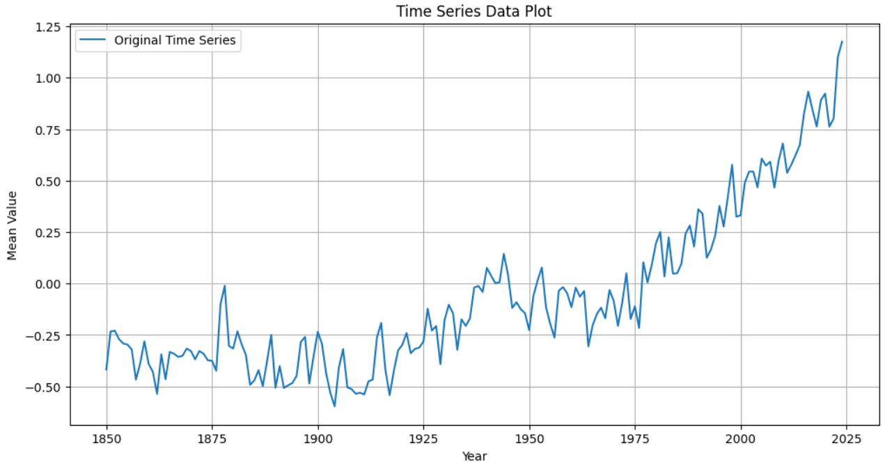

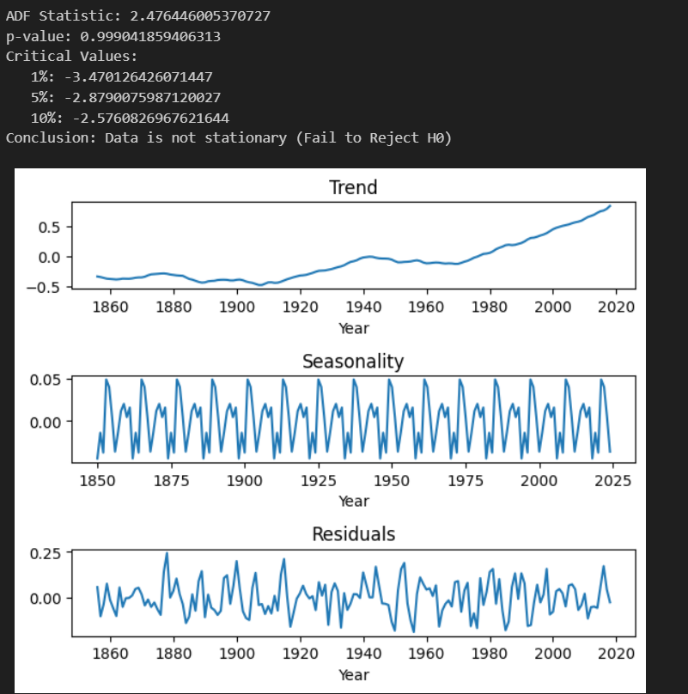

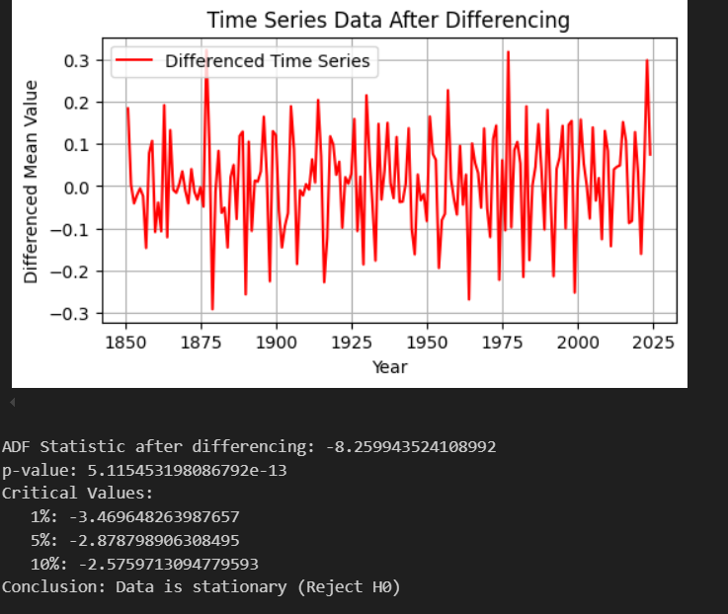

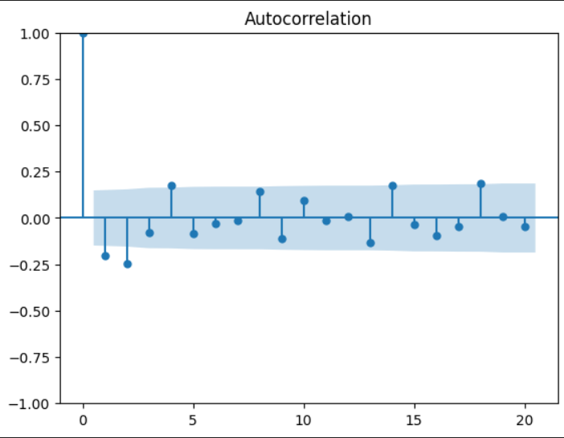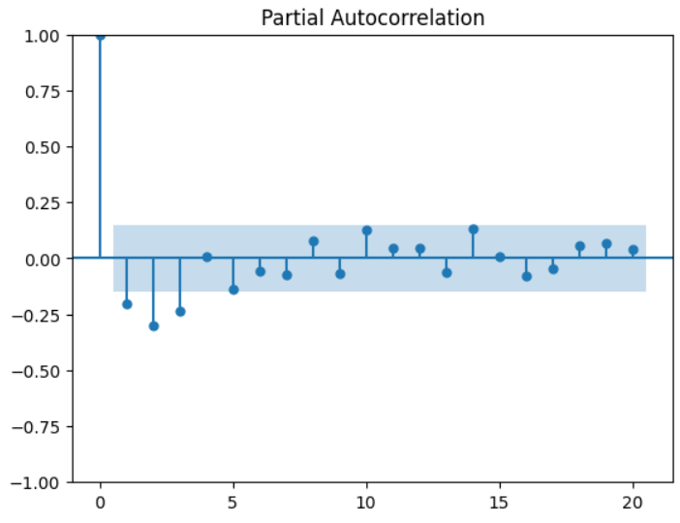

**RESULT:**

Thus the program has been completed and verified successfully.