**Implement program for decomposing time series data into trend and seasonality.**

**EX:No.7**

**DATE:7/4/2025**

**AIM:**

To Implement program for decomposing time series data into trend and seasonality.

**ALGORITHM:**

1. Import Required Libraries
2. Load the Time Series Dataset
3. Set Proper Date/Time Index
4. Check for Missing or Duplicate Values
5. Plot the Original Time Series
6. Apply Seasonal Decomposition (Additive or Multiplicative)
7. Extract and Plot:

* Trend Component
* Seasonal Component
* Residual Component

1. Analyze the Decomposed Components
2. Use Components for Further Modeling or Forecasting

**CODE:**

import pandas as pd

import numpy as np

import matplotlib.pyplot as plt

import statsmodels.api as sm

from statsmodels.tsa.stattools import adfuller

from statsmodels.tsa.seasonal import seasonal_decompose

import statsmodels.graphics.tsaplots as tsaplots

from sklearn.linear_model import LinearRegression

from sklearn.metrics import mean_squared_error

# Load your time series data

filepath = 'C://Users//Jayashrinidhi V//OneDrive//Documents//VScode//TimeSeriesAnalysis//globaltemp.csv'  # Replace with your actual file path

df = pd.read_csv(filepath, parse_dates=['Year'])

df.set_index('Year', inplace=True)

# Remove duplicate indices

df = df[~df.index.duplicated(keep='first')]

# Ensure column selection for plotting

if 'Mean' not in df.columns:

    raise ValueError("Column 'Mean' not found in the dataset. Check the CSV file.")

# Plot 1: Original time series

plt.figure(figsize=(12, 6))

plt.plot(df.index, df['Mean'], label='Original Time Series')

plt.xlabel("Year")

plt.ylabel("Mean Value")

plt.title("Original Time Series Data")

plt.legend()

plt.grid()

plt.show()

# Decomposition - Additive Model

decomposition = seasonal_decompose(df['Mean'], model='additive', period=12)

# Plot 2: Trend Component

plt.figure(figsize=(12, 4))

decomposition.trend.plot(title='Trend Component', color='blue')

plt.xlabel("Year")

plt.ylabel("Trend")

plt.grid()

plt.show()

# Plot 3: Seasonal Component

plt.figure(figsize=(12, 4))

decomposition.seasonal.plot(title='Seasonal Component', color='green')

plt.xlabel("Year")

plt.ylabel("Seasonality")

plt.grid()

plt.show()

# Plot 4: Residuals

plt.figure(figsize=(12, 4))

decomposition.resid.plot(title='Residual Component', color='gray')

plt.xlabel("Year")

plt.ylabel("Residuals")

plt.grid()

plt.show()

# Plot 5: Combined decomposition layout

fig, axs = plt.subplots(4, 1, figsize=(12, 12))

df['Mean'].plot(ax=axs[0], title='Original Series')

decomposition.trend.plot(ax=axs[1], title='Trend')

decomposition.seasonal.plot(ax=axs[2], title='Seasonality')

decomposition.resid.plot(ax=axs[3], title='Residuals')

plt.tight_layout()

plt.show()

**OUTPUT:**

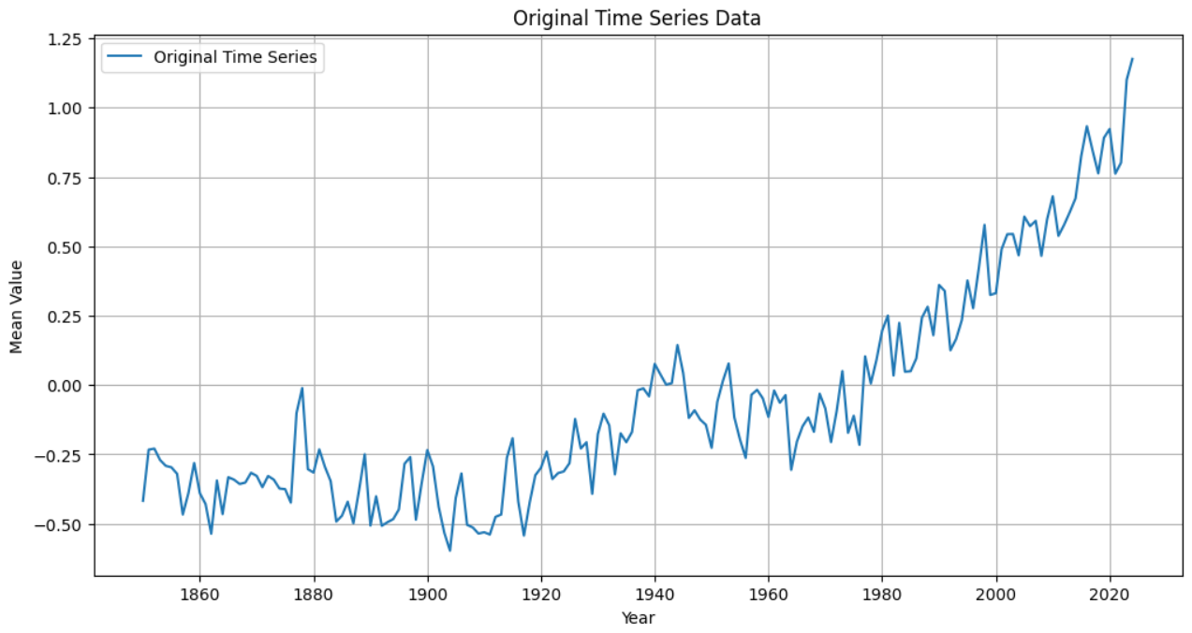

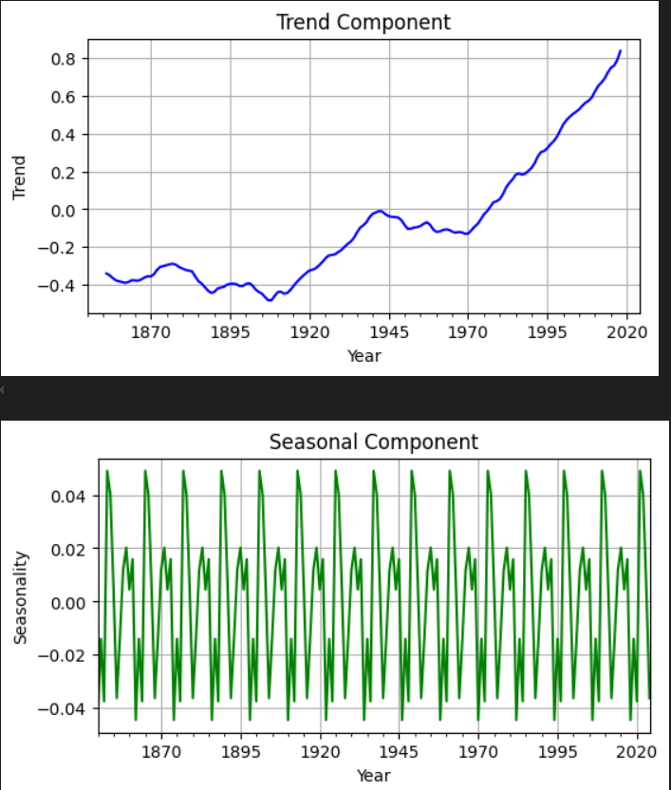

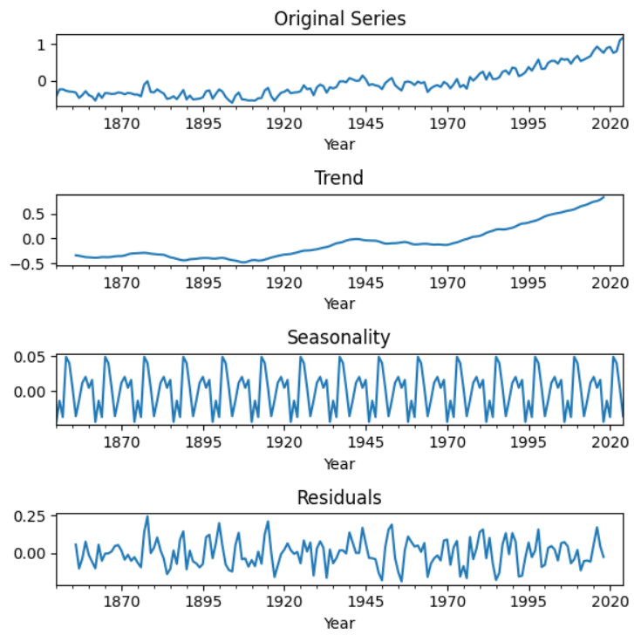

**RESULT:**

Thus the program has been completed and verified successfully.