Implementation

Description

Our product is made up of two parts: A portable accelerometer connected with a WiFi-model esp8266, and A LED displaying the signal that retrieved from cloud.

Hardware required

Grove - 6-Axis Accelerometer&Gyroscope v1.0

ESP-12S

ESP-8266

Expansion board

Batteries

220 ohm resistor

LED

Software

Arduine IDE

Google Firebase Realtime Database

Architecture

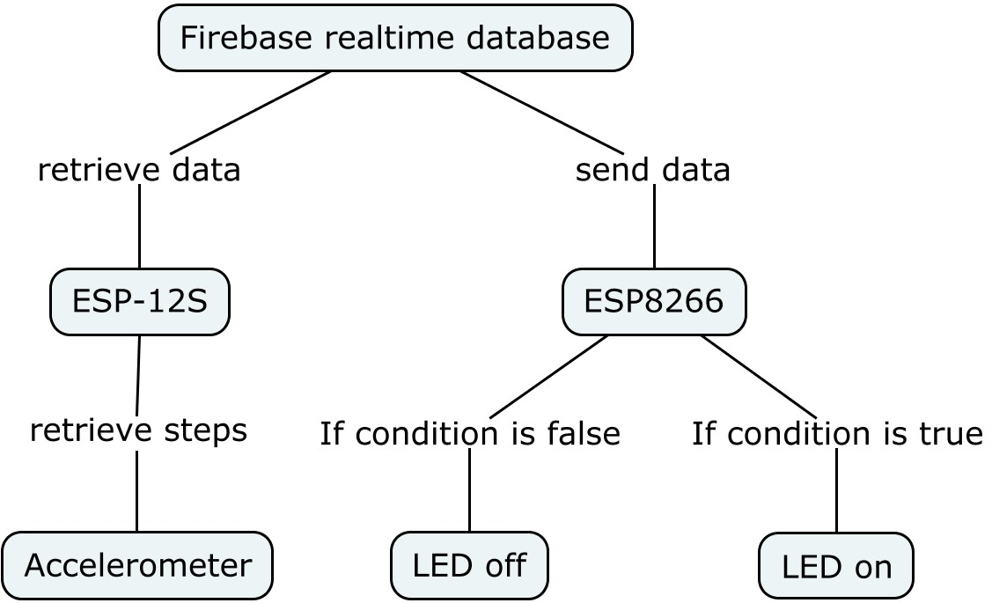

Circuit

Accelerometer Part

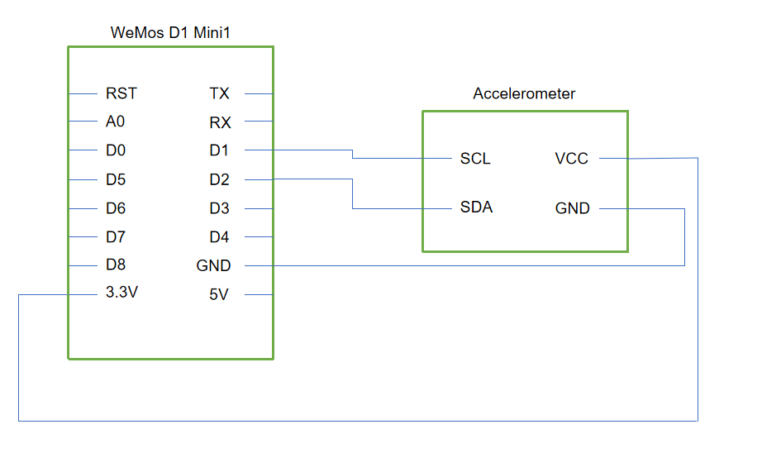

Display Part

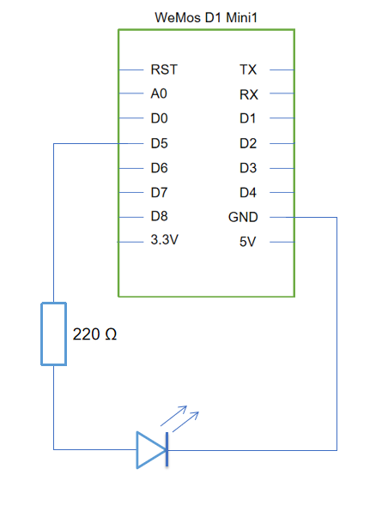

Workflow

First of all, when the power is on, these two parts will automatically connect with WiFi. In the display part,the LED will flash three times if the WiFi is successfully connected. After both of two parts are successfully connected, users can set target on web and start counting steps anytime. Before the users achieve the target, the LED will stay off. Once the target is achieved, the LED will turn on immediately as a notification. And users can still change the target steps after finish one. The LED will turn off again until the next target is achieved.