Containers

Jayviar Laporte

Table of Contents:

**Installing Docker**

**Installing Microk8**

**Installing Minikube**

**Using Minikube on centos**

**Commands are highlighted in blue**

Installing Docker

*Centos Install-*

1. Firstly, to install docker we need to add dockers repository. We do this by running the command:

Sudo yum install -y yum-utils

followed by the command

sudo yum-config-manager --add-repo <https://download.docker.com/linux/centos/docker-ce.repo>

*Screenshot sudo yum install –y yum-utils*

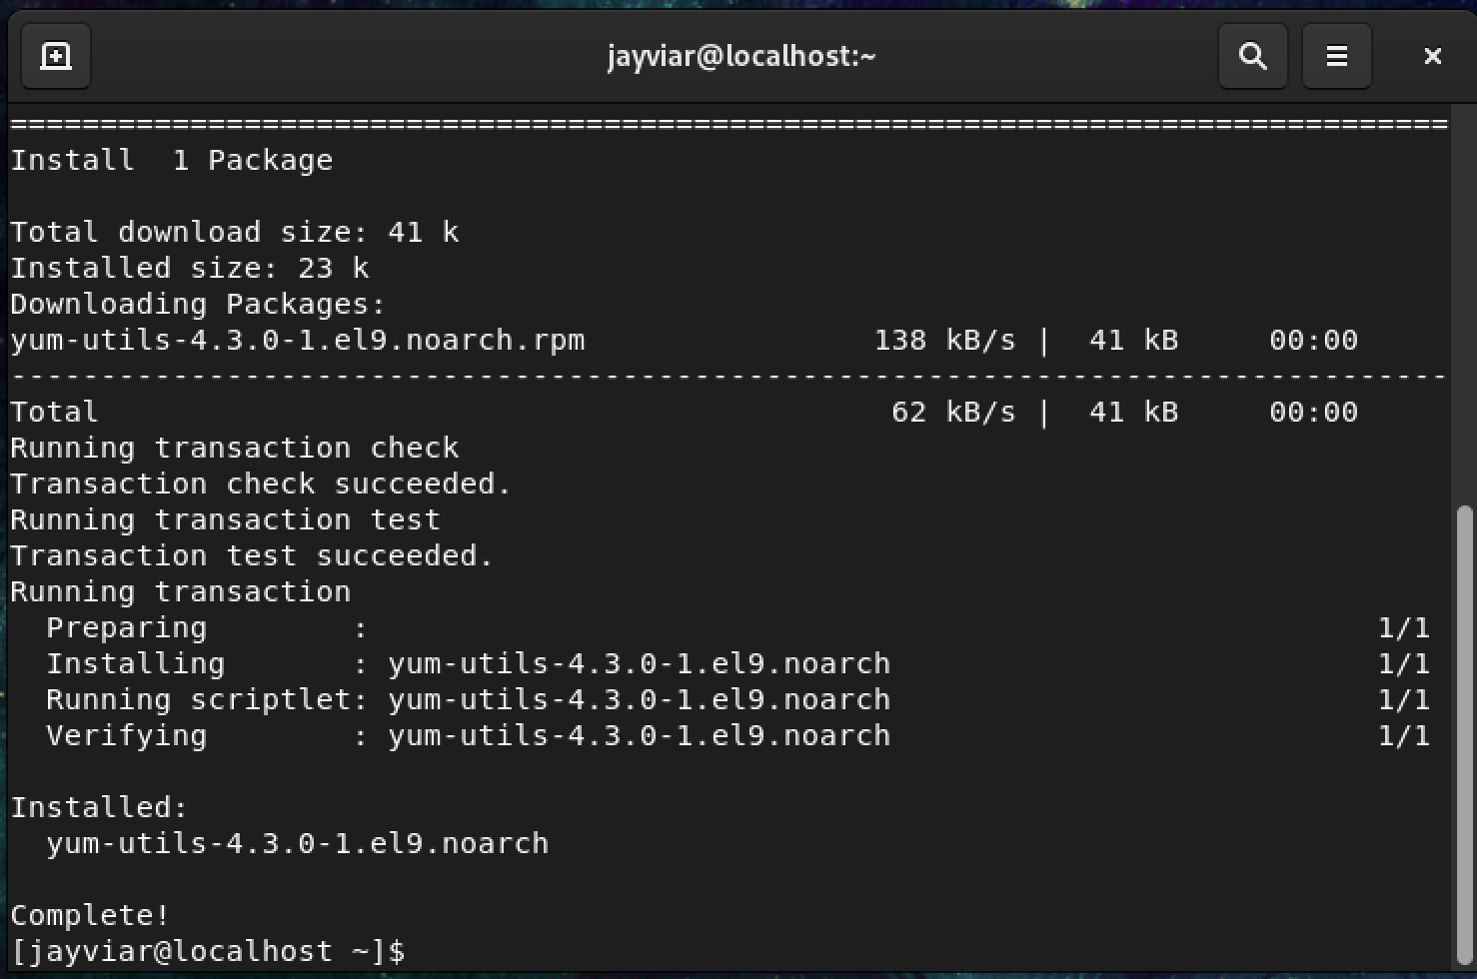

*sudo yum-config-manager --add-repo* [*https://download.docker.com/linux/centos/docker-ce.repo*](https://download.docker.com/linux/centos/docker-ce.repo)

*Be sure to select “y” when installing*

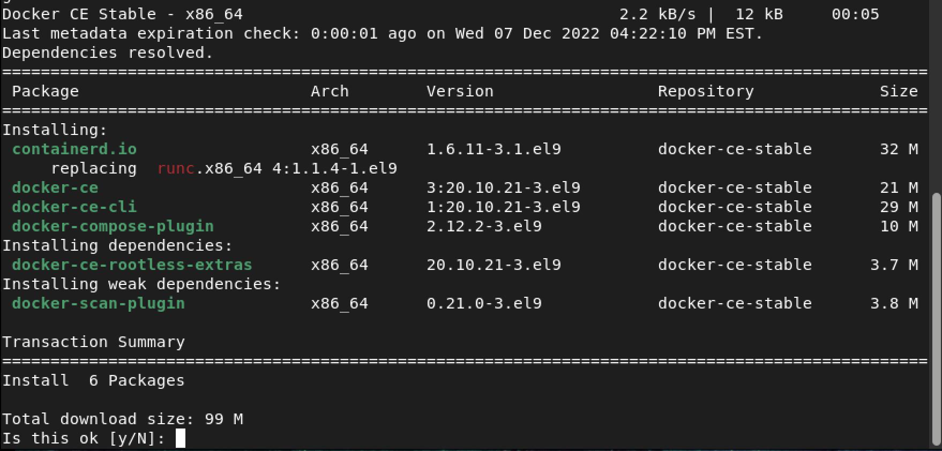

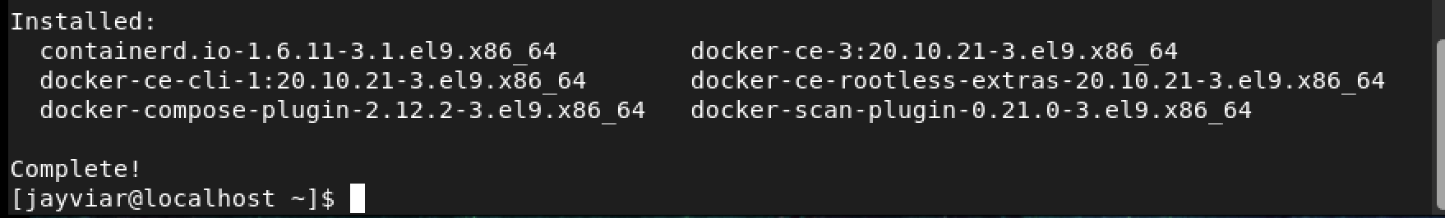

2) Now to install docker. We simply run the sudo yum install command followed by docker plugin:

sudo yum install docker-ce docker-ce-cli containerd.io docker-compose-plugin

*Docker is already installed on our VM but this is just conformation that it is installed*

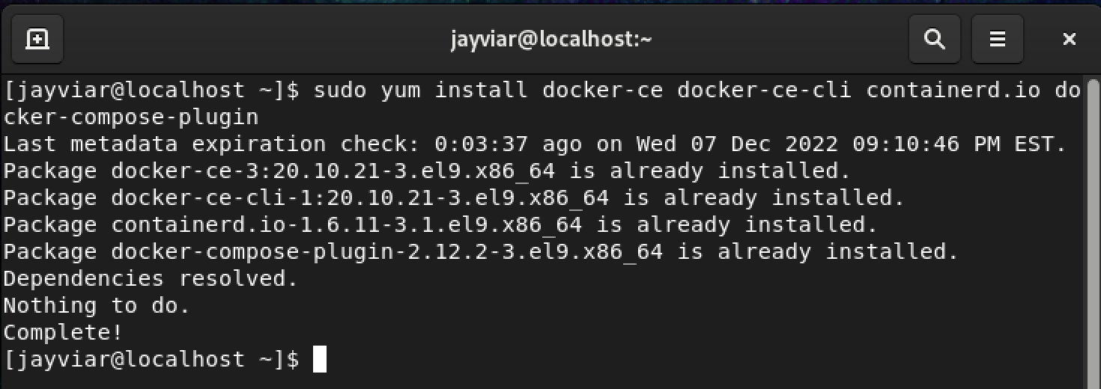

*Ubuntu Install-*

1. To install docker on Ubuntu. Simply run the following command:

Sudo apt-get install docker

*The screen should look like this once complete. You do not have to restart any systems specified here.*

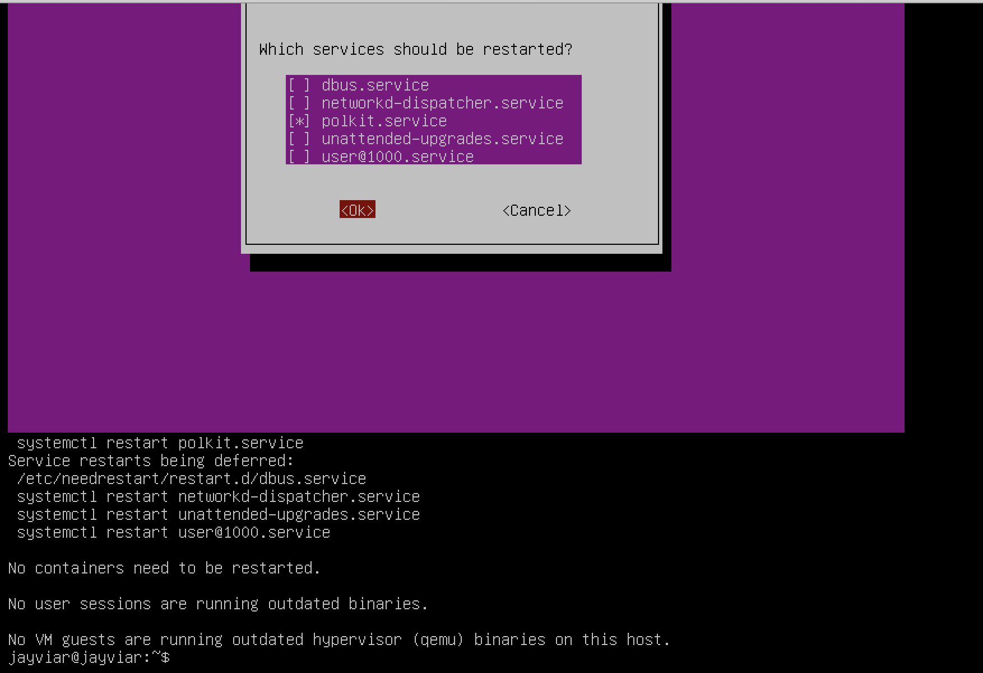

Installing Microk8

* For Centos and Ubuntu, we need to install something called snapd before we can install Microk8. Snapd is what is going to allow us to install Microk8 as snapd has Microk8 available on their snapcraft.io website which can also be installed from our command lines.

*Centos Install-*

1. To start off, we must install the epel-release for centos. This command will look like this:

sudo yum install epel-release

1. Once complete we can now install snapd in order to then install microk8. The command looks like this:

sudo yum install snapd

1. We then need to enable snap in order to access microk8s. We do this by enabling its socket with the following command:

sudo systemctl enable snapd.socket --now

*User should be prompted then cmd will return to normal*



1. We now need to create a link to enable snap support and it looks like this:

sudo ln -s /var/lib/snapd/snap /snap

1. Now we can install microk8

Sudo snap install microk8

*Snap enabled and microk8 installed*

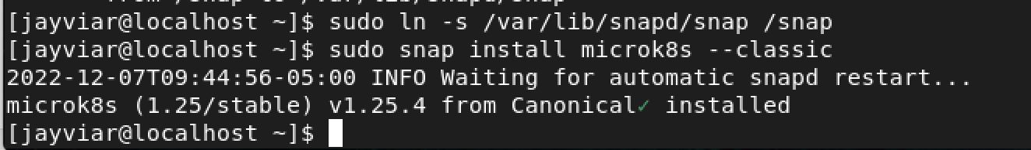

*Ubuntu Install-*

1. For Ubuntu , the installation for microk8 is short and as follows. First start off by installing snapd.

Sudo apt-get snap

*Below is what your screen should look like with a successful install. The yellow highlight is just to show the specific package being installed which in this case is snapd*

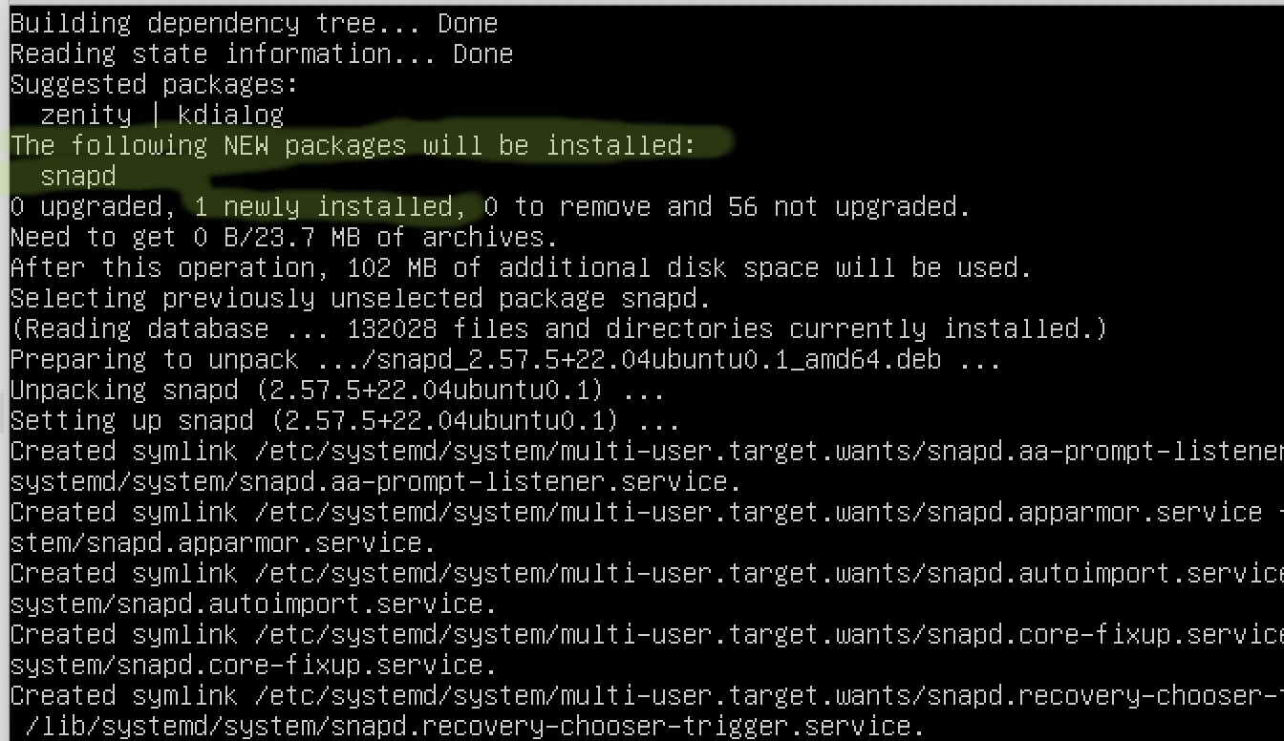

1. Then, reboot using the reboot command. This is done just to restart and make sure we start fresh
2. Finally, install microk8 . Now that we have snap installed. We can use that instead of apt-get In order to obtain microk8 from snapd’s services.

Sudo snap install microk8 –classic

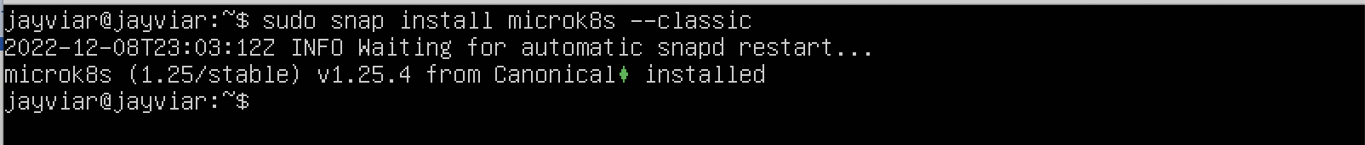

Install Minikube

***Note* Make sure curl is instaled on both servers before starting.***

*Centos: sudo yum install curl*

*Ubuntu: sudo get-get install curl*

*Centos Install-*

1. To install the latest release, we can go on Minikubes website and look for our specific device and version. The command for Centos should look like this:

curl -LO https://storage.googleapis.com/minikube/releases/latest/minikube-linux-amd64

sudo install minikube-linux-amd64 /usr/local/bin/minikube

*Finished install*

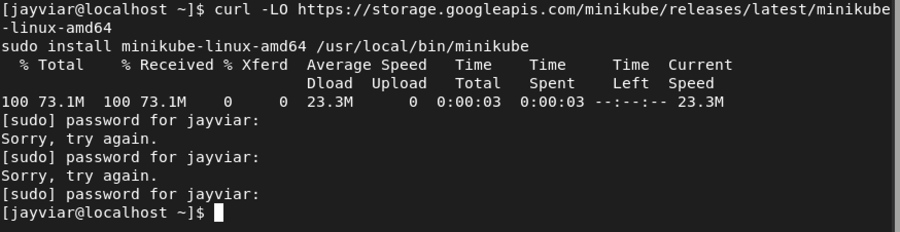

*Ubuntu Install-*

1. To install the latest release, we can go on Minikubes website and look for our specific device and version. The command for debian should look like this:

curl -LO https://storage.googleapis.com/minikube/releases/latest/minikube_latest_amd64.deb

sudo dpkg -i minikube_latest_amd64.deb

*Finished install*

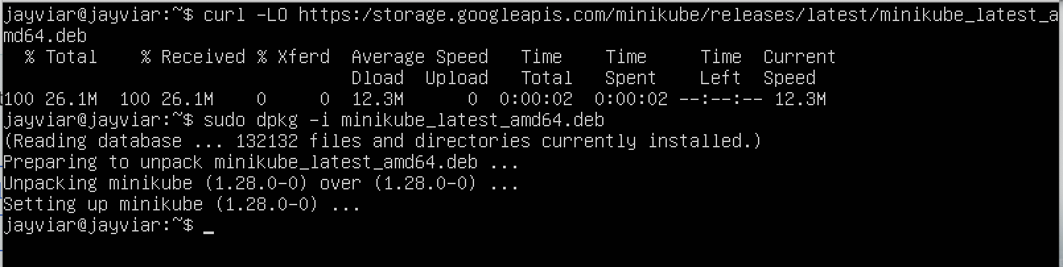

1. Now we can use minikube! For this example, Firstly, we must start docker in order to use it for our Minikube. Then we must start Minikube. Below is both commands back to back. Then we have a screenshot of what your screen will look like once it is running:

First:

Systemctl start docker

Second:

Minikube start

*Here is what that will look like once run*

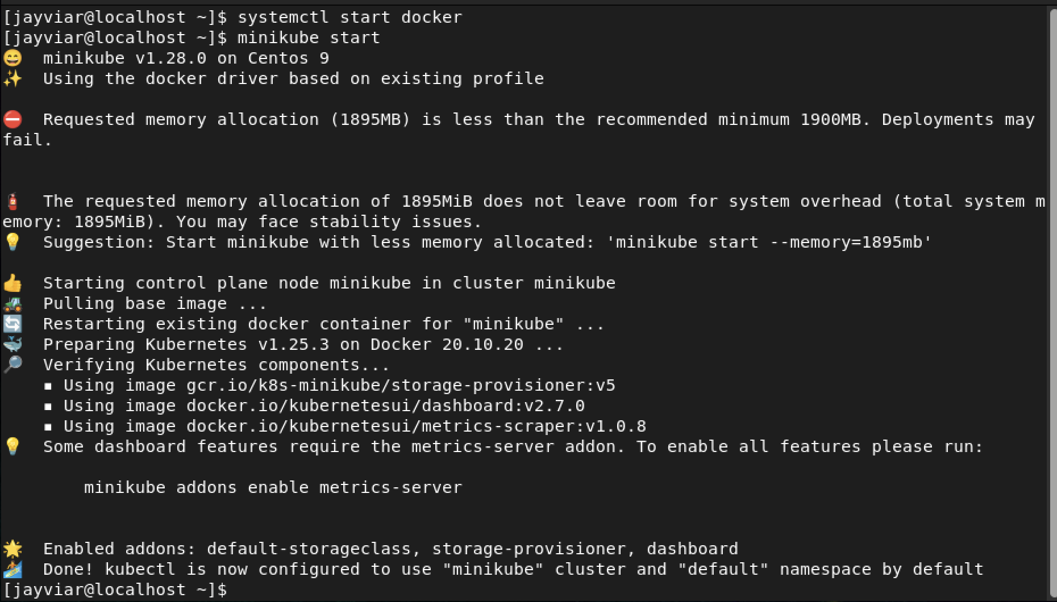

Using Minikube On Centos

1. Next, We want to run a deployment. For this lab, We will use the sample provided by the Minikube website. Firstly, lets access our cluster, this can be done running the following command:

Kubectl get po-A

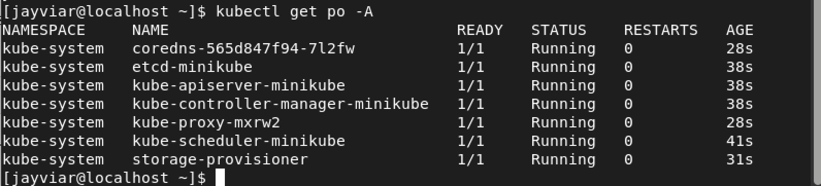

1. Now, we can create the sample deployment. When we follow the code below, we expose our cluster on port 80 with minikube:

kubectl create deployment hello-minikube --image=kicbase/echo-server:1.0

kubectl expose deployment hello-minikube --type=NodePort --port=8080

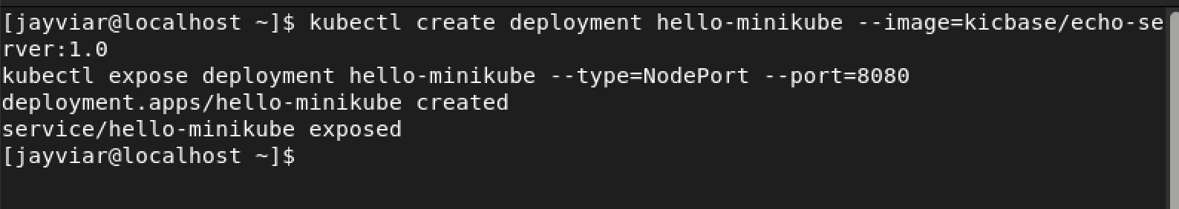

1. Next, let us run it. We first start off by getting services for the minkube cluster. This command will look like:

Kubectl get services hello-minikube

*Below is what happens when the command is run and what we see in a web browser.*

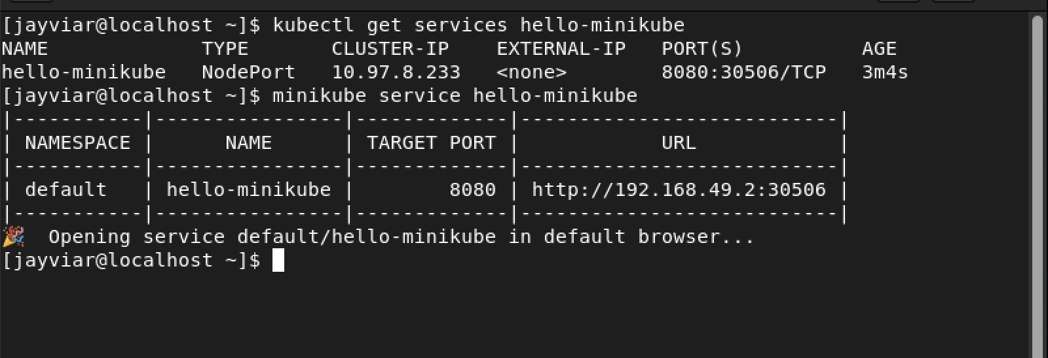

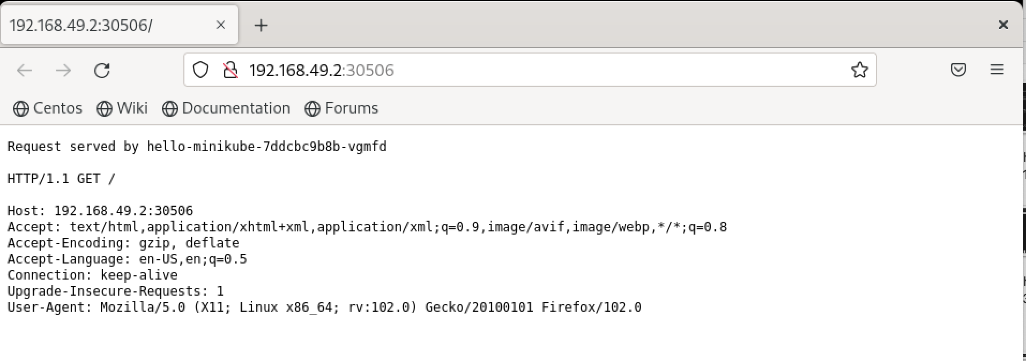

Rerferences:

<https://linuxhint.com/install-enable-snap-centos-8/>

<https://microk8s.io/docs/getting-started>

<https://minikube.sigs.k8s.io/docs/start/>