Continue Setup(CentOS)

Jayviar Laporte

Table of contents:

Tmux Install- pg 1-3

Installing Emacs pg 4-6

Installing fail2ban pg 6-9

Installing Cowsay pg 10

Installing lolcat pg 11-14

Update VIM pg 15

Changes Made pg 16

**Installing Tmux**

To begin we want to check what repositories we have before we start.

* To check our repositories, we are going to simply run the yum repolist command

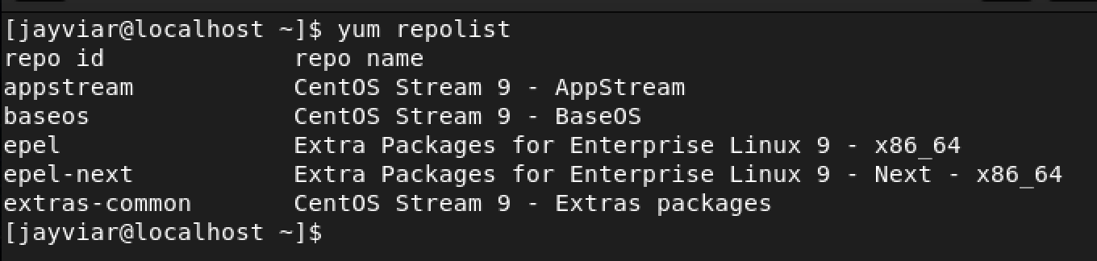

* Next, if we wish to install a new repository, we are going to use the following command:

sudo yum install ~insert desired repository~

* Below we are going to install the application named *tmux.* The syntax for this is the same as above and Is as follows

**sudo yum install tmux :**

*Image of what it looks like installed*

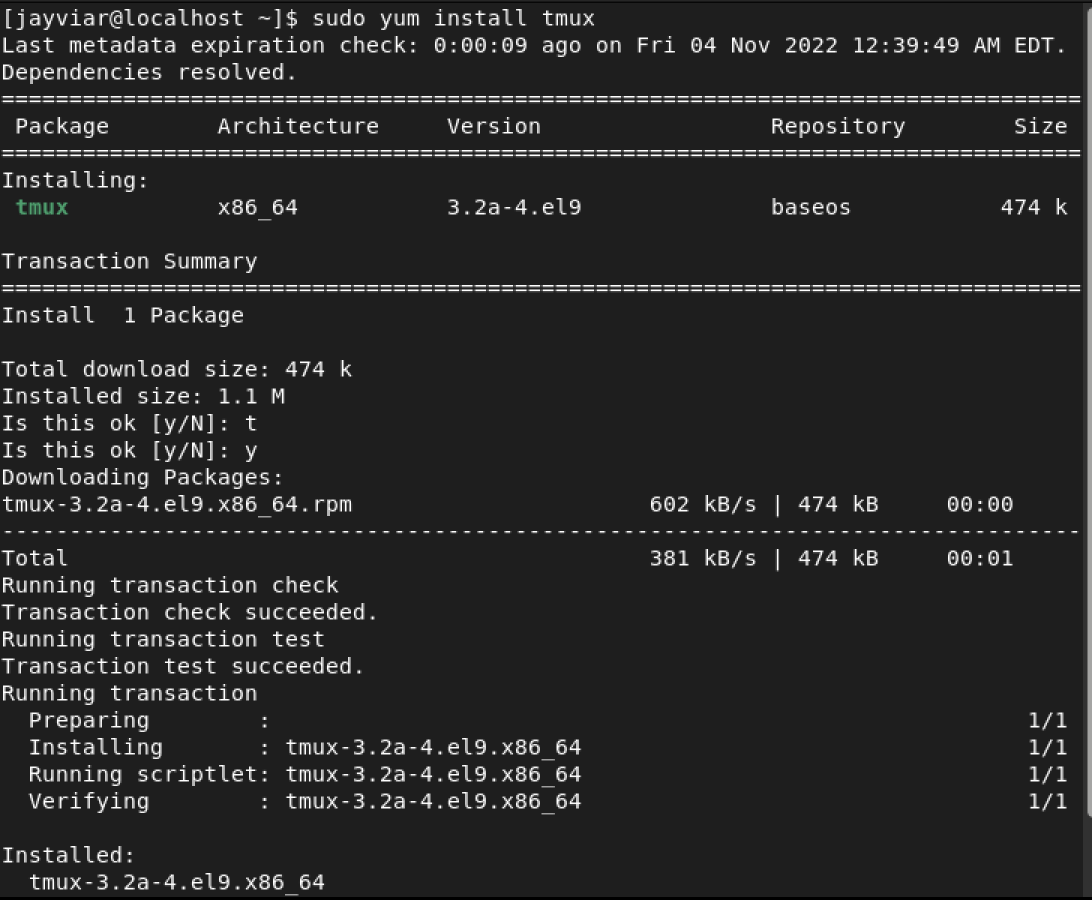

**A brief summary of what this does is: Tmux can do things in the terminal without a user having to sit there and wait for it. For example, let's say we had to install a very large item that was estimated to take over an hour. We would not want to be completely powerless in our terminal and unable to do anything so it can download. So, we use tmux to work around that. It allows users to have multiple command prompts at one moment as to not slow down any work that needs to be done while something may need to be run for an extended period of time.**

**To open tmux just simply type, tmux followed by the syntax new-session –s any name you may want to give it.**

**EX: tmux new-session -sjay.**

**Below is what our tmux will look like once opened. Notice the green to identify it in use and open, but that’s really the only difference between this and what your regular terminal** **will look like.**

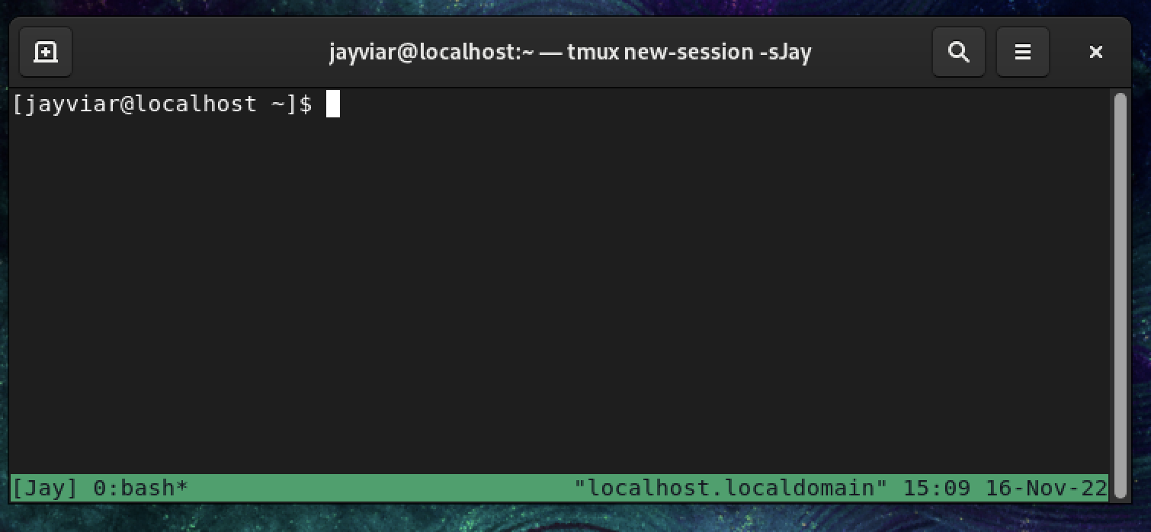

* Now to test this we can do something simple, per say download a file. For this example we are going to use the following command that will just install htop

Sudo yum install htop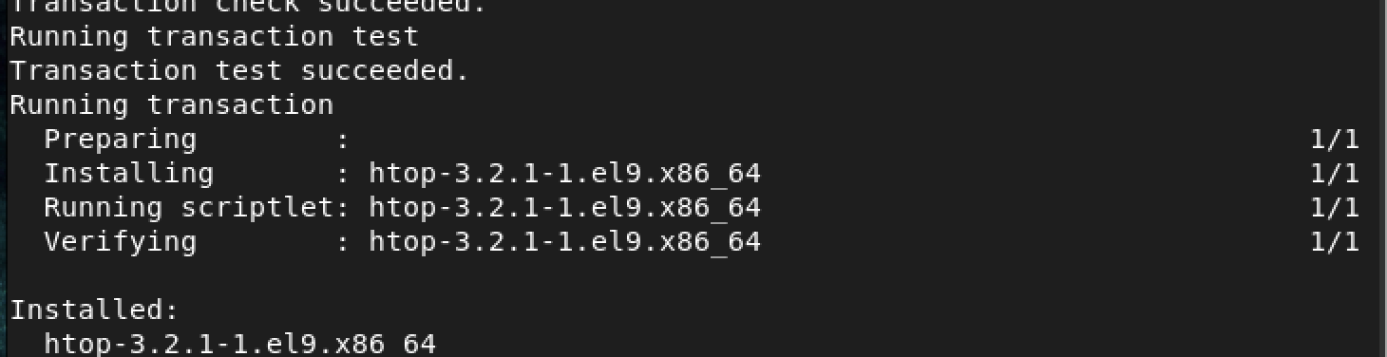

To exit a session we can simply use the

Exit command in an empty command line

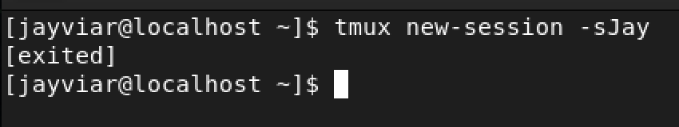

**Installing Emacs**

* For the next part of this lab we are going to install the application *emacs* with the following command:

sudo yum install emacs

*Here is what that will look like once installed*

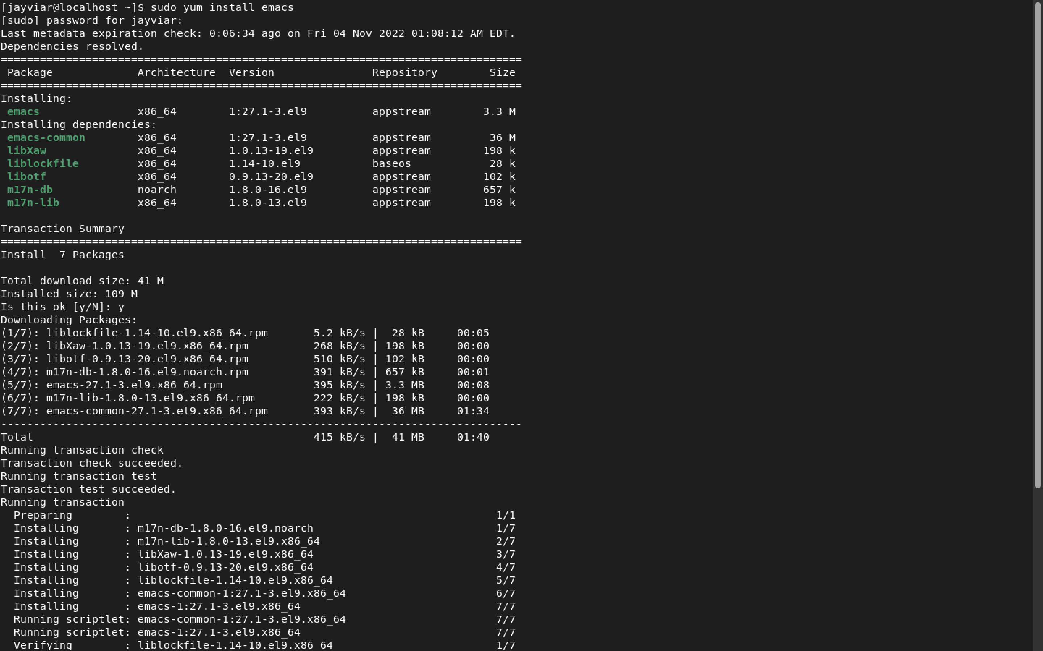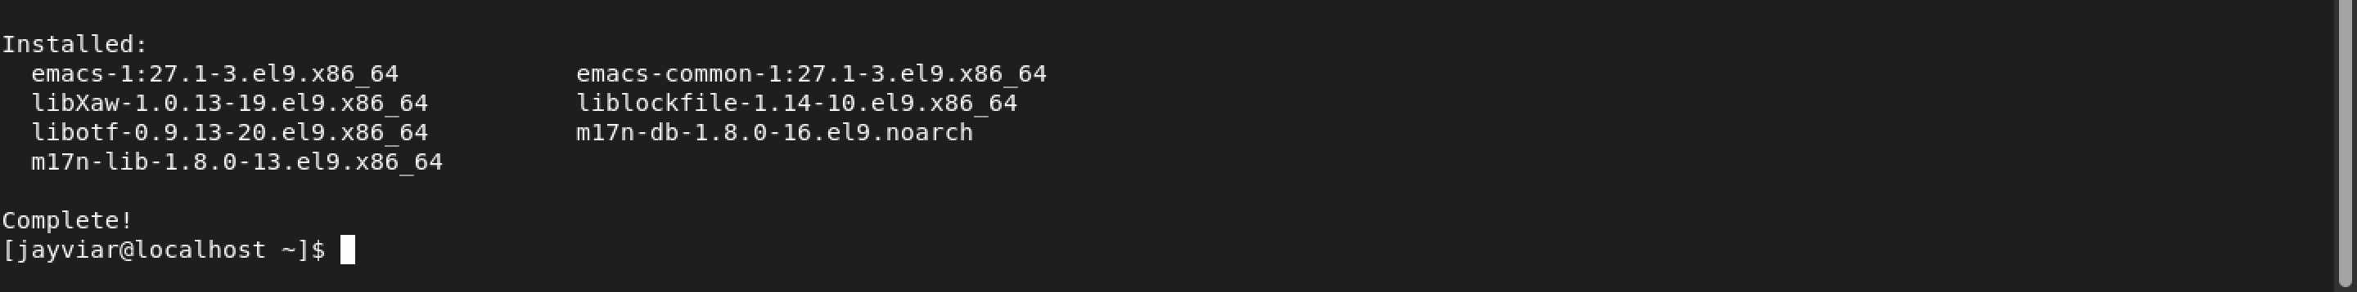

* Now We are going to open Emacs and just test it so you can see for yourself. Simply type: emacs on the command line and it will boot up!

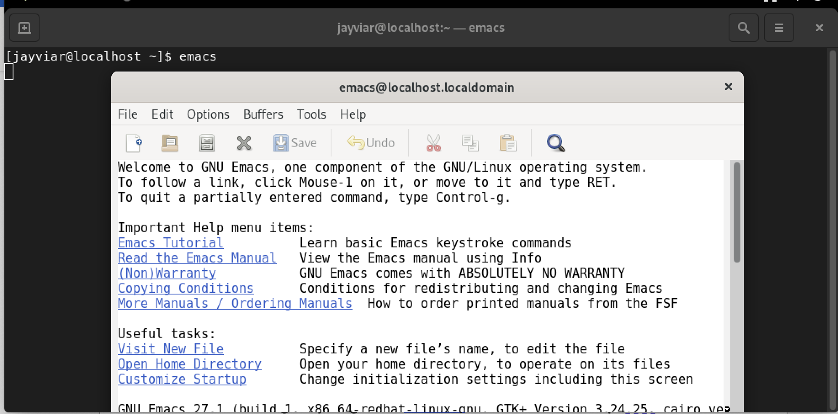

* Our CentOS Distro has a GUI to it which makes it easy to navigate the emacs tool. With this, it is encouraged to try all things you would like to edit with this. For example, if you want to make a new file, click the paper on the top left and your screen will look like this:

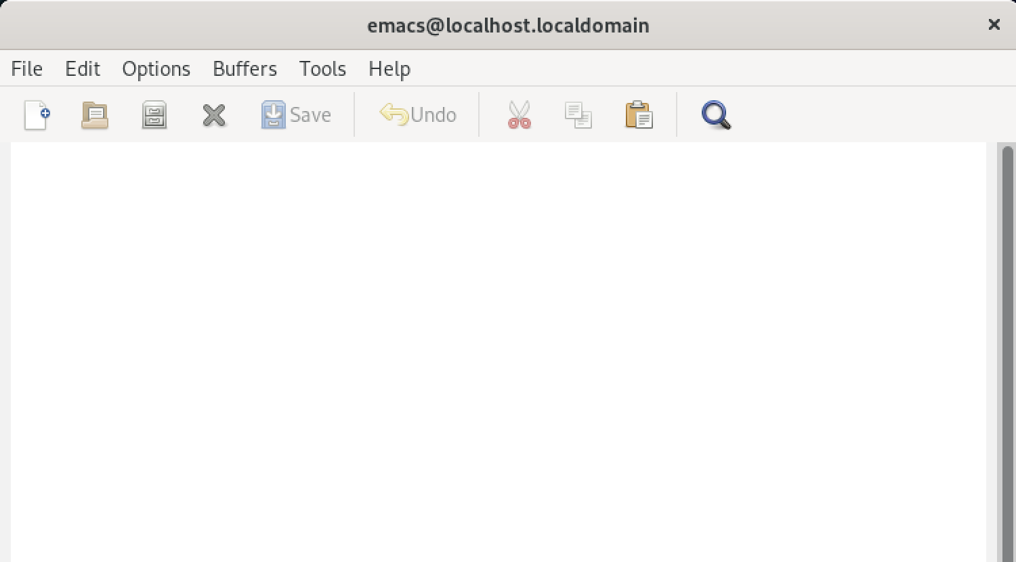

**Installing Fail2Ban**

* Next we are going to install fail2ban. Just as before, we are going to install this using the command:

Sudo yum install fail2ban

*Fail2ban being installed*

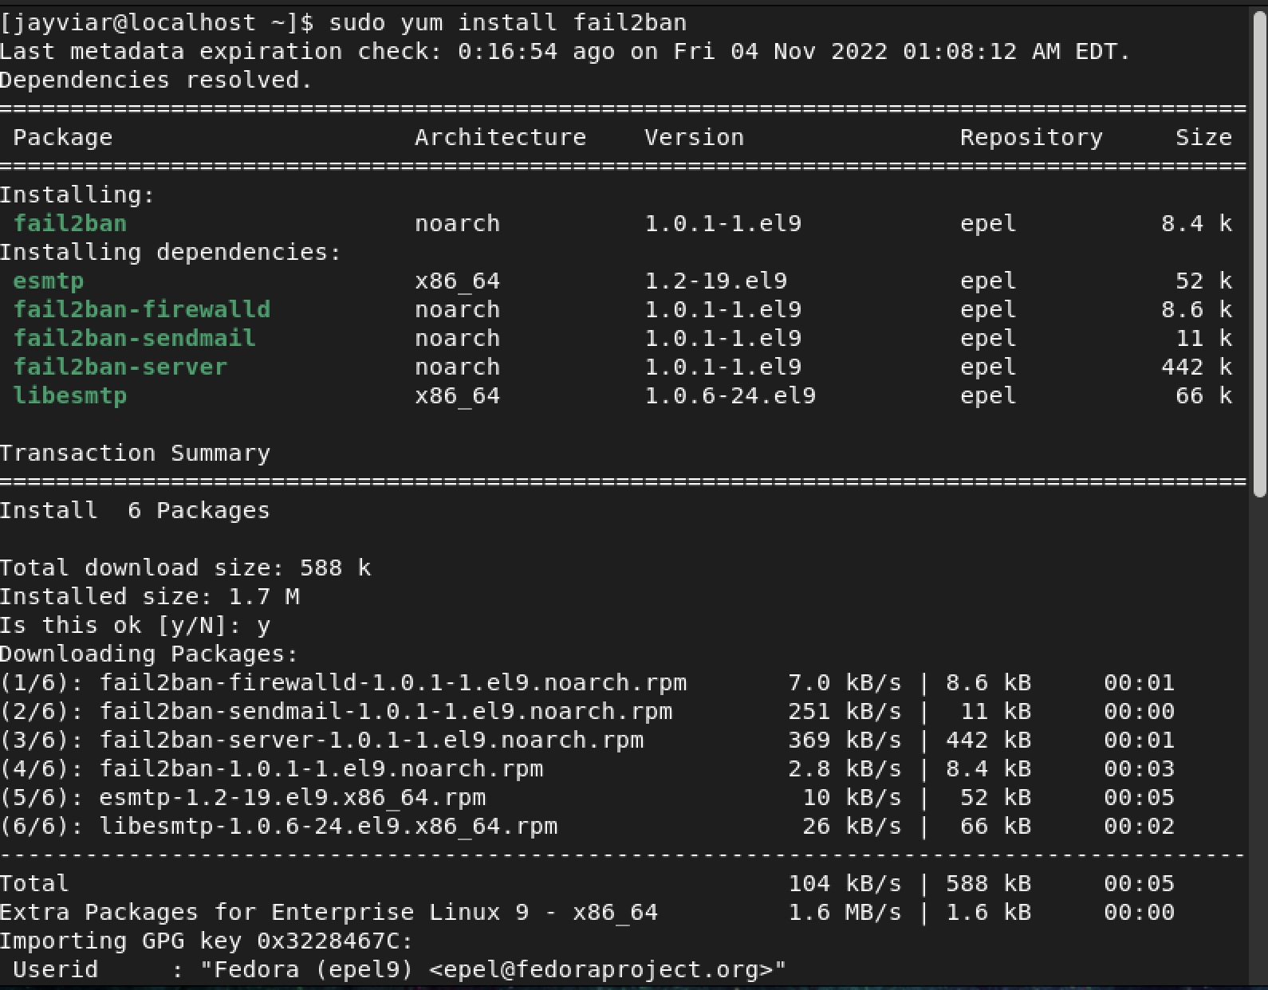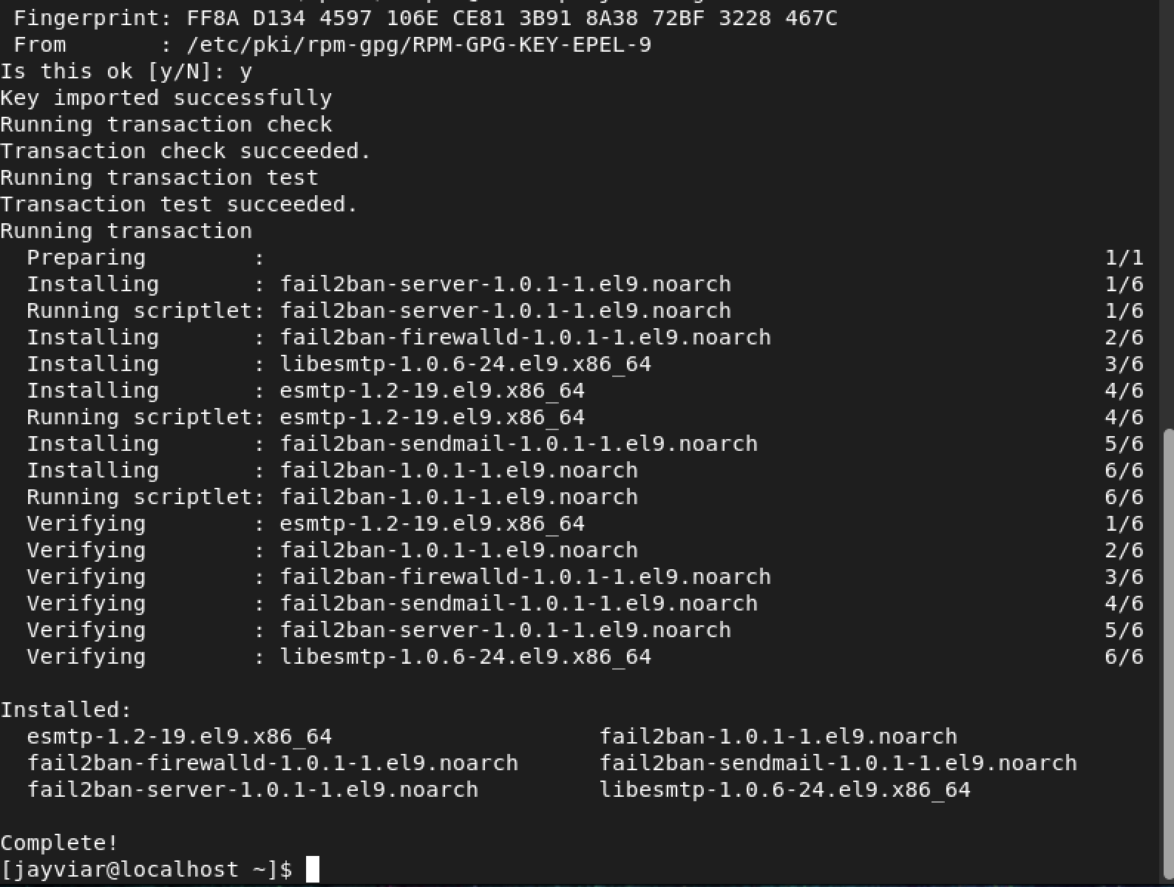

* To enable fail2ban, we must run the following command:
* sudo systemctl enable fail2ban
* Now, we can edit fail2ban to whatever it is we want it to be. For this lab we are going to edit the ban time. To do this, we must open the file that contains the script we want to edit the file in this case is jail.local and the command is:

**sudo nano /etc/fail2ban/jail.local**

* *Below is what our finished script should look like. Note, the following script was pulled from an outside source linked in the references below.*

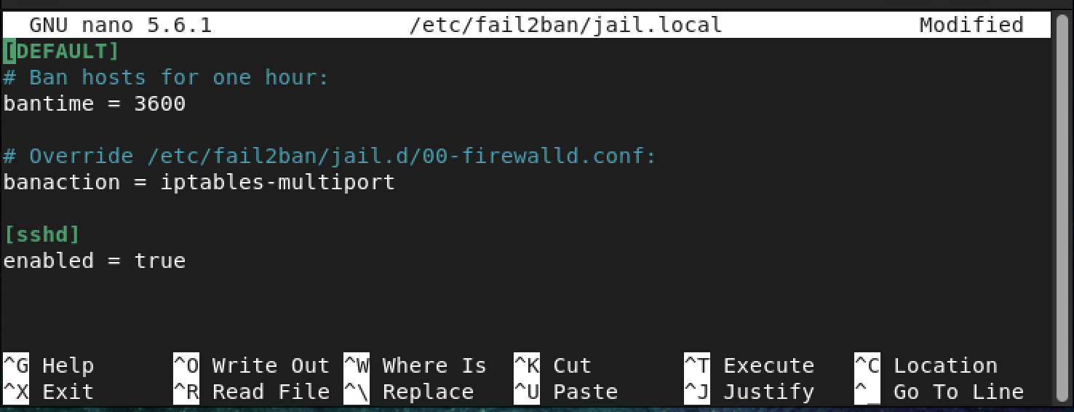

**Installing Cowsay**

* Here we are going to install Cowsay. Installation is as follows:

sudo yum install cowsay:

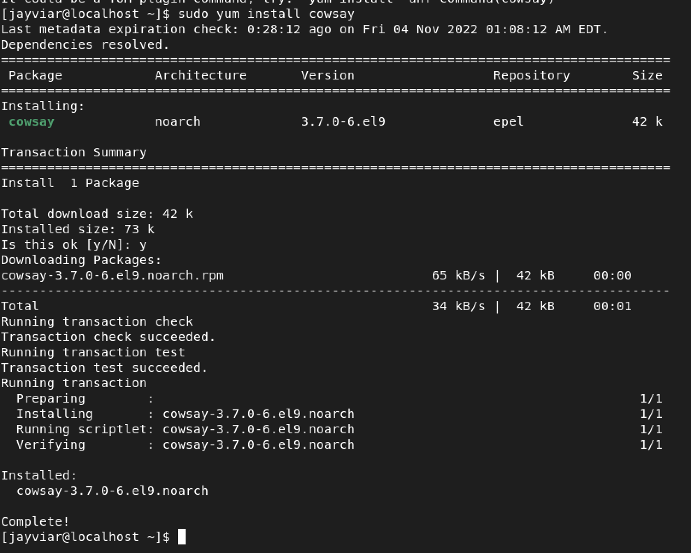

* Now cowsay is very straight forward. the syntax is as follows:
* Cowsay “insert any text here”

*Below is an example of cowsay being used in action*

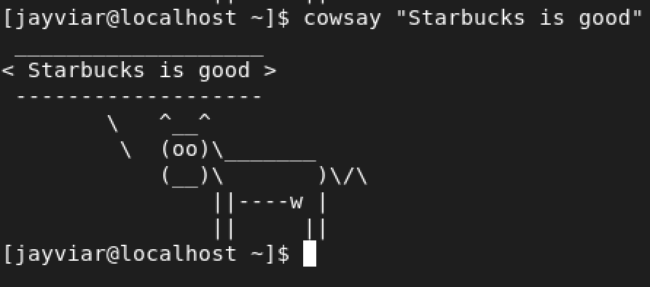

**Installing lolcat**

* To begin the lolcat install. We must first install the gem *ruby.* It will be a necessary download now in order to use lolcat later

Sudo yum install ruby

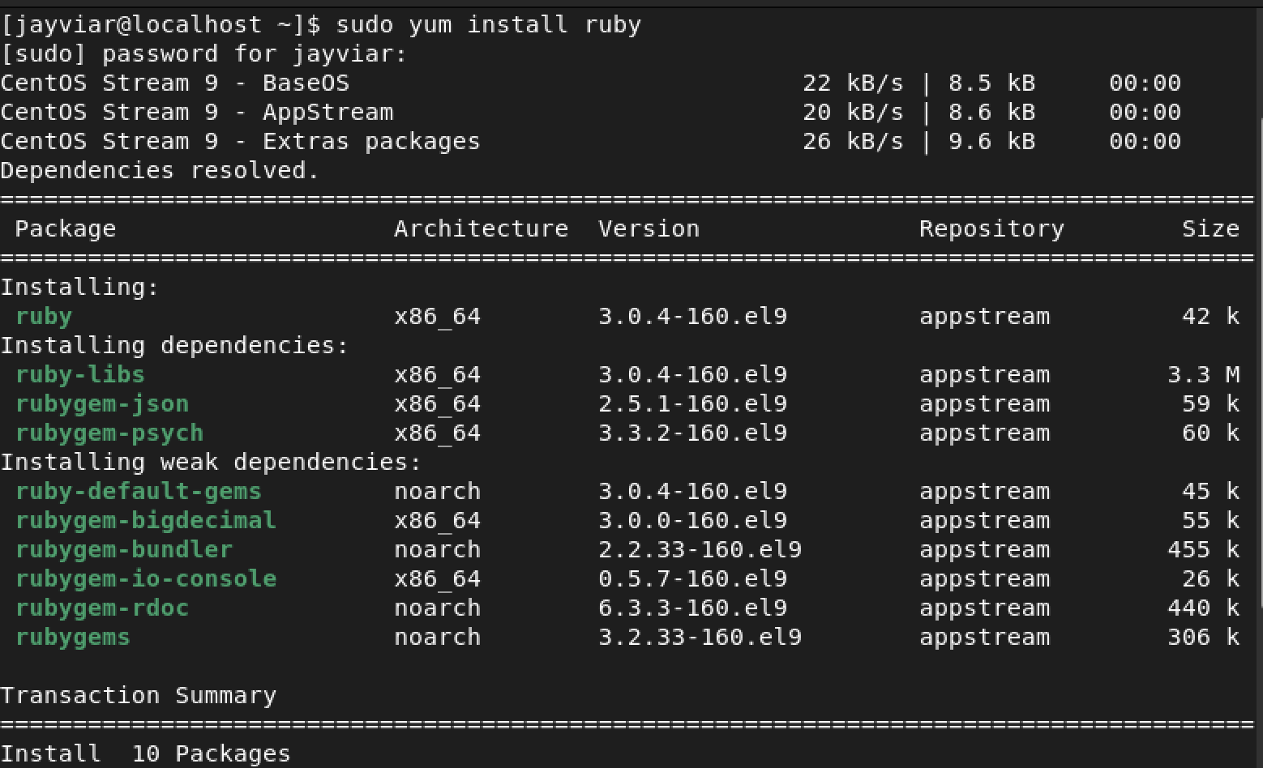

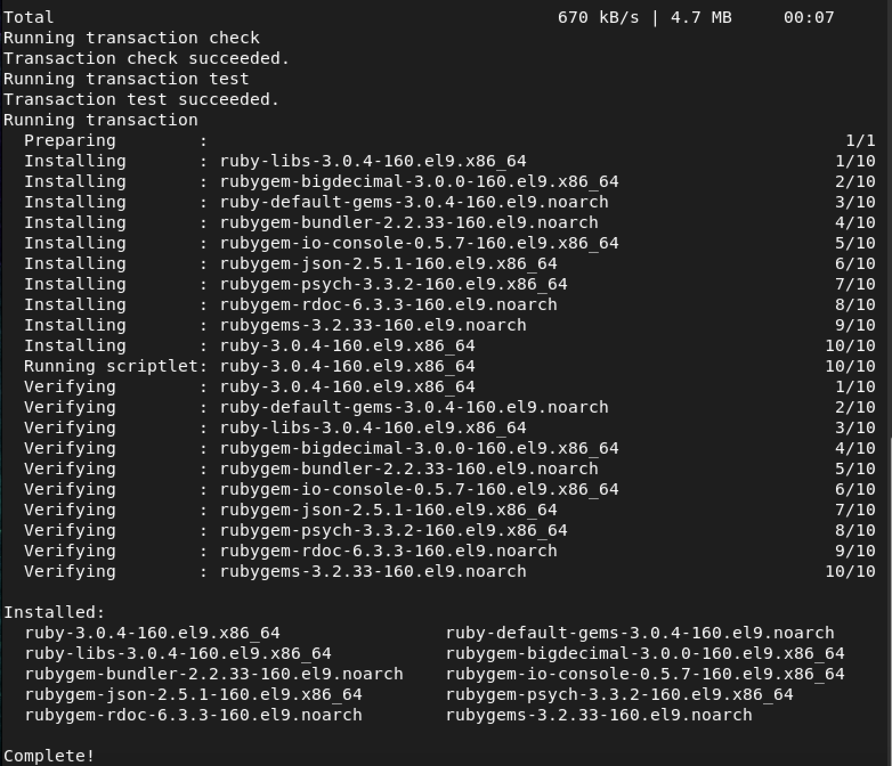

* Next, we are going to use the get command in order to retrieve the file from GitHub that is needed to install lolcat.

wget <https://github.com/busyloop/lolcat/archive/master.zip>

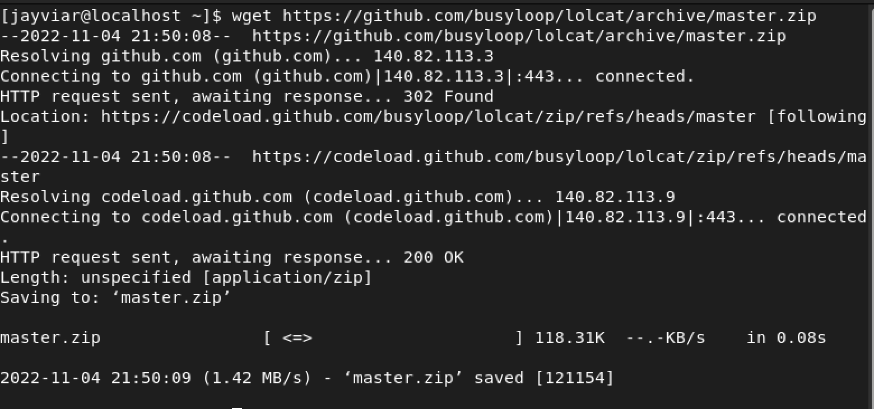

* Since the file we installed previously was a zip file we need to unzip below in order to access content within it:

Unzip master.zip

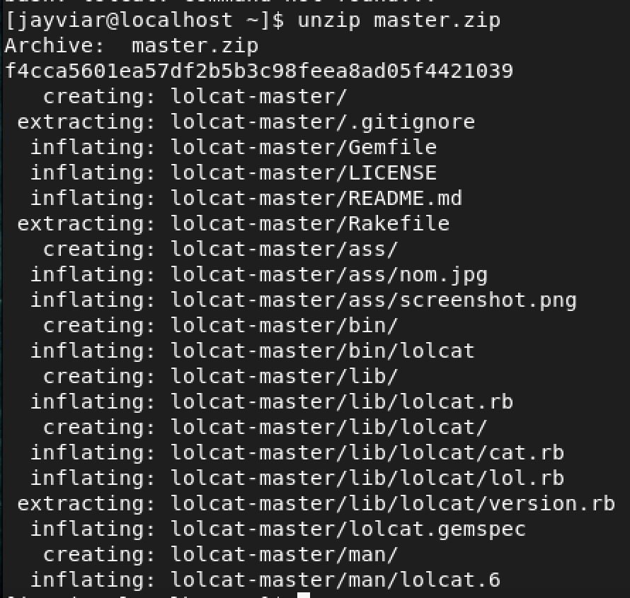

* We then want to change the directory that we are in. We want to change it so we are in the masterfile where lolcat is going to be located. Once we are in the new directory, we then are going to use the gem command which allows us to interact with ruby and then simply use install lolcat to finally install it:

Cd lolcat-master/bin then gem install lolcat

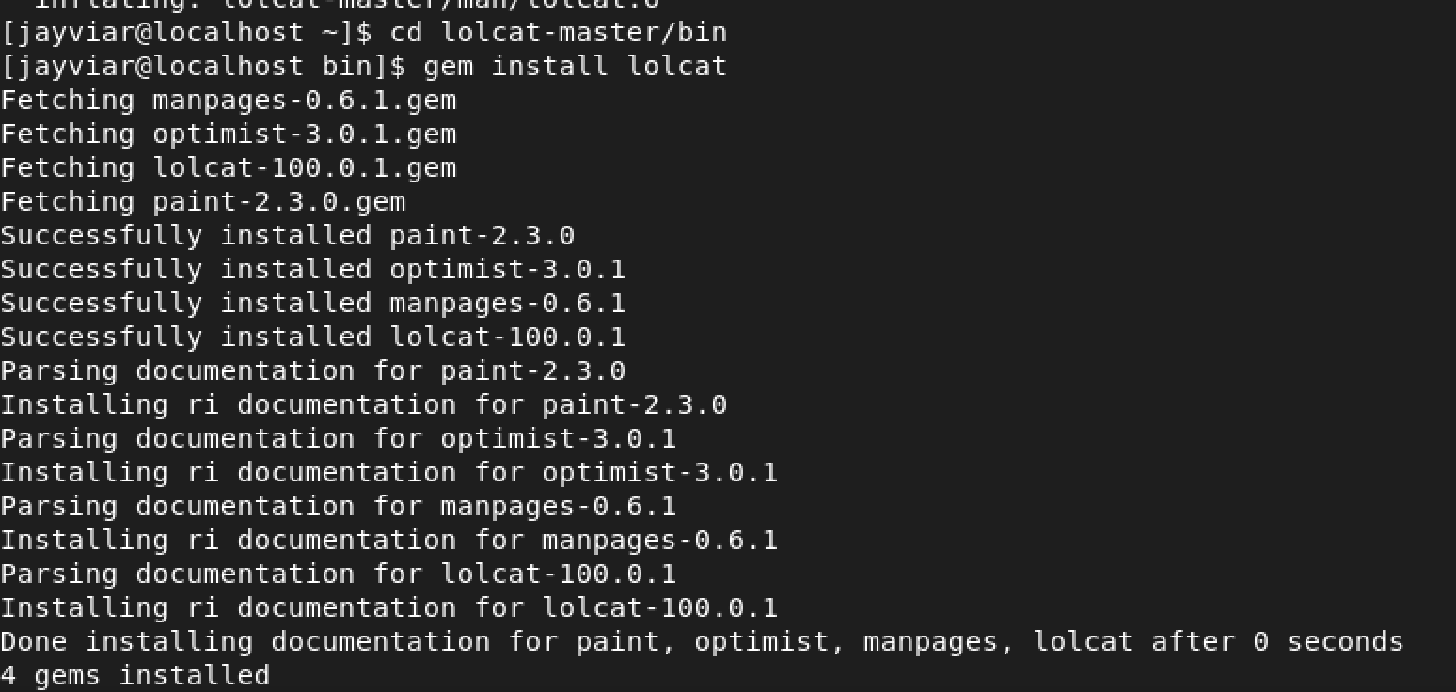

*To Test lolcat we will use lolcat -h*

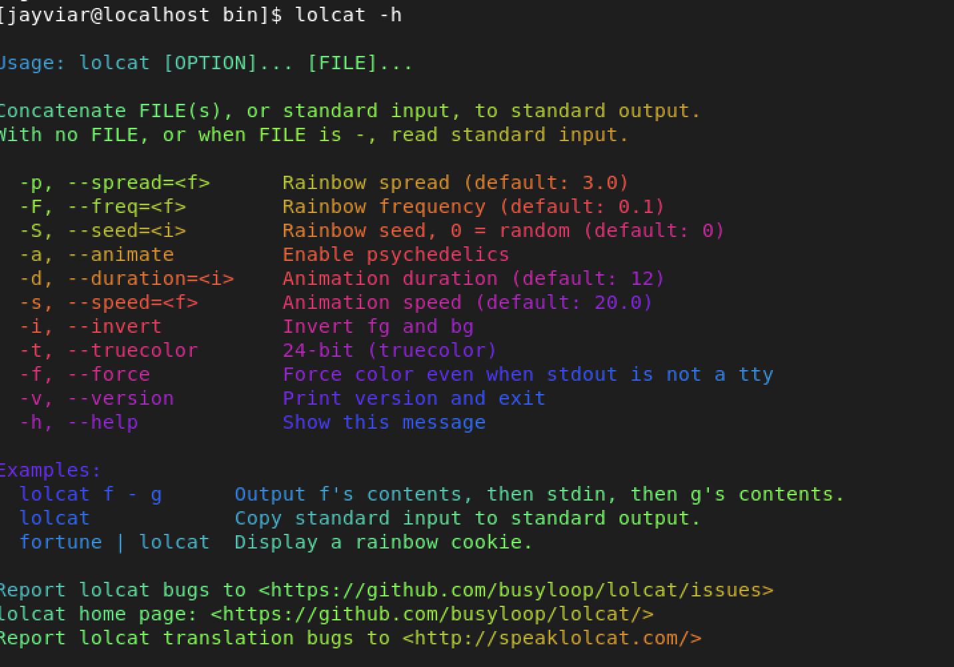

**Update VIM**

Here is just updating the vim by running the admin command sudo and then using yum to use update vim

Sudo yum update vim

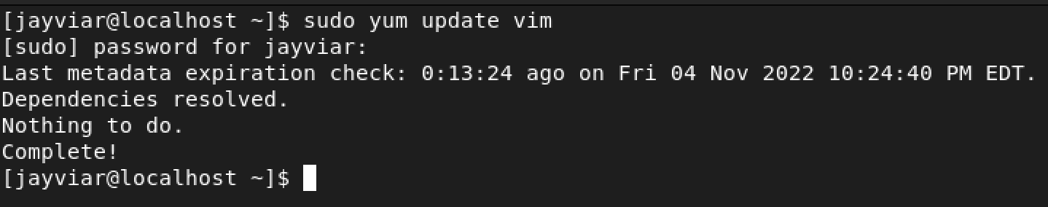

**Changes Made**

* Nothing has changed as far as what we installed goes. We did not edit any of the configurations that came with all our downloads besides updating our vim as well as changing the fail2ban program. We edited fail2ban and changed its ban time to be significantly longer if the password was guessed wrong too many times.

References -

-

<https://www.tecmint.com/lolcat-command-to-output-rainbow-of-colors-in-linux-terminal/>

-

<https://github.com/git-game/git-game>

-

[**https://www.digitalocean.com/community/tutorials/how-to-protect-ssh-with-fail2ban-on-centos-7**](https://www.digitalocean.com/community/tutorials/how-to-protect-ssh-with-fail2ban-on-centos-7)