**Our Current Network Setup**

To begin this lab, we need to check off a few things regarding the network. For starters. We are going to note by stating nothing new has been installed or downloaded for the sake of this lab. Along with this, we did perform an update on our server using the sudo yum update command on our Centos server as well as the sudo apt-get update command to update our Ubuntu server just to make sure it was up to date. Both were taken place on the same day Nov 15th 2022.

For our ubuntu and centos server we have a NAT. Connection. Which just means it is connected to my current device and shares an IP address with it

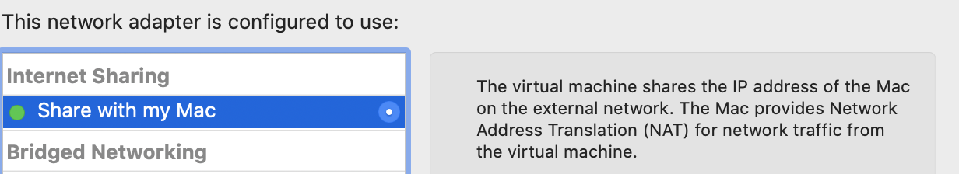

**Centos-**

For our centos server. A big bulk of its information can be found simply through the network setting in the servers GUI menu. Not really any commands would need to be run for us to find this information as mot of the documentation looks like this-

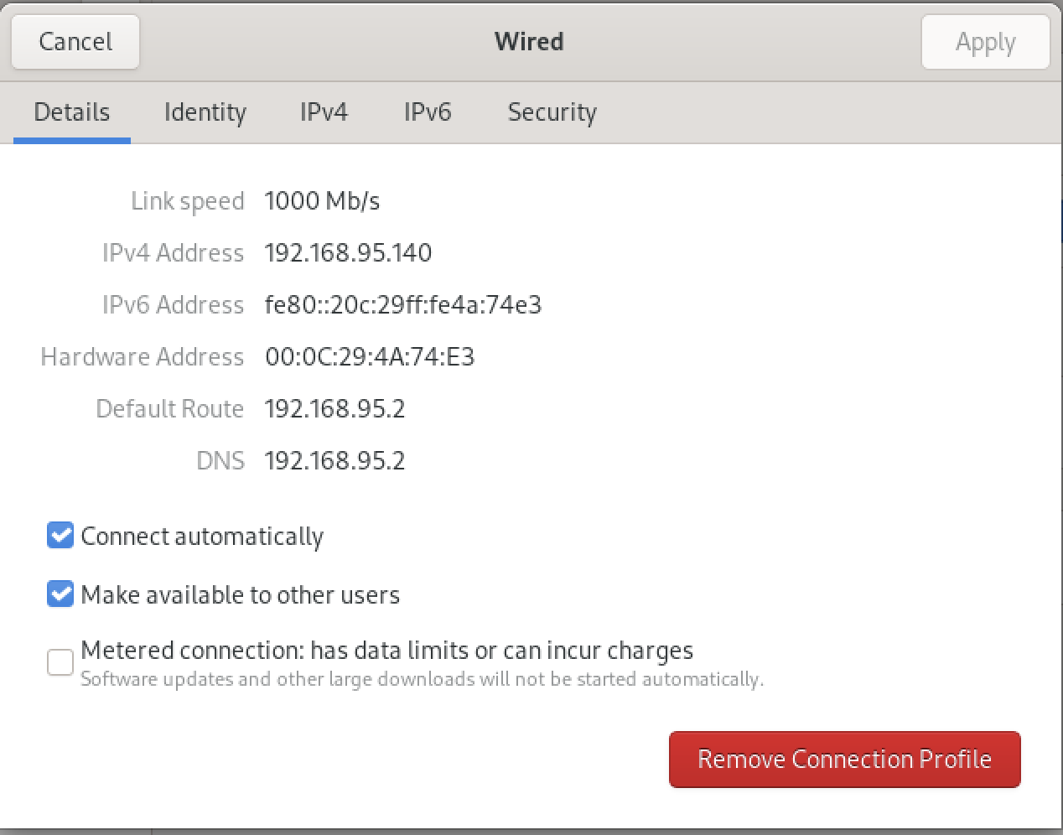

For the network setup on our Centos server. Almost all its settings are displayed here in the window above. If one were to wish to edit anything, it could be done here.

For more information on editing it, here Is the link the centos website where anything not talked about in the lab can be viewed-

<https://docs.centos.org/en-US/centos/install-guide/NetworkSpoke-x86/>

**Ubuntu-**

For our ubuntu server, we can find most of this info running basic commands such as ip addr and arp-

Here we can see our ip address as well as MAC addresses.

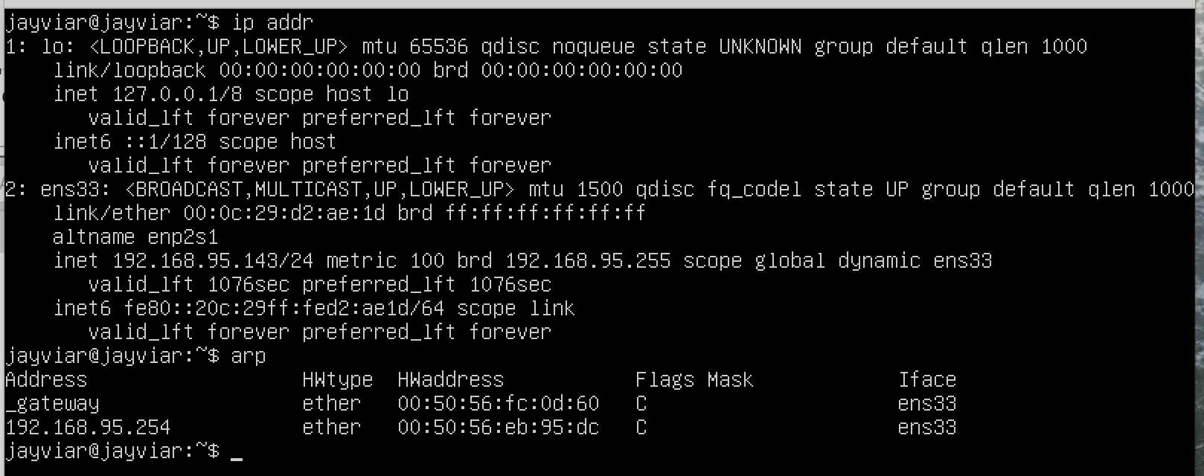

For the network setup on our server. Ubuntu states that “ TCP/IP is the driving force of the Internet, and thus it is the most popular set of network protocols on Earth.” TCP is what sends and delivers data from one network host to another. This is essential for networking as it is very literally what networking is all about. Making sure we can communicate from one client to another on a network. In short, our sever uses this as well as many other things that can be viewed in its entirey from the official website link here-

<https://ubuntu.com/server/docs/network-introduction>