Sed Lab

By Jayviar Laporte

Hello! Below is a guide on how to use sed in various ways

1. Change Jo to Josephine

So, to start off we will simply use the sed command to change the name Jo to Josephine using the substitution command.

Sed s/Jo/Josephine.

Basically, the syntax takes the first word after s/ and changes it to whatever comes after it.

Below is what that looks like



1. Delete Last 5 Lines

To figure out the what lines exactly I would be deleting. I used wc to check how many lines were in the entire file of sedlab so I can use the d command with sed to delete the range of lines

This is what that looks like:

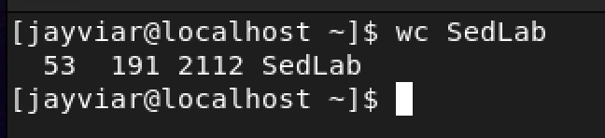

Then with this I knew I had to delete lines 48-53 using “sed 48,53d SedLab” to remove them. Below is what that command looks like

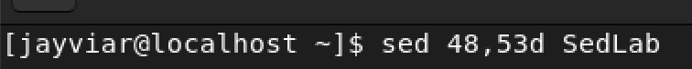

1. Print lines 3-15

To print specified lines, we will just use /p with sed and simply tell it what range we want to see.

The syntax is very simply as we just type the number we want to start with followed by a comma and the last line we want to see and finish it off with p

Sed 3,15p sedlab

Below is what it looks like

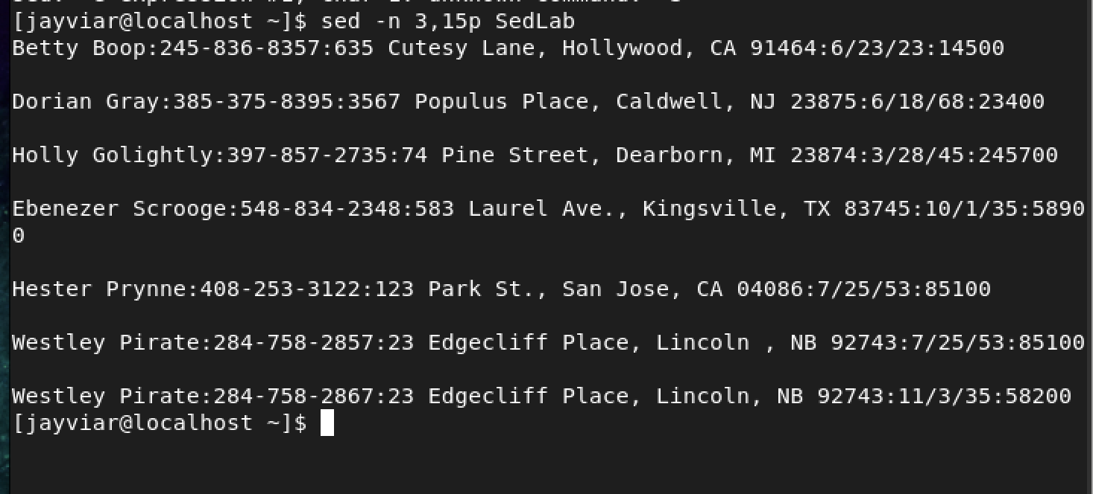

1. Delete lines for people in California

To delete the lines that include California we simply tell type the pattern for california followed by a /d to tell sed to delete it

The command for that would look like this: sed /CA/d Sedlab

And below is what the fle looks like with CA deleted

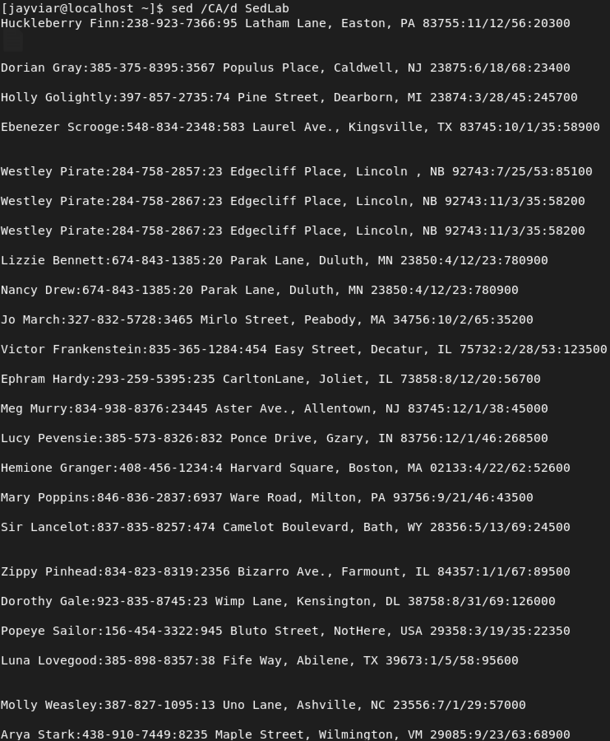

1. Print birthdays during the first week of the month

To print birthdays ONLY at the beginning of the month, we need to use a regular expression. The way I did it looks like this



The regex in this line will only search for the pattern of a date that has the range of 1-7 only in the /dd/ column.

Below, only days that are between 1-7 of the month are printed twice. (to avoid this, use –n to negate every line from being printed and or printed twice)

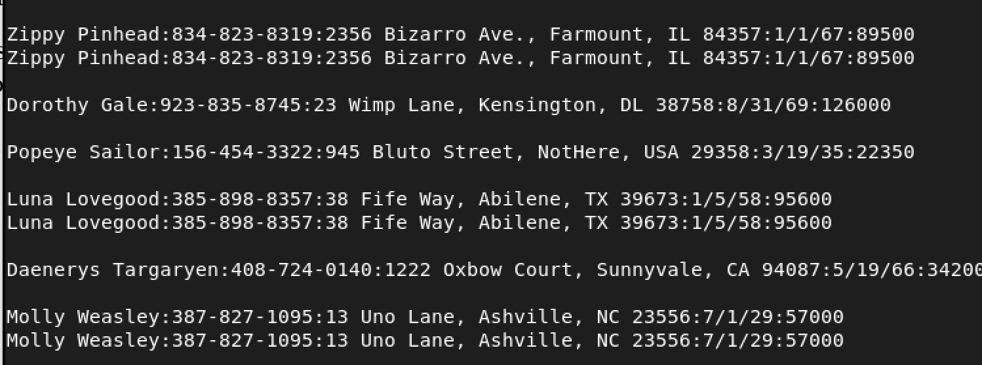

1. Append 3*** to lines starting with sir

To do this we are simply going to specify the word we want to substitue and then right after, specify the word or string we want to put at the end of that,

It would look like this: sed ‘Sir/ s/$/ ***/ ‘ SedLab





1. Replace Westley Pirate With as you wish

Sed “s/Westley Pirate.*/As You Wish/g” SedLab

Here we are using the sed command to change the ENTIRE line of Westley pirate and replacing every instance of it with the phrase, “As you Wish”

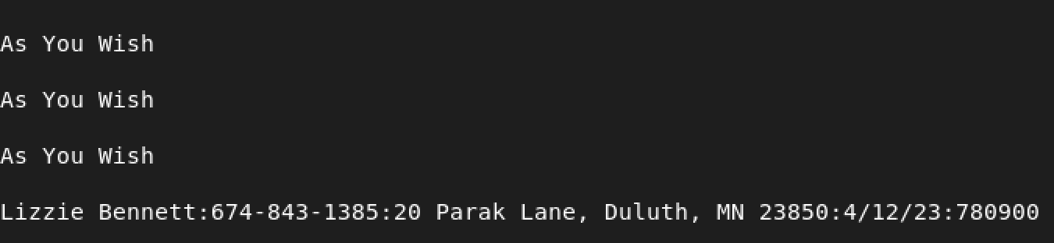

1. Change Minervas Birthday and search for it

The easiest way to get her birthday is simply to just search for Minervas full name and go from there



After which we can see her birthday is this:



With this we can find her exact birthdate and use sed to change it specifically

For this we will substitute the new date specific to her and then print it using the following

Sed ‘s/2\/3\/36/10\/4\/35\/g’ SedLab

Above we used backslash separate each of the forward slashes as the syntax would no be correct if we had a regular date like this 2/3/36 because it would just be too many replacements at once and the code wouldn’t work

Our result looks like this with the new date



1. Delete all blank lines

To delete all blank lines we will use a regular expression to find the blank line pattern, and then delete them with d.

Sed ‘/^$/d’ SedLab

This command will basically search for every line that starts to finishes with a blank and deletes it with d

Below is how the file looks without any blank lines

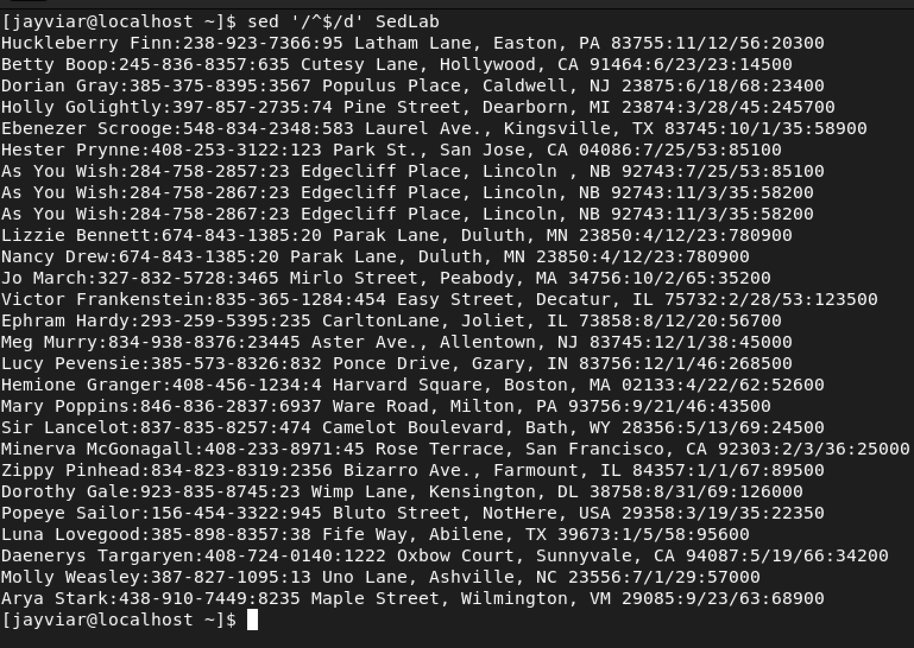

1. Wrtie a script to insert, print, and append.

This was the hardest part for me as I am a little new and rusty to using sed. I tried doing each part individually which helped a bit. However the hardest portion is figuring out a regular expression for last name and phone number and then applying that with two other things such as append and insert Below I have attached a screenshot of what my current thought process is in the sed script.

The first line is to insert before the first line

The second line is my unfished attempt at printing just lastnames and phone numbers

The third line is putting happily ever after at the end of the file

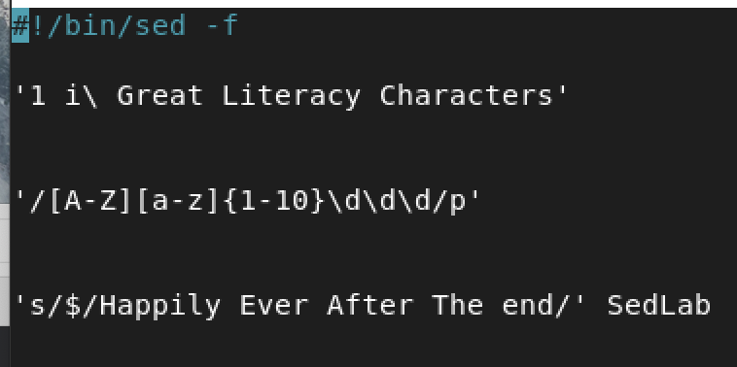

I have watched numerous videos on this but the ones I used mostly were all of the ones Adrianna posted on her website/ youtube. The rest are linked down here

Luke Smith- [Using `sed` and Regular Expressions (Unix/Linux command line)](https://www.youtube.com/watch?v=QaGhpqRll_k&t=726s)

[](https://www.youtube.com/watch?v=QaGhpqRll_k&t=726s)

Learn Linux- [Linux Crash Course - The sed Command](https://www.youtube.com/watch?v=nXLnx8ncZyE&t=181s)

[](https://www.youtube.com/watch?v=nXLnx8ncZyE&t=181s)