**Question 1**

**An electricity board charges the following rates to user.**

**For the first 100 units → 60p per unit.**

**For the next 200 units→80p per unit.**

**Beyond 300 units→90p per unit.**

**1).All users are charged a minimum of Rs. 50; if the total amount is more than 300 then an additional surcharges of 15% is added. Write a program to accept name of user consumed and print charges with their rates**.

**Solution**

#include<iostream.h>

#include<conio.h>

const int minimum=50;

void main()

{

float total,unit,additional=0;

char name[20];

clrscr();

cout<<"Enter Name :- ";

cin>>name;

cout<<"Enter Unit :- ";

cin>>unit;

if(unit<=100)

total=(unit*0.6)+minimum;

else if(unit<=300)

total=(unit*0.6)+((unit-100)*0.8)+minimum;

else

total=(unit*0.6)+((unit-100)*0.8)+((unit-300)*0.9)+minimum;

if(total>300)

{

additional=total*0.15;

total+=additional;

}

cout<<"Name :- "<<name<<endl;

cout<<"Units Consumed :- "<<unit<<endl;

cout<<"Additional Charges :- "<<additional<<endl;

cout<<"Minimum Charges :- "<<minimum<<endl;

cout<<"Total :- "<<total;

getch();

}

**Output**

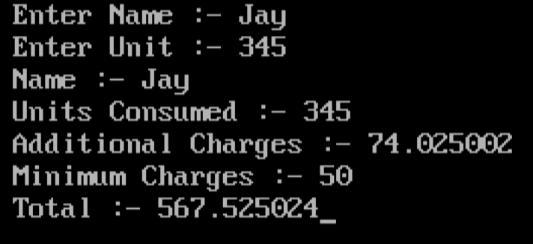

**Question 1**

**Define a class to represent a bank account. Include the following members:**

**a. Name of the depositor b. Account number**

**c. Type of Account d. Balance amount in the Account Member Functions:**

1. **To assign initial values.**
2. **To deposit an amount.**
3. **To withdraw an amount after checking the balance.**
4. **To display name and balance.**

**Write main program and handle accounts of 5 customers.**

**Solution**

#include<iostream.h>

#include<conio.h>

class bank

{

protected:

char name[20],type[10];

float amount;

public:

int acno;

void getdata()

{

cout<<"\n\nEnter Name :- ";

cin>>name;

cout<<"Enter Account Number :- ";

cin>>acno;

cout<<"Enter Type Of Account :- ";

cin>>type;

cout<<"Enter Deposited Amount To Open Account :-";

cin>>amount;

cout<<"Your Account Opened Successfully..."<<endl;

}

void deposit()

{

float d;

cout<<"\n\nEnter Amount to Deposit :- ";

cin>>d;

amount+=d;

cout<<"Amount Successfully Deposited To your Account..."<<endl;

}

void withdraw()

{

float w;

cout<<"\n\nEnter Amount To Withdraw :- ";

cin>>w;

if(w>amount)

{

cout<<"You have insufficient Balance..."<<endl;

return;

}

amount-=w;

cout<<"Amount Successfully Withdrawn..."<<endl;

}

void display()

{

cout<<"\n\nName :- "<<name<<endl;

cout<<"Balance :- "<<amount<<endl;

}

};

void main()

{

int ch,i,acc,j=0,choice;

bank b[5];

clrscr();

do

{

cout<<"\n1.New Account\n2.Existing Account\n3.Exit\n";

cin>>ch;

switch(ch)

{

case 1:

b[j].getdata();

j++;

break;

case 2:

cout<<"\nEnter Account Number :- ";

cin>>acc;

for(i=0;i<j;i++)

{

if(b[i].acno==acc)

{

do

{

cout<<"\n1.Deposit\n2.Withdraw\n3.Display\n4.Exit\n";

cin>>choice;

switch(choice)

{

case 1:

b[i].deposit();

break;

case 2:

b[i].withdraw();

break;

case 3:

b[i].display();

break;

case 4:

cout<<"Exitting..."<<endl;

break;

default:

cout<<"Enter Corrct Choice...";

}

}while(choice!=4);

break;

}

}

if(i==j)

cout<<"Account Not Found..."<<endl;

break;

case 3:

cout<<"Exitting..."<<endl;

break;

default:

cout<<"Enter Correct Choice...";

}

}while(ch!=3);

}

**Output**

