Assignment

1. What is Metaspace and heap memory?

* Metaspace is a new memory space – starting from the Java 8 version; it has replaced the older PermGen memory space. The most significant difference is how it handles memory allocation.

Specifically, this native memory region grows automatically by default

* JVM Memory Structure is divided into multiple memory area like heap area, stack area, method area, PC Registers etc.

*JVM Memory area parts*

Here, the heap area is one of the most important memory areas of JVM. Here, all the [java objects](https://www.geeksforgeeks.org/classes-objects-java/) are stored. The heap is created when the JVM starts. The heap is generally divided into two parts. That is: 

1. Young Generation(Nursery): All the new objects are allocated in this memory. Whenever this memory gets filled, the [garbage collection](https://www.geeksforgeeks.org/garbage-collection-java/) is performed. This is called as *Minor Garbage Collection*.
2. Old Generation: All the long lived objects which have survived many rounds of minor garbage collection is stored in this area. Whenever this memory gets filled, the garbage collection is performed. This is called as *Major Garbage Collection*.
3. Generate multiples of 2 until 20 using recursive function

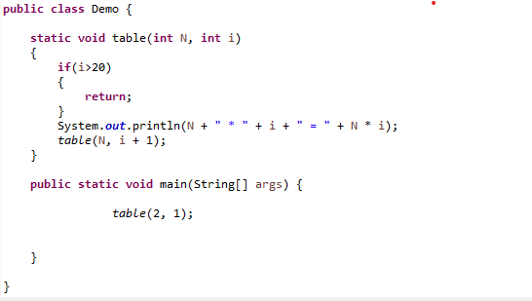

1. Check if two strings are equal or not

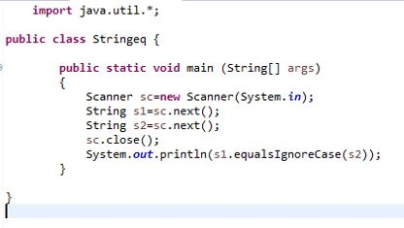

1. Print the character count in a string say :string s ="helloworld" print h-1, e-1, l-3,o-2

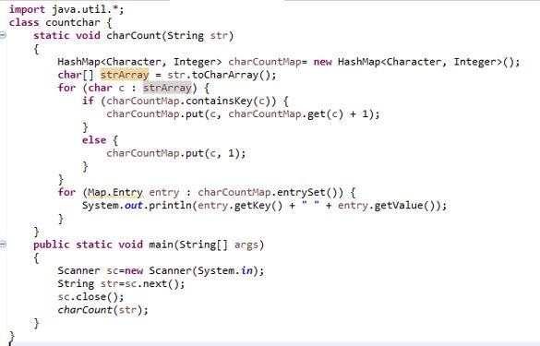

1. Why java is platform independent?

Java compiler produces a unique type of code called bytecode unlike c compiler where compiler produces only natively executable code for a particular machine.

When the Java program runs in a particular machine it is sent to java compiler, which converts this code into intermediate code called bytecode. This bytecode is sent to Java virtual machine (JVM) which resides in the RAM of any operating system. JVM recognizes the platform it is on and converts the bytecodes into native machine code. Hence java is called platform independent language.

1. Can we create class as final

Yes, you can declare that your class is final; that is, that your class cannot be subclassed. There are (at least) two reasons why you might want to do this: security reasons and design reasons.

**Security**: One mechanism that hackers use to subvert systems is to create subclasses of a class and then substitute their class for the original. The subclass looks and feels like the original class but does vastly different things possibly causing damage or getting into private information. To prevent this kind of subversion, you can declare your class to be final and prevent any subclasses from being created. The String class in the java.lang package is a final class for just this reason. The String class is so vital to the operation of the compiler and the interpreter that the Java system must guarantee that whenever a method or object uses a String they get exactly a java.lang.String and not some other string. This ensures that all strings have no strange, inconsistent, undesirable, or unpredictable properties.

If you try to compile a subclass of a final class, the compiler will print an error message and refuse to compile your program. In addition, the bytecode verifier ensures that the subversion is not taking place at the bytecode level by checking to make sure that a class is not a subclass of a final class.

**Design**: Another reason you may wish to declare a class as final are for object-oriented design reasons. You may think that your class is "perfect" or that, conceptually, your class should have no subclasses.

To specify that your class is a final class, use the keyword final before the class keyword in your class declaration. For example, if you wanted to declare your (perfect) ChessAlgorithm class as final, its declaration would look like this:

final class ChessAlgorithm {

. . .

}

1. consider we have employee class with empid, empname and salary and list of employees get the the highest salary paid employee data

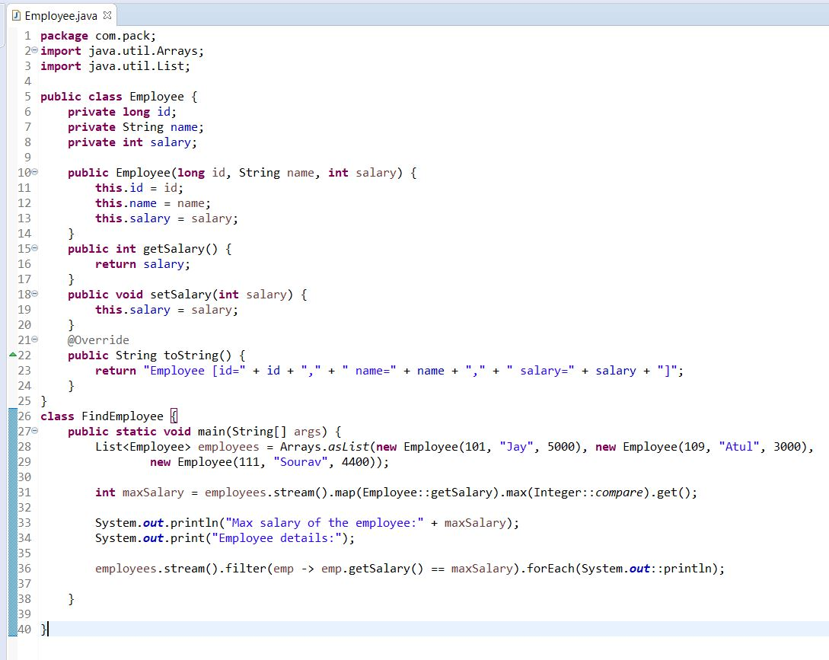

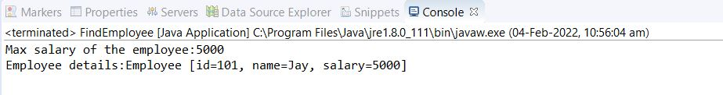

1. consider a list of duplicate values remove duplicate value and get unique values from the list

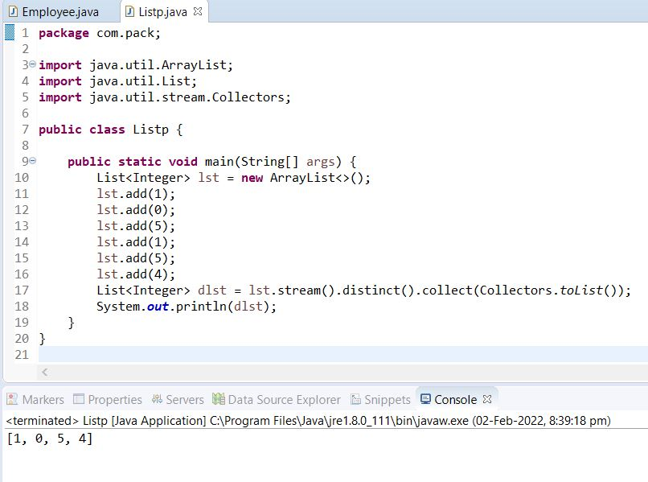

1. can we write try and finally without catch block what is the use

Yes, we can have try without catch block by using finally block.

You can use try with finally. As you know finally block always executes even if you have exception or return statement in try block except in case of System.exit().

1. Create a java application for College Management.

**package** l.pack;

**import** java.util.ArrayList;

**import** java.util.List;

**import** java.util.Scanner;

**import** java.util.stream.Collectors;

**public** **class** StudentD {

**public** **static** **void** main(String[] args) {

List<Employee> empList = **new** ArrayList<>();

List<Employee> dlst = empList.stream().distinct().collect(Collectors.*toList*());

System.***out***.println("Welcome to College Management");

**char** choice;

String result;

**int** count = 0;

**do** {

**if** (count > 0) {

System.***out***.println("C : Check Student Result");

}

System.***out***.println("A : Add Student Result");

System.***out***.println("X : Exit");

Scanner sc = **new** Scanner(System.***in***);

String c = sc.next();

**switch** (c.toUpperCase()) {

**case** "A":

System.***out***.println("Enter student id");

**int** id = sc.nextInt();

System.***out***.println("Enter student Name");

String name = sc.next();

System.***out***.println("Enter marks in hindi");

**int** hindi = sc.nextInt();

System.***out***.println("Enter marks in english");

**int** eng = sc.nextInt();

System.***out***.println("Enter marks in maths");

**int** maths = sc.nextInt();

System.***out***.println("Enter marks in science");

**int** science = sc.nextInt();

System.***out***.println("Enter marks in social");

**int** social = sc.nextInt();

**int** total = hindi+eng+maths+science+social;

**float** per = (**float**) total / 5;

per = per * 100;

**if** (per > 50) {

result="Pass";

} **else** {

result="Fail";

}

dlst.add(**new** Employee(id, name,hindi,eng,maths,science,social,result,total,per));

System.***out***.println("Student added successfully");

count++;

**break**;

**case** "C":

System.***out***.println("Enter Student Id to Check result: ");

**int** in=sc.nextInt();

**for**(Employee e:dlst)

{

**if**(e.getEmpId()==(in))

{

dlst.stream().filter(emp->emp.getEmpId()==in).forEach(System.***out***::println);

System.*exit*(0);

}

}

System.***out***.println("No such data found");

**break**;

**case** "X":

System.*exit*(1);

**default**:

System.***out***.println("Invalid choice");

**break**;

}

System.***out***.println("Do you want to continue (Y/N)");

choice = sc.next().charAt(0);

} **while** (choice == 'Y' || choice == 'y');

System.***out***.println("Bye");

System.*exit*(1);

}

@Override

**public** String toString() {

**return** "MyClass []";

}

}

**class** Employee {

**private** **int** empId;

**private** String empNm;

**private** **int** m1, m2, m3, m4, m5;

**private** String r;

**private** **float** per;

**private** **int** t;

Scanner sc = **new** Scanner(System.***in***);

**public** Employee() {

}

**public** Employee(**int** empId, String empNm, **int** m1, **int** m2, **int** m3, **int** m4, **int** m5, String r,**int** t, **float** per ) {

**super**();

**this**.empId = empId;

**this**.empNm = empNm;

**this**.m1 = m1;

**this**.m2 = m2;

**this**.m3 = m3;

**this**.m4 = m4;

**this**.m5 = m5;

**this**.per=per;

**this**.r=r;

**this**.t=t;

}

**public** **int** getEmpId() {

**return** empId;

}

**public** **void** setEmpId(**int** empId) {

**this**.empId = empId;

}

**public** String getEmpNm() {

**return** empNm;

}

**public** **void** setEmpNm(String empNm) {

**this**.empNm = empNm;

}

**public** **int** getm1() {

**return** m1;

}

**public** **void** setm1(**int** m1) {

**this**.m1 = m1;

}

**public** **int** getm2() {

**return** m2;

}

**public** **void** setm2(**int** m2) {

**this**.m2 = m2;

}

**public** **int** getm3() {

**return** m3;

}

**public** **void** setm3(**int** m3) {

**this**.m3 = m3;

}

**public** **int** getm4() {

**return** m4;

}

**public** **void** setm4(**int** m4) {

**this**.m4 = m4;

}

**public** **int** getm5() {

**return** m5;

}

**public** **void** setm5(**int** m5) {

**this**.m5 = m5;

}

**public** String getR() {

**return** r;

}

**public** **void** setR(String r) {

**this**.r = r;

}

**public** **float** getPer() {

**return** per;

}

**public** **void** setPer(**float** per) {

**this**.per = per;

}

**public** **int** getT() {

**return** t;

}

**public** **void** setT(**int** t) {

**this**.t = t;

}

@Override

**public** String toString() {

**return** "Student Result {Id=" + empId + ", name=" + empNm + ",marks=Subject Marks{ Hindi=" + m1 + ", English=" + m2 + ", maths=" + m3 + ", Science="

+ m4 + ", Social=" + m5 + "}, result=" + r +", total=" + t + ", percentage=" + per + "}";

}

}

* + .Class File of assignment:

